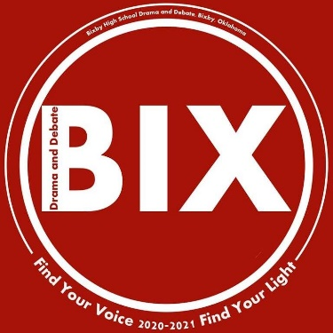

We are happy to invite you to the Bixby Green Corn Classic Tournament. This year, we will be a virtual tournament with asynchronous speech and live rounds in Policy, LD, and PF debates and in foreign and domestic extemp.

We are happy to be an OSSAA qualifying tournament, and also a NIETOC bid tournament in our Champs division.  **Schools from outside Oklahoma are welcome in our Champs and Novice divisions (5A/6A divisions are only for Oklahoma competition.)**

Oklahoma schools, please note that there is a slight fee increase in for entries in Champs events that are eligible for NIETOC bids (Duet, Duo, HI, DI, OO, DX, FX, INF, and POI).

**SCHEDULE (Very subject to change!)**

All entries will be due by Tuesday, Jan. 12

All speech videos will be due by Wednesday, Jan. 13

**Thursday**

All prelim ballots in asynchronous events will be sent out.

* 5A/6A speech events will have 1 prelim round.
* Champs and Novice will have 3 prelim rounds in asynchronous events.
* If an event has enough entries to need a semifinal, they will be due at 9 AM on Friday. If an event is straight to finals or will only need a prelim/final, it will be due on 9 AM Saturday.

**Friday**

8 AM: Semifinals in asynchronous IE will be sent out if needed, due by 9 AM Saturday.

4 PM: Debate Round 1

6 PM: Debate Round 2

8 PM: Debate Round 3

We will single flight if possible, but it usually is not possible.

**Saturday**

8 AM: Finals in asynchronous IE will be sent out, due by 2 pm.

Specific times for live rounds on Saturday will be decided as we see the number of entries in debate and extemp, but Debate rounds will happen in the morning, and extemp will happen in the afternoon.

Champs and Novice Extemp will only have 1 prelim round, unlike the other IEs in those divisions.