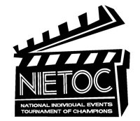
We are happy to be a bid tournament for the NIETOC national tournament.
Bids will come from our CHAMPS division only, as this is the only varsity division that Out of State schools can compete in.
Oklahoma schools, if you would like a student to try for a NIETOC bid but they also need to use this tournament to attempt to qualify for OSSAA Regionals, they are welcome to enter both their qualifying division AND Champs. In the extemps they will need to choose one division or the other.
Events eligible for Bids are:
- Domestic Extemp
- Foreign Extemp
- Original Oratory
- Informative Speaking
- Combined Duet Interpretation
- Duo Interpretation
- Humorous Interpretation
- Dramatic Interpretation
- Program of Oral Interpretation

Bids are awarded as follows:
- 0-19 contestants = FIRST PLACE BID
- 20-34 contestants = FIRST, SECOND & THIRD PLACE BIDS
- 35-50 contestants = FINAL ROUND BIDS
- 51-70 contestants = SEMIFINAL ROUND BIDS
- 71-99 contestants = QUARTERFINAL ROUND BIDS
- 100 + contestants = OCTAFINAL ROUND BIDS

For more information about this tournament (which we here at Bixby think is an amazing tournament!) see their website @ http://nietoc.com/

