***The Willard Online Invitational*** 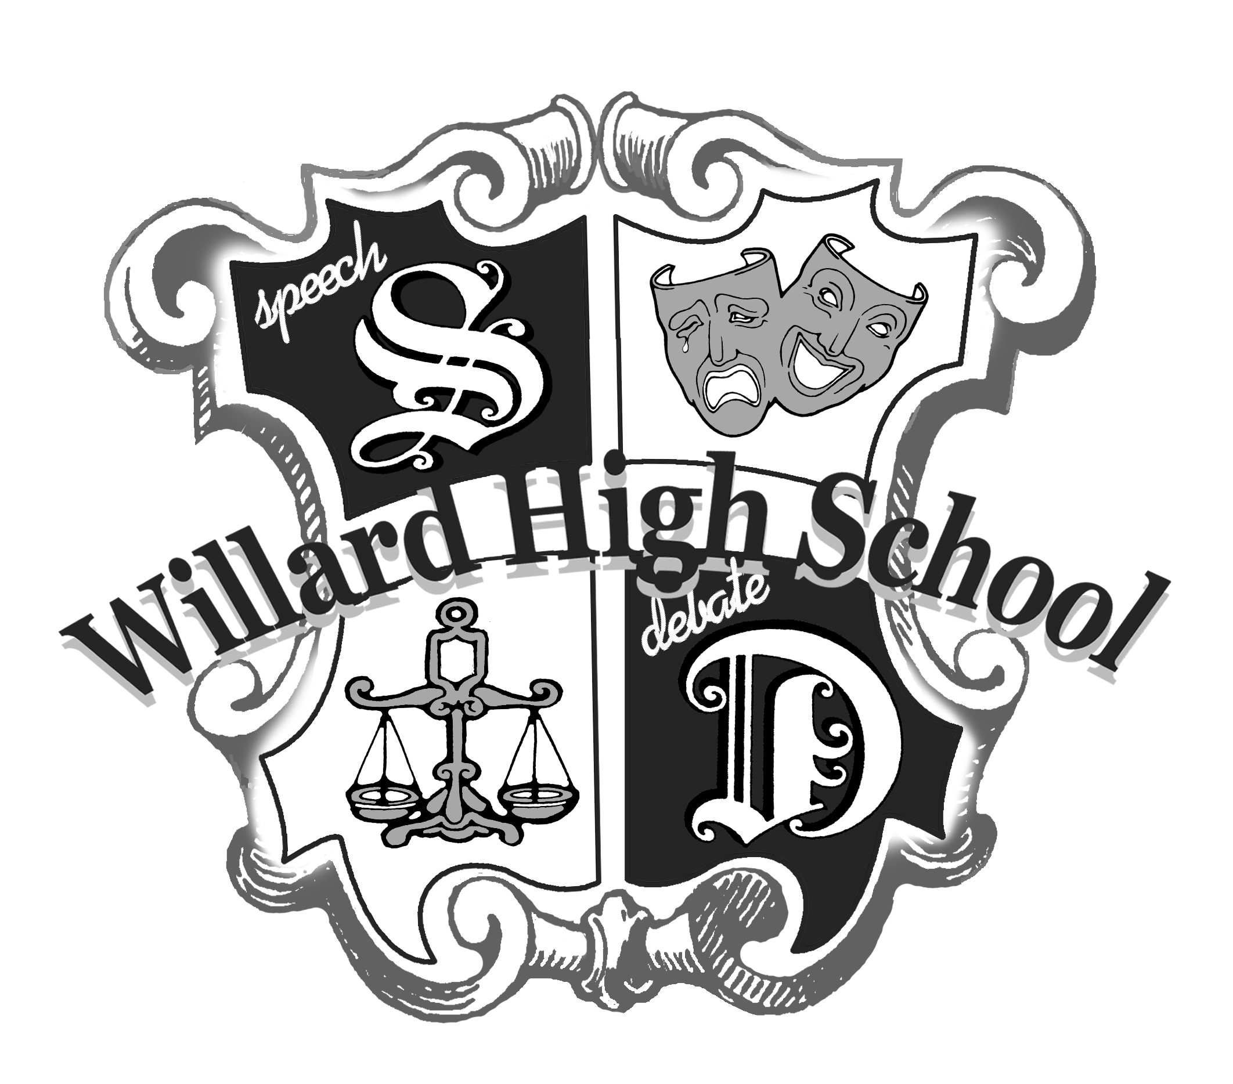

Dear Colleagues,

We cordially invite you to the ***Willard Online Invitational*** on October 16-17, 2020!

We will be offering Champ, Reg. and Novice Policy Debate, Public Forum and Lincoln Douglas Debate. We will also be offering Varsity and Novice International Extemporaneous Speaking, Domestic Extemporaneous Speaking, Original Oratory, Informative Speaking, Humorous Interpretation, Dramatic Interpretation, Duo Interpretation (Not Duet), and POI.

**PLEASE READ WHS ONLINE SUPPLEMENTS FOR SPECIFIC DETAILS ABOUT OUR VIRTUAL TOURNAMENT**

**\*\*\*Here is the short version:**

* All registration/ scheduling/ etc. will be through [http://willardonlineinvitational.tabroom.com](http://willardonlineinvitational.tabroom.com/). Entries not entered through tabroom will not be accepted. Rounds will be conducted through the NSDA Campus platform.
* We will waitlist students when they are first registered. We will guarantee 3 entries per event and open up other entries the week of the tournament.
* Pre-recorded events will be charged $5 per entry, live events will be charged $9 per entry. For ease of payments and scheduling, all checks should be made to WHS. There may be an additional invoice for fines at the end of the tournament.
* Please make sure your students show up for the tournament and stay through the rounds**.**We expect that students will be connected to the internet during rounds. Each debate round will have 10 minutes of “tech time” that is not prep time. This should only be used if there are tech issues.
* By Wed. 10/14 @ 4PM All speech prelim rounds, except extemp, will be pre-recorded and submitted into

<https://drive.google.com/drive/folders/1t_MVEL5ANjx07NBLxOcULN7P5_KZB_ZI?usp=sharing>

* Please remember to extend grace to us and to each other. This is the second weekend for online tournaments that will be run in the state using primarily volunteer judges. You may be asked to judge rounds.

All entries must be received by 3:00pm on October 9th. Please submit as soon as possible. Extra entries will be granted as space allows and confirmed after the entry deadline.

We look forward to hosting your school!

Tanner Ladouceur, Tournament Chair Emma Loeber & Melody Tate Asst. Chairs

Katherine Tobin, Willard Head Coach Katelynn Wilson, Willard Assistant Coach

Email: [kathytobin@willardschools.net](mailto:kathytobin@willardschools.net) Email: [katelynnwilson@willardschools.net](mailto:katelynnwilson@willardschools.net)

School: (417) 742-3524 ext. 3108 School: (417) 742-3524 ext. 3109

Cell: (417) 380-4050

**Please Note: Your team will lose 5 Sweepstakes points for each change made after 10AM on Friday and after 7AM on Saturday! It is important to call early so changes can be made to the schedule promptly and the tournament can run on time. Varsity students performing in the wrong room, due to no fault of the tournament, will be given the last place in the room or the loss.**

**WILLARD TOURNAMENT SCHEDULE**

**Wednesday, October 14**

**Videos Submitted by 4PM**

**Friday, October 16**

**Online Reg by 2PM**

2:30 Extemp Draw

3:00 Rd 1 Extemp/Semis of Sync IEs

5:00 Extemp Draw

5:30 Rd 2 Extemp/Finals of Sync IEs

7:00 Finals Extemp Draw Since extemp breaks directly to finals, we are planning on using two judges for each extemp round and breaking extemp based on ballot counts.

7:30 Finals of Extemp

9:00 Awards for IEs

**Saturday, October 17**

**Online Reg by 7 AM**

8:00 Rd 1 Debate

10:00 Rd 2 Debate

12:00 Rd 3 Debate

2:00 Rd 4 Debate

4:00 Quarters

6:00 Debate Awards

7:00 Semis

9:00 Finals

**General Tournament Rules (**See **WHS Online Supplements** for more information**)**

* Each school must be accompanied by an adult sponsor.
* A student may enter two individual events and debate.
* Students may only enter one division of extemp.
* Debaters may enter only one of the following: Policy, Lincoln-Douglas, or Public Forum Debate. Team personnel must remain consistent throughout the tournament.
* Fees will not be refunded for cancellations made after 3PM Monday, October 12th.
* **Please Note: Your team will lose 5 Sweepstakes points for each change made after 10AM on Friday and after 7AM on Saturday! It is important to call early so changes can be made to the schedule promptly and the tournament can run on time. Varsity students performing in the wrong room, due to no fault of the tournament, will be given the last place in the room or the loss.**
* Novice students shall be defined as in their first year of competition.
* Schools must provide two student Novice Judges. See **WHS Online Supplements** for more information
* Judges and students need to please report to their rooms(or draw) online 10 minutes prior to the start of the round. This includes second flight debate teams.

JUDGING RULES

* Student judges may be used in the Novice division, and all schools should provide 2 student judges in the interest of the tournament. **(**See **WHS Online Supplements** for more information**)**

INDIVIDUAL EVENTS RULES

* *U.S. and International Extemporaneous Speaking*: Topics will be based on current events. Consultation during prep time is prohibited. Time limit: 7 minutes.
  + - **The plan for right now is to use 2 judges for extemp since there is not a semi-final round. This should allow your students to get sufficient feedback while keeping the tournament on a good schedule.
* *Original Oratory*: The speech must be the original work of the student and may contain no more than 150 words of direct quotation. Time limit: 10 minutes.
* *Informative Speaking*: The speech must be the original work of the student and may contain no more than 150 words of direct quotation. Time limit: 10 minutes. You can use props
* *Humorous, Dramatic Interpretation, and POI*: Selections may be taken from published novels, short stories, or plays. Selections must possess literary merit and be of good taste. Time limit: 10 minutes.
* *Duo Interpretation*: **This is not duet acting.** Selections should be from any appropriate novel, short story, or play. Performances should be memorized, use offstage focus, and incorporate limited movement. Time limit: 10 minutes.
* All students who are double entered must notify their judges of their double entry 15 minutes before the round!

# GENERAL DEBATE RULES

* Entries must remain constant in personnel throughout the tournament.
* NSDA evidence rules will be enforced.
* Being more than 10 minutes late to a round, through no fault of the tournament, may result in a forfeit.
* Novice Debaters should be in their first year of competition.
* Runoff debates may be held before quarterfinals to prevent undefeated teams from elimination.

POLICY DEBATE RULES

* **See attached Novice policy rules. Novice Affirmative teams are limited to the attached case areas list (mandatory minimums, ban facial recognition, drug decriminalization, immigration). Novice teams are not to use kritiks. Novice Negative teams are not to use counter plans.**
* Time limits will be 8-3-8-3-8-3-8-3-***5-5-5-5***. Prep time: 5 minutes.
* The national topic will be debated.
* ***Policy Debate – 2020-2021 Topic***

***Resolved: Resolved: The United States federal government should enact substantial criminal justice reform in the United States in one or more of the following: forensic science, policing, sentencing.***

* The following criteria will be used to determine quarter finalists: win/loss record, speaker ranks, win/loss record of the team inflicting loss, total opposition record, opposition’s opposition record.

LINCOLN-DOUGLAS DEBATE RULES

* Time limits will be 6-3-7-3-4-6-3. Prep time: 4 minutes.
* Rounds will be flighted and will take place during other debate rounds.
* The topic for both Varsity and Novice will be*:* ***2020 September/October Topic Resolved: In a democracy, voting ought to be compulsory.***

PUBLIC FORUM DEBATE RULES

* Format: 2-person teams. Rounds will be flighted and will take place during other debate rounds.
* Time limits will be 4-4-3-4-4-3-3-3-3-2-2 Prep time: 3 minutes.
* The topic will be the Public Forum topic*,* ***2020 September/October Topic Resolved: The United States federal government should enact the Medicare-For-All Act of 2019.***
* In a case of forfeit or bye, the winning team’s speaker points will be marked as 1-2.
* The following criteria will be used to determine quarter finalists: win/loss record, speaker ranks, win/loss record of the team inflicting loss, total opposition record, opposition’s opposition record.
* Each round shall begin with a coin toss. The winner of the toss may select the side (pro or con) OR select the speaker order (begins the debate or has last speech). The loser of the toss chooses speaker order (if the winner has chosen side of the topic) OR chooses side (if winner has chosen speaker order). *Please note: The negative may begin the debate as first speaker and argue against the topic.*
* The CX periods are crossfire periods and both speakers may ask and answer questions in a polite but argumentative exchange. (The first question is asked to the speaker who just finished). There is also Grand Crossfire for all four debaters.
* No plans, counterplans, kritiks, or spreading are allowed.

Quarter Finalists will be determined by win/loss record, win/loss record of debater inflicting loss, total opposition record, opposition’s opposition record.

**SWEEPSTAKES RULES**

The ***top two entries*** in each event will count for sweepstakes.

* 5 points for qualifying for semifinals in individual events.
* 10 points for qualifying for finals in individual events.
* 5 points for placing third in individual events.
* 10 points for placing second in individual events.
* 15 points for placing first in individual events.
* 5 points for each win in preliminary debate rounds.
* 15 points for qualifying for quarterfinals in debate.

Awards will be presented to the top six in each individual event on Friday. On Saturday, debate competitors advancing to quarterfinals, and beyond and Sweeps will be on Saturday.

* **Please Note: Your team will lose 5 Sweepstakes points for each change made after 10AM on the day of the tournament! If you have NO Shows that are dropped from the tournament you will lose 10 Sweepstakes for each. It is important to call early so changes can be made to the schedule promptly and the tournament can run on time.**