2020 Warhawk Invitational

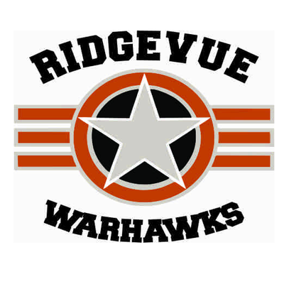

In memory of Chief Master Sgt. William M. "Bill" Gornick

Ridgevue High School in Nampa is pleased to host this year’s Warhawk Speech and Debate Invitational Tournament!

Events offered at this year’s Warhawk Invitational will be all 14 Idaho Speech Events. We will also offer Open divisions of Lincoln Douglas, Public forum, and Policy debates as well as Open only divisions for Congress and Big Questions Debate formats. Big Questions debate will be offered as a 1v1 format. As this is the last regular invitational of the year, we have opted to give everyone 4 rounds of debate in the Open division in order to ensure the most practice leading up to NSDA Qualifiers and districts as possible. Also, by not scheduling elimination rounds, we are able to start later, end earlier, and create a more humane schedule for our amazing volunteer judges.

There will be a concessions stand available for students to purchase food from on both days of the tournament. There are no fast/easy food locations nearby so please plan accordingly.

**Bus Arrival**

If you arrive to Ridgevue via bus on Friday please drop off students on the north side of the stadium/activities entrance and have them report to the cafeteria. School lets out at 3:35 and will be very busy in the back of the school until 4:00 pm. Saturday-you may park wherever you wish!

**AWARDS:** Speech rounds and awards will be in the traditional format and the top 6 finalists in each round will receive an award There will be 4 prelim rounds in debate and a 5th “hidden” gold/silver round. All gold and silver finalists will receive awards. There will also be awards for Top PO and Top Speakers. Sweepstakes trophies will be awarded.

**COST/JUDGE REQUIREMENTS**

Speech Events: $7 per speech entry

Debate Events: $5 for LD and B entries $10 for PF and CX entries

School Fee: $20

**Judge Requirements:**  1 for each 5 speech entries, 1 for each 4 LD, PF, or Big Questions entries, and 1 for each 2 CX entries.

**SCHEDULE**

**Friday – February 7th**

3:45 – 4:15  Registration in Tab Room: Library  4:15 draw -round 1

4:15     Draw begins for Round 1

          (Extemp, Radio/Broadcast, Retold Story) 5:30 draw- round 2

      Round 1 all other Speech events

5:30    Draw begins for Round 2

           (Extemp, Radio/Broadcast, Retold Story) 6:45 draw -round 3

     Round 2 all other Speech events

6:45    Draw begins for Round 3

           (Extemp, Radio/Broadcast, Retold Story)

8:00 Finals

***judges meeting 3:45-4:15 In library upstairs!

**Saturday – February 8th**

8:15-8:45am   Team & Judge Check-In

9:00 – 11:15   Round 1, All Debate    Congress Session 1-9:30-12:00

11:30-1:45    Round 2, All Debate

                           Congress Session 2-12:30-3:00

2:00 – 4:15    Round 3 , All Debate

4:30 – 6:45    Round 4, All Debate( Hidden Gold/Silver Rounds)Congress Session 3-3:15-5:45

7:00PM Awards