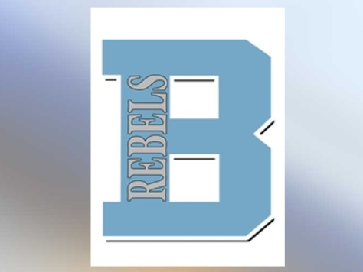Dear High School Forensic Coaches,

Boone County High School is pleased to invite you to the December 7th **Throw Down in Flo-Town.** We would love you to join us at Boone County High School for a down-right good time!

CATEGORIES

All KHSSL IE categories will be offered. Students may do as many as three events, but rounds will not be held for any student because they are triple entered. It is not recommended that a student triple in more than two limited prep events.

AWARDS

We will be giving trophies to the top 6 speech performers in each event. A “next out” award will be given to each 7th place competitor in each category. Sweepstakes trophies will be given to the top 3 schools.

ENTRIES

Teams are free to enter an unlimited amount of students in each event. Only the top three students in each event will count towards sweepstakes. Each entry will be charged $5 with Duo Interpretation and Duo Improvisation entry charged $10.

**The deadline for entries is December 4th at 4:00 PM. Any drops or adds after this date will be charged a $10 drop fee.**

JUDGES

Speech: You must provide one judge for every six entries or fraction thereof; 7 entries = 2 judges, etc.

Remember Duo Interpretation and Improvisational Duo count as one entry in judges needed and as two entries in fees to pay ($5 per kid = $10 per duo entry). You may hire judges you do not provide for $40 apiece. Your judges should be familiar with the KHSSL rules and ballots. We promise to have a delicious hospitality room. So bribe your parents and volunteers to judge with food and goodies! We want your judges!

SPEECH SCHEDULE

7:00 – 8:00 AM Registration

8:00 AM Extemp Draw will begin in the library

8:30 AM Round 1

9:30 AM Extemp Draw Round 2

10:00 AM Round 2

11:00 AM Extemp Draw Round 3

11:30 AM Round 3

1:30 PM Finals

4:00 PM Awards

FOOD

There will be a hospitality room available for all judges, coaches, and bus drivers. Student will be able to purchase food in the cafeteria. There will be a wide variety or goodies to choose from for students and judges alike.

DIRECTIONS

**South of Boone (From 71/75)**

1. Take the KY-18 exit, EXIT 181, toward Florence/Burlington.
2. Turn right onto KY-18/Burlington Pike.
3. Boone County High School will be on your left.

**North of Boone (71/75)**

1. Take Turfway Exit 182
2. Turn right off the exit onto Huston Rd
3. Turn right at the intersection of Huston and Turfway
4. Turn right at the third light onto KY 18/Burlington Pike
5. The high school will be on your right.

**You may drop students off at the main entrance and then park busses in the parking lot to the left of the school.

HOW TO ENTER

Please register online at [www.tabroom.com](http://www.tabroom.com) . Please feel free to email us with any questions. Email is the best way to get in touch with us throughout the day. [emily.brownstead@boone.kyschools.us](mailto:emily.brownstead@boone.kyschools.us) or [erin.tharpe@boone.kyschools.us](mailto:erin.tharpe@boone.kyschools.us)

We look forward to seeing many of you on December 7th.

Sincerely,

Emily Brownstead and Erin Tharpe