THIEL COLLEGE FORENSIC TOURNAMENT
REGISTRATION AND INFORMATION

FEES: $5.00 per entry in speech and congress
$10.00 per team in duo Interp and PF
Checks made payable to “Thiel College”

ENTRIES: Registration in speech is open UNTIL an event has reached the max that we can hold in that event. At that point, the next entries will be put on a waiting list. Please note that the waiting list pays no attention to schools and the numbers of entries by any school. In other words, register early!
There is a school entry cap in congress, LD and PF.
Because of space limitations, some categories may close before the registration deadline.

FORMAT: There will be four rounds of competition and no final round in speech events. Final results will be determined by ranks with reciprocals and speaker points to be used as tiebreakers, respectively.

There will be three guaranteed rounds of debate. Final results will be determined by win-loss records, median points, then total points.

JUDGES: 1 per 5 in speech, or fraction thereof
1 per 2 in debate, or fraction thereof
1 per 6 in Congress, or fraction thereof
Judges must be present for all rounds. If a judge leaves early without notifying the tab room and/or without providing a replacement, that school will be disqualified. Judges may be moved from one event to another if the tab staff feels that is necessary to move the tournament along!

EVENTS: Original Oratory 10 minutes maximum
Dramatic Interp 10 minutes maximum
Humorous Interp 10 minutes maximum
Duo Interp 10 minutes maximum
Prose 10 minutes maximum
Poetry 10 minutes maximum
Extemporaneous Speaking 7 minutes maximum
Impromptu 5 minutes maximum
Public Forum NSDA time limits and topic
Lincoln Douglas Debate NSDA time limits and topic
Student congress

PHSSL rules apply for all events except Original Oratory which will follow NSDA rules.

Please note: “The coaches’ of the Pittsburgh NSDA district are in agreement with the statement issued by PHSSL after its summer 2000 meeting.”Material that is presented in competition must be suitable for a high school audience. Contestants presenting material that is not suitable may be penalized.” This tournament supports this policy.

CONGRESS: Congress legislation will come from the newly established district congress bank. Please check your Google Drive account/Files Shared with Me, or the website of this tournament.

SNACKS/LUNCH:Orders for lunch must be placed in the morning before rounds begin.

TENTATIVE SCHEDULE:
All events Registration 7:30 - 8:15
Pedas Communication Bldg.
Speech: Assembly 8:30 - 8:45
Round I 9:00 - 10:00
II 10:00 – 11:00
III 11:00 – 12:00
Lunches 12:00 - 1:00
IV 1:00 – 2:00
Congress: First session 9:00 - 11:00
Second session 11:45 - 1:45
Debate Round I 8:30
Lunch as announced by debate tab
Awards: 2:30

AWARDS: Plaques will be presented to the top 5 award winners in each category.

The top two schools will receive sweepstakes awards. Sweeps will be based on the top ten entries in all categories.

Speech 6 minus each rank for each speaker
Debate 5 points for a win, 2 points for a loss
Congress Outstanding Speakers 15 points

DEADLINES: REGISTRATION DEADLINE: THURSDAY DECEMBER 19 3:00 PM

Registration can only be done at www.tabroom.com Create an account if you don’t already have one, then go to the list of tournaments and click on the Thiel tournament. You can then begin your registration.

Fees are set at the registration deadline of Thursday 3:00 PM
You may continue to make changes (drops but no adds) to your registration until 8:00 AM on Saturday, but the fees are set on Thursday 3:00 PM

MISCELLANEOUS:
No double entries.

Tournament registration begins at 7:30 a.m. on Saturday. Call or text 412 398-4174 between 7:30 and 8:15 if there are any problems. If you know that you will be arriving late, please text in drops. We will begin round I as scheduled.

Registration will take place in the lobby of the Pedas Communication Building. Parking should not be a problem since Thiel is on holiday break. I would suggest using the lot located NEXT TO THE FOOTBALL FIELD which you will see as you come up to the campus from the south—Thiel College sign is there/turn right into campus and right into the parking lot. Walk up the hill to the main campus. (A campus map can be printed out- see Thiel.edu website...). Opening and closing meetings are expected to be held in a large lecture hall in the Pedas Communication Building.

WE ARE USING ONLINE BALLOTING FOR ALL EVENTS. Please be sure that your judges are linked to your school with a Tabroom account and that they bring a device on which they can input their ballots!!!

Judge: Online Balloting
Pittsburgh NSDA/NCFL/PHSSL
(with many thanks to our friends in WACFL)

Overview: Tournament Online Balloting & Text Pairings
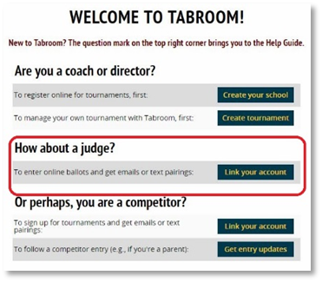
For a judge to receive text/email round assignment communications (“pairings”) and complete and submit ballots online for Lincoln-Douglas, Policy, and Public Forum debate events, they must have a Tabroom.com (“Tabroom”) account linked to their team’s Judges roster. The set-up process takes about two minutes to complete.
- To create your Tabroom account, go to www.tabroom.com and click on Sign-Up in the upper right of the website.
Tabroom Account Set-Up
- Under Create a Tabroom Account, enter your email address, name, cell phone information, and the password you wish to use for the account. Make sure you provide your cell number and provider so you can receive pairings texts during tournaments.
- On the Welcome to Tabroom! screen, click the Judge “Link you account” button.
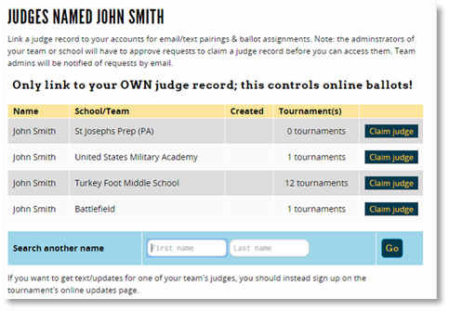
- If your coach already has you on the team’s Tabroom Judges roster, you will see your name listed next to the school and a button. If the name and school are accurate, click the button.
If your name and school don’t appear, try searching for them using just your last name. (If unsuccessful, confirm with your coach that you’re on the roster.)
- The next screen will display a message that will be confusing, saying “There are no judges named [Your Name] who are not connected to an account already. If this is in error…” As misleading as this may be, this actually confirms your account is ready to be linked by the coach to the team’s Judges roster. You are finished and can log out.
- The team’s coach will receive both an email and Tabroom alert informing them your account is ready to be linked to the Judges roster; they then approve. Once linked, you will receive round assignment texts/emails (pairings) when at tournaments, and online ballots will be available for completion and submission for each round you judge.
Judge Online Ballot Voting and RFDs/Comments Entry
Judges must have an electronic device—such as a laptop, phone, or tablet/iPad—to enter and submit online ballots. Laptops are strongly encouraged due to ease of keying Reasons for Decisions (RFDs) and Comments to the competitors; phones are not optimum for entering the amount of text associated with RFDs and comments, and may conflict with using them as timers. Judges should also locate their seat during the round near a power outlet to ensure there is no interruption or delay during the round to a dead computer. (Paper ballots will be provided in exceptional circumstances, such as poor WiFi reception in a classroom.)
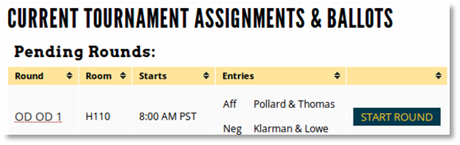
- To see your current ballots, log into Tabroom and go to your account dashboard by clicking your email/username in the upper part of the page. Your current ballots are listed under Pending Rounds (just one for a Policy round, and two if you’re judging a double-flighted Public Forum or Lincoln-Douglas round).
- If you don't see your ballot, check upcoming rounds by clicking the "Upcoming" link in the sidebar to the right, and then clicking the "Enter" button for the tournament you're at.
- Click on start round as soon as you arrive at the room. (This notifies Tab Room all is well.)
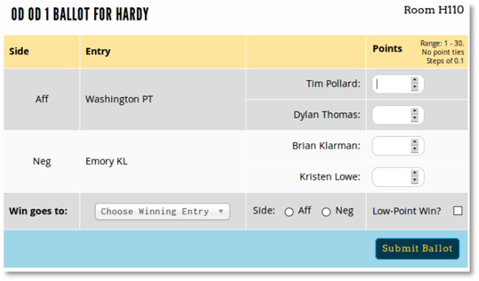

- For each ballot, verify the competitor information (schools and names), including sides (AFF/NEG or PRO/CON). Fill out the required information and then click submit ballot. Keep in mind that ballot appearance may vary from event to event.
- After submitting your ballot the first time, you must confirm the ballot — you'll be shown the data you entered, and then the option to confirm or re-enter if you made a mistake.
Review this information carefully before Confirming.

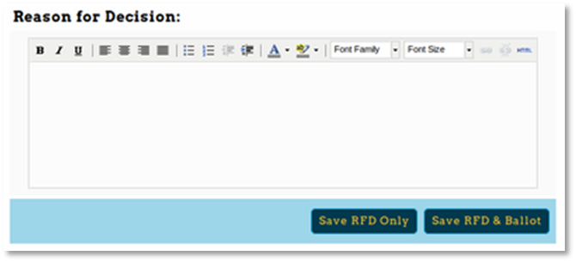
- The Reason for Decision (RFD) is separate from the “voting” part of the ballot, and, therefore, can be completed separately, after the ballot is submitted.
The RFD is below the ballot—this will be saved and available to competitors and their coaches. If you'd like to provide individual comments for each debater/team, you can use the "Comments" section on the sidebar. RFDs go to everyone; Comments only to the competitor and the coach.
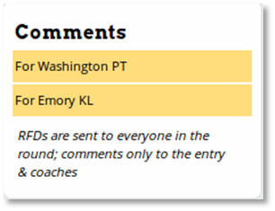
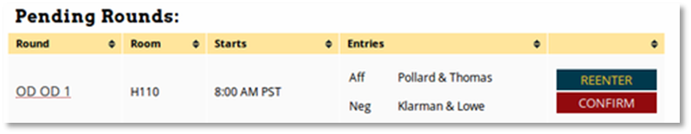
- If you accidentally close your ballot before filling it out completely or confirming it, you can still access it from your account dashboard. You'll see "Re-Enter" or "Confirm" options. Once you have confirmed your ballot, you cannot make changes to the results/points without contacting the tournament director.
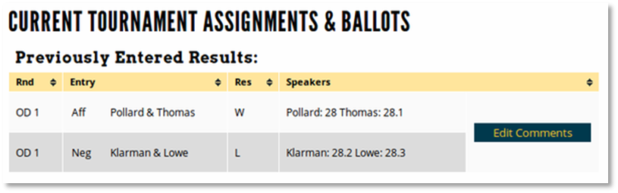
However, if you would like to add additional information to the RFD or Comments sections, you can access them in your "Upcoming" list, by viewing previous ballots you've entered and clicking "Edit Comments" before the tournament ends.

Additional information regarding your Tabroom Judge account and managing your online ballots can be found at http://docs.tabroom.com/Judging#Online_Ballots. Also, please feel free to consult with your coach or the tournament Tab Room staff. Our district contact judges with questions are Christine Robb of BP, Rich Platts of NA, Mary Krauland of SSA, and Ben Edwards of USC.

