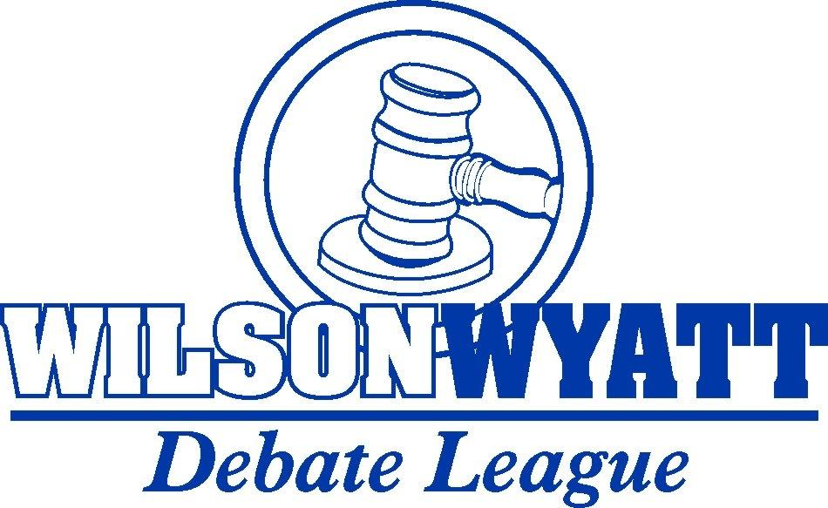

OCTOBER TOURNAMENT INVITATION

You and your team are cordially invited to attend the Wilson Wyatt Debate League October Tournament, to be held on October 12 at Trinity High School.

Wyatt Debate League Tournaments are open to all school-aged individuals in 6th grade or higher at accredited public, private, or parochial institutions, or to students being homeschooled.
The tournament will begin with registration from 7:00AM-7:45AM with the first round of competition starting at 8:00AM.

Registration:

Registration will be handled solely through tabroom.com. Registration is now open and will remain open until Wednesday, October 9 at 5pm EST. At that time all new entries and judges must be entered. Only coaches may register entries. Additionally, only coaches may check in at the tournament - no student, parent, or judge may check in at the tabroom.
You may drop teams and judges from your registration until Thursday, October 10 at 5:00PM, without penalty. After that time, each registration change will be assessed a $25 penalty.

Location:

Trinity High School
4011 Shelbyville Rd
Louisville, KY 40207

Parking:
Park in any of the parking lots located off of N Sherrin Ave. We will be meeting all day in the cafeteria, which can be accessed directly from the parking lot and has a drop-off loop. If you enter Sherrin Ave from Shelbyville Rd, this is the parking lot on your left.

Entry Fees:
Entry fees are $5 per student ($10 total per Public Forum/Policy entry) if you are not a full member of the Wilson Wyatt Debate League. Entry fees are waived for members.
Full membership is provided automatically for all schools located within Jefferson County, KY. Schools located in Kentucky, and further than 100 miles from Jefferson County, are entitled to free membership. Entry fees are waived automatically, but schools must actively register to receive other benefits. Schools outside of Kentucky, or within 100 miles of Jefferson County, may join the league on an annual basis for $100. Please visit www.wyattdebateleague.org for more information on membership benefits.

Events:
WWDL offers the following events and divisions: Novice, Junior Varsity, and Varsity Lincoln Douglas debate; Novice, Junior Varsity, and Varsity Public Forum debate; Varsity Cross-Ex debate (when numbers allow); and Congressional debate.
Novice is open to all debaters in their first academic year of debate. Eligibility is exhausted at the end of the year in which a debater has competed at three or more tournaments, regardless of the division(s) or event(s) in which they competed.

Junior Varsity is open to all debaters through their first three years of competition. In team events, in order to compete in novice or JV, both debaters of the partnership must meet the requirements.
In the event that a division of a debate event has fewer than six entries, that division may be collapsed into another division of the same event at the discretion of the tab room and tournament director.

Please send all legislation to wyattdebateleague@gmail.com by Monday, October 7 at 5PM. Legislation must already be properly formatted and exported to a PDF document. This can be done for free via the Save As menu in most recent versions of Word, or in Google Docs.

Topics:

Lincoln Douglas: Resolved: In the United States, colleges and universities ought not consider standardized tests in undergraduate admissions decisions.

During the fall semester only, novice Lincoln Douglas will debate the Modest Novice topic. This is a nation-wide, standard topic that provides both new debaters and new coaches with the widest possible set of tools and curricula to learn the activity. This topic is:
Resolved: Civil disobedience in a democracy is morally justified.

Public Forum: Resolved: The European Union should join the Belt and Road Initiative.

Judging:
Each school is required to fulfill its judging obligation by providing one judge for every two entries, or fraction thereof. Thus, one judge can cover between 1-2 entries, two judges for 3-4 entries, 3 judges for 5-6 entries, and so on. In Congressional debate, the requirement is one judge for every six entries, or fraction thereof.
In the event that you cannot fulfill your entire obligation, there are a limited number of judges available for $100 each. Please submit all hired judge requests on tabroom.com.

If you are unable to meet your obligation, and there are insufficient hired judges available, you will be required to reduce the size of your entry. You will be notified prior to the date of the tournament if this is necessary.

Once the tournament has begun, judges are expected to remain onsite and available for the entirety of preliminary rounds and, if their school is represented in semi-finals, the final round. Judges who fail to appear for a round and need to be replaced will have a $10 fine assessed to their school for each round missed. If a judge misses two rounds, they will be removed from the tournament and, in addition to the missing round fines, the school will be assessed a $100 missing judge fine even if they are over their judging requirements.

Congress/Debate Dual Judges:

Because only one chamber of Congress is typically run, judges entered in congress may also be applied for HALF CREDIT (covering 1 debater/team) towards your debate commitment. They will still count for the full commitment in Congress. If you choose to utilize this option, you MUST e-mail the tabroom director at woody.zorn@gmail.com, or league director at wyattdebateleague@gmail.com, prior to the close of registration. We must account for this manually. Failure to notify us on time will result in a $25 nuisance fine per judge.
Awards:
Awards will be given to each student reaching elimination rounds as well as the top ten speakers in each division. In Congress, the top ten students will be recognized.

Schedule:
The tournament will feature 5 preliminary rounds of competition, semifinals, and finals. The schedule below is tentative and subject to change:
Registration 7:00AM-7:45AM

Lincoln Douglas/Public Forum
Round 1: 8:00AM
Round 2: 9:00AM
Round 3: 10:00AM
Lunch: 11:00AM
Round 4: 12:00PM
Round 5: 1:15PM
Semifinals: 2:30PM
Awards: 3:30PM
Finals: 4:15PM

Policy
Round 1: 8:00AM
Round 2: 9:30AM
Lunch: 11:00AM
Round 3: 12:00PM
Round 4: 1:30PM
Awards: 3:30PM
Finals: 4:15PM

Congress
Round 1: 8:00AM
Lunch: 11:00AM
Round 2: 12:00PM

Food:
Breakfast and lunch will be provided at each tournament at no cost to competitors, coaches, and judges. Please take advantage of Tabroom to note any dietary restrictions that debaters may have.
Chaperones:
A designated adult representing your school must be with your students at the tournament. A designated adult is the approved coach or assistant coach, a teacher from the school, or an approved parent with explicit principal permission. We cannot allow students to compete, or be at the tournament site, without them.

Tournament Processes:
Judge Feedback:
We will allow and strongly encourage judges to provide oral feedback to students after the round. While we ask judges not to disclose their decision, we do ask that you provide some guidance as to what you thought each debater did well and what they could improve. Filling out the written ballots is still a requirement.

Tabroom:
The tabroom is open to all coaches throughout the course of the tournament. Upon request, results and ballots will be provided to coaches for review with the understanding that this information will not be shared until after the conclusion of the tournament. Coaches found to have shared results with their students, or coached their students based upon feedback from the tabroom will lose access to the tabroom at future tournaments. Students and parents are not allowed in the tabroom at any time.

Photography:

By registering students to compete in this tournament, you affirm that you or your school district have obtained consent from the student(s) parent(s)/guardian(s) for their image and/or likeness to be used in promoting the Wilson Wyatt Debate League (League), and that their likeness may be used without compensation. Such images may be used on the League website or social media pages, and will never include student names unless affirmative consent has been given directly to the League by the student’s parent(s)/guardian(s).

If you have any other questions please feel free to email the league director, Brian Huot, at wyattdebateleague@gmail.com, or the tabroom director, Woody Zorn, at woody.zorn@gmail.com.
See you soon!!!

