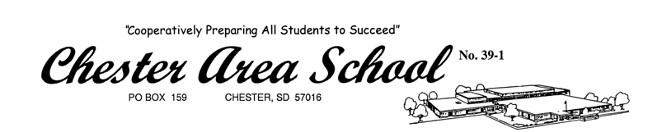

102 2nd Avenue Superintendent – Mr. Heath Larson
PO Box 159 Secondary Principal – Mrs. Julie Eppard
Chester, SD 57016 Elementary Principal – Mrs. Amy Johnson
Business Manager – Mrs. Kristi Lewis

(605) 489-2411
(605) 489-2413 Fax

September 20, 2019

Dear Big East Oral Interpretation Coaches,

The Big East Conference HS Oral Interp. Meet will be held on Monday, October 14, 2019 at Chester.

The deadline for registration is Friday, Oct. 11, at 3 p.m. Only non-refundable “drops” or substitutions will be taken after the deadline. Please visit Tabroom.com to complete your entry: http://bigeast.tabroom.com This is the first time we’ve tried to use Tabroom for this tournament, so please be patient while we work out the kinks.

Registration will be from 8:15 to 8:45 a.m. in the cafeteria right inside the north doors. There should be no problem with parking as Chester has no school that day. There will be a short meeting for coaches and judges at about 8:50 p.m. in the high school library to the east of the cafeteria. Students will meet in the cafeteria and starting instructions will be given after the coaches meeting. We would like to begin Round 1 no later than 9:00 a.m. with results as close to 1:00 as possible. At this time, no group has committed to running a concession stand, so please plan on making alternative lunch arrangements if need be.

There will be three rounds of competition in seven categories. SDHSAA contest rules apply. Three entries per category are allowed per school, and each student may be entered in a maximum of two events not including the Readers’ Theater category. One judge is required for every five entries or fraction thereof. ***That means, for example, if you have 7 entries, you will need to bring 2 judges. It is going to be imperative that you bring your own judges. As usual, awards will be presented to the 1st through 6th place finishers in each event except Readers Theatre.

I invite any of you coaches who are not judging or have breaks between rounds to stop in and help to check totals as we go. I welcome any help I can get!

If you have any questions, please feel free to contact me. We hope that you can join us!

Sincerely,

Tina Moyer, HS Oral Interp. Coach

