# ***SUPER IMPORTANT STARTER NOTE***

This is all copied from the Tabroom help center, located at <https://www.tabroom.com/docs/wiki/Main_Page>. (It’s also downloadable in PDF form.) If you’ve got questions that aren’t answered by this cheat sheet, please visit their site and/or contact me ([rberryncp@gmail.com](mailto:rberryncp@gmail.com)). Headings that are flagged with an asterisk will be specifically of use to schools new to Tabroom.

# *Sign Up

Signing up for a Tabroom.com account is quick and easy:

Click the "Sign Up" link in the upper right hand corner of the page:

[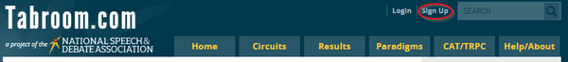](https://www.tabroom.com/docs/wiki/File:index_index-signup.png)

Then, fill out the form and click "Create Account:"

[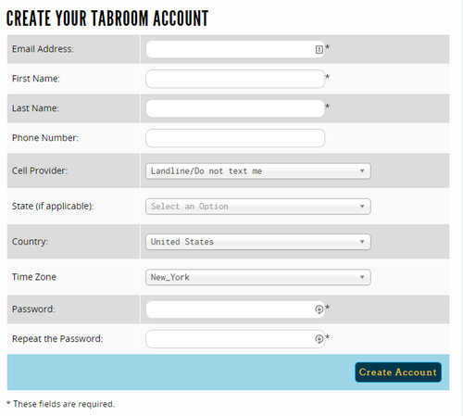](https://www.tabroom.com/docs/wiki/File:user_login_new-user.png)

You can use any email address you like to sign up. If you put in your cell phone number and choose your provider, you will be able to receive texts from tournaments you attend with pairings, information, etc.

You can edit your contact information as well as opt out of text or notification emails in your [account settings](https://www.tabroom.com/docs/wiki/Your_Account) after signing up.

Once you have signed up, you will be given a number of options to get started, whether you're a coach, a student, or a tournament director:

[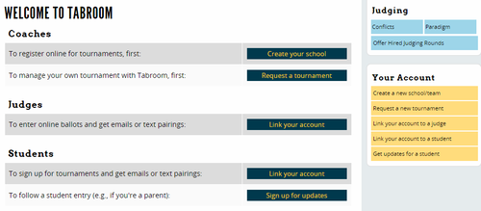](https://www.tabroom.com/docs/wiki/File:user_setup.png)

# School Setup

Before you can access your school's student roster, tournament registrations, etc. you must first either create a new school (also known as a chapter), or link your Tabroom account to the pre-existing school account.

## *Creating A School

#### ***NOTE***

Most CDL Blue/White conference schools already have entries. If you aren’t sure if you have one, or if you’re a first-year coach who might not have access to your team’s entry, please contact me.

If your school doesn't exist in Tabroom yet, you'll need to create it. After logging in, click the link for "Create a new school/team" in the sidebar:

[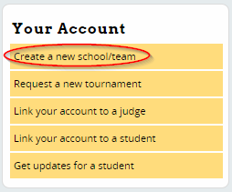](https://www.tabroom.com/docs/wiki/File:user_setup-createnew.png)

Then, fill out the required information such as School Name, State, etc. If you have a National Speech & Debate chapter number, or a variety of other school ID numbers, you can put them in here to ensure proper tracking. When done, press Save School Info.

[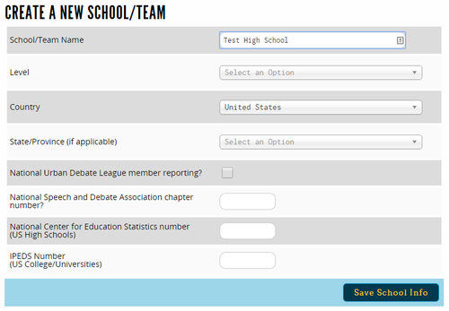](https://www.tabroom.com/docs/wiki/File:user_chapter_create.png)

If a school already exists in Tabroom with a similar name, you will see a warning that says "THAT INSTITUTION ALREADY EXISTS!"

If you need help getting access to an existing school, email [[mailto: help@tabroom.com]]. If you're sure you need to create a new school, check the "Confirm duplication" box:

[user chapter create-confirm.png](https://www.tabroom.com/docs/wiki/File:user_chapter_create-confirm.png)

Once your school is created, you should see a welcome message telling you what to do next - each of the suggested steps is covered in this manual in detail:

[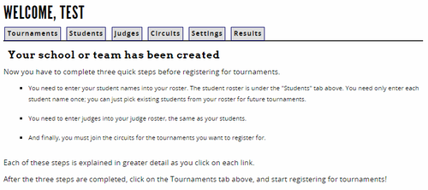](https://www.tabroom.com/docs/wiki/File:user_chapter_chapter-welcome.png)

## School Settings

To make changes to your school name, coach access, etc. you will use the Settings tab:

[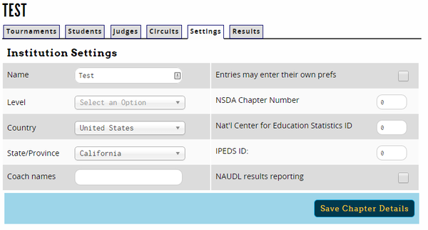](https://www.tabroom.com/docs/wiki/File:user_chapter_settings.png)

# Student Roster

Before registering for a tournament, you must add students to your student roster. When you first go to the Students tab, your roster will be empty:

[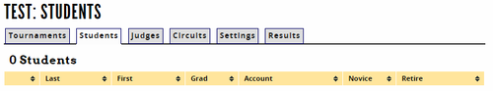](https://www.tabroom.com/docs/wiki/File:user_chapter_students-empty.png)

You can add students to your roster manually, import them from your NSDA account, or import them from a file.

## *Adding Students Manually

Click the "Add a new student" link on the sidebar:

[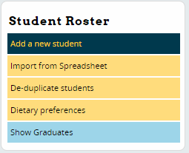](https://www.tabroom.com/docs/wiki/File:user_chapter-students-rostersidebar.png)

This will give you two options - you can search for a student to add by their Tabroom account's email address, or you can manually enter their information and click the "Save Student" button. You can always link your student roster entries to your student's Tabroom account later if you wish.

[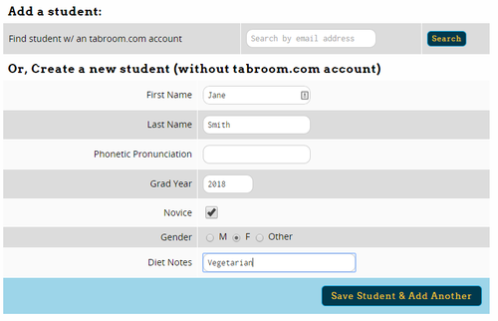](https://www.tabroom.com/docs/wiki/File:user_chapter_student-edit.png)

Make sure to give each of your students a 4-digit graduation date, like "2018," and not just two-digits. You can also fill out additional information, such as diet preferences and gender. When you're done entering all your students, you can return to your student roster by using the link on the sidebar.

## Adding Students From A File

To make it easier to add large numbers of students to your roster at once, you can use the "Import From Spreadsheet" option in the sidebar instead.

This will give you a form to choose the file to import:

[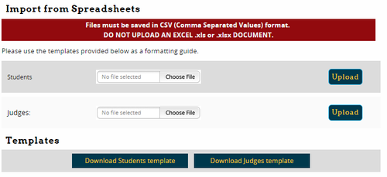](https://www.tabroom.com/docs/wiki/File:user_chapter_import-csv.png)

Your file must be saved as a ".csv" comma-delimited file. You can download a sample file to fill out on the upload page. While it is possible to create an upload file manually, it is much easier to use this template, fill out the names and other information, then save and upload the file - just make sure your spreadsheet program doesn't change the file format.

## Managing Your Student Roster

### Student Info

Once you have added students to your roster, you will see them in a list on the Students tab:

[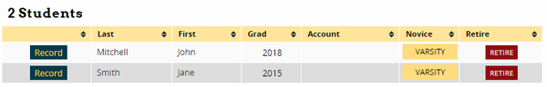](https://www.tabroom.com/docs/wiki/File:user_chapter_students-roster.png)

Each line on your roster has a number of options. Clicking the "Record" button will take you to individual results for that student:

[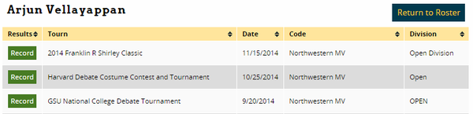](https://www.tabroom.com/docs/wiki/File:user_student_index-results.png)

Clicking either their first or last name will let you edit their information, such as name and gender. This will also let you link or unlink them to a Tabroom account:

[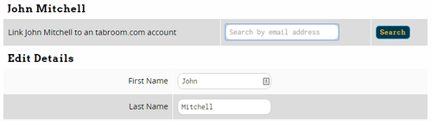](https://www.tabroom.com/docs/wiki/File:user_chapter_student-edit-existing.png)

You can see if an entry on your roster is linked to a Tabroom account on your roster by looking in the "Account" column.

## *Judge Roster

The judge roster works very similar to the student roster. You can click the "Add a new judge" link in the sidebar, or if your judge roster is empty, the form will appear automatically:

[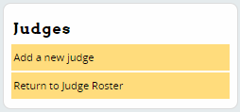](https://www.tabroom.com/docs/wiki/File:user_chapter_judge-edit-judges.png)

You can add judges by their Tabroom account email, or manually enter their information and click the "Save Judge" button. You can link judges on your roster to their Tabroom accounts later if you wish.

If you want to add a large number of judges at once, you can also use the "Import from Spreadsheet" option, which is found in the sidebar on your Students tab (not the Judge tab). For more information, see the section on [Adding Students From A File](https://www.tabroom.com/docs/wiki/School_Administration#Adding_Students_From_A_File) above. Make sure you use the "Judge" template, instead of the "Student" template.

Once you have added judges to your roster, they will appear in a list:

[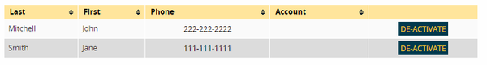](https://www.tabroom.com/docs/wiki/File:user_chapter_judges.png)

Clicking on a judge's first or last name will let you edit their information. You can also toggle a judge between active/inactive to keep your roster easier to manage. You can select whether to see active or inactive judges on the sidebar:

[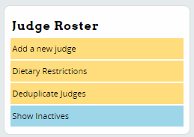](https://www.tabroom.com/docs/wiki/File:user_chapter_judges-inactives.png)

If you accidentally created duplicates on your judge roster, you can easily remove them by using the "Deduplicate judges" link on the sidebar. If any duplicates are found, you will be given the choice to merge them:

[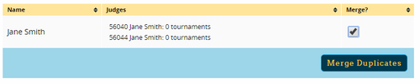](https://www.tabroom.com/docs/wiki/File:user_chapter_dedupe-judges.png)

To keep track of your judges dietary preferences, you can use the "Dietary Restrictions" link on the right - it will take you to the same page as for your student roster.

## *Circuits

In order to register for a tournament, you must first join the appropriate "circuit." All tournaments on tabroom must be part of a "circuit" - to find out which circuit the tournament you're interested in is a part of, look on the main [Calendar](https://www.tabroom.com/docs/wiki/Calendars).

Then, use the "Circuits" tab to join the circuit

[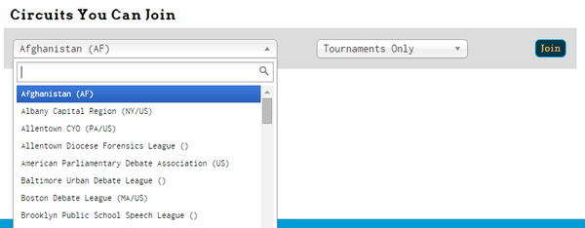](https://www.tabroom.com/docs/wiki/File:user_chapter_circuits.png)

First, select the circuit you want to join from the dropdown. Then, choose whether to join for "Tournaments Only" or "Full Membership."

Choose "Tournaments Only" if you want to register for tournaments, but don't want circuit emails or to be a dues paying member. Some circuits are run entirely on a tournament-only basis, such as the US National Circuit (HS).

"Full Membership" means you will be able to register for tournaments, and will receive emails about the circuit. You may also be billed for membership dues. This is best for joining a state or local circuit that uses Tabroom to manage its membership.

Once you have joined a circuit, your Circuits tab will change to show you the list of tournaments your school is a part of, and will give you the option to leave a circuit:

[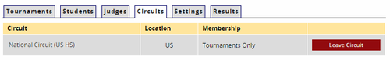](https://www.tabroom.com/docs/wiki/File:user_chapter_circuits-leave.png)

# Registering for a Tournament

#### ***NOTE***

T3 and T4 are “closed” tournament in that I have to manually add your school (this prevents random non-CDL schools from taking space that might be necessary for CDL teams). You shouldn’t need to take the following steps to register for this tournament, but they’re here to be safe.

Once your school has joined a circuit, your Tournaments tab will show you a list of upcoming tournaments that you can register for:

[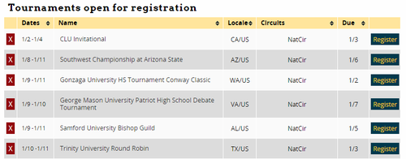](https://www.tabroom.com/docs/wiki/File:user_chapter_tournaments-upcoming.png)

Click the "Register" button next to the tournament to get started. You can also click the red "X" next to a tournament to ignore it so it won't show up on your list. You can then choose "Show Ignored Tournaments" at the bottom if you want to add it back.

Once you click "Register," you may be asked to provide an Adult Contact for tournaments which require it. You can edit this information later on the General tab of your entry:

[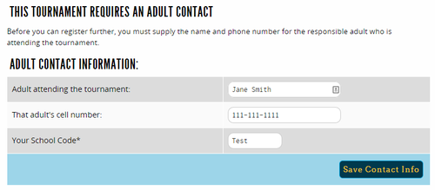](https://www.tabroom.com/docs/wiki/File:user_enter_entry.png)

## *Adding Entries

Click the Entries tab and then choose an Event on the sidebar. The number next to each event is the number of entries you currently have in that event.

[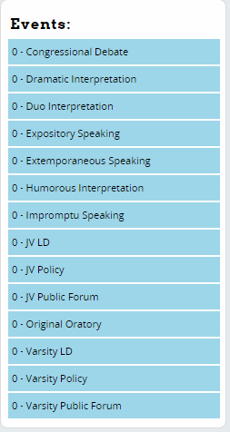](https://www.tabroom.com/docs/wiki/File:user_enter_students-events.png)

Use the "Add Entry" box on the right to select a student(s) names, and then click "Add Entry:"

[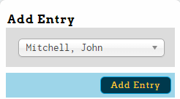](https://www.tabroom.com/docs/wiki/File:user_enter_students-addentry.png)

Once you have created entries, you will see them in your list, where you can edit or drop them:

[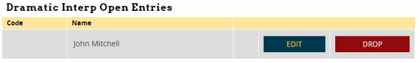](https://www.tabroom.com/docs/wiki/File:user_enter_students-existing.png)

## *Adding Judges

Once you have entered competitors, you can use the Judges tab to enter your judges. The sidebar will show you a list of judge groups you can enter judges in, and will appear in red if you have not entered enough judges to meet your commitment:

[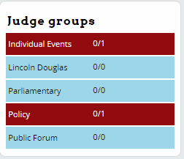](https://www.tabroom.com/docs/wiki/File:user_enter_judges-judgegroups.png)

Choose a judge group on the right, and then use the Add Judges box in the sidebar to add a judge:

[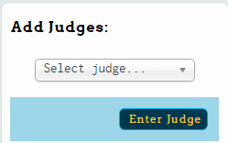](https://www.tabroom.com/docs/wiki/File:user_enter_judges-addjudges.png)

Judges will then appear in your list, where you can edit or drop them:

[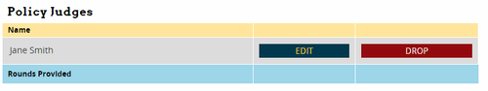](https://www.tabroom.com/docs/wiki/File:user_enter_judges-existing.png)

When adding a judge, you may be asked to provide additional details, such as how many prelim rounds they are entered for, or contact information for them:

[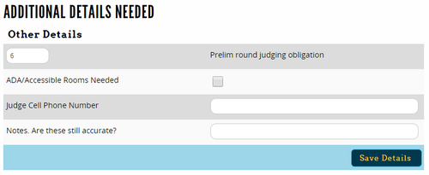](https://www.tabroom.com/docs/wiki/File:user_enter_judge-details.png)

### Limiting Judge Availability

Once you have added a judge to your entry, you can notify the tournament if they will not be available for certain days/rounds. From your judge entry, click the link under the "Availability" column:

[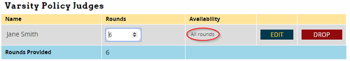](https://www.tabroom.com/docs/wiki/File:user_enter_judges-availability.png)

Depending on the tournament, this will let you mark a judge as unavailable for particular rounds or days - click the button in the Available column to toggle between Yes and No:

[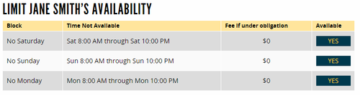](https://www.tabroom.com/docs/wiki/File:user_enter_judge-striketime.png)

If fines apply for being under your judging obligation, you will be shown the applicable amount.

# Accessing Results

## School Results

If your account is the admin for your school, you can access results for your entire team.

### Accessing Results

From your account dashboard, you can use the Results tab to see a list of tournaments with available results:

[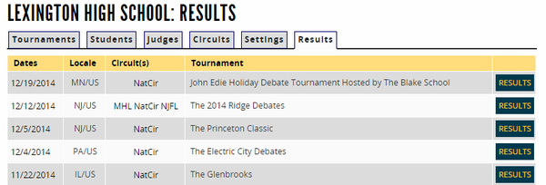](https://www.tabroom.com/docs/wiki/File:user_results_index.png)

Clicking the Results tab will give you a list of of available reports for that tournament. Full Tournament Results takes you to the full public results for the entire tournament instead:

[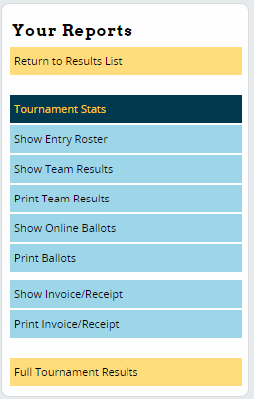](https://www.tabroom.com/docs/wiki/File:user_results_tourn-yourreports.png)

Tournament Stats will give you a general overview of participation at the tournament.

Show Entry Roster will show you your complete entry from the tournament.

Show Team Results will give you the complete results for the entire team, including final places, seeds, and speaker awards:

[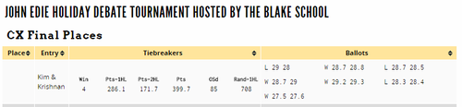](https://www.tabroom.com/docs/wiki/File:user_results_report.png)

Print Team Results contains the same information, but in PDF form for easy printing.

### Accessing Online Ballots/Comments

The Show Online Ballots link in the sidebar allows you to access and RFD's or Comments (if any) that judges entered online:

[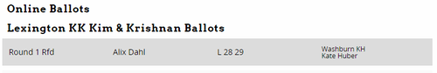](https://www.tabroom.com/docs/wiki/File:user_results_online-ballots.png)

Print Ballots contains the same information in PDF form.