2019 Warhawk Invitational
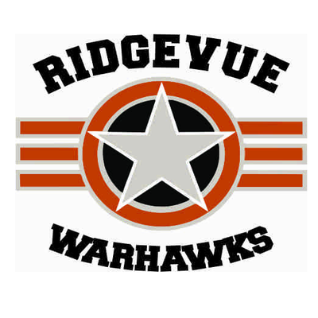
In memory of Chief Master Sgt. William M. "Bill" Gornick
Ridgevue High School in Nampa is pleased to host this year’s Warhawk Speech and Debate Invitational Tournament!
Events offered at this year’s Warhawk Invitational will be all 14 Idaho Speech Events. We will also offer Open divisions of Lincoln Douglas, Public forum, and Policy debates as well as Open only divisions for Congress and Big Questions Debate formats. Big Questions debate will be offered as a 1v1 format. As this is the last regular invitational of the year, we have opted to give everyone 5 rounds of debate in the Open division in order to ensure the most practice leading up to NSDA Qualifiers and districts as possible. Also, by not scheduling elimination rounds, we are able to start later, end earlier, and create a more humane schedule for our amazing volunteer judges.
There will be a concessions stand available for students to purchase food from on both days of the tournament. There are no fast/easy food locations nearby so please plan accordingly.
Bus Arrival
If you arrive to Ridgevue via bus on Friday please drop off students on the north side of the stadium/activities entrance and have them report to the cafeteria. School lets out at 3:35 and will be very busy in the back of the school until 4:00 pm. Saturday-you may park wherever you wish!
AWARDS: Speech rounds and awards will be in the traditional format and the top 3 finalists in each round will receive a T shirt. The top 3 finalists in each debate format will receive a T shirt and there will also be awards for Top PO and Top Speakers. Sweepstakes trophies will be awarded.
COST/JUDGE REQUIREMENTS
Speech Events: $10 per speech entry
Debate Events: $10 for single entry events (LD, Congress, Big Questions)
Debate Events: $15 for partner events (CX, PF)

Judge Requirements: 1 for each 6 speech entries, 1 for each 4 LD, PF, or Big Questions entries, and 1 for each 2 CX entries.

SCHEDULE
Friday – February 8th
3:45 – 4:15 Registration in Tab Room: Library
4:30 Draw begins for Round 1
(Extemp, Radio/Broadcast, Retold Story)
4:45 Round 1 all other Speech events
5:45 Draw begins for Round 2
(Extemp, Radio/Broadcast, Retold Story)
6:00 Round 2 all other Speech events
7:00 Draw begins for Round 3
(Extemp, Radio/Broadcast, Retold Story)
7:15 Round 3 Speech events
9:00/ASAP -Finals

Saturday – February 9th
8:45-9:15am Team & Judge Check-In
9:30 – 10:45 Round 1, All Debate Congress Session 1-9:30-11:30
10:55 – 12:10 Round 2, All Debate
Lunch Break-12:10-12:30 Congress Session 2-12:00-2:00
12:35 – 1:50 Round 3 ,All Debate
2:00 – 3:45 Round 4, All Debate Super Congress 2:30-5:00
3:55-5:10 Round 5, All Debate

Awards-5:30/ASAP

