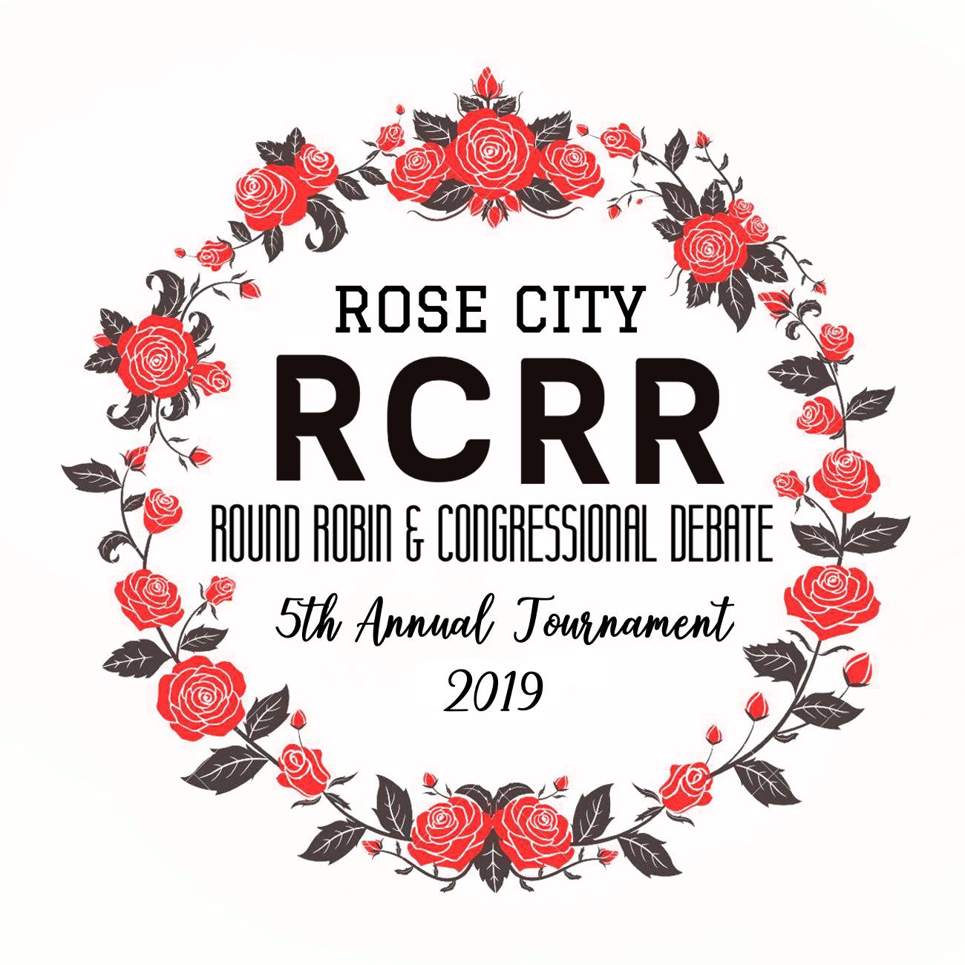
–––
Lincoln High School
1600 SW Salmon Street
Portland, OR 97205

December 15, 2018

Dear Colleagues,

On behalf of Lincoln Speech & Debate, I invite you and your teams to the 5th Annual Rose City Round Robin at our downtown Portland campus, February 22-23, 2019. This tournament will take place after school on Friday and all day Saturday.

Events offered are Congressional Debate on Friday afternoon/evening & Saturday, Lincoln-Douglas (LD) and Public Forum (PF) Debates on Friday afternoon/evening, and Policy and Parliamentary Debates all day Saturday. Students not competing in Congressional Debate are welcome to compete one or two days but may only compete in one debate form each day. Only open division is available. LD, PF, Policy, and Parli will be hosted in the round robin style described below. The dress standard for RCRR is casual.

We will provide an opportunity for debaters to hone their skills prior to National Qualifiers and Districts/State with four preliminary rounds in LD and PF and five preliminary rounds in Policy and Parli Debate. LD will use the March-April topic; PF will use the March topic; Policy will debate the 2018-19 topic; and, Parli debates will be run in accordance with Oregon rules. The Congressional Debates will follow the format set forth in the following pages and the top six speakers will earn a bid to the Tournament of Championships, April 27-29, 2019, at the University of Kentucky at Lexington.

Please feel free to reach out with any additional questions not addressed herein.

Sincerely,

Jennifer Owen
Head Coach
Lincoln High School Speech & Debate
(503) 502-0158/ jowen@pps.net

Tournament Registration

Registration Opens and Drop Deadline: Registration for the RCCR opens January 1, 2019, and the drop deadline is Friday, February 8, 2019. Fees will be set at that point. If you must drop an entry after the deadline, please contact Jennifer Owen at jowen@pps.net directly.

Entry Caps/Limitations: Up to 20 teams total may enter in LD & PF and 24 teams in Policy & Parli. No more than 120 students will be permitted in Congressional Debate. Students may enter up to one debate form per day or congress for both days. Each school may enter no more than two entries per debate form and five in Congressional Debate.

Judging Requirements: We require one judge for every two debate entries and one per five student congress entries. Teams that bring Policy entries need to supply qualified Policy judges. We require all judges to fill out a judge philosophy on Tabroom.com prior to the tournament.

Pairing and Round Robin Format
The following applies to LD, PF & Policy debate forms:
In order to guarantee four preliminary rounds in LD and PF on Friday, we will assemble pods of five teams. There will be a maximum of four pods per form of debate. Within a given pod, each team will have the chance to debate every other team. We will attempt to assemble pods randomly. However, we will divide teams from the same school evenly amongst pods to minimize the number of same-school debates. All preliminary rounds will be randomly pre-matched and have one judge.

In order to guarantee five preliminary rounds in Policy and Parli, we will assemble pods of six teams. There will be a maximum of four pods per form of debate. Within a given pod, each team will have the chance to debate every other team. We will attempt to assemble pods randomly. However, we will divide teams from the same school evenly amongst pods to minimize the number of same-school debates. All preliminary rounds will be randomly pre-matched and have one judge.

After preliminary rounds of LD, PF, Policy and Parli debate, the tournament will break directly to semifinal (SF) rounds. Advancing teams will be identified as follows:
- If there is one pod, the four highest-seeded teams will advance.
- If there are two pods, the two highest-seeded teams from each pod will advance.
- If there are three pods, the highest-seeded teams from each pod will advance. From the remaining pool, the team of the highest seed overall will advance.
- If there are four pods, the highest-seeded team from each pod will advance.

Semifinal (SF) rounds will be paired as follows: Among the four teams that advance, the top-seeded team will debate the fourth-seeded, and the second-seeded will debate the third-seeded. The winner of each SF round will advance to finals. In the event of tournament delay, we reserve the right to cease debates at the end of the SF round; however, the goal shall be to run a final in all debate forms. Panels of three will judge all elimination rounds.

*** In order to follow this format, it is important that the total number of entries in each debate form is a multiple of five in LD and PF, and six in Policy and Parli. If this is not the case, we will need to turn down the most recent entries unless the school is able to bring enough additional entries to reach an adequate number (5, 10, 15 or 20 in LD and PF, and 6, 12, 18, or 24 in Policy and Parli). ***

Fees
$25/School registration fee
$20/Policy or Public Forum entry
$15/Lincoln-Douglas entry
$15/Student Congress Entry
$15/Uncovered judging obligation (per round)

Postings
Again, we will use Tabroom.com this year and will continue with online postings as well as online ballots. Physical postings may also be available at Lincoln High School during the tournament.

Awards
Here is who will earn awards at the 2019 RCRR:
- LD, PF, Policy & Parli Debate
  - All semifinalists and finalists
  - First, second, and third place speakers
- Student Congress
  - First, second, and third place speakers, and outstanding chair
  - Tournament of Champions bids for the top six Congressional Debate speakers
Debate Events
- Lincoln-Douglas: 6-3-7-3-4-6-3 format (with 4 minutes of prep for each side) using the 2019 MARCH-APRIL topic
- Public Forum: 4-4-3-4-4-3-2-2-3-2-2 format (with 2 minutes of prep for each side) using the 2019 MARCH topic
- Policy: 8-3-5 format (with 5 minutes of prep for each side) using the 2018-19 topic (Resolved: The United States federal government should substantially reduce its restrictions on legal immigration to the United States.)
- Parli: 7-8-8-8-4-5 format (no prep time); there shall be three resolutions per round. One resolution shall be a policy resolution, one resolution shall be a value resolution and the third resolution may be either a value or a policy resolution.
- Student Congress: We will follow NSDA & OSAA rules for Student Congress. When the two are in conflict, OSAA rules will be preferred. Students may submit no more than one bill or resolution each, up to a maximum of four per school, through their coach via upload to Tabroom by 2/1/19. We will post all items we receive on 2/2/19, removing school names to avoid prejudice, and provide schools two days to consult with their students and submit their votes by 2/4/19 for the top 10 bills or resolutions to be included in the preliminary docket. The legislative packet will be posted on the tournament’s Tabroom page no later than 2/5/19. For semifinals and finals, we shall use the February NSDA legislative packet.

Other Information

The dress standard for this tournament is casual (jeans and t-shirts are acceptable). Use of computers (with internet capacity disabled) is encouraged. We also encourage debaters to use their own timing devices rather than relying on judges for time signals. We also plan to use electronic ballots, so all judges entered on Tabroom need to have a registered Tabroom account.

There is limited parking available on campus after school hours. Street parking is available in the vicinity. Parking is $2.10 per hour from 8 a.m. to 7 p.m. on both days. Lincoln is also easily accessible via Trimet, and the Kings Hill/SW Salmon St MAX Station is less than a block away.

There are many nearby options for food. If you are willing to make the small trek, we recommend the large pod of food carts on 10th and Alder. We will provide food & beverages for judges for supper on Friday night as well as a delicious Indian luncheon buffet on Saturday, courtesy of Swagat Restaurant for judges, coaches and students.

If your team requires housing, please contact Jennifer Owen at jowen@pps.net for recommendations.

Schedule
Friday, February 22nd
Registration opens on Friday at 3:45 p.m., at the main entrance of the school

Student Congress
4:00-6:30 pm | Session I
7:00-9:30 pm | Session II

Lincoln-Douglas Debate & Public Forum Debate
4:15 | Round 1
5:15 | Round 2
6:15 | Round 3
7:15 | Round 4
8:15 | Semifinals
9:00 | Finals

Saturday, February 22rd
Registration opens on Saturday at 7:30 a.m. at the main entrance of the school

Student Congress
8:30-11:00 am | Session III
12:00- 2:30 pm | Semifinal Congress
3:30-6:00 pm | Super Congress

Policy & Parli Debate
8:00 | Round 1
9:45 | Round 2
11:30 | Round 3
1:15 | Round 4
3:00 | Round5
4:45 | Semifinals
6:30 | Finals

