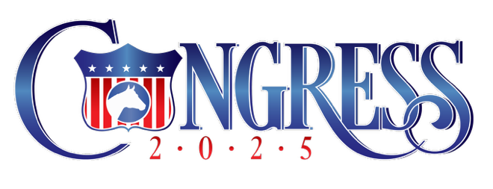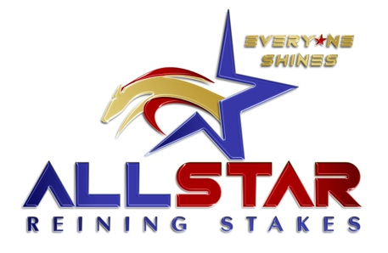

Night Riding Schedule – October 6, 2025

Celeste Center
- The arena will open after the conclusion of the show and ground maintenance for 6 hours for derby horses only.
- Any remaining time will be open riding until 5am.
- Arena closes at 5am.
VS Code Red Coliseum
- YEDA (Youth Enrichment Development Association)

