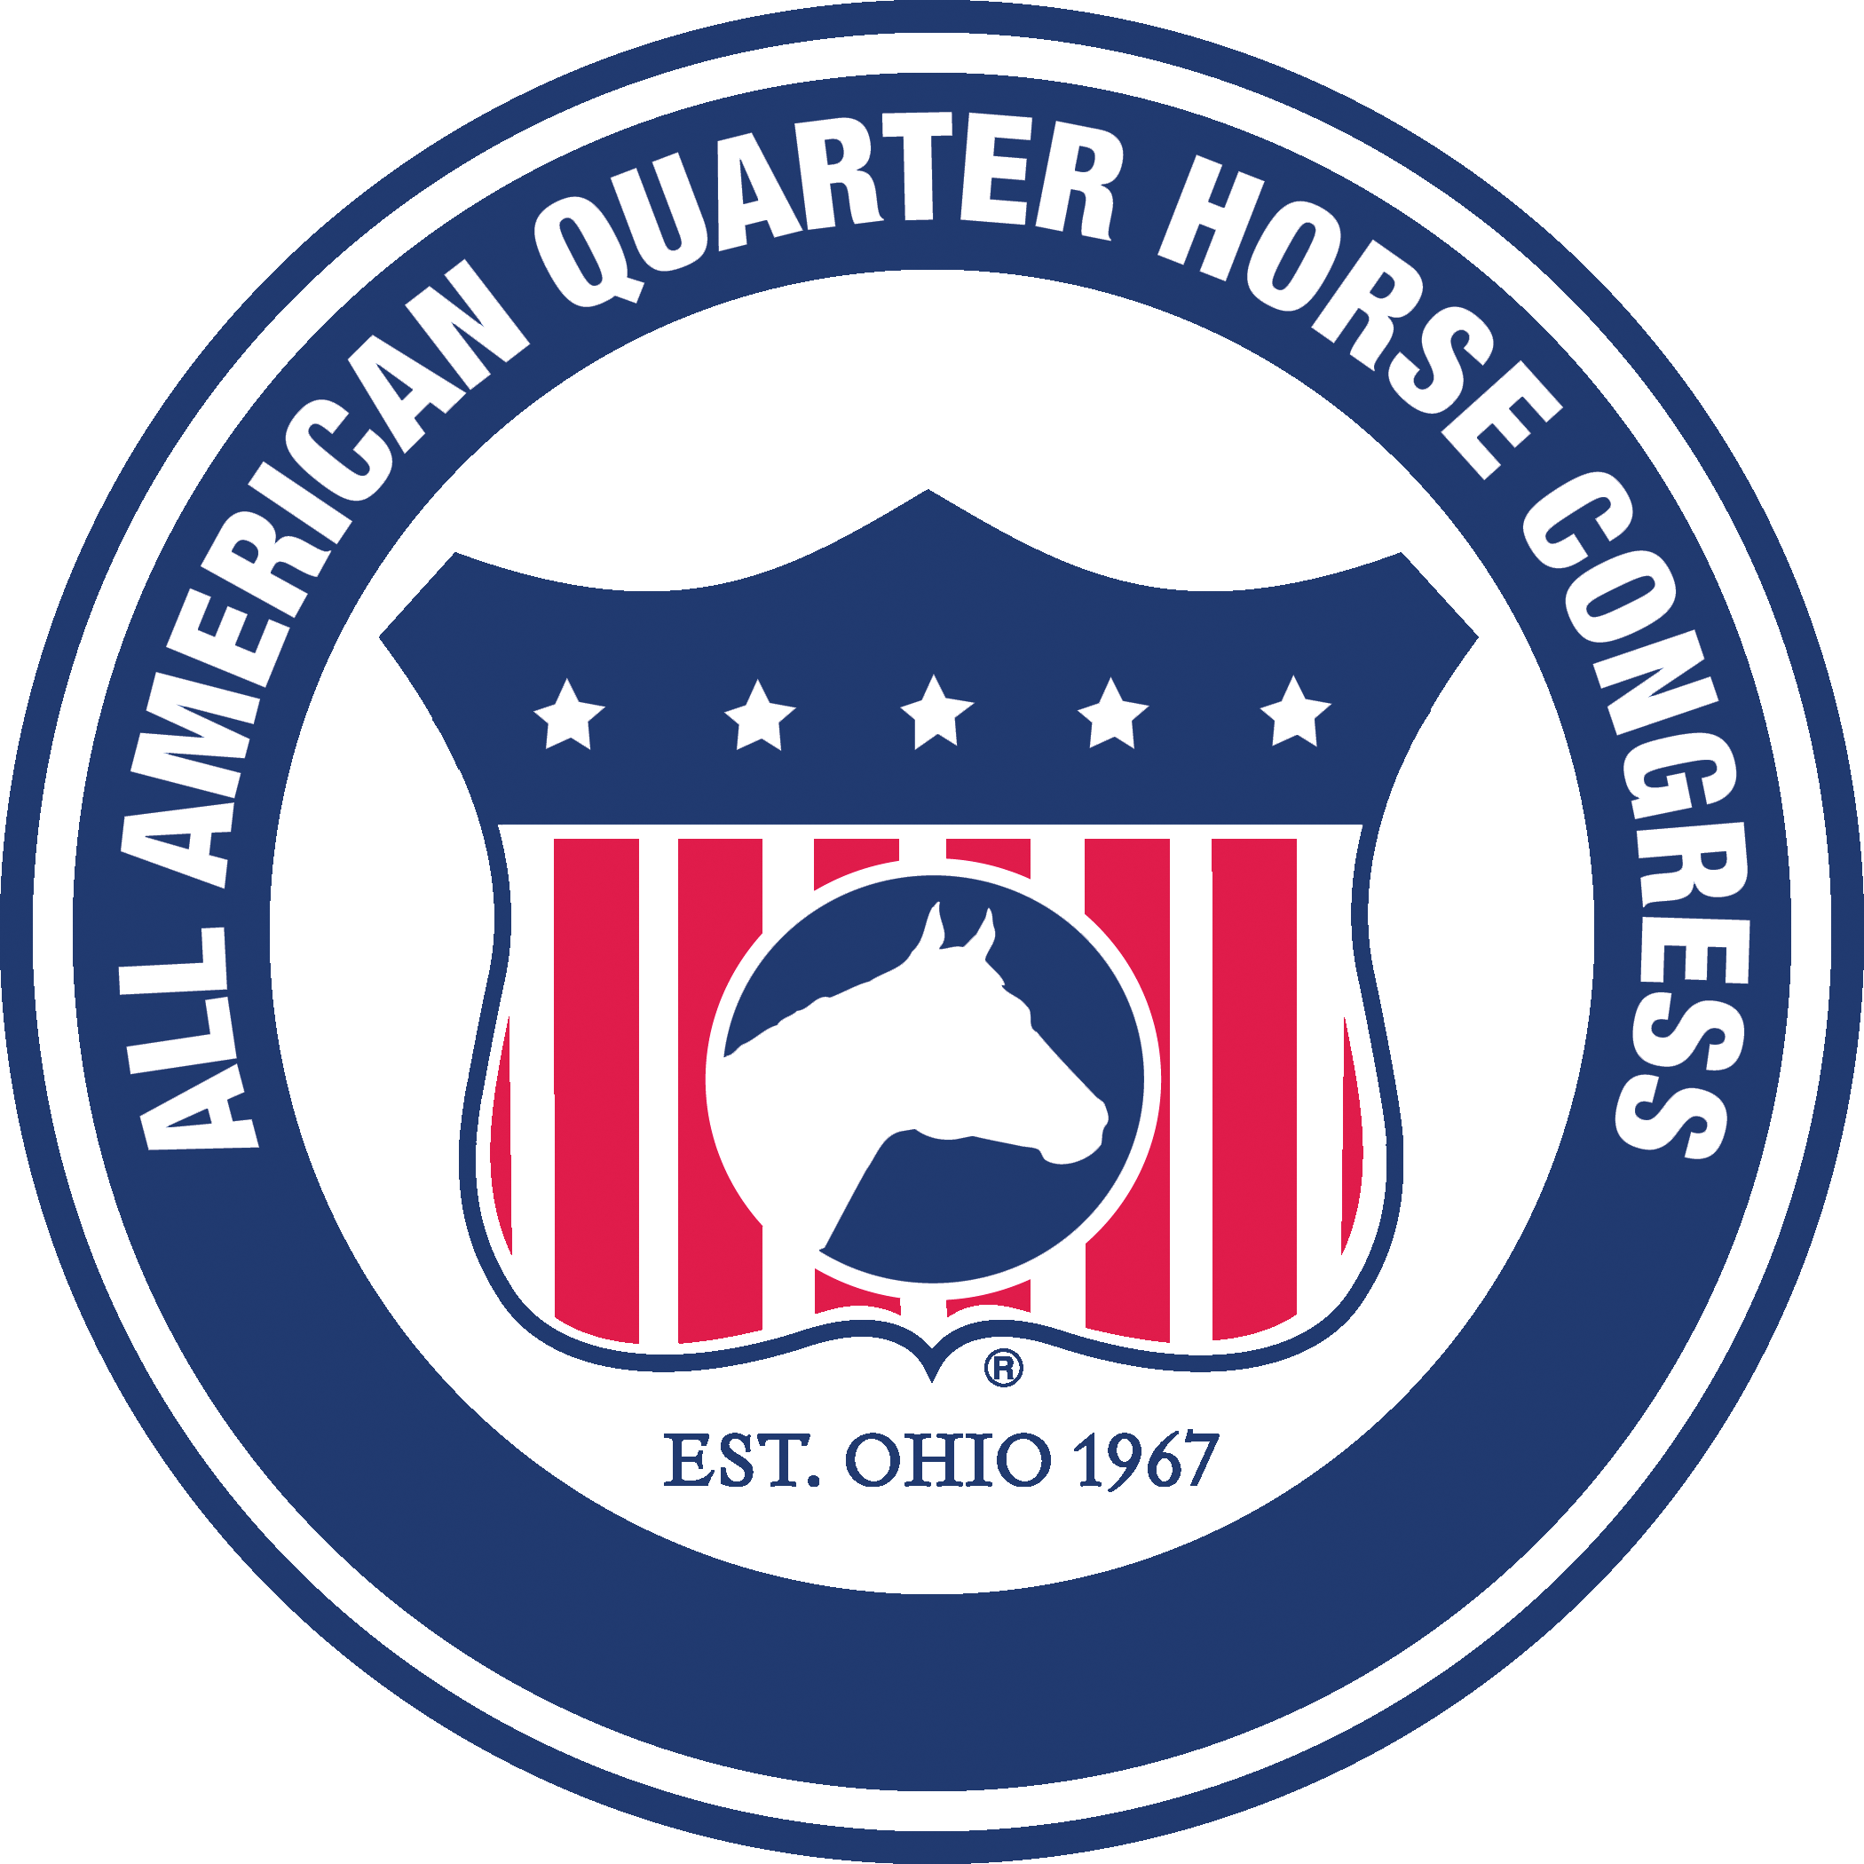

**2018 Ohio Quarter Horse Youth Association Election Biography**

(MAXIMUM OF 450 WORDS)

Name:

Address:

Phone:

E-Mail:

Running For:

Where do you live:

School Name & Grade:

Please discuss your past and current involvement in OQHYA (previous officer and/or director positions, committees chaired and/or served on and number of meetings attended).

Explain your current involvement with horses: (Do you show? What classes do you show in? What’s your horses name? List any accomplishments you have in the show ring.)

Are you involved in any other horse-related organizations? If so, please list them and state your level of involvement:

Please state your involvement in any charities, hobbies, community or extracurricular activities:

If you are a current OQHYA officer or director, please describe how you have contributed to OQHYA during your most recent term. If you are not currently an OQHYA officer or director, describe what you will contribute to OQHYA, if elected:

What do you feel should be OQHYA’s top three priorities in the next 2-3 years and why?

Please return, along with a current picture no later than October 28th.

E-mail: dstephenson@oqha.com or hand in to the Press Room at the Congress.