
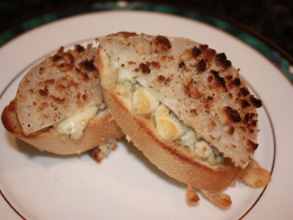
Blue Cheese and
Pear Crostini

Recipe by Y Cook?
INGREDIENTS:

- 1 Baguette
- 2 Pear, firm
- 8 ounces Blue cheese crumbles, room temperature
- 2 Tbsps. Butter, melted
- 1 cup Walnuts , finely chopped
- 1 Tbsp. Sugar

DIRECTIONS:
- Slice each pear into 12 quarters remove core. Put in zip lock with sugar and set aside.
- Slice bread into 3/8 inch angled pieces.
- Mix butter and Blue cheese in a bowl. Spread blue cheese butter to cover top, (not too thick).
- Dip pear wedges into ground walnut and place on top of blue cheese with walnuts on top.
- Set aside until ready to serve. Just before serving place in oven set to broil, until walnuts look toasted. This can be done early in the day and no need to refrigerate until ready to cook.
- Serve hot or room temperature.



Securities and advisory services offered through LPL Financial,
a registered investment advisor. Member FINRA/SIPC.

