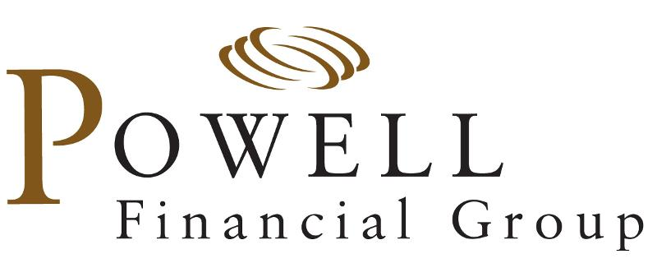

Discovery Meeting Questionnaire | Investments

Name: _______________________________________ Email: _______________________________________

Phone: _______________________________________ Date: _______________________________________

Are you contributing to the 401(k) plan?

No
Yes Deferral %: _________ / Per Pay Period: $ _________ Current Balance: _______________

What is your investment experience / knowledge?
Stocks: None Limited Good Extensive
Bonds: None Limited Good Extensive
Mutual Funds: None Limited Good Extensive
Real Estate: None Limited Good Extensive
Annuities None Limited Good Extensive

Current 401(k) Allocation:
_______________________________________

Investment Objective:
Preservation of Capital Income Growth & Income Growth Speculation

Risk Tolerance:
Conservative Moderately Conservative Balanced Growth Aggressive Growth

Do you currently work with a financial advisor? Yes No

What are your expectations from the financial planning process?
_______________________________________________________________________

To the best of your knowledge, approximately how much do you currently have invested in:
Mutual Funds & Stocks $ ________________
Retirement Accounts (401(k), IRA, 403(b)) $ ________________
Cash, Bonds, CDs $ ________________
Real Estate $ ________________

What is your approximate annual family income? $_________________

Are there any details of your current financial situation that you’d like to share?

_______________________________________________________________________

Advisor Notes:

Rebalance Yes No Current Model: ___________ Target Model: ___________
_______________________________________________________________________
_______________________________________________________________________

370 North Westlake Boulevard, Suite 230 | Westlake Village, CA 91362
805.495.6895 Tel | 805.497.9324 Fax | www.powellfg.com

Securities and Advisory Services through Commonwealth Financial Network®, Member FINRA / SIPC, a Registered Investment Adviser.

