

Discovery Meeting Questionnaire | Tax Planning

Name: _______________________________________ Email: _______________________________________

Phone: _______________________________________ Date: _______________________________________

Are you concerned with the amount of income tax you pay each year?
Yes
No

What is your current marginal federal income tax rate?
10%
12%
22%
24%
32%
35%
37%

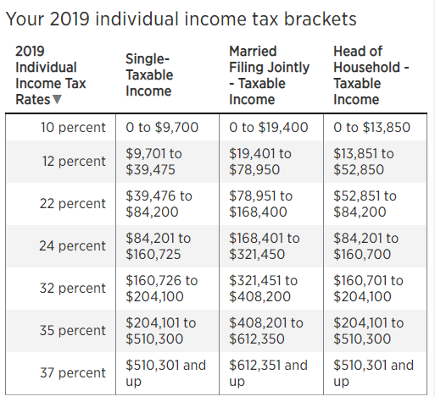

What is your future outlook on tax rates?
Decrease
Stay the same
Increase
Don’t know

What is your current 401(k) contribution percentage? ______ %

Are you contributing to a Roth IRA? Yes No

370 North Westlake Boulevard, Suite 230 | Westlake Village, CA 91362
805.495.6895 Tel | 805.497.9324 Fax | www.powellfg.com

Securities and Advisory Services through Commonwealth Financial Network®, Member FINRA / SIPC, a Registered Investment Adviser.

