¡Fiesta Mágica!
Irvine Regional Park
Coyote Corner – Parking Lots O and P

Following please find step by step instructions from the park entrance to our event location at Coyote Corner.

- Once you pay the entrance fee, you’ll pass by the ranger hut on the right and three parking places for ranger vehicles. Make your first right turn after the parking spaces. | 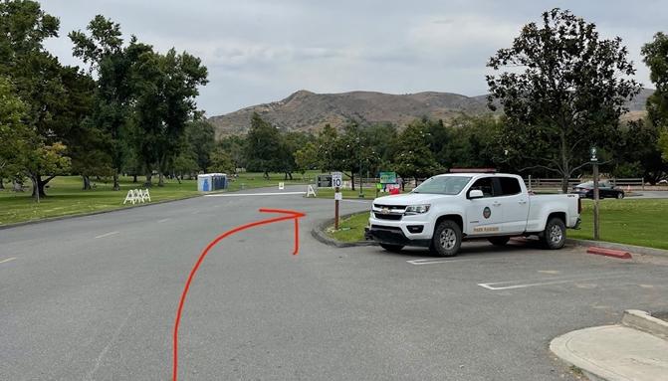
- After you turn right, you will pass Lot G on the left. You will then approach a split in the road. Stay to the right and proceed under the white Irvine Regional Park arch. | 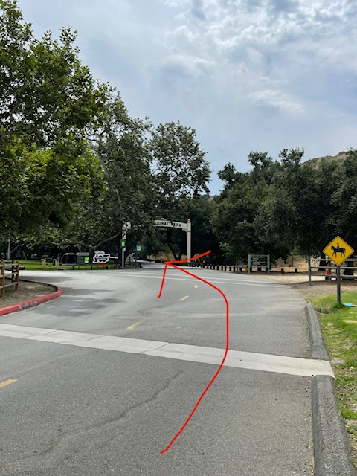
- Continue straight. There will be another fork in the road. Follow the road as it bends to the left. | 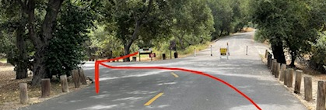
- Continue straight. You will pass Lots J, K, L, and M on the left. Enjoy the beautiful scenery! | 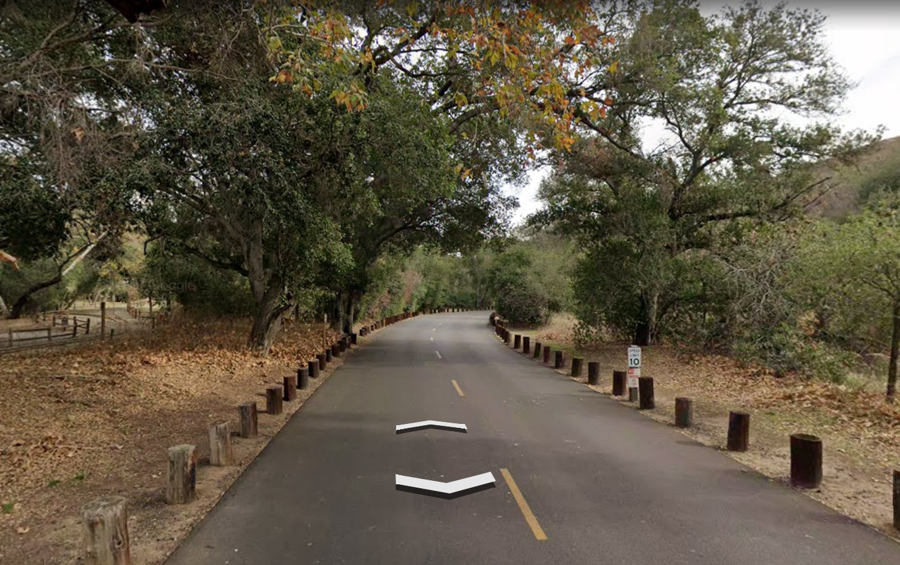
- At the end of Lot N, there is a stop sign. You will make a right turn, then a quick left. | 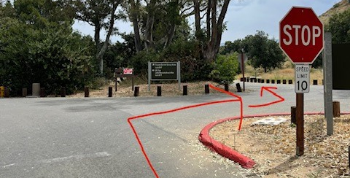
- Continue straight. Turn left at Lot O and park. | 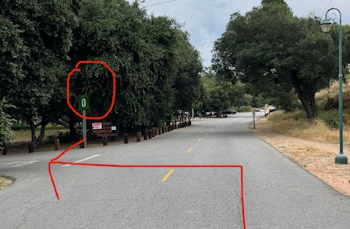
- The entrance to our event is at the far end of Lot O.
- If Lot O is full, go back out and turn left onto the road. Lot P is a very short distance further. You can park there and then walk back to our event site through Lot O. Lot O is accessible via the road or the grass next to the parking lot. | 