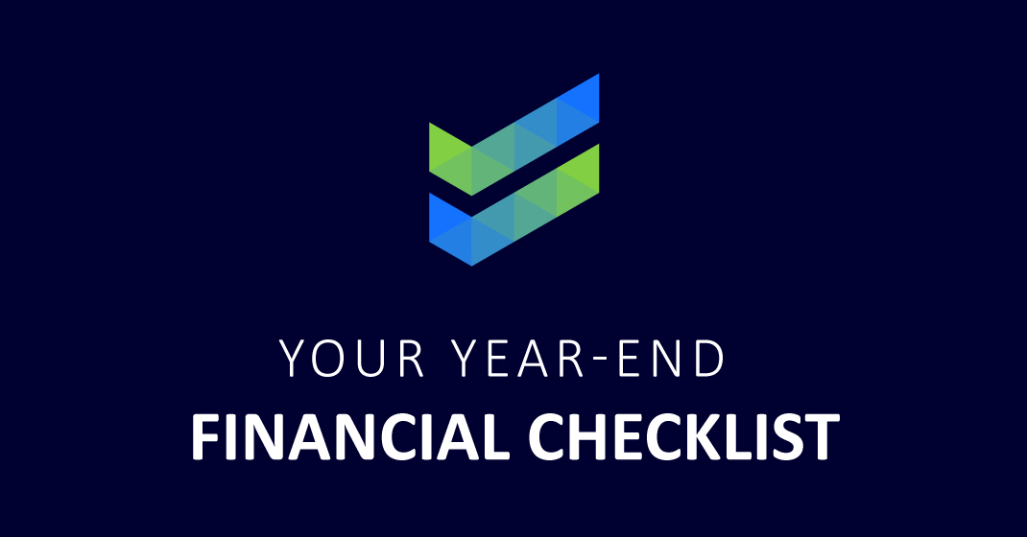

Aspects of your financial life to review as the year closes.

The end of the year can remind us of last-minute things we need to address and the goals we want to pursue. Here are some aspects of your financial life to consider as this year leads into the next.

Keep in mind that this article is for informational purposes and is not a replacement for real-life advice. Contact a tax or legal professional before modifying your tax strategy. The ideas presented are not intended to provide specific advice. Also, tax rules are constantly changing, and there can be no guarantee that the rules will stay the same for any period of time.

Investments: If you aren't already, you may want to consider contributing the maximum to your retirement accounts and review any existing retirement accounts from work. If you are eligible to make any catch-up contributions, it may be a great time also to consider making that decision.

Retirement strategy: If you aren't already, you may want to consider contributing the maximum to your retirement accounts and review any existing retirement accounts from work. If you are eligible to make any catch-up contributions, it may be a great time to also consider making that decision.

Taxes: It's a good idea to consider checking in with your tax or legal professional before the year ends, especially if you have questions about an expense or deduction from this year. Also, it may be prudent to review any sales of property as well as both realized and unrealized losses and gains. Look back at last year's loss carried forward. If you've sold securities, gather up cost-basis information. As always, bringing all this information to your financial professional is wise.

Charitable gifting: Plan charitable contributions or contributions to education accounts and make any desired cash gifts to family members. The annual federal gift tax exclusion allows you to give away up to $19,000 in 2025. Such gifts do not count against the lifetime estate tax exemption amount as long as they stay beneath the annual federal gift tax exclusion threshold. Besides outright gifts, you can explore creating and funding trusts on behalf of your family. The end of the year is also an excellent time to review any trusts. Using a trust involves a complex set of tax rules and regulations. Before moving forward with a trust, consider working with a professional familiar with the rules and regulations.¹

Life insurance: The end of the year is an excellent time to double-check that your policies and beneficiaries are up to date. Don't forget to review premium costs and beneficiaries and consider whether your insurance needs have changed. Several factors could impact the cost and availability of life insurance, such as age, health, the type of insurance purchased, and the amount purchased. Life insurance policies have expenses, including mortality and other charges. If a policy is surrendered prematurely, you may pay surrender charges, which could have income tax implications. Before implementing a life insurance strategy, you should consider determining whether you are insurable. Finally, remember that any guarantees associated with a policy are dependent on the ability of the issuing insurance company to continue making claim payments.

Life events: Evaluating any significant life changes in the last year:

- Marital status
- Moving
- Changing jobs
- Buying a home
- Starting a business
- Inheritance
- Gifts
- Additions to the family.

All these circumstances can financially impact your life and how you invest and plan for retirement and wind down your career or business. While it's likely that you have discussed these matters with your financial professional already this year, bring them up in your review.

Citations
- IRS.gov, 2025

