
Justin K. Whitsell

Confidential Questionnaire

970 Reserve Dr ▪ Suite 104
Roseville, California 95678
Phone: 916.538.9997
Fax: 916.677.1554
justin@whitsellwealth.com

www.whitsellwealth.com

Justin Whitsell is a Registered Representative with, and Securities offered through LPL Financial, Member FINRA/SIPC.
Investment Advice offered through Western Wealth Management LLC, a Registered Investment Advisor.
Whitsell Financial Partners and Western Wealth Management LLC are separate entities from LPL Financial.
CA Insurance Lic# 0G50593

Thank You for The Opportunity For Us To Work With You

At Whitsell Financial Partners, we know how important planning is, so we prepared this Confidential Questionnaire to help us understand where you are today, and where you want to be, as well as to help you create strategies for your goals.

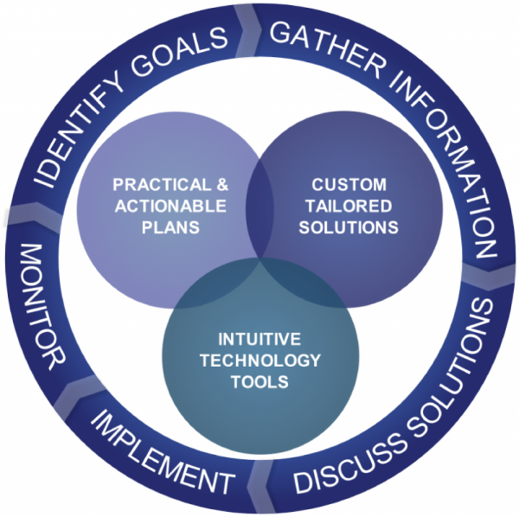
Understanding Our Process

Our process of working with you is one that is on-going. Our goal is to become a trusted advisor and work with you and your other advisors to help make sure you are implementing strategies to help you work toward your goals. Throughout our process, we will use monitoring tools that will allow us to see your progress.

Every Situation is Different

While this is a comprehensive view, not everything is applicable to your current situation. If something does not apply, please leave it blank, if you have questions about specific sections, please contact us.

What To Do Next

Please fill out our comprehensive Confidential Questionnaire and return it to our offices prior to our appointment. That will allow us to review your information. If we have not scheduled an appointment, our office will contact you to schedule a time for us to meet.

What Will We Review?

While you are filling out our comprehensive Confidential Questionnaire, we will cover most of the topics listed in the pyramid on this page. Please take your time and fill out the information as accurately as possible. Please refer to your statements as necessary. At the end you will find a list of documents, including statements that we ask you to bring to our appointment. Thank you again for the opportunity and we look forward to meeting with you.

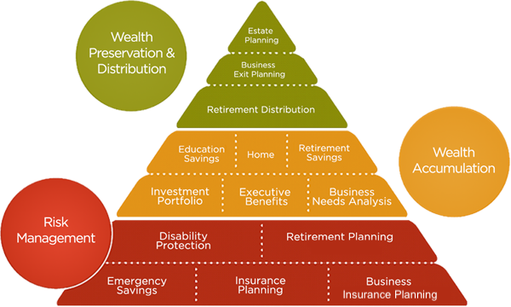

Table of Contents

Thank You For The Opportunity For Us To Work With You 2
What Will We Review? 3
Table of Contents 4
What keeps you up at night? 5
Your Information 7
Employment Information 8
Family Members 9
Advisors 10
Budget Worksheet 11
Liabilities 13
Insurance 14
Assets 16
Retirement Planning Details 18
Education Planning Details 20
Major Purchase Goals 20
Estate Planning 22
DOCUMENTS NEEDED FOR NEXT MEETING 23

What keeps you up at night?

General Finances
- How do I keep my records safe and organized?
- How do I do a better job budgeting?
- How do I reduce my debt?
- Do I have enough in case of an emergency?
- How do I set goals and plan for them?
Retirement
- Will my money last through retirement?
- Do I need long-term care?
- What are my retirement investment options?
- How do I manage all my retirement plans?
- What should I do with my employer retirement plan?
- I am an employer and do not have a retirement plan, what do I do?
- I am an employer and I do not receive the service I need, what do I do?
- Since I’m retiring soon, what do I need to do now?
Education Planning
- How much should I save? When should I start planning?
- Will I qualify for financial aid? Where do I start?
- What are my college savings options?
- How do I team my children about money?
- How do I fund my new/existing grandchild’s education?
Life events
- What happens to my 401(k) when I change jobs?
- What are my options if I am laid off?
- I’m getting divorced. What happens to my assets?
- What do I do when a loved one dies?
- I’m getting married, how do we combine assets and accounts?
Eldercare
- How does Medicare work?
- What should I look for in a nursing home?
- How do I cope with Alzheimer’s disease?
- What happens if I must care for my parents?
Estate Planning
- What should I know about estate planning?
- How do I protect my estate from taxes?
- Will my family be secure if something happens to me?
- How do I create a legacy for my children?
- Can I provide for my favorite charity when I’m gone?
- What will my survivors need to know?

Your Information
Client Co-client
Full Name
Date of Birth
Address
City/State/ZIP
Phone (Home)
Phone (Cell)
Email

Employment Information
Client Co-client
Employer
Position
Date of Hire
Business Address
Business Phone
Business email

Family Members
PLANNING ASSUMPTIONS
Name | Date of Birth | Gender | Relationship |  | Inflation Rate | 3.0% or %
 |  |  |  |  |  | Client | Co-client
 |  |  |  |  | Retirement Age | 65 or | 65 or
 |  |  |  |  | Life Expectancy | 90 or | 90 or

Advisors

 | Name | Address | Phone
Financial Advisor
Accountant
Lawyer
Insurance
Banker
Other

Budget Worksheet
Income |  |  |  |  | Tax Brackets
 | Client | Co-Client | Joint |  |  | Marginal Tax Rate | Effective Tax Rate
Wages, salary, tips |  |  |  |  | Federal
Cash dividends |  |  |  |  | State
Interest received
Social Security income
Pension income
Rents, royalties
Annuities
Business income
Other income
Sub-total | $ | $ | $
Total Monthly Income |  |  | $
*Separate sheet attached with itemized expenses? _____ Yes _____ No

Social Security Retirement Benefits Client Co-Client
Include Monthly Retirement Benefits? | Yes  No | Yes  No
Monthly Amount | Use default formula  Use benefit estimate $ | Use default formula  Use benefit estimate $
Start Date | Age | Age
Index (COLA) rate for Social Security | 2% or % | 2% or %
Do you expect a significant change in your income during the next two years?

Do you want or expect to make changes to your current spending and savings strategies?
Living Expenses

 | Monthly | Annual
General
Mortgage / Rent
Homeowner’s / Renter’s Insurance
Life Insurance
Health Insurance (Medical / Dental / Vision)
Auto Insurance (Licenses)
Property Taxes (Real Estate / Vehicle)
Home Repairs / Maintenance
Utilities (Gas / Electric / Phone / Water / Garbage)
Groceries
Personal Goods (Toiletries / Dry Cleaning / Housekeeping)
Entertainment (Dining Out / Travel / Vacation)
Clothing
Gifts (Birthday / Holiday / Special Occasion)
Transportation (Gas / Taxis / Maintenance / Parking)
Charitable Contributions
Child care (Lessons / Sports / Alimony)
Other:
Other:
Other:
Sub-total | $ | $

Liabilities

Other Liabilities (Home Loans, auto loans, credit cards, lines of credit, education loans)

Debts | Responsible Party | Balance | Monthly Payment | Interest | Lending Institution
Primary Residence |  | $ | $ | %
Home Equity / Other Mortgage |  | $ | $ | %
Real Estate |  | $ | $ | %
Real Estate |  | $ | $ | %
Business |  | $ | $ | %
Credit Card |  | $ | $ | %
Credit Card |  | $ | $ | %

Debts | Responsible Party | Balance | Monthly Payment | Interest | Lending Institution
Automobile |  | $ | $ | %
Automobile |  | $ | $ | %
Other |  | $ | $ | %
Other |  | $ | $ | %
Other |  | $ | $ | %
Other |  | $ | $ | %

Insurance

Life Insurance Policy 1 Policy 2 Policy 3 Policy 4 Policy 5
Company
Type (e.g. term, universal)
Effective Date
Insured
Policy Owner
Beneficiary
Contingent Beneficiary
Death Benefit
Annual Premium
Cash Surrender Value
Loan
Statement Attached?
What is your primary goal for your life insurance policies?

How did you arrive at the amount of life insurance you have?

When you purchased your policy(ies), what was the policy to cover? (e.g. Policy 1 - was to replace income for a spouse)

Are you still in contact with the agent(s) of the policy/policies?
Disability Insurance Policy 1 Policy 2 Policy 3
Description (group LTD, group STD, individual DI)
Effective Date
Insured
Monthly Benefit
Taxable (yes / no)
Index Rate for Benefit Amount
Elimination Period
Benefit Period
Annual Premium

How would it affect your family’s lifestyle if you became disabled or injured?

Long-Term Care Insurance Policy 1 Policy 2
Description
Insured
Daily Benefit
Index for Inflation
Waiting Period
Benefit Period
Annual Premium

Has anyone in your family experienced a long-term care need?

Assets

Non-Qualified Assets* (Bank accounts, investments and non-qualified annuities)
Name | Ownership | Market Value | Cost Basis | Annual Contributions | Statement Attached?
Checking
Savings / MM / CDs
Brokerage Accounts

How much do you keep on hand for emergencies?

How many months of expenses do you have in case of an emergency?

How did you determine how much to keep in savings?

How much do you have saved toward your immediate goals (e.g. roof, washer/dryer, vacation home, etc…)?

How much do you keep in other brokerage accounts?
House / Property
(Including Investment Real Estate) Property 1 Property 2 Property 3
Description
Ownership
Real Estate Tax (annual)
MORTGAGE INFORMATION:
Loan Start Date
Original Loan Amount
Interest Rate
Loan Duration
Monthly Payment (principal + interest)
Current Market Value of Property
Outstanding Loan Balance
Rental Income (if applicable)
Rental Expenses (if applicable)

Personal Use Assets (e.g. Furnishings, jewelry, collectibles, etc.)
Name | Ownership | Market Value

Retirement Planning Details

Qualified Assets* (Qualified retirement plans, IRAs, qualified annuities)
Institution/  Account Name | Ownership | Market Value | Annual Contributions | Annual Employer Contributions (if applicable) | Beneficiaries | Statement Attached?
*Please also provide account statements with asset allocation information.

Defined Benefit Pensions Client Co-Client
Monthly or Lump Sum Amount | $ _____ | $ ____
Effective Date | Age | Age
Index (COLA) rate for monthly benefits | 0% or % | 0% or %

Retirement Incomes (including annuity income or expected inheritance)
Type of Income | Client or Co-client | Amount | Frequency | Index or COLA rate (if any) | Start Age | End Age

Retirement Expenses Monthly Amount or % of Current Spending
Retirement Spending Goal | $ _____ | %

How do you envision your retirement?

How might your spending in retirement change (travel, downsize, health care)?

What is your greatest retirement concern?

How did you decide the percentage of contribution to your employer sponsored accounts?

Education Planning Details

Education Funds (529 Plans or UTMAs)
Name | Owner | Donor | Beneficiary | Market Value | Annual Contributions

How did you decide how much to contribute?

When did you open these accounts?

Has anyone else other than yourself or immediate family contributed to these accounts?

Which school did you base your contributions on?

Are you anticipating on paying for all or a portion of your child(ren)’s education?

Major Purchase Goals

(For example: cars, vacations, 2nd home, remodel, etc.)
Description | Start Year | Number of Years | Amount Needed | Existing Assets | Contributions (Amt/(mthly/qtrly/ann))
*Please indicate if your contributions are monthly, quarterly, or annual

How did you decide the amount you need to put away?

Did you have to change the amount of time until you needed to accomplish this goal?

Estate Planning
Client Co-client
Do you have a will?
Do you have advance directives? (living will, health care power of attorney, durable power of attorney)
When was the will / advance directives last updated?

Trust Details (indicate date of last update)
Family Member | Credit Shelter Trusts | Marital Trust | Living Trust | QTIP Trust | Other Testamentary Trusts
Client
Co-client
Trustee(s)

Gifting: Current Strategies Gift 1 Gift 2 Gift 3
Description
Gifting Strategy (i.e. Cash Gift, Asset Gift)
Amount
Applicable Period
Beneficiary Name
*Please provide copies of all estate documents.
Do you have a sense about how much your estate may be eroded at your death? Would you like to examine strategies to minimize estate expenses and taxes due at your death?
(If there are children) What would you like to see happen at your death (receive assets immediately,
receive assets at set times, receive income at set times, use assets for set purposes, etc.)?
Does your current estate plan reflect all of your wishes for what you want to happen when you pass away?

DOCUMENTS YOUR ADVISOR NEEDS FOR PLANNING*
The following documents will be needed for study and analysis as we work together to create a financial strategy for you. It is understood that this material will be treated confidentially and returned when the plan is completed, or earlier if requested.

 | Most Recent Payroll Stubs |  | Insurance Policies and/or Statements
 |  |  | Life
 | Budget Worksheet (See Pg. 9) |  | Medical
 |  |  | Disability
 | Income Tax Returns |  | Long-term Care
 |  |  | Auto and Home
 | Investments/Retirement Statements |  | Liability
 | Pension/Profit Sharing |  | Group Insurance
 | SEP/SIMPLE
 | 401k/ TSA/ PEDC |  | Wills and Trusts
 | IRA/ Roth
 | 529 |  | Business Documents
 | Securities Accounts |  | Buy-Sell Agreements
 | Savings and investments |  | Deferred Compensation Agreements
 | Annuities |  | Split Dollar Agreements
 |  |  | Wage Continuation Agreements
 | Liabilities |  | Employee/Consulting
 | Mortgage Statements |  | Group Benefit Programs
 | Credit Cards |  | Other Employer Paid Benefits
 | Student Loans
 | Auto Loans |  | Employee Benefit Statements/Booklets
OTHER:
*Please note that any documents withheld may not provide you with accuracy. It will be assumed that all information was provided.

