DISCOVER SIMPLE
HEALTH STRATEGIES
TO MAXIMIZE YOUR
RETIREMENT


Meet the Speakers
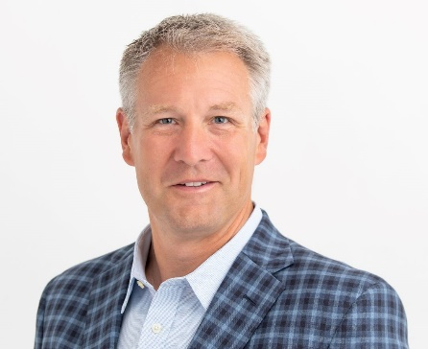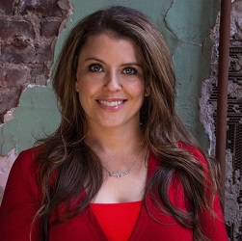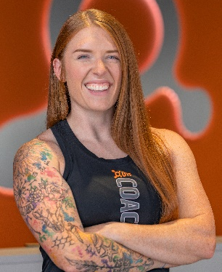
Heather Holmes
Kaity Wachtel
Brett Ramsey

Brett Ramsey
Brett is one of the owners and LPL Financial Advisor at Artisan Wealth Strategies. He has been in the financial industry for 20 years. He specializes in retirement income planning, as well as comprehensive financial planning, and enjoys guiding and supporting his clients through major financial decisions in their lives. While working as an executive at an insurance company, Brett began to realize how much he enjoyed working directly with his clients and wanted to be able to provide more comprehensive support and guidance to help them reach their goals. So, he received his CFP certification to become a financial advisor, and soon began helping clients on their financial journeys. In his 20 years in the industry, he's worked for major financial corporations such as Sheridan Road Financial, Novus Wealth Management, and Networth Financial Group prior to establishing his own financial planning practice. Now he provides his clients at Artisan Wealth Strategies with a handcrafted portfolio and a wealth of knowledge accumulated from his decades of experience.
Heather Holmes
Heather is the Founder and CEO and leads the vision for Genivity. She focuses on product design, business development, and fundraising. She brings a decade of sales, marketing, and market development experience to Genivity from her time in the medical device industry working for Medtronic & Abbott Vascular.
Kaity Wachtel
Kaity Wachtel is a Regional Fitness Educator for Orangetheory, in which training and onboarding OTF coaches as well as directly overseeing 8 head coaches and their studios' fitness product are her top priorities. She also is blessed with the opportunity to coach at the Carmel & Fishers-Geist locations and has coached over 7,000 classes to date! She additionally trains runners towards race goals and is a wellness coach outside of her role with Orangetheory. She began to develop her love of fitness during college, gaining certifications ranging from personal training to yoga & Pilates to sports nutrition and beyond. She has a unique perspective holding fitness certifications and experience in one hand and mental health and social work acumen in the other. She obtained her Bachelor’s in social work in 2011 at IU Bloomington and her Master’s in social work in 2013 from IUPUI Indianapolis. She has been in fitness going on 10+ years now and loves the ability to constantly learn and provide the best training modalities to her clients and staff as research and technology bring more information and possibilities to light.

