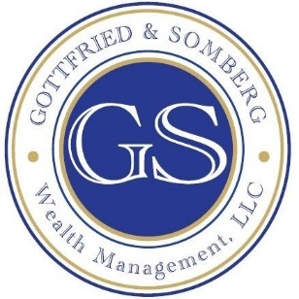

41 East Main Street (Avon Old Village) Avon, CT 06001 860.430.9104

Directions heading Westbound from West Hartford towards Avon:
• Head West on Route 44 over Avon Mountain to the intersection of Routes 44 and Route 10/202 South; Avon Old Farms hotel and restaurant is on the corner
• Proceed 4/10 of a mile to the next light.
• Left at light into the 51 East shopping plaza.
• Proceed past the 1st building on your left (Bruegger’s Bagels) up the hill. Our office is located in the 2nd building on your left, a yellow cape cod style house on the corner, #41.
• Parking is available in the front and back. Park in front and enter through front door, unless you need handicapped access which is available by parking in the back lot and entering through our back door located to the left of “Pick-A-Mix Korean” Restaurant.

Directions heading Eastbound from Simsbury towards Avon:
• Route 44 East towards Avon.
• Travel past Simsbury Commons plaza.
• Continue through the intersection of Route 44 and Route 10/202 North. O’Neil’s Chevrolet is on the corner.
• In 800 feet, make a Right at light into Avon Old Village.
- 1st Left. Pass UPS on your right. We are the next building on your right, a yellow cape cod style house on the corner, #41.
• Parking is available in the front and back. Park in front and enter through front door, unless you need handicapped access which is available by parking in the back lot and entering through our back door located to the left of “Pick-A-Mix Korean” Restaurant.

From Points North of Avon:
• Route 10 South until it intersects with Route 44. O’Neil’s Chevrolet is on the corner.
• Left onto Route 44 East.
• In 800 feet, make a Right at light into Avon Old Village.
- 1st Left. Pass UPS on your right. We are the next building on your right, a yellow cape cod style house on the corner, #41.
• Parking is available in the front and back. Park in front and enter through front door, unless you need handicapped access which is available by parking in the back lot and entering through our back door located to the left of “Pick-A-Mix Korean” Restaurant.

