From San Diego:
Take the 5 North
Merge onto the 405 North
Take MacArthur Blvd exit
Turn left onto MacArthur Blvd S
Turn left onto Campus Dr
Turn right onto MacArthur Ct (at the light)
**Please refer to map below for parking**

From North Orange County/Inland Empire:
Take the 55 South
Merge onto 405 South
Take MacArthur Blvd exit
Turn left onto MacArthur Blvd
Turn left onto Campus Dr
Turn right onto MacArthur Ct (at the light)
**Please refer to map below for parking**

From the 405 South:
Take 405 South
Take MacArthur Blvd exit
Turn left onto MacArthur Blvd
Turn left onto Campus
Turn right onto MacArthur Ct (at the light)
**Please refer to map below for parking**

**60 Minute parking does not apply after hours. Please DO NOT park in parking structure. We cannot validate.
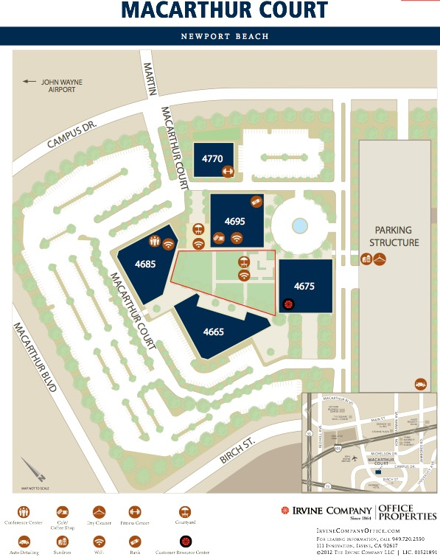
60 Minute Parking

