If You’re Worried About Your Retirement & Taxes
PLEASE JOIN US FOR THIS
Complimentary Dining Experience.
You are cordially invited to attend this Complimentary Dinner Event at Maggiano’s Little Italy. This event is by invitation only, for first time attendees age 55+, who have saved over $250,000 for retirement. Seating is limited, so please guarantee your space now by using one of the convenient RSVP options listed below.
Are You Trying to Avoid the Mistakes That Could Ruin Your Retirement?
Learn from a seminar created by a Certified Financial Planner™, Accredited Tax Advisor, and former Enrolled Agent with the IRS for 30 years. Subjects discussed:
• The 5 biggest retirement risks: stock market losses, taxes, longevity, fees, no written plan.
• How to reduce risk and help hedge against down markets.
• The 7 rules for retirement security.
• How to use annuities to create guaranteed monthly income that will last for life and more.

Reservations required. Seating is limited and may fill quickly.
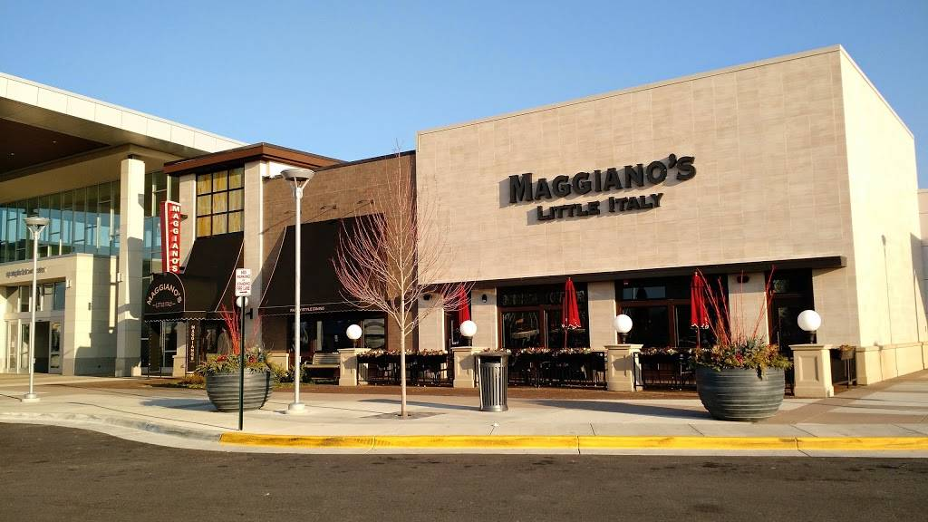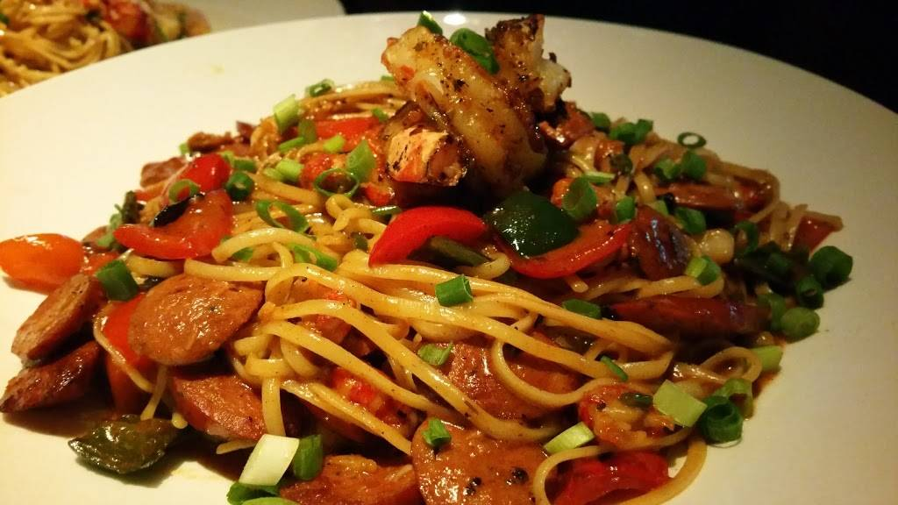
MAGGIANO’S LITTLE ITALY
6500 Springfield Mall, Springfield, VA 22150
Tuesday, July 29th Dinner at 6:30pm
RSVP: To ensure your reservation, call 301-965-0990 or go to www.abramsfinancialsvcs.com
Our guests can expect to have a little fun, a good meal and obtain some meaningful information. There is no cost to attend, and no obligation.
Sincerely, Anthony D. Abrams, CPA, IAR
Investment advisory services provided by Regal Investment Advisors LLC, an SEC registered investment adviser. Regal Investment Advisors is independent of Abrams Financial Services, LLC. Advisory services are only offered to clients or prospective clients where Regal and its representatives are properly licensed or exempt from licensure. SEC registration does not imply a certain level of skill or training. 108407
. 108407

