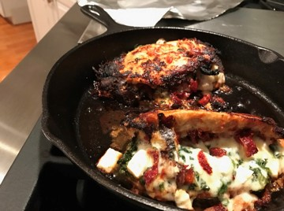

Sundried Tomato
Stuffed Chicken Breast

Recipe by Y Cook?
INGREDIENTS:

- 2 chicken breast
- 1/3 cup soft sundried tomatoes, julienned
- 1/4 cup frozen spinach chopped, drained
- 1/4 cup feta cheese
- 1/4 cup mozzarella
- 1 Tbsp. oil
- 1/2 cup Sundried tomato vinaigrette, Kraft
- 1/4 cup the oil from the sundried tomatoes or non-flavored oil
- 1/8 cup white vinegar
- 1/8 cup sundried tomato

- salt and fresh ground pepper
Directions:
1. Slice chicken to make a pocket. Put chicken in a zip lock bag and add dressing.
If you want to make your own vinaigrette put the last 3 ingredients in a bullet, blender, or food processor and blend.
Get air out of bag and seal put in refrigerator for about 4 hours.
2. Preheat Oven to 400 Degrees: Take chicken out and put on a plate, throwing the rest of the dressing away.
3. Stuff each breast with half the sun-dried tomatoes, feta, mozzarella and spinach.
Salt and pepper inside and out.
4. In an oven proof skillet put 1 Tbsp oil in bottom and turn heat to med high.
When hot add chicken and sear about 4 minutes. Turn carefully and sear 4 minutes, turn heat down if cooking to fast.
5. Turn off stove and place in hot oven. Let cook 20 minutes or till done.



Securities and advisory services offered through LPL Financial,
a registered investment advisor. Member FINRA/SIPC.

