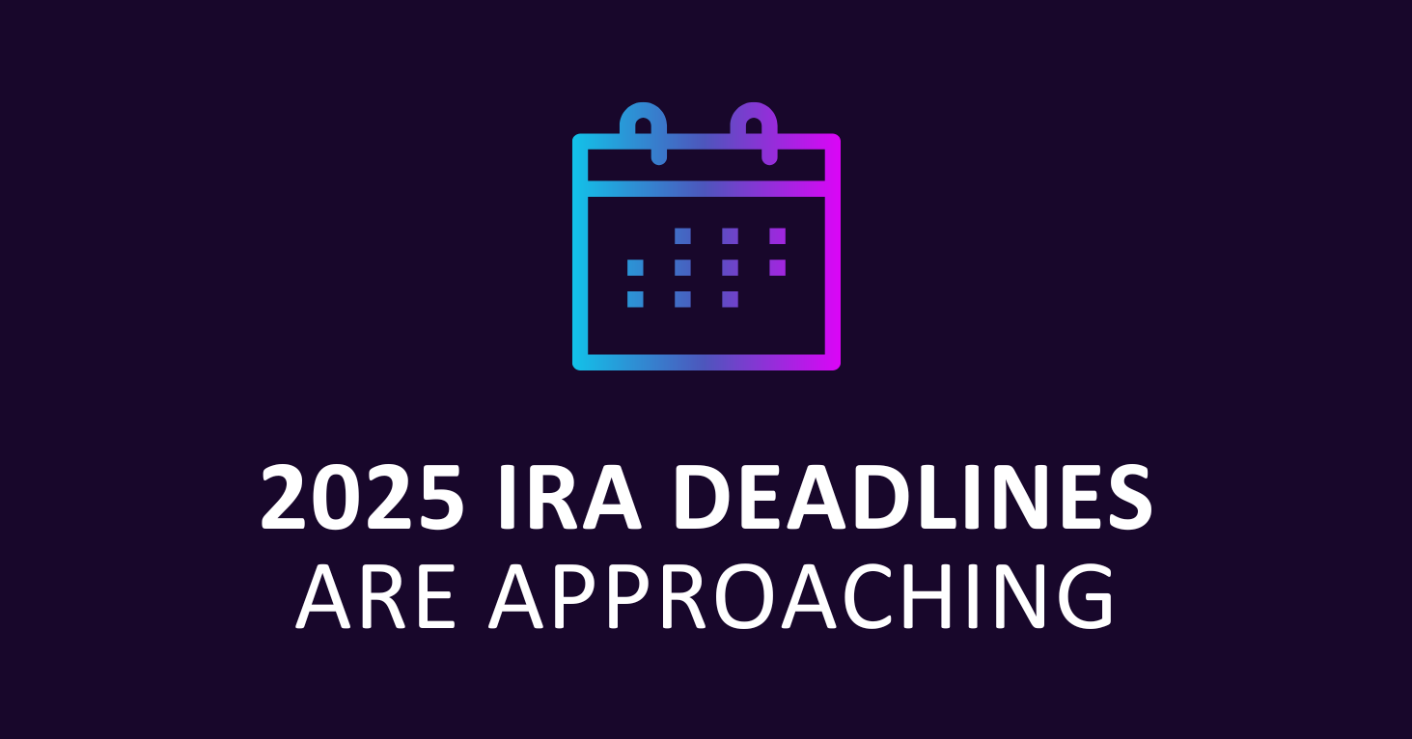

What You Need to Know
Financially, many of us associate the spring with taxes—but we should also associate December with important Individual Retirement Account (IRA) deadlines. This year, like 2024, will see a few changes and distinctions.
Remember, this article is for informational purposes only. It is not a replacement for real-life advice, so consult your tax, legal, and accounting professionals for the most up-to-date information about IRA account deadlines and contribution strategies.

The deadline to take your Required Minimum Distribution from traditional IRAs is December 31, 2025.

The deadline for making 2025 annual contributions to a traditional IRA, Roth IRA, and certain other retirement accounts is April 15, 2026.¹

Some people may not realize when they can make their IRA contribution. You can make a yearly IRA contribution between January 1 of the current year and April 15 of the next year. Accordingly, you can make your IRA contribution for 2025 any time from January 1, 2025, to April 15, 2026.¹

If you make a 2025 IRA contribution in early 2026, you must tell the investment company hosting the IRA account for which year you contribute. If you fail to indicate the tax year that the contribution applies to, the custodian firm may make a default assumption that the contribution is for the current year (and note exactly that to the IRS).

So, write “2025 IRA contribution” or “2026 IRA contribution,” as applicable, plainly and simply in the memo area of your check. Be sure to write your account number on the check. If you make your contribution electronically, double-check that these details are present.

Citations
- IRS.gov, 2025
This content is developed from sources believed to be providing accurate information. The information in this material is not intended as tax or legal advice. It may not be used for the purpose of avoiding any federal tax penalties. Please consult legal or tax professionals for specific information regarding your individual situation. This material was developed and produced by FMG Suite to provide information on a topic that may be of interest. FMG Suite is not affiliated with the named broker-dealer or state-registered, or SEC-registered investment advisory firm. The opinions expressed and material provided here are for general information purposes and should not be considered a solicitation for any security purchase or sale. Copyright 2025 FMG Suite.

