

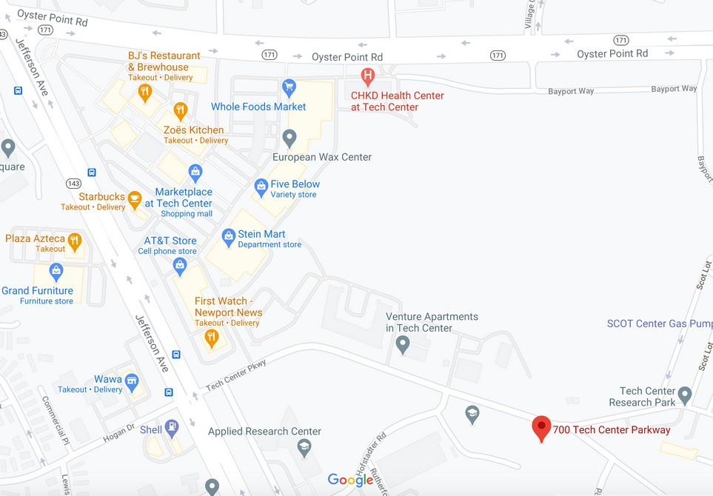
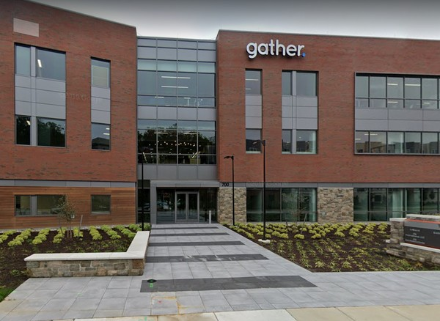
Parking Lot Entrance

Dawkins Financial
700 Tech Center Parkway, Suite 200-9
Newport News, VA 23606
(757) 530-9700

Dawkins Financial- Office and Conference
rooms are located on the 2nd floor in
Gather. Please check in with the receptionist at the desk upon arrival. In the event there is no receptionist at the desk, please call the office phone number listed above and you will be greeted in the lobby.

Securities offered through LPL Financial, Member FINRA/SIPC. Investment advice offered through Colonial River Investments LLC, a registered investment advisor. Colonial River Investments LLC and Dawkins Financial are separate entities from LPL Financial.

