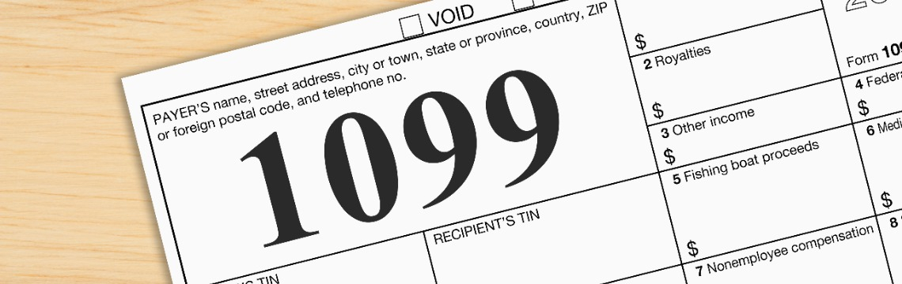
If you receive income from investments, dividends, education savings plans, or contract work, you’re undoubtedly familiar with IRS Form 1099. By the time April 15th rolls around, you might have even collected a hefty stack.

However, what might be less clear is when you should expect to receive them. Some insist that the deadline is January 31st. Or maybe it’s February 28th?

In practical terms, the fuzzy deadline does not matter as much as when you can expect to receive these critical forms. After all, you owe taxes on the income, even if the 1099 doesn’t arrive at all.
Common Forms 1099
Form 1099-B | Sale of stocks, commodities, or other securities
Form 1099-DIV | Income from dividends and distributions
Form 1099-INT | Interest payments
Form 1099-G | Payment from federal, state, or local government, including local tax refunds or unemployment benefits
Form 1099-MISC | Miscellaneous income
Form 1099-NEC | Nonemployee compensation
Form 1099-Q | Payments from 529 Plans or other Qualified Education Programs
Form 1099-R | Distributions from pensions, annuities, retirement accounts, or IRAs
Form 1099-S | Income from real estate transaction
Form 1099-SA | Distribution from Health Savings Accounts or Medicare Advantage Medical Savings Accounts
Source: IRS.gov
Businesses, financial institutions, and even local governments have any number of reasons for why they might not send Form 1099s as early as you expect to receive them. Some are still balancing their books until the last minute, and certain investment funds may take longer to reconcile overseas holdings.

Below you will find the updated mailing schedule for your 1099 consolidated tax form from LPL Financial. LPL mails 1099 consolidated forms weekly to account for various deadlines and income variations so that your tax information is timely, accurate, and reliable.

Form Name | Mailing Dates | What's Reported
1099 Consolidated Tax Statement | January 17, 24, & 31: Accounts with the simplest tax information and not subject to income reclassification.  February 7 & 14: Accounts holding more complex securities, for which issuers provided final tax information after January 24.  February 21, 28 & March 7: Accounts where security issuers did not furnish tax information to LPL in time for the anticipated mailing date. | All reportable income and transactions for the year. Depending on the account activity, the 1099 may include: form 1099-B, form 1099-DIV, form 1099-INT, form 1099-MISC, and form 1099-OID.
1099-R/Q Tax Statement | January 17 | Distributions from qualified retirement plans (ex. individual 401K, profit sharing, and money-purchase plans), or any IRAs or IRA recharacterizations.
Preliminary 1099 Consolidated Tax Statement | February 14 | An advanced draft copy of the 1099 consolidated tax statement. Includes accounts that will not receive a final 1099 consolidated tax statements until all income reclassification data is finalized.
5498 – IRA | February 21 & May 23 | Contributions (including rollover contributions) to any IRA.

Here are a few things you can do while you wait:

● Make a list of Forms 1099 you expect to receive.
Proactively tracking expected Form 1099s may help you avoid surprises or, worse yet, neglecting to file one with your taxes.
● Check the online portal, if available.
In most cases, a digital copy of the expected Form 1099 may be available up to a week before you receive it in your mailbox. You can obtain your digital copy from Account View. If you need assistance, please reach out to our team.
● Watch out for corrected Forms 1099.
Sometimes, the Form 1099 you receive may be an estimate instead of the final version. Read any accompanying material and check for a watermark.
● Keep your address current.
The IRS will get a copy whether or not you get yours, so make sure you provide us with any updates to your address so we can be sure your 1099s go to the correct address.
● Look for errors and report them ASAP.
You might not have much time to correct any errors, so be sure to open, read, and act on your Form 1099s as soon as you receive them.
● The IRS gets a copy, too.
Don’t forget that the IRS receives a copy of all Form 1099s, just like you. If you forget to include one in your filing, you’ll likely receive a letter asking you to account for the funds you neglected to include.
● Be cautious with draft 1099s.
Some financial institutions may send preliminary versions of Form 1099 labeled as "draft." These are not final and should not be used for tax filing. Be sure to wait for the official version, which will be marked as final, to avoid errors or amendments to your tax return. Check any accompanying materials for clarification.
Navigating tax season can be challenging, especially when it comes to tracking down and making sense of all your Form 1099s. If you’re unsure which forms to expect, why they matter, or how they impact your financial plan, don’t hesitate to reach out. We’re here to help you make sense of the process and provide guidance tailored to your needs.
Remember, this is for informational purposes and doesn’t replace personalized advice. Be sure to consult your tax, legal, or accounting professionals before making any changes to your tax strategy.
Sincerely,
Thane McCready CFP ®


