Simple Safeguards: How to Stay Safe from Identity Theft and Cybercrime
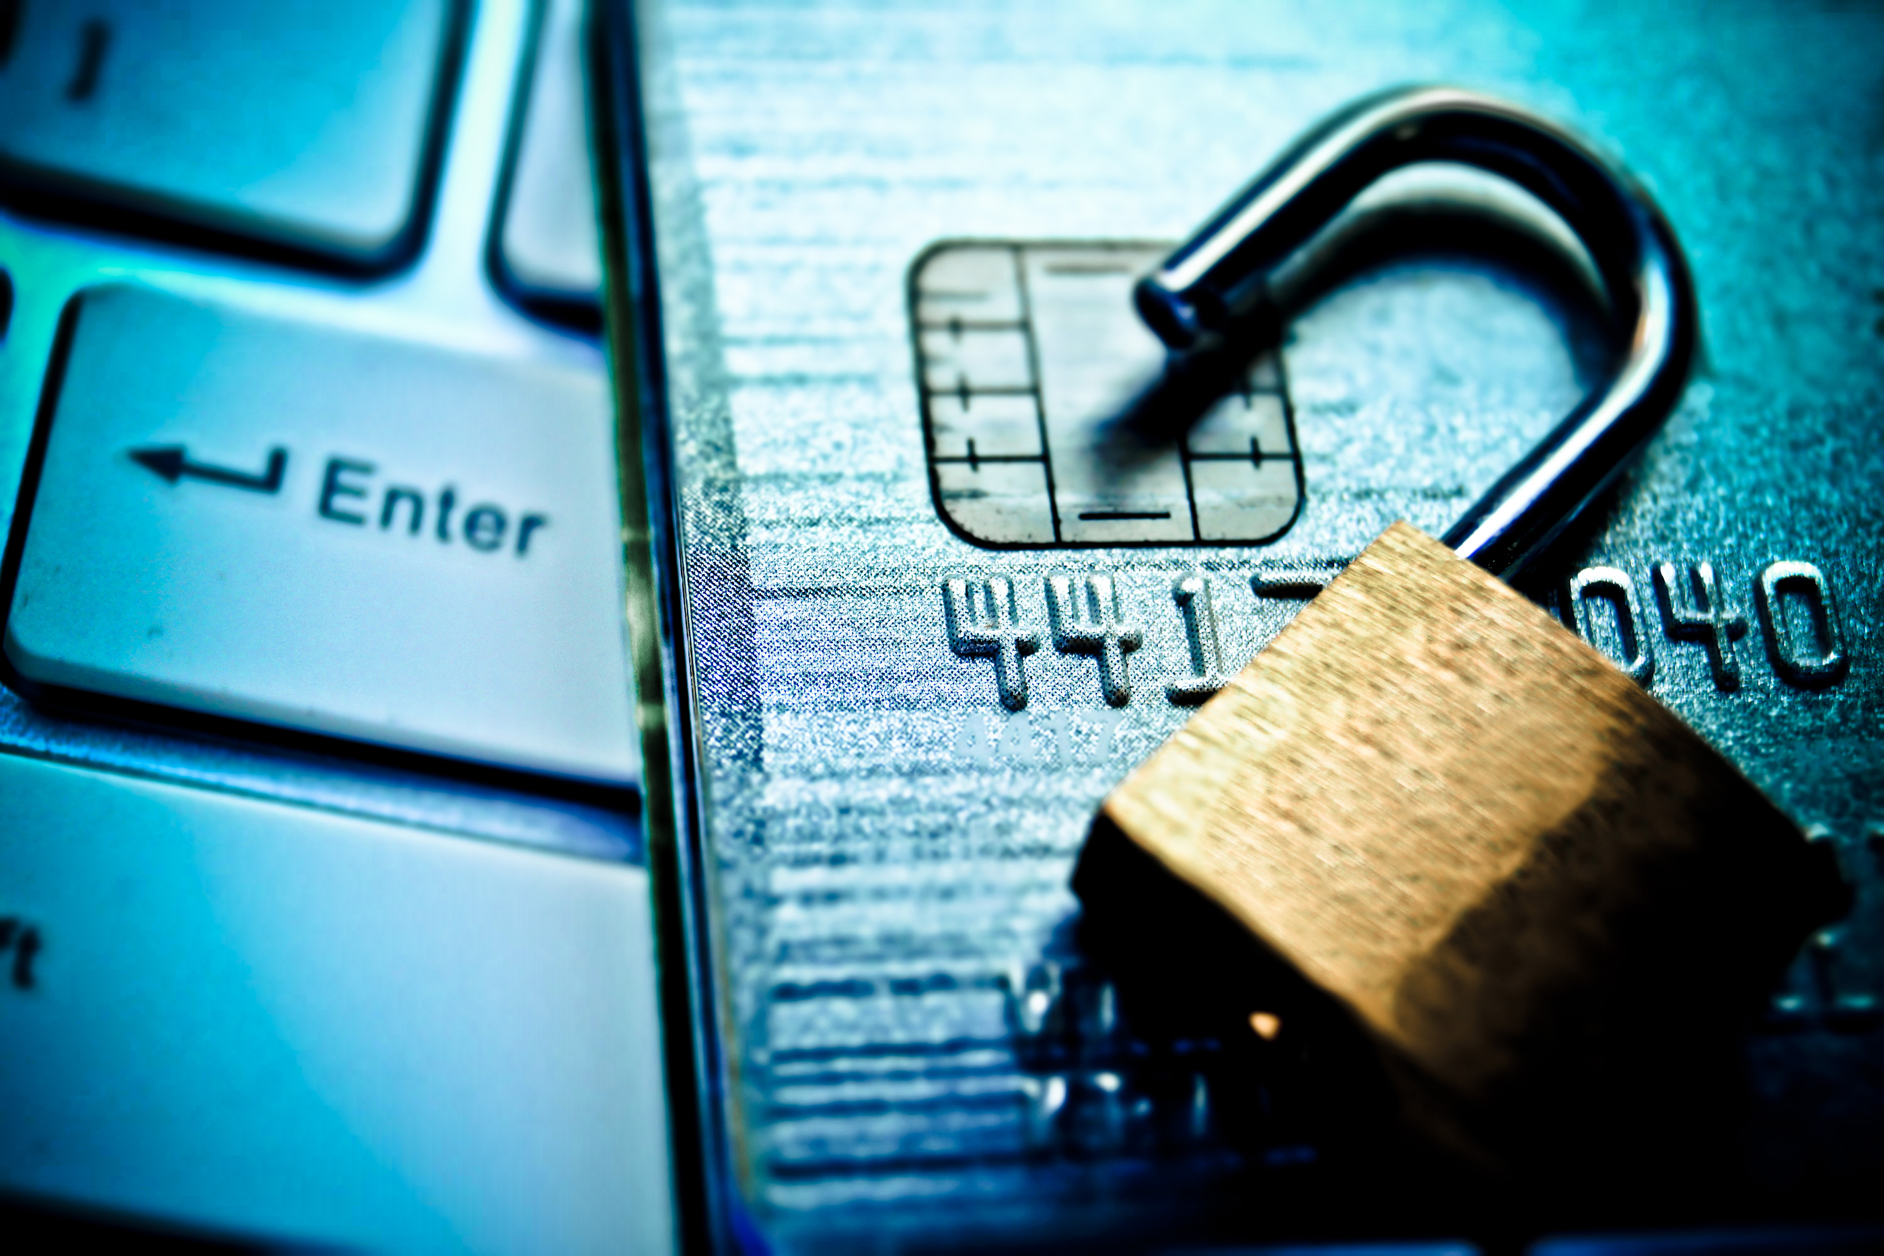

Description:

Please join us for an insightful webinar with retired FBI Special Agent, Jeff Lanza. His dynamic presentation focuses on how criminals try to trick us, steal our identity and commit cyber fraud. You will learn how to spot an online trick, a fake website and phony link. Keep your identity safe and stay protected online!

Key Points Covered in Presentation:
- Preventing bank account takeovers
- Identity theft and information protection
- Staying safe against the latest social networking frauds
- Avoiding social engineering
- Protecting mobile devices from fraud
- Recognizing phishing and spoofing
- Networking and cloud security
- Preventing internal fraud and embezzlement
- Preventing check and ACH fraud

Jeff’s qualifications on this topic:
Jeff Lanza was an FBI agent for more than 20 years during which he investigated corruption, fraud, cybercrime and organized crime. He served as chief of internal security for the FBI’s Kansas City region. He has provided thousands of presentations on risk management to associations, corporate boards, and employees of major corporations around the world. He appears regularly on CNBC, the Fox News Channel and has informed the public on other national programs including the Today Show, Good morning America, Dateline and CNN, among others. He holds a Master’s Degree in business Administration.

Wednesday, July 22nd
Virtual Client Event at 6:30 pm
Click HERE to attend

No RSVP necessary. Just click to join the event (below) before 6:30 pm on Wednesday, July 22.
Questions? Please call 781-933-2067.

Securities offered through Waddell & Reed. Waddell & Reed is not affiliated with Jeff Lanza, the FBI or any other organizations referenced. • The data, analyses and opinions contained in the presentation are those of the speaker and are for informational purposes only and do not represent an offer to buy or sell any investment product. Waddell & Reed, Inc. does not guarantee the completeness or accuracy of the information and has taken no part in producing this material. (06/20)



