

SPAIN LANGUAGE BUDGET FORM – JAN PLAN ’27 COURSES
Work with your course instructor to ensure that the “Course Fee” and “Other Costs” below are accurate. Make sure that you do not include expenses in “Other Costs” if they are part of the “Course Fee.” Enter the expenses in the table and then provide justifications in the other section below.

Course Fee | $3,200
Other Costs
Food | $150
Departure and return travel | $750
Local travel | $50
Travel related expenses | $185
Excursions, activities, and entertainment | $300
Miscellaneous expenses | $0
Projected lost wages | $500
TOTAL COST OF ATTENDANCE (Course Fee + Other Costs) | $5,135
Personal contribution | $100
TOTAL REQUEST (subtract contribution from total expenses) | $5,035

COURSE FEE
This is the amount that Colby will bill every student on their tuition account to participate in the course. This fee is not part of regular tuition or traditional financial aid at Colby, which is why you are applying for grant funding to cover some or all of it. At the time of Jan Plan billing in November, your student account will be charged the course fee (what you will owe). If you are awarded grant funding, any portion of your award that is equal to or less than the Course Fee will be credited to your tuition account to cover what you owe. If your grant funding is at least equal to the Course Fee, this credit will “zero out” the charge and you will not need to make a payment. If your award is less than the Course Fee, you will owe the balance. All students that owe $500 or more of the Course Fee will need to submit a deposit to Student Financial Services by October 16,, 2026. For example, if the Course Fee is $4,000 and you are awarded $3,500 or less, you will need to submit a deposit.

The course fee that will be billed to my student tuition account is $3,200.

OTHER COSTS
Please provide written explanations (with as much detail as possible) in each expense category below. If not applicable, you can write $0.

These expenses are not part of the “Course Fee” but are required for attendance. You will handle these transactions independently on-site using your own form of payment (cash or card). For example, if flights are not included in the “Course Fee,” you will need to arrange and book your own flights. As another example, some courses include lunch and dinner, but not breakfast. In this case, the instructor will arrange and pay for lunch and dinner but you will need to bring cash and buy breakfast yourself. If your award is more than the “Course Fee,” this extra amount will also be credited to your student tuition account and then subsequently be “refunded” into your checking account via direct deposit.

1) FOOD
Only include food that is not part of the “Course Fee.”

Meals will be included in the course fee but $150 is recommended by local snacks and coffee.

2) DEPARTURE + RETURN TRAVEL
Only include if this is not part of the “Course Fee.” Domestic and international transportation is eligible. Please find the closest and/or least expensive departure city for flights (e.g. Boston, MA instead of Portland, ME). You may show several estimates in your explanation.
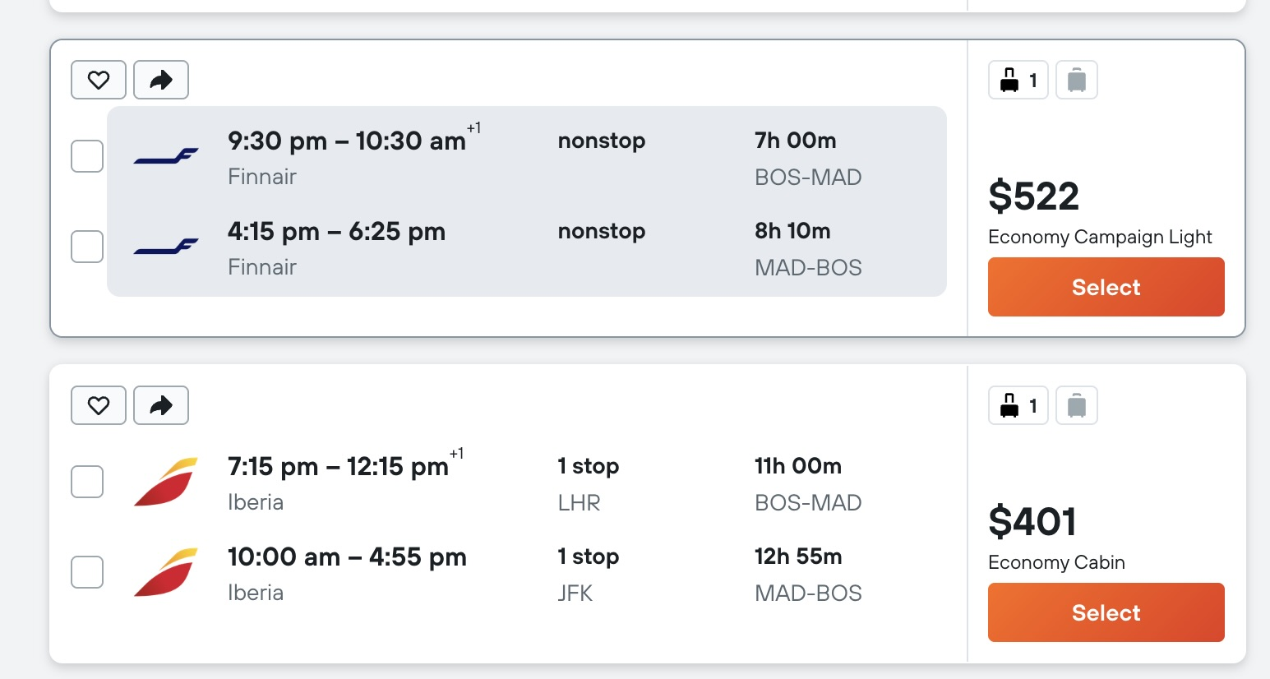

I am flying roundtrip from Boston to Madrid and I expect prices to increase by the time I will book my flight. The total is expected to be $750.

3) LOCAL TRAVEL
Some courses require students to pay for their own local travel such as taxis or buses.

$50 is budgeted to travel by taxi to parts of the city that are not walkable.

4) TRAVEL RELATED EXPENSES
Passport, visas, and other related expenses are eligible to request. International students may request funding for visa appointment travel to embassies or consulates but must first speak with Aura Moreno (aemoreno@colby.edu). Phone service is also eligible to request.

The cost of a first time passport is $165, which includes a $130 application fee and a $35 acceptance fee.
The cost of a SIM card is $20.

5) EXCURSIONS, ACTIVITIES, AND ENTERTAINMENT
Depending on the course, students are expected to cover their own entertainment and recreation expenses unless it is part of the program itinerary (e.g. museum fees, cultural excursions, etc.).

There will be one weekend without scheduled activities so I will budget $300 for this.

6) MISCELLANEOUS EXPENSES
Any expenses necessary for the course that have been identified by your instructor.

There are no miscellaneous expenses needed so $0.

7) PROJECT LOST WAGES
Only students on financial aid (and who provide compelling justifications below) are eligible for lost wages. If you are giving up a specific paid employment opportunity or on-campus job to participate in this experience, what is the total amount of wages that you’ll lose? Lost wages are capped at $500 for Jan Plan so please do not exceed this amount in your request. Lost wages may only factor into a decision rather than a guaranteed addition to other costs. Applicants who simply list an amount without explanation will not be considered. Please describe the employment, provide your hourly rate, and detail the number of hours you would have worked.

I would work as a lifeguard at Colby’s athletic center for $16.10 per hour at 12 hours per week and will cap my lost wages at $500

PERSONAL CONTRIBUTION
The purpose of our student grants is to help make an experience possible. Personal contributions are expected if you are able. Feel free to provide an explanation for your contribution whether it is from your savings, friends or family, or other funding sources.

Although I will be losing a month of pay by participating in this course, I have saved a small amount from my on-campus job this past semester and therefore would be willing to contribute / reduce my lost wages request by $100.

___________________________________________________________________________________________________________________

Please feel free to add any additional comments about your budget:

