

EXAMPLE BUDGET FORM INSTRUCTIONS
Applicants are required to provide justification for each expense. Applicants who just list expenses without any description will not be funded. How did you come to that dollar amount? Where did you do your research? Enter each dollar amount in the following table and then provide an explanation for these amounts below.

Program tuition or fees (if applicable) | $ 0
Food | $ 450
Housing | $ 550
Destination travel | $ 1,000
Local travel | $ 175
Travel related expenses | $ 100
Project or miscellaneous expenses | $ 30
Projected lost wages | $ 500
TOTAL EXPENSES (add above columns) | $ 2,805
Personal contribution | $100
TOTAL REQUEST (subtract contribution from total expenses) | $ 2,705

EXPENSE BREAKDOWN

- PROGRAM TUITION OR FEES
Only fill this out if you are paying an organization to have this experience. Otherwise, skip this part. Provide a breakdown of what this payment includes (educational costs, housing, food, insurance, etc.) as best as you can. For any expenses that you are directly responsible for, not included in the program tuition or fee, please use the other sections below.

This is an internship (not a structured program) that I have curated myself and so there are no associated fees or tuition.

2) FOOD
Food costs are based on your location and average daily food or monthly groceries costs can easily be Googled. Every effort should be made to buy groceries instead of eating out.

My internship will take me across many different locations, so based on the average price of food in Ghana (https://www.numbeo.com/cost-of-living/country_result.jsp?country=Ghana&displayCurrency=USD), I would need $15 per day. The anticipated length of the experience is 30 days so the total food cost would amount to $450 ($15 x 30 days).

3) HOUSING
Every effort needs to be made to find the most affordable option (e.g. an apartment on Craigslist, airbnb.com, and/or find a roommate) Rental costs above the median market price for cities will not be considered. Please cite specific sources.
I have found several affordable apartments in the Greater Accra region in the range of $14 – $25 a night for a total of $420 – $750 for 30 days. The organization meets in Kosao, Ghana so I tried to find housing that is close to that location and will have cheaper transportation. The two most appealing Airbnb apartments are each a one bedroom/one bathroom (where one is priced at $18/day and the other $19/day) in the Greater Accra region. I will say that the best estimate for housing will be $550.

4) DESTINATION TRAVEL
If traveling outside of the U.S., it is helpful to find multiple quotes for airfare (and list them below). You may also take into consideration estimated rises in airfare as funds will not be disbursed immediately (all fund disbursement requirements must first be completed). If connecting domestic airfare is booked through a separate agency or carrier, please note that as well. If you are driving, taking the bus or train within the U.S., please use this section to calculate gas mileage or list fares.
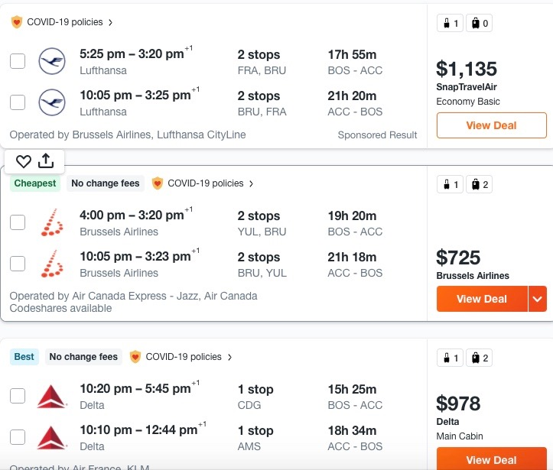
Based on the potential for rising airfare, I think $1,000 would be a reasonable estimate for this roundtrip cost.

5) LOCAL TRAVEL
This line item is for travel once you reach your destination, during your experience. You are expected to use public transportation and to find the best deal (i.e. monthly passes). Ubers and taxis will not be covered unless they are critical for safety or the only/most inexpensive option.

I will be using public transportation mostly every day to travel back and forth between my apartment and the meeting area for the organization’s members and volunteers. Transportation will be determined based on where I live but the average monthly costs of public transportation in Ghana is estimated to be $175

6) TRAVEL RELATED EXPENSES
Passport, visas, and other related expenses are eligible to request.

insurance company, I estimate the costs of these shots to be about $100

7) PROJECT OR MISCELLANEOUS EXPENSES
Other reasonable costs critical to the experience not listed above may be eligible. Expenses such as clothes, personal entertainment, toiletries, gym memberships, etc. are not eligible for funding. DavisConnects does not fund supplies, materials, or equipment but other departments may as appropriate for the criteria and purpose of the fund (e.g. the Center for the Arts and Humanities may fund supplies for their research grants and applicants for the O’Hanian-Szostak Fellowship for Civic Leadership may include supplies and materials, but not equipment). This category also includes services, fees, and purchases for project deliverables such as printed materials and surveys.

My apartment will not have wi-fi and so I will have to rely on a local internet café. The monthly cost should be at most $30.

8) PROJECTED LOST WAGES
Only students on financial aid (and who provide compelling justifications below) are eligible for lost wages. If you are giving up a specific paid employment opportunity or on-campus job to participate in this experience, what is the total amount of wages that you’ll lose? Lost wages are capped at $500 for Jan Plan so please do not exceed this amount in your request. Lost wages may only factor into a decision rather than a guaranteed addition to other costs. Applicants who simply list an amount without explanation will not be considered. Please describe the employment, provide your hourly rate, and detail the number of hours you would have worked.

I would work as a lifeguard at Colby’s athletic center for $15.15 per hour at 12 hours per week and will cap my lost wages at $500.

PERSONAL CONTRIBUTION
The purpose of our student grants is to help make an experience possible. Personal contributions are expected if you are able. Feel free to provide an explanation for your contribution whether it is from your savings, friends or family, other funding sources, or income that you will receive if it is a paid opportunity. Please report and contribute the entirety of your hourly wage or stipend if this is a paid internship. Purposefully withholding or misrepresenting information about personal finances or internship compensation is a violation of the student code of conduct and will result in a denial of funding.

Although I will be losing a month of pay by accepting this unpaid internship, I have saved a small amount from my on-campus job this past semester and therefore would be willing to contribute / reduce my lost wages request by $100.

___________________________________________________________________________________________________________________

Please feel free to add any additional comments about your budget:

I would like to try and find a roommate to reduce food and housing costs but have not yet had any luck. If I am able to find a shared living situation that feels safe then I will let the funding committee know to reduce my award.

