July 29, 2014
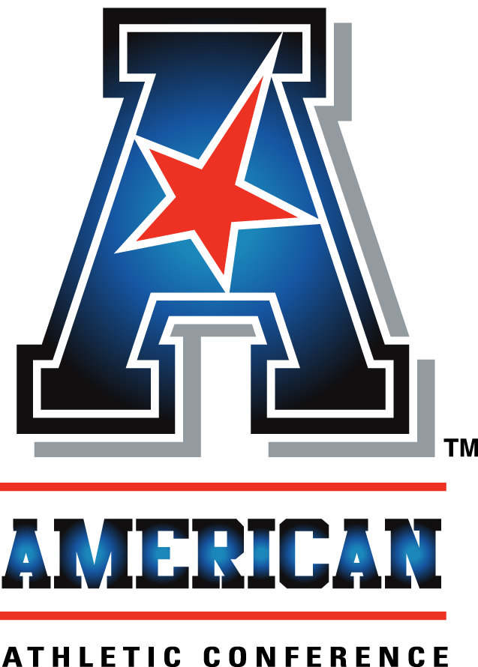
An interview with:

COACH BOB DIACO

THE MODERATOR: Next from the University of Connecticut, we welcome the only new coach in the conference this year, Coach Bob Diaco, coming from Notre Dame where he had extraordinary success.
COACH DIACO: Thank you very much. Thank you to everyone for still sticking around. I wasn't sure what it was going to look like at the very end. I think I'm last. I appreciate everyone.
I want to say thank you to the coaches of the American Conference and the athletic directors. The interaction over the last few days has been the best moments that we've had, very treasured, having a chance to interact, the hospitality they showed me specifically.
I'd like to thank Mike Aresco and his leadership of our powerful conference. It's been a great opportunity to meet him, spend more time with him and his staff. I thank President Herbst, Warde Manuel, giving me a chance to represent UConn here. I'd like to thank the work with our two players representing UConn today, Geremy Davis and Byron Jones. We could have chosen a bunch of good players to come, but we wanted to choose two guys, one already has his degree, working on a second, and the other one is an A student with a challenging academic background. They also happen to be two of the very best players at their position in the country.
The last eight months on the job have been wonderful, challenging. We've intensely focused in a few areas: their physical development, their mental development, which would be the development of our culture, and then the engagement of school spirit, which we believe to be a lasting four-quarter energizer. Those have been hallmarks of what we've been doing as a staff on a day-to-day basis as well as recruiting.
I can say unequivocally as we've analyzed their nutritional component with blood panels, their power ratios, we've had players that put on 10 pounds, losing 5% body fat, giving them a chance to win their individual matchups in the games.
Culturally that's a little bit more intangible. But when you're with your guys and they don't want to leave, when you see these bright smiles that you haven't seen around, when they're in the hallways, they're not trying to run out of the building, they come early, they leave late. The emails that are negative decrease, and the ones that are positive about their engagement with these guys on campus and in the community, those are all hallmarks of individual moments of us working on our culture to create a winning culture, a culture that would be indomitable against things that cause losing.
I've spent a lot of time in the state and around the Northeast trying to create a complete engagement and interface opportunity with the fans, and then on campus. I believe, just like Newt Rockne said, when you have an apathetic student body and a faculty, you're probably going to have failure on your athletic fields. But where you have that great school spirit, it creates an extra heartbeat for the teams. That's present at UConn. I want to help do everything I can to foster that and grow it.
So now we start a new phase. We move from those first eight months to a new phase. I just can't wait. I'm so anxious and excited about Friday when we start. I can speak to anyone here. You don't have to be a football player or athlete. If you were ever at camp, you went to space camp or fishing camp or soccer camp or football camp, if you were ever at camp sequestered, intensely focused on one specific thing with other like-minded people intensely focused on that one specific thing, those end up inevitably being some of your greatest memories in life.
That's why I'm excited for Friday, for camp. I just cannot wait to get sequestered with the staff and the team and the players and work hard to grow in all of our development areas.
I really haven't looked ahead. I would like to mention that we are so excited to open with BYU on national TV. For the last 30 years you'd be hard-pressed to find a team with a greater winning percentage than BYU. They have a national brand. Boise State at home. Not to not mention other opponents, but those two specifically. Then how about Army? What a storied program over the last hundred years. By the way, we're going to play them in Yankee Stadium.
What an experience for the coaches, players and fans, to go to one of the most tradition-rich environments and venues in the world and play the Army. So we're excited about this to come.
We're going to drill down, focus on this next phase before we get to that phase, but there's some exciting times ahead for UConn football.
With that said, I'd like to open it up to questions.

Q. You talked about the transition of the program. Let me ask you about your own transition. Going from being an extraordinarily successful assistant, what have you found to be the most challenging parts of that transition and the most pleasantly surprising parts of that transition?
COACH DIACO: I think for me, I just love these guys. I need to be able to manage the stories 'cause the stories come at you fast and furious. As a unit leader, I'd hear the stories of about 40 or 50. Now I'm hearing the stories of about 150. I need to be able to help those people that are needing and need help and support. It's all the stories that you hear that need to be managed and cared for on a day-to-day basis I'd say has been one of the bigger challenges, unexpected challenges.
But it also happens to be the greatest piece. If that's your mission, and your mission is wanting to develop young people, help them become great husbands and fathers, business leaders, community service members, and football players, then it also happens to be some of the greatest times that I've had a chance to experience here in the last eight months.
It's been a great challenge, but it's been a fun challenge. I surely don't know it all. I learn every day. It's like whatever the Coach Wooden quote was, I'm not the guy that I was yesterday, and tomorrow I hope to be better than I am today, however that reads.
I'm going to make a lot of mistakes. I'm not going to pretend not to know everything. I'm going to rely on the players, the people supporting our team, for as much support and help as we possibly can have. Try to get better every day.

Q. Team had a solid finish last year. Over the summer, what do you do to make sure when you pick up, what do you tell them to keep the roll going?
COACH DIACO: Nothing. Nothing. I'm not addressing that at all. I don't talk disparagingly against them or critique them negatively for the things they did wrong. I'm not going to praise them or build on anything that went right.
All I have is our string of histories for being together here the last eight months. Not to mention that a core belief is that every single year with every new phase, you have to put the team back together. You don't pick up where you left off and you can't build on where we were.
The fact of the matter is you're making a vanilla cake, you don't have vanilla, you have to use nutmeg. You might as well throw it away.
When you add a new recipe, a new element, a new component to your team, it's totally different and needs to be addressed in a different way.

Q. You have three quarterbacks coming back, each of whom started four games last year. Some people might look at that as an embarrassment of riches, some might see it as a problem. How do you view it?
COACH DIACO: I think that game experience is a positive. If we can strip away the moments where the players tethered like an anchor, he has this collar around his neck dragging him down from a past experience, if we can repackage that into something positive, even if it's as a learning experience, not one that is going to define who you are, 'cause it never is going to be defined, you just keep growing, but an experience that was a positive, whether it was positive or negative.
So game experience is always a positive. We're blessed to have three players that played in games. In fact, four players that played in games. We have had a transfer that has come in. We have four physically capable and mentally capable quarterbacks to quarterback the team, and that's a positive thing.
THE MODERATOR: Coach, welcome to the conference.
COACH DIACO: Thank you so much.
THE MODERATOR: Good luck this year.
COACH DIACO: It's an honor to represent the conference and the university.

FastScripts by ASAP Sports

