July 29, 2014
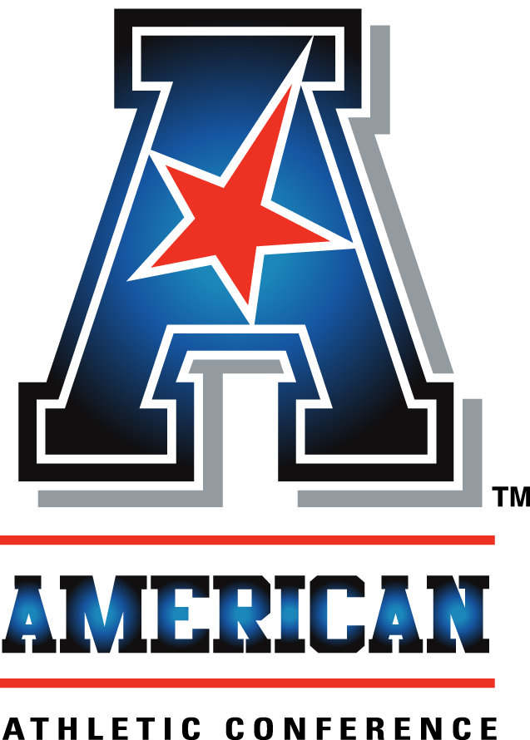
An interview with:

COACH GEORGE O'LEARY

THE MODERATOR: Next we have from University of Central Florida Coach George O'Leary. Coming off an extraordinarily successful year, a year culminating with that marvelous win in the Fiesta Bowl. The longest tenured coach here in the conference, going into his 11th year. Finalist for a number of Coach of the Year awards.
COACH O'LEARY: Welcome and thank you. UCF right now, we will be a very solid football program. Obviously we lost, before you start asking questions, the number three pick in the draft, Blake Bortles at quarterback. Pretty much from the team last year we only lost seven players on the whole team. Pretty much we have the team back intact.
I don't think the 12-1 record just occurred. It's been something that's been going on. The kids that we have with us today, they've won 10 games, 11 games, finalized with 12 games. I think the culture of winning is there.
I think last year we had a terrific season. I think it was great for the conference, great for UCF as far as national recognition. But that's over. I think it's a new year. As I told the team, new team, new leadership, new chemistry. I think all those things have to fall in place for us to be successful.
We tee it up this Wednesday. Tomorrow the kids report, we start practice on Thursday. I listen to all the talk about the Equity 5, Power 5. We're not going to change. We're going to do exactly what we have to do to be competitive as far as cost of attendance, meals. I just don't know how much you can feed 'em, all right, as far as some of these kids, what their needs are.
I think we're going to do what we have to do to make sure we're competitive in recruiting and everything else we need to do to be basically where we need to be.
I think the key, I've always said this, you have to play a very competitive non-conference schedule and win those games. I think that's what needs to be done. That's why I've always believed through all my years of coaching, as I told my wife, I stay a couple more years, they'll put my name on a ship. But I think the big thing is that basically we're going to be competitive, we're going to go out and play the best teams we can play, then go from there.
The key to our program's going to be just replacing the quarterback position, which we have four young athletes there that we feel can do that. It's just about getting them in place.
We do open up in Ireland, over in Dublin. How that game came about, it was O'Leary, O'Brien. When Billy was at Penn State, he left to take the Houston Texans job. Billy thought he would take his Penn State team on a trip, with the probation they were on. But the game is going to be great.
Toughest thing we had to do was get passports. As I told our players, we needed birth certificates. We had trouble finding some of them. We found them all. We got them passports. It's worked out well. We're looking forward to the game from recognition.
I think over in Ireland, England, there's all sorts of signs up. I think it's great for American football. We're looking forward to the game.
It will be back in the States on national TV. It will be a great experience for our players. With that we come back and we play Missouri. We play BYU. Then we'll play a very competitive non-conference game.
I think the key for us this year is when you look at the season, we don't play on eight Saturdays. Either we were picked up with ESPN on Thursday night or Friday night. There's eight Saturdays where we're sitting home or practicing. So it's a different type of schedule, something you have to adjust to.
But, again, with the number of players back, the number of experienced players back, the winning culture, we'll be a very solid team and be very competitive with everybody we play.
That's really it. We have a bunch of good players back. I don't get into who. I tell you, the game of football has changed. Football's success has always been a 'we'. It's changed more and more to a 'me' deal. A lot of these players coming out of high school, the exposure they're getting.
We built the team on two things: accountability and responsibility. That's pretty much the way we do the program. The players know what they have to get done. As much as we're proud of the success on the athletic field, we're number five in graduation rate in the country. If you looked at the top 10 last year, at the season-ending rankings, you rate them academically, we're number one of the top 10 teams in the country.
We're not just doing it on the athletic field, we're doing it on the academic field also. The players understand that.
The only thing I talk to them about when I recruit them is to make sure they graduate. That's the way we go.
Again, I think the conference has a great future ahead of it. I think they've got some outstanding coaches in it. They've got some outstanding players. I think the direction with Commissioner Aresco has been outstanding. I thought his Mission Statement was right on target as far as the direction we need to head as a conference is concerned.
We need to be scheduling people and then not just scheduling but winning these games. That answers a lot of ills. Go out and win and play a good schedule, then see where the chips may fall.
But we're moving on at UCF. We'll do everything we have to do to be successful. But as I tell the players, I'm more concerned about them on the field and then in the classroom. We'll do what we have to do to be successful in all areas, no matter what direction the country heads regarding autonomy, whatever that may be.
With that I'll take questions.

Q. Coaches often say they prefer to be the team that's sneaking up on other teams. After the extraordinary year you had last year, what are you saying to your players about this year being one of the target teams?
COACH O'LEARY: You know, I'm a Yankees fan, all right? No one ever sneaks up on them. That's who they are.
I've been at the other end, too. I know what it is to be the one sneaking up. But I'd much rather be where I'm at. At least I know where the target is.
What I do with the season is this, is I take the 12 games and I make them 12 one-game seasons. Every weekend is a season. Once the season is over, we can go on to the next season.
We have one goal on the team, period, and that's to win the conference championship. Every year same goal. I think when you win the conference championship, that leads to individual honors. I'm not concerned about individual honors, I'm concerned about team. I tell our team that all the time. We're a 'we' team, all right? The 'me' part of it comes when we win.
Again, we understand where we're at. Again, I think it's hard to get to last year's season, but I think it's hard to stay there. That's the contest we have this year.
I'll go after the kids tomorrow night when they report about the challenge we have. Basically I lean on our senior class every year. I think you're only as good as your senior class, not in playing, but really just in terms of camaraderie, team, those type things.
As I tell them, you know, I think it's harder and harder to get leaders today. I think it was much easier 20 years ago. Everybody wants to sit down and let somebody else make a decision.
We have a terrific senior class back. Last year I only had seven seniors on the whole team. This year I think we have 20 seniors that have all been around, a lot of double-digit wins. They understand what it takes to win, which is something I think you have to teach.
Effort, trust, loyalty, we're very solid. A lot of these players understand what the expectation levels are.

Q. I noticed last year watching several games, the team is quite physical. What are you doing to make sure that physicality stays up?
COACH O'LEARY: I'm big on contact speed. I always tell the players, I got a bunch of kids, even when I was in the pros, that ran 4.5, but they hit you at 4.9. You can't win with those guys. When you're watching kids on TV, watch the back leg. You don't see that back leg coming through, they're stopping, all right? You can win with 4.6, 4.7 guys if they hit you at that. I'm not talking about 40 speed, I'm talking about contact speed.
We have a culture where we understand it's a contact game offensively, defensively. Everybody talks about throwing the ball. We're still 60/40 run percentage-wise but we're going to take what the defense gives us from a run-pass standpoint.
If you don't want to hit anybody, you're probably not going to be around my program because you're going to get hit. You better be able to hit back. That's every position. The wide receivers block as well as anybody in the country. That's why we get a lot of big chunk plays.
I think they all have to be able to stand up, bow up, get things done. And that's the expectation level.
I think the seniors teach the juniors, sophomores, what the expectations are. As a matter of fact, when I first got to UCF, it was very easy to pick out the contact players. There weren't too many of 'em, all right? Now it's the other way. The non-contact players are a lot easier to pick out because they separate themselves pretty quick.
But we're a very aggressive team. I think that's what the game's about. It really is about winning the line of scrimmage, offensively, defensively, then getting the best people.
I always recruit from the front back. I recruit linemen. I like big, ugly kids. I do. Think they're good getting off the bus. Even if they don't play for you, make sure everybody sees them getting off.
I like guys that understand the game and do things with it.

Q. It seems that this league really needs a shot of adrenaline in the non-conference season. You're playing a lot of big games. Tulsa plays Oklahoma. Those are games, if you want to be taken seriously, the league needs to win a bunch of those games, doesn't it?
COACH O'LEARY: I think so. Don't just schedule them, but win. If you don't win, don't come by at the end of the year complaining you didn't go to the playoffs. Same with these other teams. I think the new Playoff schedule, the way you look at it, Bill showed you the different formats.
Obviously the first format where UCF is listed, I think that's the best one. That's the one I would give to the committee and go from there.
The best scenario is schedule good people and win, win your share of 'em. That's what you got to do. Whether I was at Georgia Tech, UCF, I've always played a good out-of-conference schedule. One is your players understand it, they're very competitive that way. You got to go out and basically that's what the game's about, in my opinion.

Q. Looking forward to the very first game with Penn State, I know how important it is to schedule these tough opponents. At the same time there's a lot of pressure to have a lot of home games for revenue purposes. How do you get a nice balance?
COACH O'LEARY: Well, we're getting a pretty good paycheck from the GAA to go over. Ireland is a funny country. There's only five million residents, but a million of them belong to the GAA. We're getting a pretty good payday to go.
I think it's a great situation for the players. None of them will ever get there again in their lifetime. Again, we have a schedule there. We'll continue practice, give them a chance to see the city of Dublin itself.
I think we will take them to Kilmainham Jail. I may leave a couple if they can fit in.
The big thing with all that, it's great exposure, not just in this country, but over in Europe the exposure the game is getting. Not just in London, but all over Europe. I think it's great for American football. It's something we're looking forward to. It's not going to be too much of a burden on our schedule at all, it really isn't.
THE MODERATOR: Coach, thank you so much. Congratulations on an exceptional year last year and good luck this year.
COACH O'LEARY: Thank you.

FastScripts by ASAP Sports

