July 29, 2014
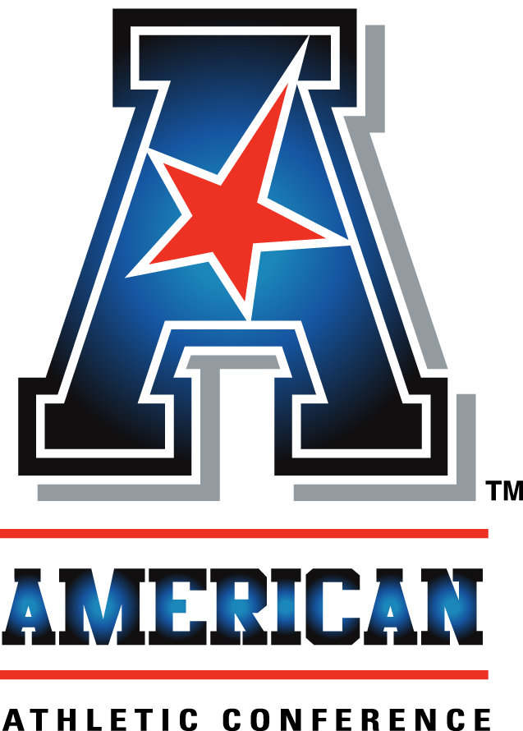
An interview with:

COACH MATT RHULE

THE MODERATOR: We welcome our next coach from Temple University, Coach Rhule.
COACH RHULE: Thanks for everybody here. Obviously we're excited to get started with the season, our second in the conference, my second as the head coach. We think we're going to have a really good team. We think we're going to surprise a lot of people in the league. We have some talented young players. We think we're going to be a team people are going to have to reckon with over the next couple years.
First of all, we have four tremendous players with us today. Kyle Friend is here with us today. P.J. Walker is here with us today. Kenny Harper is here with us today. Tyler Matakevich is here with us. We're proud to have them here representing our team.
We're obviously coming off a disappointing year, our first year in the conference. I know we're certainly better. We had seven losses by 10 points or less. We were winning in the fourth quarter the last six games of the year, weren't necessarily able to win those games.
I think those moments, those heartbreaks, some of which they showed on ESPN a thousand times, spurred us on.
Obviously we have a tremendous non-conference schedule in sticking with the theme of the league. We certainly believe in this league, we believe in the strength and power that's here. We want to go challenge everyone we can.
We're going to open up in Nashville against Vanderbilt. Excited to be the first game on the SEC Network. We're going to follow that up non-conference-wise with Navy.
We've had some great games at Temple over the years with Navy both when Paul Johnson was there. Delaware State, then Penn State later in the year. A chance for us to play an SEC team, a Big Ten team, be one of the teams in the league that shows everybody across the country who and what we are.
As I look at our roster, we really struggled on defense at times last year. We've done a good job of recruiting those kids. I think we're going to be a lot better on defense. Hopefully some of our fourth-quarter windows, losing on the last play pass of the game, will be ended by that recruiting.
With that, I'll see if anybody has any questions.

Q. Temple has had difficulties in the past. What did you learn from Al Golden and Steve Addazio that you think will help Temple move up in the new conference?
COACH RHULE: I think it all starts with players. That's why I mention the kids we have here right now.
We won at Temple because Al put structure in place. We recruited great players like Bernard Pierce, Muhammad Wilkerson, Terrance Knighton, many more. Not all went on to the NFL. But we had a brand or style of football that you knew what it was. Coach Chaney, the legendary basketball coach came in one day and said, If you want to win at Temple, you have to be tough. He had some colorful language that I'm not going to go into here.
That in our mind solicited our brand. As we move forward, I'm not proud of the fact we had a 21-point lead twice last year and lost that. I'm not proud that we lost those games in the fourth quarter. It definitely tells us where we are and what we need to do.
We need to continue to recruit, and we need to develop that Temple tough mentality we've always had.

Q. One of the challenges in coaching at a school that's an older city school is finding the room for your facilities. I saw Temple has made some progress in your practice facilities, locker room facilities. We know in the current day and age, when you're recruiting, a big portion of that is what do the facilities look like. Are you pleased with where you are right now?
COACH RHULE: Since I've come back as head coach, we constructed an indoor facility, a training table. They redid the locker room. Put down brand-new turf. We have everything we need to compete and recruit at the highest level. We have everything we need for our players to be developed at the highest level.
As people in the Northeast come, do their college tours, they're shocked at what Temple has.
I'll throw in there, Kenny Harper, who is here, he's from Gainesville, Florida, he's our senior runningback. He's also getting up every morning, lifting at 6:00 in the morning. He takes the subway down 1.1 miles to PNC Bank where he is working in the mega wealth division with anyone that has between $25 million and $2 billion. He comes back at 5:00 and goes to night class. You can only do at Temple. I went to Penn State. You couldn't do that at Penn State. He's walking up and down the halls with people that are going to write him recommendations.
Most of the jobs nowadays are in the city. Our guys have a chance to play big-time college football, get a great degree, and build their résumé for their career moving forward.

Q. How about the challenges, three new teams coming into the conference this season, a fourth with Navy next season, how about the challenges they present for you?
COACH RHULE: I think we play seven new opponents this year. It was different last year in that I don't know that I recognize this league, how wide open it was going to be, how fast it was.
We had kind of built our team a different way. So coming back off last season, facing all the four-wide teams, great teams like Houston, knowing East Carolina is coming in, Tulsa is one of the inventors of the fast, no-huddle offense, we changed a lot of what we do. We took linebackers and moved them to D end. We took D ends and moved them to defensive tackle. We are recruiting secondary guys like crazy because the days of having two corners are over. We play with four corners most of the season.
It was probably midway through the Cincinnati game when Coach Tuberville was going no-huddle, at breakneck speed I said, We have to change how we do business.
In a second year I think we're more prepared for what this league means. What this league means to me is really strong, competitive teams that play a dynamic style of offense.
Every Saturday you could pick up the remote and choose what you want to watch. I think people want to watch what we do.
I've had more people stop me and say they cut into and watched the end of our UCF game, painful the way it ended, but it was great for college football. More people saw two great offenses, great players, Blake Bortles, one of the great quarterbacks in the league, third pick in the draft, and our quarterback T.J. Walker go toe-to-toe. We're excited for all these new teams. For us, I'm excited to get through this season and get an idea for who everybody is.
THE MODERATOR: Thanks, coach.
COACH RHULE: Thank you.

FastScripts by ASAP Sports

