July 29, 2014
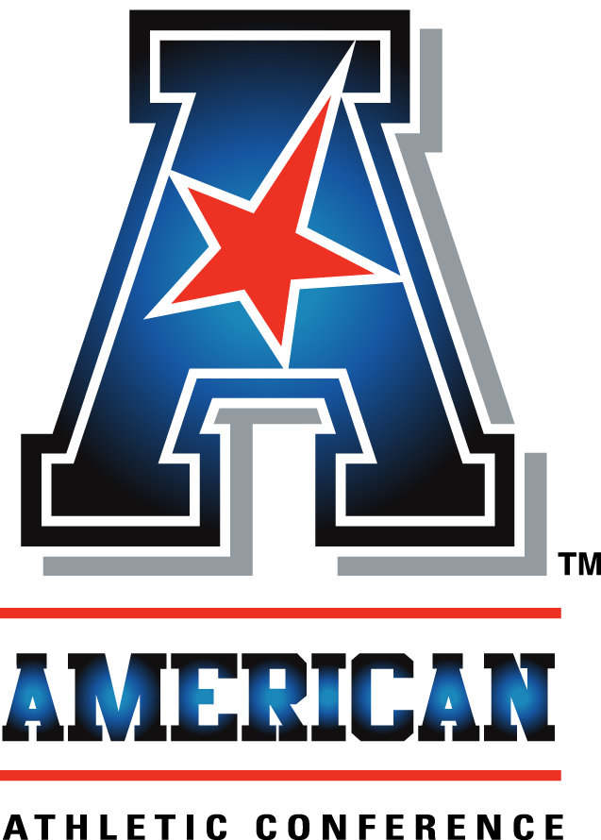
An interview with:

COACH RUFFIN McNEILL

THE MODERATOR: We welcome East Carolina University and Ruffin McNeill. This is his fifth season, seven bowls in the last eight years, a 10-win season last year, second in the storied school history, only to the 11 wins of the 1991 team. We are delighted to welcome him to the American.
Coach Ruffin McNeill.
COACH McNEILL: Good morning.
I know I speak on behalf of not just myself, but our university, players, program. We're excited today to be a part of the American Athletic Conference. This has been a move that began happening a year ago, knowing our acceptance would come today.
Just to be here today in front of you means the world not just myself and our players, but our administrative staff, but also our fan base.
From the moment of our invite to the conference, there has been excitement about this day, this season starting.
One of the things when I go out to speak in Greenville and around, we go out and do our tours, the fan base has been I'm talking excited. There is a different type of buzz, excited about our team.
I want to thank I think one of the top commissioners and premiere commissioners in the country in Commissioner Aresco for inviting us here. I've known of him for a long time. When this move happened, he told me we would not be in better hands.
The American Athletic Conference is one of the premiere conferences in the country and it is a part of the power movement.
When you judge things in this business, you judge by the numbers. In the first year of its existence, Commissioner Aresco pointed out numbers. It proves the point.
Also I've been coaching 34 years. A lot of times you go to different conferences, different arenas, I've had a chance to sit in the room with our coaches in this league. Of course, you know about the players. But I look across and there's 10 really good football coaches in that room that get after it.
Coach O'Leary beating the Big 12 opponent in the bowl game did not surprise me. Our team has played UCF three times in our four years before this year, and every time it's been one of those hard-hitting football games. That win did not surprise us, as well as some other great coaches in our league.
Not only do I think it's a premiere conference led by a premiere commissioner, but it's also got a room full of coaches with great programs.
I talked about the excitement of our fan base. I want to say hello to them. I know they'll be watching everything.
I'm anxious to get the media, who have not covered East Carolina University, around our fans. Come to Greenville on a Thursday or Friday or Saturday, you will see excitement unmatched.
I look at this in three ways. Some coaches can. Some coaches can't. I look at East Carolina University, the pride and passion there from three points: as a student, student-athlete, and as a coach. I am honored to be a part of it. I'm anxious to get you there and get you around us.
I think one of the things I've learned in this is making sure when you advance, then you have a chance to be around different programs. When I was blessed to have this one, some things I knew I needed to have in place, to begin with a strong staff. I have no doubt my staff is one of the best staffs I've been around, and I would put them against any staff in the country, not because of the X's and O's or strategy or screams, but they're good people, good men.
This business is more than just winning or losing. But it's also now time, you can try to dodge it, I won't dodge it at our place, it's a critical time for our young men, having the right people around those young men. It's very important to me.
One thing I tell the parents when I go into the home is that the responsibility of taking care of their most prized possession is my honor. They are now my sons. I'm now their dad.
My coaches, our coaches, think the same way. Great strategist, good teachers, better men. I'm blessed to have them there.
The continuity is going to be the key this year for continued success. We all believe in the same thing since day one.
I brought four of my sons with me today. You'll meet them later on. They've been with me since the very beginning, when we began building the foundation, building the blocks. They have not flinched.
What's amazing about the move to the American Athletic Conference, the rise in the power, it's amazing how it correlates with Pride Nation. I've lived it and been there. The pride and passion, the tradition that's beginning, but a non-flinching attitude with this conference and with the administration begins with Commissioner Aresco. That same pride, passion and non-flinching, it also rests in our football program and throughout our athletic department, but among our guys.
I want you to meet the four. They are my sons. I am their dad. They know that. I can't wait for you to get around these four. We have a bunch we left back in Greenville. But I brought Maurice Falls, linebacker senior, already graduated. Graduated this past May. Great player.
Also Brandon Williams, inside linebacker came to us. Brandon is a great young man, getting ready to graduate this summer. I'm proud of him.
Justin Hardy, one of the top receivers I've been around in a long time, but a better person. Graduated in May. You'll get a chance to meet him.
Then the captain, Shane Carden. Shane graduated before the bowl game. Shane is already starting his graduate degree. All of them have.
You'll get a chance to meet my sons. I'm looking forward to y'all doing that.
We have some things we do, we hang our hat on there. One of the things that these guys have been about is about the team concept and dedication to the team concept, dedication to the mission. That's what we're about.
We'll be dedicated to the team concept from day one, we have been, dedicated to the mission from day one.
What do I mean by that? At our place, no egos allowed, no entitlement allowed. Teamwork first. Everything evolves around, What can we do to make the team better? We want the players to make the team great more than we want a great player.
The leadership core begins with those men. We did not flinch. We did not microwave it. We're not going to do it with shortcuts. Block by block. We'll continue to do that.
It's also about the environment. At East Carolina, I'm not afraid to say it this way, the environment comes before academics there. Before football. Academics is second, then football third. Environment is first there. If you make sure that the environment is right, everything else falls into place. Off the field, in the classroom, and on the field. We call it PIP off the field. That's Pride in Public. We call it Champ Days and Champ Reps in the classroom, as well as on the field. It's also proven by our team.
The mission we talk about is, yeah, we expose our team to our vision and goals for the season right at the beginning. The way we operate best, I operate best, is we attack it one day at a time. One day at the a time, one play at a time. That's in every aspect of our program.
We're looking forward to the season. We're looking forward to the first game. I'm looking to the kids reporting on the 3rd, starting practice on the 4th. We'll take it day to day, rep by rep. We'll attack the whole season in that manner. That's what we believe in and that's what we've built our mission on, dedication to the team and the mission.
The guys in our program, there's expectations placed upon you, and they accept it, and we accept those. The expectations within our office and among the players is higher than anyone can put on them on the outside. It's amazing if you could do that. The key to expectation is commitment to it.
I'm very fortunate. I mentioned my coaching staff earlier, great continuity, but I have a great group of core leadership men that carry that for us, dedication on the field and off. The team is their first concern. Everybody's thought process is how we can make the team better.
I'm excited about the season. We have a very exciting non-conference schedule. We have a very exciting conference schedule. Already six, seven nationally televised games that we have a chance to expose our program, and home programs which we have a chance to show off our team to the nation. Maybe I'm biased, but you'll see it when you come there, too.
We're excited getting to know some of you who we haven't met before. I'm a pretty easy-going guy. I look forward to you getting to know us, getting to know our program.
Questions.

Q. You talked about the values of coming into this new conference. How about the challenges?
COACH McNEILL: The challenge as a coach is what you welcome. First we'll take it from the notoriety point of view. It's a great challenge. I look at it more as an opportunity for us. That's how I was coached by my dad. It's a challenge, but more of an opportunity.
I mentioned how Commissioner Aresco has welcomed our entire program into it. But knowing the coaches that are in it, knowing the results that happened, not just in football, but basketball and other sports, that opportunity was welcomed by us.
Like I mentioned, we just began changing to the next level and live up to whatever expectations we put first, and whatever expectations are put to us by the conference, but look forward to it.
THE MODERATOR: Coach, I had the opportunity to play some golf with Shane the other day. He can hit it. I can understand why you're so proud of him and the rest of the team. Thank you.

FastScripts by ASAP Sports

