July 29, 2014
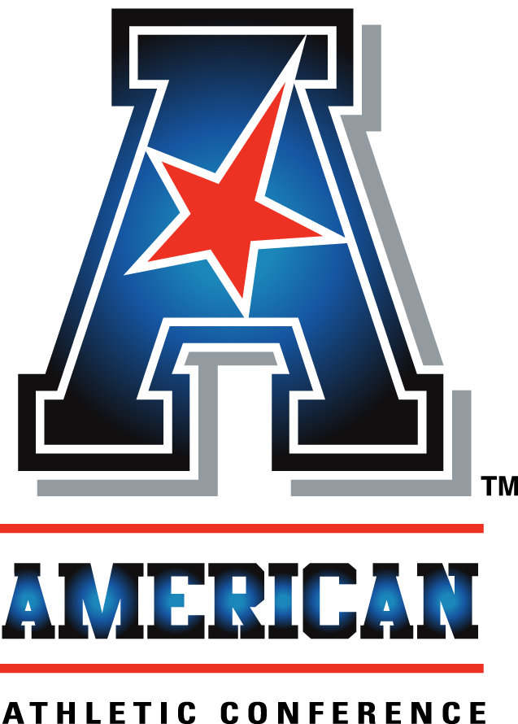
An interview with:

COACH TOMMY TUBERVILLE

THE MODERATOR: Next we have from the University of Cincinnati, Coach Tommy Tuberville. An exceptional career for nearly two decades as a head coach. Last year, his first year, supported a 9-4 record. I'm sure the fans are expecting at least that and perhaps more.
COACH TUBERVILLE: We're looking forward to this year with a lot of unknowns. I'm excited because I know a lot about our team.
First year of a coaching change, I've done it a few times, it's about the hardest thing you can do, trying to learn a whole new group of guys and fans, put together a staff. Really the unknown is more than anything else trying to overcome yourself for the first year.
We're to the point now where we know the players, they know us, they know the philosophy we're trying to put in. It will be the second year of our offense and defense.
Know a lot more about the players. I think we've got them in the right spots. That's the biggest thing about coaching, get your guys in the right areas where they can help you the most. Then get recruiting going. Our recruiting has gone a lot better than I would have expected in two years.
Excited about the thoughts of what most of you think about us. Somebody said we're picked to win the conference. Of course, I'd be thrilled about that. But you were wrong last year. Louisville didn't win it. Hopefully we can uphold that.
But we've got a good football team. We've got a lot to do. We're trying to build our defense to the point where we can play just rushing defense. Last year I think we were first in the conference in rushing defense, but we have to get better at pass defense.
Our offense we won't change a whole lot. Looking for a quarterback. Looking for somebody that can lead the team. Everybody says, You got Gunner Kiel. He hasn't taken a snap in three years. Lot unknown there. Munchie had a terrible knee injury last year in the second game. We have a young kid by the name of Jarred Evans.
We're still in the building stages of where we want to be. We want to build our team to a point to where each week we know we have a chance and can compete with anybody we play.
Our schedule is very competitive. We play three Ohio teams the first three games after opening up real late. We play Toledo, Miami of Ohio, then we got Ohio State. That will be fun for our fans. Then we go on to the conference schedule with Miami of Florida mixed in there among our conference teams.
Looking back at last year, we had a good football team. I didn't know how good we could be, but we had a chance to really be good. Then we started getting injuries. We had 19 surgeries. That goes along with luck. You can't blame it on that.
As a coach, you can look at the point you started and where you had a chance to get to. We lost three fifth-year senior offensive linemen. Put us in a tailspin. A lot of those kids that we had to put in those guys' places have a lot more experience had those guys not gotten hurt.
We're looking for balance on offense, 50/50 run and pass. We're not going to be an every-down running team. We want to throw the football. I think we led the conference in rushing. We have to get better on defense. We were God awful in our kicking game last year. We had no consistency. We couldn't count on it in a game situation.
I think it's going to be better with the guys coming back that were with us last year. They've worked hard. We have to do whatever we can do to make this an overall football team. I don't want to be an offense, defense, kicking football team.
We have Mike Bohn, our athletic director, who I'm excited about. But the guy I'm most excited about is our president who is bound and determined for us to have the best athletic program in the country. He's dedicated to it. He's committed to it. Wet put over $250 million in all of our programs in the last four or five years. Football program doesn't have to take a backseat to anyone. We're one of the winningest programs in college football in the last 10 years. We want to continue that, get better in every year. I think we've got a great group of guys to oversee that and make that happen.
Any questions.

Q. Stadium is in the process of being renovated. Playing off campus, does that present any challenges to you?
COACH TUBERVILLE: It does. It's like not having a home-field advantage. Not that we won't have a lot of fans there. We're the Wrigley Field of college football. Old stadium in the middle of campus. Sunken down. Crowd noise is very good. Students walk out of their dorm to the stadium. We're putting close to $100 million into it. Construction is on schedule. Seating capacity. Press box.
It's going to be interesting. It seats 80,000. We'll be stretched to get that many fans into the stadium. But I think it's going to be a good venue for recruiting.
Fortunately we have that opportunity to have a stadium like that where we can redo our stadium, have the opportunity to have home games just down the street, which is probably a quarter of a mile from our campus.
Our players are looking forward to it. We had our spring game there last year. We'll have two scrimmages on a Friday night as we start the season. I think it will be a good home venue for us, but not near as good as Nippert Stadium will be when we get back next year.

Q. Us knowledgeable people picked you number one to start the season. How do you keep your team prepared?
COACH TUBERVILLE: That's a challenge for college football coaches because you have so many players on your team. You probably can convince a few of them, Hey, we're to the point where we're going to have some very tough games.
We might be picked number one, but you can look at four or five teams in our league, there's not very much difference in any of us, so anything can happen.
It will be a challenge for me. I've really in 19 years of being a head coach never been predicted to win a conference championship. That's one piece of experience I'll have to go through. I'll have to go back to my Miami days when I was with Jimmy Johnson and Dennis Erickson, we were always predicted to be number one. Go back and think about some things he told the team, Dennis and Jimmy, use those experiences.
It will be fun. I think it's good for your fans. I think it will be an awakening for all of our players. They worked hard this summer.
I think that we're ahead of schedule. I think the new rules where we changed it where coaches can go out and watch practice and meet with your players during the summer has given us a little bit of an advantage of being a new staff only a year around our players to continue to catch up with what we want to do with our philosophy on offense and defense.
It will be a challenge, but it will be a challenge for me to convince a lot of young players. 50% of our team are with us, guys I recruited. I've only been on campus 16, 17 months. It will be a challenge to get into the heads of the younger guys more than the older guys of understanding what you're getting ready to get into because we will have a big target on our back, as Louisville did last year going into the season.

Q. You've been in a couple of power conferences. What do you make of this whole power conference versus non-power conference thing? How big an impact do these non-conference games like you have with Miami and Ohio State have on the future of where this league lands?
COACH TUBERVILLE: It's huge. Our commissioner has come and talked to us last year when we first got here. We have to all make sure that we understand where we're at, what our schedules need to look like. We're kind of on the outside looking in in terms of the BCS. Not that we can't get there. Not that any of us are locked out. We have to understand that we have to make a statement not only with our schedules but how we play our schedules, how we play in the games and as a group, as a whole, not just one or two teams.
Last year, Central Florida, me coaching in the Big 12 for three years coming over, I knew what Central Florida was getting into. But I knew they could play with them. Of course, they won the game. Our conference beat a Big 12 champion. Probably one of the best teams Baylor has ever had.
We can compete with everybody. I've looked and studied the athletes in our conference. The only difference in our conference and a lot of other conferences is the name of the conference. Anybody in our conference can beat anybody in any other conference year in and year out. There's going to be a lot of years. You're going to have an upper echelon each year as other conferences are going to have. Teams with experienced starters, players coming back, quarterbacks, stand-out players.
It's going to be important as we get into the BCS era, the plus-one playoff, to make a statement each and every week for how we play, how we present ourselves on television, not just for our fans, fans in our conference, but fans across the country and the media, especially the way we're getting started.
I'm excited next year having a championship game. I think it's important we all have a championship game. I can't imagine the plus-one coming up and some teams not having it. I know there's some other teams that don't have championship games. I think it's imperative that we're all on the same level, have that right to get to the plus-one to play those championship games, everybody play the same number, do what's right for college football.
THE MODERATOR: Coach, thank you very much.
COACH TUBERVILLE: Thank you.

FastScripts by ASAP Sports

