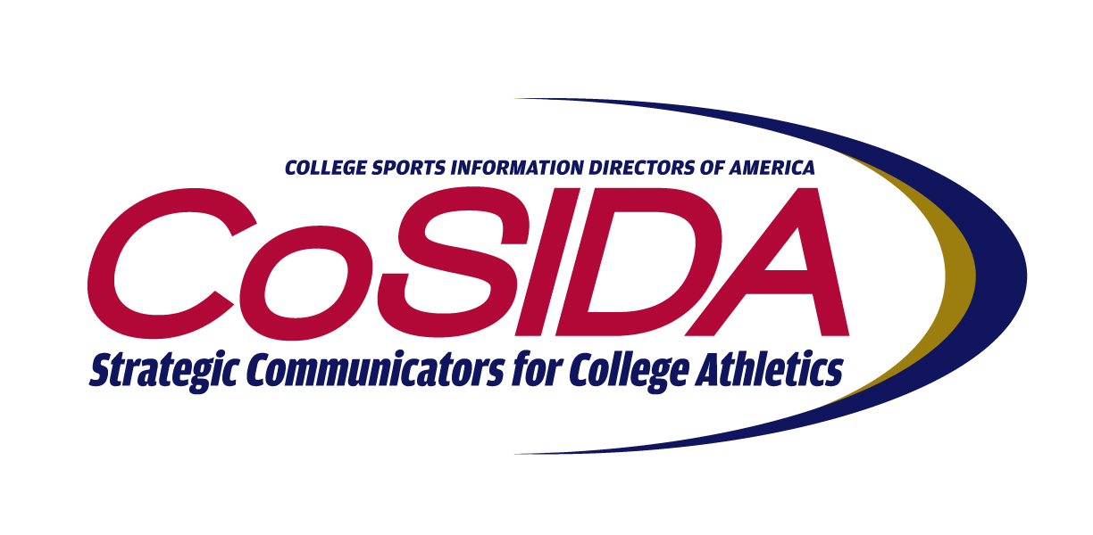
FINAL 2013-14 CoSIDA PUBLICATIONS CONTEST WINNERS

Baseball Guide/University (8 entries)
- Clemson University (Brian Hennessy)
- University of Oklahoma (Brendan Flynn, Kelsey Hargens)

Best Cover:
University of Oklahoma (Brendan Flynn, Kelsey Hargens)

Baseball Guide/College (11 entries)
- University of Central Missouri (Mike Knipper, Kim Lakner, Madison Llewellyn)
- Washburn University (Gene Cassell, Jeremy Wangler)
- Embry-Riddle Aeronautical University (Ryan Mosher, Michael Pierce, Alison Smalling)

Best Cover:
Lewis-Clark State College (Logan Fowler, Brian Adamowsky)

Men’s Basketball Guide/University (24 entries)
- University of Kansas (Alissa Bauer, Jackie Berra, Jeff Jacobsen)
- Clemson University (Philip Sikes)
- Kansas State University (Tom Gilbert, Ron Cook)
- West Virginia University (West Virginia University Sports Communications)

Best Cover:
University of Houston (Jeff Conrad, Houston Athletics Communications Office)

Men’s Basketball Guide/College (20 entries)
- Washburn University (Gene Cassell, Jeremy Wangler)
- Tarleton State University (Dameon Myres)
- Christopher Newport University (Kenny Kline, Francis Tommasino, Kate Newmeyer)
- Embry-Riddle Aeronautical University (Alison Smalling)

Best Cover:
Faulkner University (Ryan Bartels)

Women’s Basketball Guide/University (23 entries)
- Oral Roberts University (Rob Walden, Blake Freeland, Eric Scott)
- West Virginia University (West Virginia Sports Communications)
- University of Kansas (Zach Carnahan, Jackie Berra, Jeff Jacobsen)
- University of Kentucky (Susan Lax, Kim Troxall)

Best Cover:
McNeese State University (Pam Lafosse)

Women’s Basketball Guide/College (18 entries)
- Johnson County Community College (Tyler Cundith)
- Washburn University (Gene Cassell, Jeremy Wangler)
- Fort Hays State University (Andrew Sogn, Ryan Pickett)
- Tarleton State University (Nathan Bural)

Best Cover:
Nebraska Wesleyan University (Alex Linden, Jonah Bradley, Zach
Adams)

Basketball Programs/University (13 entries)
- University of Notre Dame (Bernadette Cafarelli, Tony Black)
- University of Alabama (Aaron Jordan, Brent Hollingsworth)
- University of Alabama (Aaron Jordan, Brent Hollingsworth)

Best Cover:
University of Notre Dame (Bernadette Cafarelli, Tony Black)

Basketball Programs/College (11 entries)
- Saint John’s University (Lori Gnahn, Ryan Klinkner, Tom Stock)
- Southwest Baptist University (Ty Declue, Jeff Weseloh)
- Dakota State University (Deb Pauley, Nick Huntimer)

Best Cover:
Saint John’s University (Lori Gnahn, Ryan Klinkner, Tom Stock)

Basketball Poster/University (14 entries)
- University of Kansas-Women (Kate Stoess, Jackie Berra, Jeff Jacobsen)
- Kansas State University-Men (Ron Cook, Tom Gilbert)
- Louisiana State University-Women (Krystal Bennett, Bill Martin, Chris Parent)

Conference Guides (3 entries)
- Big 12 Conference Men’s Basketball (Rob Carolla)

Best Cover:
Big 12 Conference Men’s Basketball (Rob Carolla)

Cross Country Guide/University (4 entries)
- University of Kansas (Brad Gilbert, Jackie Berra, Jeff Jacobsen)
- University of Notre Dame (John Heisler, Lauren Chval)

Best Cover:
University of Memphis (Brandon Kolditz, Brad Pope)

Cross Country Guide/College (6 entries)
- Johnson County Community College (Tyler Cundith)
- Embry-Riddle Aeronautical University (Ryan Mosher, Alison Smalling, Brianne Wigley)

Best Cover:
Nebraska Wesleyan University (Alex Linden, Jonah Bradley, Zach Adams)

Fall Posters (18 entries)
- St. John’s University-men’s soccer (Mekale Jackson, Timothy Brown)
- University of Kansas-cross country (Jackie Berra, Jeff Jacobson, Brad Gilbert)
- University of Kansas-women’s soccer (Jackie Berra, Jeff Jacobson, Brad Gilbert)
- University of Kentucky-soccer (Brent Ingram, Kim Troxall)

Football Guide/FBS (19 entries)
- Stanford University (Kurt Svoboda, Alan George, Sam Fisher)
- Florida State University (Kerwin Lonzo, Scott Moriak, Zach Stipe)
- Arizona State University (Jeremy Hawkes, Mark Brand, Thomas Lenneberg)
- University of Alabama (Josh Maxson, Jeff Puringon, Buddy Overstreet)

Best Cover:
Oklahoma State University (Gavin Lang, Kevin Klintworth, Jordan Smith)

Football Guide/FCS (5 entries)
- Wofford College (Brent Williamson)
- University of Tennessee at Chattanooga (Jay Blackman, Jim Horten, Anne Wehunt)

Best Cover:
McNeese State University (Matthew Bonnette)
Football Guide/College (17 entries)
- Washburn University (Gene Cassell, Jeremy Wangler)
- Tarleton State University (Dameon Myres)
- University of Central Missouri (Mike Knipper)

Best Cover:
Faulkner University (Ryan Bartels)

Football Game Programs/University (48 entries)
- University of Alabama (Rich Davi, Douglas Walker, Brent Hollingsworth)
- Clemson University (Tim Bourrett, Brian Hennessy)
- West Virginia University (WVU Sport Communications)
- Louisiana Tech University (Patrick T. Walsh)
- University of Kansas (D.J. Haurin, Katy Lonegran, Jeff Jacobsen)
- Louisiana State University (Bill Franques, Krystal Bennett, Chris Parent)
- North Dakota State University (Ryan Parrault)
- University of Notre Dame (Bernadette Cafarelli, Lizzie Mikes)
- University of Houston (Allison McClain, David Bassity)
- Marshall University (Steven Schoon, Marshall Sports Information)

Best Cover:
University of Alabama (Rich Davi, Douglas Walker, Brent
Hollingsworth)

Football Game Programs/College (16 entries)
- Saint John’s University-MN (Lori Gnahn, Ryan Klinkner, Tom Stock)
- Stevenson University (Jason Eichelberger, Sam Murray)
- Washburn University (Gene Cassell, Jeremy Wangler)

Best Cover:
Saint John’s University-MN (Lori Gnahn, Ryan Klinkner, Tom Stock)

Football Posters/University (6entries)
- Louisiana State University (Michael Bonnette, Hannah Brinks)
- West Virginia University (West Virginia Sports Communications)

Multi-Sport Guide/University (3 entries)
- Oklahoma State University-men’s and women’s cross country (Gavin Lang, Blake Zimmerman)

Best Cover:
Oklahoma State University-men’s and women’s cross country (Gavin Lang, Blake Zimmerman)

Multi-Sport Guide/College (8 entries)
- Northwest Mississippi Community College –baseball/softball (Kevin Maloney)
- Embry-Riddle Aeronautical University-men’s and women’s track (Brianne Wigley, Alison Smalling, Ryan Mosher)

Best Cover:
Rose-Hulman Institute of Technology (Kevin Lanke, Nicole Watkins)

Posters/College (40 entries)
- University of Alabama-Huntsville baseball (Joey Daniels
- Rogers State University soccer (Sara Williams, Randy Riggs, Steve Braun)
- Edgewood College basketball (Martha Burnett, John Maniaci, David Petroff
- Rogers State University baseball/softball (Sara Williams, Randy Riggs, Steve Braun)
- Rogers State University basketball (Sara Williams, Randy Riggs, Steve Braun)
- Fresno Pacific University men’s basketball (Brandon Tripp)
- Florida Institute of Technology football (Jonathan Hower)
- University of Houston-Victoria baseball (Paul Ebner, George Rodriguez)

Postseason Guide/University (9 entries)
- University of Houston (David Bassity, Michael McCrory, Roman Petrowski)
- Kansas State University (Kenny Lannou, Ron Cook)

Best Cover: University of Kansas (Alissa Bauer, Chris Theisen, Jackie Berra)
Postseason Guide/College (3 entries)
- Johnson County Community College (Tyler Cundith)

Best Cover:
Rose-Hulman Institute of Technology (Kevin Lanke, Nicole Watkins)

Single Sport Guide/University (6 entries)
- University of Notre Dame fencing (Lizzie Mikes, Cathy Scholz)
- University of Georgia equestrian (Jen Blackwell Gates)

Best Cover:
University of Memphis rifle (Brandon Kolditz, Jared Brown)

Single Sport Guide/College (1 entries)
- Northwest Mississippi Community College - soccer (Kevin Maloney

Best Cover:
Northwest Mississippi Community College - soccer (Kevin Maloney)

Single Sport Programs/University (5 entries)
- University of Wisconsin Volleyball vs. Ohio State (Diane Nordstrom, Doreen Dower)
- University of Wisconsin Volleyball vs. Iowa (Diane Nordstrom, Doreen Dower)
Best Cover:
Union College Hockey (Daniel Jankowski)

Men’s Soccer Guide/University (5 entries)
- University of Notre Dame (Sean Carroll)
- UNLV (Mark Wasik, Paul Palmer)

Best Cover:
University of Memphis (Brandon Kolditz, Alex Hubbard, Brad Pope)

Men’s Soccer Guide/College (13 entries)
- Johnson County Community College (Tyler Cundith)
- Ohio Wesleyan University (Mark Beckenbach, Doug Thompson)
- Embry-Riddle Aeronautical University (Alison Smalling)

Best Cover:
Christopher Newport University (Kenny Kline, Rob Silsbee)

Women’s Soccer Guide/University (13 entries)
- University of Kansas (Brad Gilbert, Jackie Berra, Jeff Jacobsen)
- University of Notre Dame (Chris Masters, Cathy Scholz)
- University of Alabama (Aaron Jordan, Erin Hill)

Best Cover:
Louisiana Tech University (Kane McGuire)

Women’s Soccer Guide/College (14 entries)
- Johnson County Community College (Tyler Cundith)
- Washburn University (Gene Cassell, Jeremy Wangler)
- Christopher Newport University (Kenny Kline, Rob Silsbee)

Best Cover:
Faulkner University (Ryan Bartels)

Softball Guides/University (7 entries)
- Missouri State University (Tim Bohn)
- University of Oklahoma (Karl Anderson, Kelsey Hargens)

Best Cover:
- University of Oklahoma (Karl Anderson, Kelsey Hargens)

Softball Guides/University (9 entries)
- Johnson County Community College (Tyler Cundith)
- Tarleton State University (Nathan Bural)

Best Cover:
Faulkner University (Ryan Bartels)

Special Events/University (8 entries)
- University of Notre Dame-men’s soccer championship commemorative (Sean Carol, John Heisler, Karen Heisler)
- Kansas State University-football yearbook (Tom Gilbert, Ryan Lackey, Ron Cook

Best Cover:
University of Notre Dame-men’s soccer championship (Sean Carol, John Heisler, Karen Heisler)

Special Events/College (13 entries)
- Johnson County Community College-NJCAA basketball program (Tyler Cundith)
- University of Dubuque-Football information guide (Paul Misner)
- Calvin College-volleyball national champions (Jeff Febus, Gary Lepsch)

Best Cover: University of Dubuque-football information guide (Paul Misner)

Spring At-Large Guide/University (15 entries)
- University of Kansas-track (Brad Gilbert, Jackie Berra, Jeff Jacobsen)
- Hofstra University-men’s lacrosse (Len Skoros, Stephen Gorchov, Jim Sheehan)
- University of Alabama-women’s golf (Josh Maxson, Erin Hill)

Best Cover: University of Memphis-golf (Brandon Kolditz, Trevor Kuss)

Spring At-Large Guide/College (8 entries)
- Embry-Riddle Aeronautical University-tennis (Alison Smalling)
- Johnson County Community College-golf (Tyler Cundith)

Best Cover: Embry-Riddle Aeronautical University-tennis (Alison Smalling)

Volleyball Guide/University (14 entries)
- University of Kansas (Alissa Bauer, Jackie Berra, Jeff Jacobsen)
- Michigan State University (Jamie Weir Baldwin)
- University of Georgia (Jen Blackwell Galas)

Best Cover: University of Alabama (Rich Davi, Erin Hill)

Volleyball Guide/College (21 entries)
- Christopher Newport University (Kenny Kline)
- Johnson County Community College (Tyler Cundith)
- Fort Hays State University (Ryan Pickett, Andrew Sogn)
- Washburn University (Gene Cassell, Jeremy Wangler)

Best Cover:
Tarleton State University (Nathan Bural)

Winter At-Large Guides/University (10 entries)
- Union College (N.Y.)-men’s hockey (Jeffrey Weinstein, Kristopher Nolt)
- University of Kansas-women’s swimming (Tabetha Bender, D.J. Haurin, Jeff Jacobson)
- University of Oklahoma-women’s gymnastics (Makayla Hipke, Kelsey Hargens, Jared Thompson)

Best Cover:
University of Tennessee-Chattanooga-men’s wrestling
(Jay Blackman, Jim Horten, Anne Wehunt)

Winter At-Large Guide/College (7 entries)
- Allegheny College-men’s and women’s swim & dive (Bryan Montgomery)
- University of Central Missouri-men’ wrestling (Mike Knipper, Madison Llewellyn, Kim Lakner

Best Cover:
University of Central Missouri-men’s wrestling (Mike Knipper, Madison Llewellyn, Kim Lakner)

Winter – Spring Posters/University (47 entries)
- University of Oklahoma-men’s gymnastics (Scott Matthews)
- Kansas State University-baseball (Ron Cook, Randy Peterson, Ricardo Cruz)
- University of Oklahoma-softball (Scott Matthews)
- Kansas State University--rowing (Ron Cook, Chris Kutz)
- University of Oklahoma-baseball (Kelsey Hargens)
- University of Kentucky-rifle (Cailyn Huston, Will Kindred, Chet White)
- University of Oklahoma-women’s gymnastics (Kelsey Hargens)
- West Virginia University-baseball (West Virginia University Sports Communications)

