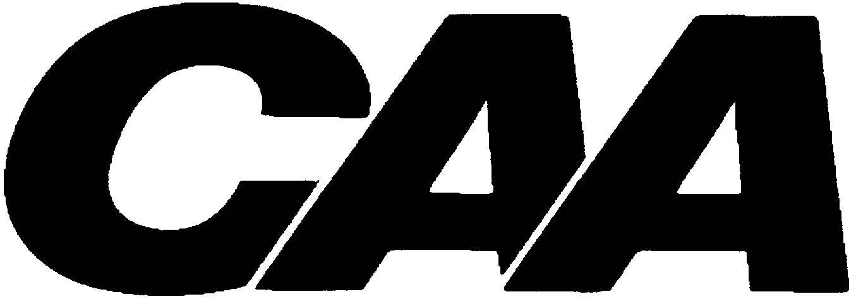

WAIVER OF PROGRESS TOWARD DEGREE RULE

OLYMPIC GAMES

1. NAME: | SPORT:
2. INSTITUTION:
3. ACADEMIC YEAR / TERM(s) IN WHICH ABSENCE OCCURRED:
- ATTACH APPROPRIATE DOCUMENTATION:
(e.g., Letter from National Governing Body)

NCAA Bylaw 14.4.3.8 Olympic Games

The Division I Progress-Toward-Degree Waivers Committee may waive this general progress- toward-degree requirement for any participant in the Olympic Games who, because of such participation, may lose eligibility for practice and competition in any sport.

Signature of Athletics Director or Designee
Date

Please submit this form and documentation from the national governing body to
Donna Jones at the CAA.
Email: djones@caasports.com or Fax: 804.754.1973

