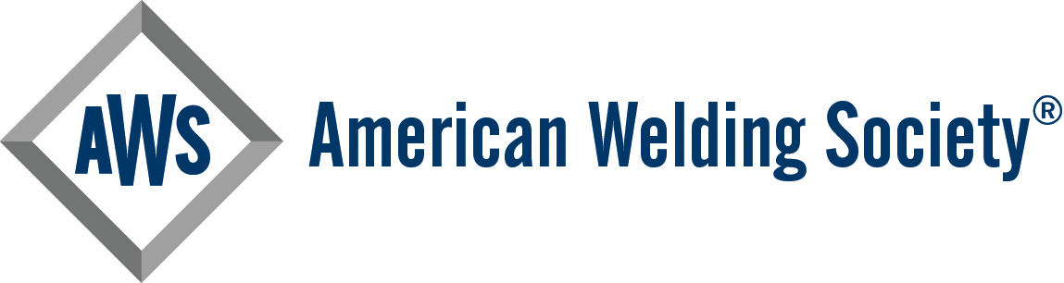
2026 AWS Section Annual Report - Part I (Secretary's Report) Worksheet

🚨DUE JULY 1, 2026

This is Part I of the Annual Report that Sections are required to fill out in order to remain active and receive their Section funds. Part I of the 2025-2026 AWS Section Annual Report will take approximately 15 minutes to complete. We strongly recommend completing the form in a single sitting for a smooth and uninterrupted submission process.

A 25% penalty will be applied to your Section's Annual Rebate if your Section's Annual Report is received after July 1, 2026 but before September 15, 2026. A 75% penalty will be applied if your Annual Report is received after September 15, 2026 but before December 15, 2026. Reports received after December 15, 2026 will be accepted for documentation purposes but the Section Rebate and Anniversary Payment will not be issued.

Part II (Treasurer’s Report) will be emailed to all active Section Treasurers in early June.

SAVE AS DRAFT OPTION
If you're unable to complete the form in one session, you may use the "Save as Draft" feature to save your progress and return later. After clicking "Save as Draft," a unique link will be generated. This link is required to access your draft.
- Important: A new link is created each time you click "Save as Draft" after making changes.
- Be sure to save the new link each time you save your draft to avoid losing progress.
- We recommend emailing the draft link to yourself with the subject line "Secretary’s Report Link" for easy access when it is needed.

USE OF THE SECRETARY’S REPORT WORKSHEET
If you prefer to compile the details required to complete the report offline, you can use this document.
- Download and Save the file to your device before editing.
**Do not attempt to fill out the worksheet in your browser.
- Use the worksheet to collect all necessary information in one place.
- Once complete, return to the online form to transcribe your responses and submit the report.

➡️Note: The worksheet is for your convenience only. Completed worksheets will not be accepted as official submissions. All Sections must submit Part I using the online form.

If you have any questions, please contact annualreport@aws.org

Name
Full Name of Person Completing the Report

Are you an AWS Member?

Please enter your AWS Member Number

Role of person completing this report
Please indicate your Section role at the time of this report. If you occupy multiple positions, please select the highest-ranking role.
Email Address
Please enter the email address of the person completing this report.

AWS District
To which District does your Section belong?

AWS Section
Which Section are you reporting for?

Designated Point of Contact - Name
All Section Officers and Committee Chairpersons will receive the AWS Section News newsletter and other correspondence intended for all Section leaders. There will be times when AWS World Headquarters (AWS WHQ) needs to contact someone to relay important information, connect a member seeking to become involved to check in on Section activity, and/or offer to provide support.
Please provide the name of the one (1) person to serve as the primary point of contact for this type of communication.

Designated Point of Contact - Member #
All Section Officers and Committee Chairpersons will receive the AWS Section News newsletter and other correspondence intended for all Section leaders. There will be times when AWS World Headquarters (AWS WHQ) needs to contact someone to relay important information, connect a member seeking to become involved to check in on Section activity, and/or offer to provide support.
Please provide the AWS Member # of the one (1) person to serve as the primary point of contact for this type of communication.

Does your Section utilize a dedicated email address to receive email from members?

If yes, what is the email address?
Section Activity - Beginning Month
Please select the month that your Section's activity typically begins for the year.

Section Activity - Ending Month
Please select the month that your Section's activity typically ends for the year.

How many meetings did your Section complete during the 2025-2026 Section season?
Please list the date, topic, speaker, location, and approximate attendance of the meetings you conducted during the 2025-2026 Section year.
Please list each meeting's details beginning with a number.
For example:
1. September 1, 2025; General Section Meeting; No Speaker; Zoom; 15 in attendance
2. October 14, 2025; Technical Talk; Ellen Ochoa and Michael Coats; Johnson Space Center; 63 in attendance
3. February 20, 2026; Annual Welding Competition; 100 in attendance (75 in person, 25 online)
If you did not host any meetings during the 2025-2025 year, please reply "N/A".
Maximum of 2000 characters

Did your Section host any "signature" events during the 2025-2026 year?
What do we consider a "signature" event?
A signature event is an event that is conducted regularly and well known by people (members and non-members alike) in the area. The AWS Central Arkansas Section's Annual Thomas B. Schueck Memorial Benefit Bass Tournament, AWS Detroit Section's Sheet Metal Welding Conference, and AWS Northern Plains Section's Behind the Mask Welding Competition are a few examples of signature Section events.

If yes, please type the name(s) of the event(s).

Is your Section planning to sponsor a member to attend FABTECH?
**FABTECH will take place in Las Vegas, NV from October 21 - 23, 2026.

The Section Sponsor is the individual selected by the Section to cover all or some of the expenses associated with a member attending FABTECH. This could be a combination of travel (airfare or mileage reimbursement), lodging, conference registration, meals, or other related expenses.

Has your Section completed the process of electing/appointing leaders for the 2026-2027 Section season?
*Note: The 2026-2027 Section season will begin June 1, 2026, and run through May 31, 2027.

If yes, please indicate which members will serve in which roles. The Secretary’s report form will require a Member # for each member.

Does the Section acknowledge any additional roles beyond those specified above, with a member assuming leadership responsibilities?
If yes, please note which role(s) and who will be serving in the role(s).

Does your Section Host a Section Library?
An AWS Section Library is comprised of publications, and possibly other resources, that a Section has been granted by AWS WHQ, purchased on its own, or gained through some other source. A Section's Library is intended to serve as a member benefit, enhancing the value of your Section to the members it serves. As such, we want to ensure we have the correct information on file so members who seek information about their Section's Library are able to locate it.
YES/NO
If yes, what is the library address and librarian name?

Successes
What successes has your Section experienced during the most recent season of activity (June 1, 2025 through May 31, 2026)?
Maximum of 2000 characters

Challenges
What challenges have prevented your Section from effectively engaging members during the most recent season of activity (June 1, 2025 through May 31, 2026)?
Maximum of 2000 characters

What additional support would be valuable to your Section Leaders?
Currently, we offer:
- Monthly Section Solutions Conversations
- Monthly Section Leader Newsletter
- Digital Marketing Kit for Sections
- AWS Speakers Directory
- AWS Merchandise Shop

Feedback
Please feel free to share any additional feedback that you wish for AWS WHQ and/or your District Director to consider.
Maximum of 2000 characters

