TEACHING HIRING FOR COLLABORATION IN URBAN SCHOOLS:
Team Task Interviews for STEM Teacher Candidates
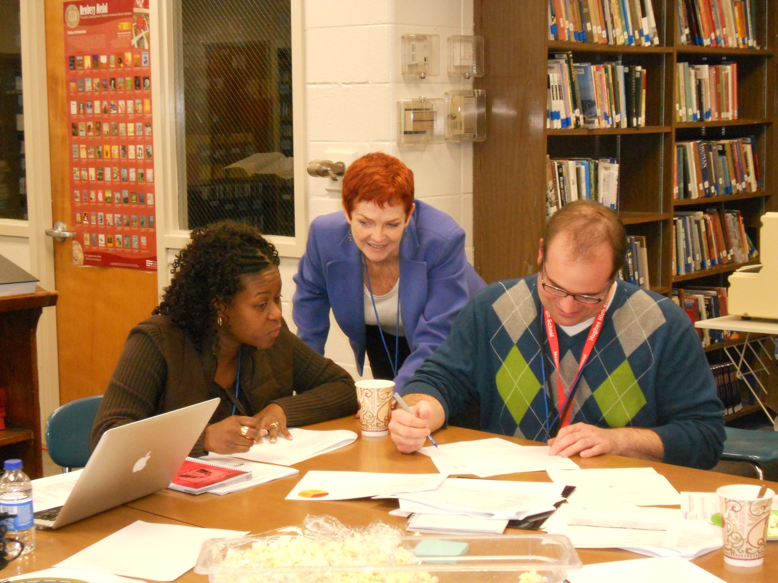
Virginia L. Rhodes, Ed.D.

ABSTRACT
Creative professionals in team-based work settings value work communications skills among their colleagues. As public schools create professional learning communities and experiment with teacher-led curriculum and program development, traditional interview processes may prove inadequate for these new collaborative environments. New and creative selection models may be needed to enable teacher or other professional teams to choose candidates with the 21st century skills needed for success. In public sector environments, work rules are often highly developed and professionals are entitled to interview. Qualifications, training, experience and seniority as determinants often get reduced to transfer rights using seniority as the main or only criteria. This trend detracts from creating a competitive environment in which to attract & retain a high-quality teaching staff. Solutions can be found within existing contract parameters, however, if the attributes necessary to teach 21st Century skills are actually required to be demonstrated, not just described, in the interview process.

INTRODUCTION
How does an innovative work team hire the right person for an opening? The new Hughes STEM High School in Cincinnati had to fill over a dozen new teacher positions to prepare for their opening in the fall of 2009. Teachers on the selection committee planned thoughtfully to choose the right questions, yet they knew what all interviewers understand by instinct: First, anyone can say anything in an interview. Secondly, the skills of responding to interview questions, however creative they might be, can sometimes be quite different than those needed to do the job well. The team task interviews were the result of a problem-solving process designed to produce a faculty for the new school whose communications skills were consistent with STEM and 21st Century learning models.
The STEM high school project was an outgrowth of a powerful local university-business-school district partnership and the Ohio STEM Learning Network, with support of Ohio Governor Ted Strickland and his administration. By design, it was to be innovative, aimed at developing and modeling 21st century learning skills. The vision of the planning team and principal? A non-selective public high school that offered an academically elite learning environment while developing a collaborative, supportive culture.
The district, Cincinnati Public Schools, and the AFT-affiliated teacher union (CFT) had a history of collaborative projects, including peer review and mutual support for strong teacher-leadership development. The lead teacher model enabled talented classroom teachers to choose paths other than administration to offer effective school leadership.
In August, four lead teachers were selected to plan the new school. As the fall progressed, curriculum and instructional design dialogues led to a choice to use project-based learning, with an interdisciplinary focus. Team planning and co-teaching was a must in this design.
The planning team’s duties also involved hiring the principal as part of a selection committee including parents and community representatives. Those principal interviews were focused on finding an administrator with a collaborative viewpoint and practice and who was open to teacher leadership and shared governance.
The group then served as the teacher selection panel during the spring of 2009, along with the new principal, who was assigned to join the group in June due to her previous assignment. This unanticipated development meant that the teacher planning group continued under its own internal, and by now, very collectivized leadership.
The planning group was passionate about their mission, and about identifying teacher-colleagues that would understand and embrace the new collegial, collaborative model.

TEACHER RECRUITMENT
In teacher recruitment sessions in March of 2009, the planning team described this approach, and made it clear that teaching in the STEM school would be very challenging. In a deliberate effort to break out of traditional teacher isolation, candidates were warned that this was not a school in which a teacher could choose to shut the classroom door and “do their own thing,” their own way. Classrooms would be a “fishbowl” environment, with university professors, grad students, and undergrads strolling through the classrooms, observing through glass and electronically, via STEM-cams and distance learning through the HUB Fusion Center, another important element of the OSLN design and the STEM partnership. In a model more familiar to medical professionals than teachers, a clinical setting was envisioned, with analysis and dialogue occurring across pre-service, novice, and veteran teachers.
Other warnings were shared with prospective applicants: Teachers would all be on a challenging learning curve, as the program involved technology integration directly into every course, and the physical facility would be highly uncomfortable the first year, as the school would be crammed into “swing space” while a district-led renovation project completed their permanent space. Every teacher would also be expected to participate in the SEL (social-emotional learning) component of the program through an advisory group.

Over 65 prospective teachers attended the teacher recruitment session in March of 2009, including many district colleagues from other high schools, from six other local districts, and some pre-service prospects. Laying out this collaborative vision to their colleagues was energizing to the group, but the real test was designing an interview process that would enable teachers with a high level of teamwork-related skills to have their assets revealed and recognized.

Discussions of interview questions were intense, and the conversation turned to a challenge: could the group find a way to have the candidates actually demonstrate their teamwork skills instead of just talking about them? Jamie Beirne, in the role of rotating chairman of the group, produced a document designed to capture responses to a host of carefully crafted questions. Key issues explored included understanding of STEM/21st Century learning skills, technology, commitment, comfort level with the clinical environment, interdisciplinary planning skills, disciplinary knowledge, project-based learning modes, teamwork, and strategies for working with students with special needs.

TEAM TASK GUIDELINES

“You have 15 minutes to design an Intersession (a 1-week non-graded alternate course). It must be interdisciplinary, active, and high interest. You have a budget of $500 for 20 students. Students will not be in regular classes during this week, and you do not have to be on campus. It must serve STEM goals, can be graded or non-graded, and has to be a project that 2 teachers could actually plan and execute together while teaching a full load in the weeks previous to the Intersession.

Candidates were usually performing this task with a candidate that was not competing for the same subject position, i.e., we paired a science teacher with a social studies teacher. This was designed to reduce raw competitiveness behaviors and increase the selection committee’s ability to see cross-curricular skills.

The selection committee observed and took notes:
How did the candidate:
Establish eye contact, introduce self, and begin a friendly rapport?
Offer ideas—and did those ideas fit the guidelines of the task?
Respond to ideas of the other candidate in an exploratory and supportive way?
Redirect if the idea was clearly not fitting the guidelines?
Extend one another’s ideas? Take risks in the conversation?
Caveats. Disclosures at the beginning of the interview included a description of a “fishbowl” or open environment, where teachers would be expected to co-plan, co-teach, and would regularly experience college professors and business partners trooping through with their colleagues, visitors, or undergrads in tow. Teachers would need to be able to discuss and engage with these partners as they analyze their lessons and be comfortable doing so. After construction, the Fusion Lab would provide a high-tech space where teachers would be able to broadcast demo lessons for observation through glass and for a distance learning audience. All staff were expected to function directly as advisors for students as part of the SEL curriculum. (SEL: social-emotional learning, including individual and leadership development and community and team-building among students.)

Disclosure. The team task process was described to the candidates as they arrived for the interviews. This was done deliberately to minimize prior over-preparation.
Candidate reaction: when the team task process was described briefly, this news invariably produced the immediate, nervous, and full attention of the candidate. Most candidates put their “game face” back on right away, signaling flexibility and adaptability to the selection committee. This created a “fishbowl” environment meant to simulate the high-scrutiny teaching environment planned for STEM teaching.

To reduce nervousness and discomfort, the committee engaged in positive greeting behaviors as the team task overlap began. Candidates were praised and reinforced for being willing to engage in this atypical process before they began, after they completed the task, and again as they completed the whole interview before exiting. This visibly provided some relief of pressure and tension, and seemed very appreciated by the candidates, as the challenge of this task and the pressure it produced was acknowledged.

Notes were taken in a two-column method that documented both process and content. Following is a composite set of notes for one team task session:

Smith Jones

Smile, jokes, repeats his name,
Acknowledges hers returns warmth, big smile
Got any ideas?
Trip to local company’s lab How about (names partner company)?
Nods, suggests pre-visit for content agrees, encourages, extends
2 content ideas extends 1 idea w/grouping details
focuses on one, specifies goal how to prep?
Prep ideas for pre-trip research adds another key question to prep idea
Suggests lab content how to structure/schedule the week?
Suggests schedule question about student teams
Assessment idea extends w/detail about tone

After about 20 minutes, the pair is asked to begin wrapping it up by providing a name for their project.

Candidate participation. There were significant variations in the behaviors and responses of the pairs. As the selection committee discussed later that day, individuals earned “points” (informally in the interviewers’ assessments, not a formal point system) in at least five different ways. Examples from the candidates’ dialogue are given for each:

- Idea generation (for content, activities, goals, or assessment)
“What if we tour several colleges, and use our core value of curiosity as the unifying theme?”
- Extension or details of ideas generated by the other candidate
“If we did that, we could link it to the energy project for 3rd quarter.”
- Questioning or commenting to clarify or probe for details or purpose
“What partner might be able to help us on that?”
- Supportive or non-supportive verbal and non-verbal “signaling,” to advance or deter the direction of the discussion
- “We wouldn’t be able to do that on the $500 budget, would we?”
- Synthesis: structuring or ordering elements of plan from either or both candidates
“That means we could do the first two days on campus preparing for the interviews at the lab, the next two at the lab, then debriefing and presentations for the last day.”

There were varying patterns to the engagement of the two candidates, from the most successful to the least, in which neither or both made a very positive impression on the selection committee:

- Some were immediately congenial and signaled receptivity to the others’ ideas with nodding and other supportive gestures or responses; these pairs tended to put across an encouraging tone to the partner, excited and positive. They were respectful but energetic; they seemed be fully aware that they had a short time together and had to be efficient in their conversation, moving from general ideas to selecting one key idea, then structuring a workable plan around that idea. Both candidates generated original ideas and responded to those of their partner. In these pairs, both exhibited listening skills and showed respect for their partner. These pairs tended to be surprised when “time” was called—they were deeply involved in their thinking about their plans, and most were easily able to name the project in less than a minute, often with creative titles. They managed their time well, carefully gauging “brainstorming” time and saving time to plan and structure in a practical way.
- In some pairs, both candidates generated ideas and responded to each other, but they failed collectively to synthesize their ideas. In these groups, there was some difficulty in choosing between competing ideas or committing far enough to rule any one idea in or out for practicality. This tended to produce a circular conversation, in which proposals kept coming back, but no structure or plan was possible and there was little direction at the end, or conversely, a direction was chosen by the end, but there was no plan to execute it.
- In some pairs, one candidate exhibited more creativity in generating content ideas, but the other was more skilled in extending, responding, and using the ideas to shape a plan. These pairs did well, though each candidate earned “points” in very different ways.
- Some pairs had one or both candidates that exhibited less than ideal listening skills. One might wait politely while the other spoke, then shared an idea that had nothing to do with what the other candidate had suggested. Candidates who generated original ideas, but failed to acknowledge and respond to those of their partner were not considered successful by the interviewers.
- Some pairs had widely divergent skills, in which one candidate both generated ideas and responded well, while the other candidate seemed lost and unable to do either. In these, the strong candidate clearly had to decide how to “manage” a weak partner. Some used encouragement and strategies that linked to a stronger idea; some signaled that the idea was impractical or not consistent with the goal, or suggested a different direction. Some compromised and sought common ground, giving way to a weaker idea, but trying to find ways to make it work. The committee found this to be interesting, as most had extensive teaming experience, including occasionally with teaching team members deficient in content or communications skills. The stronger candidate was given significant credit by the interviewers for their attempts and skill at leading the partner. In a few cases, committee members could detect concern by the stronger partner; our interpretation was that the stronger candidate was worried that the poor performance of their partner would affect the committee’s view of them. It was not difficult, however, to differentiate the skills individually and give credit where credit was due.
- In a few pairs, one partner seemed willing to make the other carry the workload without much contribution. “Mm-hmmm,” or polite nodding was followed with little or no reciprocal response and in some cases seemed disingenuous with friendly rapport but no substance. These partners did not impress the interviewers, were not viewed as skilled in teamwork, and clearly lost ground in the competitive process.
- Finally, in a few pairs, neither partner was able to generate ideas or get the other person to do so. These interviews were painful to watch, as the time dragged on while the candidates were clearly struggling with what to say to each other. A weak idea or set of them might have emerged by the end, but they had difficulty naming the project, as their goals, strategies or both were clearly undefined or not understood in common.

Results. The T2 interview process was the result of a problem-solving dialogue in which the four STEM planning committee teachers and the incoming principal sought a way to test for the elements of “21st Century” learning skills that would have to be fully understood, modeled and taught by the initial faculty being hired to open the school.

The team task portion of the interviews, while viewed initially as experimental, was confirmed as a more and more valuable element after each pair. Overall, candidates were clearly on a continuum of communications skills, easily shown by the challenge of the team task. Some candidates who did well in the traditional questioning portion were not strong on the team task; this altered the committee’s view of their total value as a candidate. The same was true in reverse; some candidates whose individual questioning portion did not put them at the top of the list, were able to shift their position on that list by showing exceptional communications and teamwork skills.

Only one group was completely unable to title the project. The titling question, while simple, became an important basic litmus test of the pair’s ability to bring a task to conclusion. Secondarily, it revealed marketing skills, as pairs were conscious of the fact that students would be choosing which Intersession projects to participate in, and an active, creative, or exciting title could help recruit students to join in.

Post-interview response of candidates. Nearly all candidates expressed visible relief after the task was finished. Most commented in a positive way about the level of challenge of the task. Some candidates expressed exhilaration or other positive orientations verbally and physically to the committee; there were smiles, and “wow!” statements, including extended positive comments as they were walked out of the room. In conversations with the principal later on the phone as a position was being offered, or in some cases not offered, additional comments were shared. These included the following ideas:

- Increased understanding of how important teamwork is to the STEM concept.
- Observation that the challenge of the team task might be predictive of the challenge of being on the STEM faculty in a non-selective high school.
- Perception that being a STEM teacher would be a very different daily experience than being a teacher in more traditional, teacher-isolated models.
- Contrast of co-planning, co-designing with traditional lesson planning.
- Appreciation for the level of energy required to co-plan.
- Acknowledgement of collegial peer expectations as a member of STEM faculty.

Conclusion:

Hughes STEM High School in Cincinnati has successfully developed and used a unique collaborative hiring process that resulted in greater student success. By building a culture of teamwork, excitement, and mutual faculty support, Hughes student benefit, and new or transfer teachers coming into Hughes are able to understand and contribute to that culture towards further organizational growth.

Author notes: (Follow-up & related ideas)

- Teacher-leadership
- Teacher-Led schools (check out CTQ Collaboratory for first such conference, Nov. 6-7 in Minneapolis
2. Behavioral interviews
3. Organizational development literature (Gavris, et al)
4. Interviews as PD. (theory: mode of interview sends signals both ways: candidates “read” the committee and the institution it represents while the committee “reads” them for comfort level & suitability.)
5. Interviews as induction—key topic 5 years later!
6. Other examples of this type of interview; might find some models in engineering, where candidates are given materials to construct something, either together or in groups or teams. Another: Interviews with individual performance tests or tasks, such as a demonstration lesson, or meeting with student, community, staff, or partner groupings.
7. Role of unions or associations. In public sector environments, work rules are often highly developed and professionals interview peers. Seniority and transfer rights and other legal protections can constrict the ability of teacher-leaders to initiate a successful teacher-led school if interpreted too narrowly. How can dynamic teacher union leaders and collaborative administrators work together in hiring to elevate the dialogue and expectations of program and instructional quality?

**********************************************
This article was initially written in 2010 and is periodically revisited/edited.

Dr. Rhodes consults at RENEGADE LEARNING renegadelearning.com
She can be reached at 513-207-2566, or by email at vrhodes@cinci.rr.com.
Rhodes welcomes feedback , discussion & questions.

