The Crypto Layers
A working standard for the crypto stack
by Aviran Vargas
Crypto is a stack. Layers built on top of layers, each one doing a different job, each one capable of failing in its own way. The word "cryptocurrency" got slapped on the whole thing somewhere along the way, and it does not fit. Currency is one slice of what is happening here, mostly at the upper layers. Layer 1, the physical layer, has very little to do with currency. It is power contracts, cooling systems, and industrial hardware. Forensic tracing on Layer 2 is closer to investigative work than to money. Smart contracts on Layer 4 do many things that have nothing to do with payments. The accurate term is just crypto. The pieces inside it are sometimes currency and sometimes not. This article uses "crypto" as the umbrella and reserves "cryptocurrency" for the parts of the stack where money is actually changing hands.
The industry is now worth trillions of dollars. It touches energy markets, banking, software development, art, gambling, and politics. It has produced overnight millionaires and overnight bankruptcies. It has been declared dead by serious news outlets more times than anyone can count, and it keeps coming back. None of that makes sense if you treat crypto as one big thing. It only makes sense once you can see the layers.
When you read a headline about a hack, a bankruptcy, a sanction, a wallet getting drained, or a miner shutting down because of the heat, those are all different layers in trouble. The faster you can spot the layer, the faster the news makes sense. And the faster you can decide whether the story actually affects you, your money, or just a corner of the industry you do not need to care about.
This guide walks through the foundation of Bitcoin, then through all five layers, with real examples for each one. The goal is not to make you a crypto expert in twenty minutes. The goal is to give you a frame that will make every crypto headline you read for the rest of your life easier to understand.

Why I Am Writing This
In 1984, a working group of computer scientists and engineers published the OSI model. Seven layers. Physical, data link, network, transport, session, presentation, application. Before that model existed, networking was a mess. Every vendor had its own stack. IBM did things one way, DEC another, Xerox another. Engineers could not talk to each other without translating, and systems could not talk to each other without expensive middleware. The OSI group sat down, looked at what was actually happening on the wire, and gave it names. They drew lines. They argued. They published. The model was not perfect (TCP/IP eventually won the actual implementation war), but the layers stuck, and forty years later every networking textbook on earth still teaches them. The mess got organized.
Crypto needs the same exercise. Right now, the terminology is a wreck. The phrase "Layer 2" alone gets used in two distinct ways: as a scaling solution built on top of a base chain (Lightning, Arbitrum, Optimism), and as the second tier in any custom framework someone proposes (including this one). "Wallet" means a piece of software, a hardware device, an exchange account, or a piece of paper depending on the sentence. "Mining" gets confused with "validating," which gets confused with "running a node." Reporters mix up exchanges and custodians. Lawmakers conflate Bitcoin and altcoins. Lawyers cite the wrong layer in court filings. Investors lose money because they thought a stablecoin was a savings account. The industry has grown to trillions of dollars and we still cannot agree on what to call the basic pieces.
This article is my attempt to fix a small piece of that. Five layers. Foundation underneath. Every concept I could find, sorted into the layer where it actually lives, with the failure modes and the headlines pinned to the right place. I have been operating mining infrastructure for years and serving as an expert witness in court cases that turn on exactly these distinctions. I see the cost of the disorganization every day. I am writing this because somebody has to start the conversation.
This is not a bible. It is a draft. If you think a topic belongs in a different layer, tell me. If you think a layer is missing, tell me. If you think Layer 5 should be split, or Layer 4 should be folded into Layer 2, or the foundation should have four pieces instead of three, tell me. Argue with it. Mark it up. Send me a counter-proposal. The whole point is that this work has to be done by the people who actually do the work, and that is us. Operators, developers, lawyers, investigators, traders, regulators, miners. The beauty of crypto is that it was built by men and women like you and me, and the categorization will be too. So let us get on with it.

The Three Things Behind Bitcoin
Strip Bitcoin down to its essentials and you find three things working together: the blockchain node, the wallet, and the ASIC. Most articles about crypto skip past these basics in two sentences. That is part of why people stay confused. Take a few minutes here. Everything else builds on these three pieces.
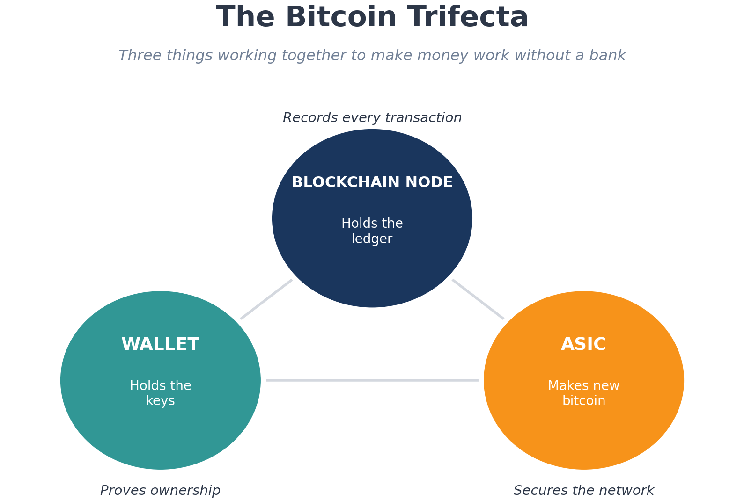
Figure 1. The Bitcoin Trifecta. Pull any one out and the system stops working.

The Blockchain Node
Every node on the network holds a copy of the blockchain, the public record of every transaction, ever. Imagine a notebook that lists every payment that has ever been made in the system. Every page of the notebook gets filled with new transactions, sealed shut, and linked to the previous page. That is the chain part of "blockchain." Each new page (called a block) is permanently connected to the page before it, all the way back to the first one.
Now imagine that notebook does not live in one place. It lives on thousands of computers around the world at the same time. Each one of those computers is called a node. A node, at the most basic level, is a regular computer with a very large hard drive. It does not need to be fancy. It needs storage (the full Bitcoin blockchain is over six hundred gigabytes today and growing), a working internet connection, and the willingness to stay online. Anyone can run one. They all hold a copy of the blockchain, and they all agree on what the next page says before it gets sealed. If one node tries to write something different, the others reject it. Because the node is a physical machine sitting somewhere, it shows up again at Layer 1 below, alongside the ASICs and the data centers.
That agreement, the part where thousands of nodes reach the same answer without anyone in charge, is the part that took thirty years of computer science to figure out. It is what makes the system trustworthy without a bank in the middle. There is no Citi, no Chase, no Federal Reserve sitting between you and your money. The math and the network do that job.
When someone sends bitcoin from one wallet to another, the transaction goes out to the network, gets picked up by mining computers, gets bundled into a block, the block gets sealed, and the transaction becomes part of the permanent record. Anyone in the world can look it up.

The Wallet
The wallet holds the keys. This is the part that confuses people the most. The coins do not actually live in the wallet. The coins live on the blockchain. The wallet stores the secret code (called a private key) that proves you own them.
Think of the blockchain as a giant safety deposit box company where every box is on display behind a glass wall. Anyone can see the box and the cash inside. But you can only open your box with your specific key. Lose the key, lose the cash. There is no clerk to ask for a replacement.
That is what makes crypto wallets different from bank accounts. A bank account is a number on a server somewhere, and the bank can reset your password, freeze your account, or recover your funds if something goes wrong. A crypto wallet is just keys. If you lose the key, the coins do not go away. They sit on the blockchain forever, untouchable, because no one alive has the key to move them.
People keep their wallet keys in different places depending on how much they care about security. A phone app like Coinbase Wallet or MetaMask is convenient, but it is connected to the internet, which means it can be hacked. A hardware wallet (Ledger and Trezor are the two best-known brands) is a small device that looks like a USB drive and keeps the keys offline. The most paranoid people write the keys down on paper or stamp them into metal plates and lock them in safes or safety deposit boxes. Multi-signature wallets require more than one key to authorize a transaction, the digital version of two-key military protocols.
When a wallet gets hacked, the keys got out. When someone "loses" their crypto, they almost always lost the keys. There are stories of people who threw out hard drives with thousands of bitcoin on them, who forgot the password to wallets they made years ago, who died without telling anyone where their keys were stored. Those coins are gone. Estimates suggest several million bitcoin, worth hundreds of billions of dollars, may be permanently locked out because the keys are lost.

The ASIC
The ASIC is the machine that makes new bitcoin. ASIC stands for Application-Specific Integrated Circuit, which is a long way of saying a computer chip built to do one thing only. An ASIC cannot run Microsoft Word. It cannot browse the web. All it does is calculate, billions of times per second, trying to solve a math puzzle.
The puzzle is set up so that the only way to solve it is to guess. The computer that guesses correctly first earns the right to seal the next block of transactions and gets paid in newly created bitcoin. This process is called mining. The puzzle gets harder when more computers join in, and easier when computers leave. The system aims for a new block every ten minutes, no matter how many machines are competing.
Tens of thousands of these machines, in warehouses around the world, race against each other twenty-four hours a day. The winners write the ledger and earn the coins. The losers waste their electricity. The math problem itself does not produce anything useful. The work is the security. If anyone wanted to rewrite the blockchain to steal coins or fake a transaction, they would have to redo all that math, on every block since the one they wanted to change, faster than the rest of the network can keep going. Nobody can. That is why Bitcoin is so hard to attack.
The reward for winning is currently 3.125 bitcoin per block, plus the transaction fees inside the block. Every four years, the reward gets cut in half, an event the industry calls "the halving." The total supply of bitcoin will cap at twenty-one million, which the math projects will be reached around the year 2140.
Pull any one of these three out and Bitcoin stops.
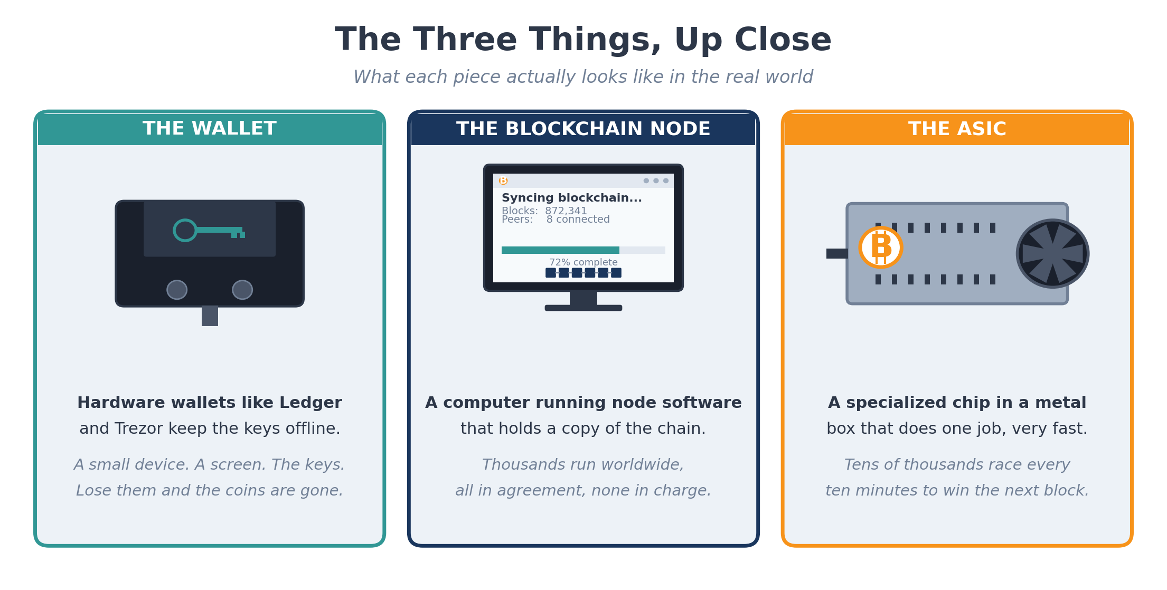
Figure 2. The three things, up close: a hardware wallet, a node, and an ASIC miner.
That is the foundation. Now to the five layers.
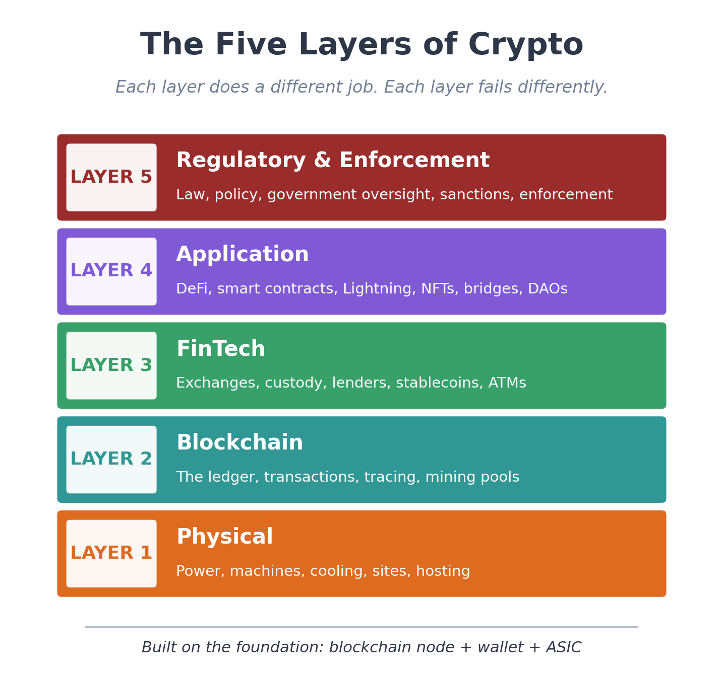
Figure 3. The five layers of crypto, with the foundation underneath.

LAYER 1

Physical
This is the world you can touch. Buildings, machines, power, cooling. ASICs need a place to live, and that place needs lots of electricity, lots of cool air, and lots of maintenance. A modern mining site looks like an industrial warehouse stacked with rows of humming, screaming machines that throw off heat the way a hair dryer throws off heat, except a thousand times over.
IN THIS LAYER
This layer covers the physical hardware of crypto: the evolution from PCs to GPUs to ASICs, computing power and the math behind it, the nodes that hold the chain, power purchase agreements, demand response, immersion and air cooling, ASIC failure rates and maintenance, colocation hosting, and permits and decommissioning. If you already work in mining or data centers, the headers below are the topics. Skip what you know.

From PCs to ASICs
In the very early days of Bitcoin, mining was something you did on a regular PC. Satoshi mined the first blocks on an ordinary CPU (Central Processing Unit, the general-purpose chip in every computer). For the first year or two, anyone with a desktop or laptop could run the original Bitcoin client, leave it on overnight, and reasonably expect to win blocks and earn coins. The whole network ran on the kind of hardware sitting on the desk in front of you right now.
That stopped working fast. As more people joined the network and the difficulty climbed, CPUs could not keep up. The next generation of miners moved to graphics cards, GPUs, the same chips that gamers used to render video. GPUs are designed to do many small math operations in parallel, which turns out to be exactly what mining requires. A high-end GPU was tens of times faster than a CPU at hashing, and a rig with several GPUs together could be hundreds of times faster. For about two years, GPU mining was the only game in town. Hobbyists built rigs in their basements with six or eight graphics cards strapped to a motherboard, fans blowing across the open frames, electricity bills climbing.
Then came the ASICs. The first Bitcoin-specific ASIC chips arrived around 2013. They were built to do exactly one calculation, the SHA-256 hash function that Bitcoin uses, and to do it as fast as silicon will allow. An ASIC was a hundred times faster than the best GPU and used a fraction of the power per hash. Within months of the first ASIC shipping, GPU mining became unprofitable for Bitcoin. The hobbyists either sold their rigs, switched to mining altcoins that were still GPU-friendly, or bought ASICs themselves. Today, every Bitcoin block on earth is won by ASICs. The chips have gone through dozens of generations, each smaller and more efficient than the last. The major manufacturers (Bitmain, MicroBT, and Canaan, all designed in China) almost all rely on TSMC in Taiwan to actually fabricate the silicon, with Samsung in South Korea handling a smaller share. Manufacturing is concentrated in just a handful of foundries on earth.
This history matters because it explains the shape of the industry. Mining started open and ended up industrial. The barrier to entry went from "a home PC" to "a million dollars in hardware and a power contract." Whether that is good or bad for Bitcoin is a debate that has been running for a decade. What is not debatable is that it happened, and the physical layer reflects it.

Computing Power and the Math
When miners talk about "hashrate," they mean how many guesses per second a machine can make at the math puzzle. A modern ASIC produces somewhere between two hundred and four hundred terahashes per second. That is two hundred to four hundred trillion guesses per second per machine. Multiply that by the millions of machines on the network and the total network hashrate sits in the hundreds of exahashes per second. An exahash is a quintillion (10 to the 18th) hashes. The numbers are absurd by any normal standard, but they are what makes the network secure.
The math itself is straightforward. A miner takes the contents of the next candidate block, adds a number called a nonce, runs the whole thing through SHA-256, and looks at the result. If the result starts with enough leading zeros (the network adjusts the threshold every two weeks to keep block times around ten minutes), the miner wins. If it does not, the miner changes the nonce and tries again. Trillions of times per second. The work itself is not productive in any traditional sense. The work is the security: anyone who wanted to attack the network would have to redo all that work faster than the rest of the network can keep going, which is why the energy that goes into mining is also what makes Bitcoin one of the most expensive systems on earth to attack.

Nodes Are Physical Too
It is easy to think of a node as a software thing, an abstraction sitting somewhere in the cloud. It is not. Every node is a physical computer in a physical place, and the network needs thousands of them to function. Most full Bitcoin nodes today are run on cheap dedicated boxes (a Raspberry Pi with a one-terabyte SSD will work, though most operators use a small server), with the full blockchain history stored on disk. As of late 2025, the Bitcoin blockchain is just past six hundred gigabytes and growing by roughly fifty to one hundred gigabytes a year, with the higher end of that range driven mostly by Ordinals and inscriptions data added since 2023.
A node’s job is to hold the entire chain, validate every new block as it arrives, relay valid transactions to other nodes, and reject anything that does not follow the rules. The node does not need to be powerful. It does not need a GPU. It does not need to be in a data center. It needs storage, a working internet connection, and the willingness to stay online. The decentralization of Bitcoin is, at the deepest level, a function of how many of these small machines are running around the world. The miners produce blocks. The nodes decide whether to accept them.

Power
Mining is, more than anything else, an electricity business. A single modern Bitcoin miner pulls about three thousand five hundred watts continuously. That is roughly the same as running a hair dryer all day, every day, forever. A small site with a thousand machines pulls about three and a half megawatts, enough to power around a thousand average American homes. A medium site runs in the tens of megawatts. A large site can pull two hundred or three hundred megawatts. The biggest operating sites in the world are approaching a gigawatt, with several more permitted or under construction at that scale.
Because power is the dominant cost, miners chase cheap electricity. That is why so many sites are in West Texas (cheap wind power, deregulated grid), the Pacific Northwest (cheap hydroelectric power), upstate New York and Pennsylvania (stranded gas and old industrial sites), Wyoming and North Dakota (oil and gas flare gas), and abroad in Iceland (geothermal), Paraguay (hydroelectric), and previously Kazakhstan (cheap coal until the government cracked down).
A mining site signs a power purchase agreement with a utility or a power producer. The agreement locks in a price, sometimes for years, sometimes adjusted hourly to match the market. The cheapest power is usually power that the grid does not have anywhere else to send. Wind farms in West Texas at three in the morning produce more electricity than the grid can use. A miner can park itself next to that wind farm, buy the power that would otherwise be wasted, and run.

Demand Response and the Grid
Miners are unusual electricity customers because they can shut off in seconds. A factory cannot turn off and back on without losing product. A hospital cannot. A mining site can. That makes miners valuable to grid operators.
Programs called demand response pay miners to be on standby. When the grid gets stressed, in a heatwave, a cold snap, or a storm, the operator calls for demand response, and the miner shuts off. The grid stays stable, and the miner gets paid for staying offline. In Texas during the February 2021 winter storm, miners shut down to free up power for homes and hospitals. Some sites earn more from demand response payments than from mining itself during peak periods. The relationship between mining and the grid is more cooperative than most coverage suggests.

Cooling
ASICs run hot. Each machine produces enough heat to bake a small room. Stack thousands together and the temperature inside the building goes up fast. If the heat is not removed, the machines slow down, then shut off, then break.
Most sites use air cooling, which is just very large fans pulling cool air across the machines and pushing the hot air out. Some sites use immersion cooling, which means dropping the machines into tanks of nonconductive liquid that absorbs the heat directly. Immersion is more expensive to build but lets the machines run faster, cleaner, and longer. A few experimental sites use the heat for greenhouse farming, district heating, or warming swimming pools.
In summer, in places like Texas or Arizona, cooling becomes the limiting factor. One hundred ten degrees outside means the air going into the machines is already hot. The machines then make it hotter. There is a point at which the equipment cannot keep itself cool no matter how hard it tries, and the site has to throttle down or shut off. This is why total network hashrate (the global mining power) tends to dip in summer.

Maintenance
ASICs are mass produced overseas, mostly in factories that build them by the millions. They fail at rates that would shock anyone used to American industrial equipment. A site running ten thousand machines might see thirty or forty fail every day. The failures are routine: power supplies blow, cooling fans seize, individual chips on the boards die, firmware corrupts. Each failure has to be diagnosed, repaired, or replaced.
A real mining operation has a repair shop on site or nearby. Technicians swap out boards, rebuild power supplies, run diagnostics, and ship dead boards back to the manufacturer or to third-party repair specialists. Sites that skip this work see their hashrate quietly bleed away over months until they are running at sixty percent capacity and not sure why.

Sites and Hosting
Some companies own their machines and run their own sites. Others run sites and host machines for customers. The customer ships their ASICs to the site, the site plugs them in, runs them, maintains them, and pays the customer the bitcoin those machines earn (minus a fee). This is called colocation hosting, the same model used by data centers for decades.
Hosting agreements get complicated fast. They cover power pricing, uptime guarantees, repair response times, cooling specifications, and what happens when the price of bitcoin crashes or the cost of electricity spikes. When a hosting site goes bankrupt, customers may lose access to their machines, sometimes for months. When a customer stops paying, the site may seize the machines. These disputes end up in court regularly.

Permits, Zoning, and Decommissioning
Mining sites need permits like any other industrial facility. Zoning, electrical, environmental. A site near a residential area faces noise complaints because thousands of fans running at full speed sound like a jet engine that never lands. A site near a small lake town in upstate New York drew protests when residents claimed the heat exhausted into the lake was hurting fish. Communities have passed local ordinances banning new mining sites in some places.
When equipment fails or becomes obsolete, decommissioning is its own challenge. ASICs older than five or six years are usually not worth running. The metal can be recycled, but the chips themselves contain lead, copper, and small amounts of rare earth elements that need careful handling. A responsible operator plans for decommissioning. A careless one leaves piles of dead machines in a corner of the warehouse.

Layer 1 Matters
This layer is where most of the energy debate around Bitcoin lives. The total Bitcoin network now uses more electricity than some small countries. Critics call it wasteful. Supporters argue that miners absorb otherwise stranded power, stabilize grids, and provide an economic use for renewable generation that would otherwise be curtailed. Both sides have a point. The truth depends heavily on which site you are talking about.
None of the rest of crypto would work without them.
It is also where the day-to-day work of mining gets done. The headlines focus on price, on hacks, on bankruptcies. But the network only exists because tens of thousands of operators show up every day, swap broken boards, watch the temperature, manage power contracts, and keep the machines running.

LAYER 2

Blockchain
This is the ledger and the rules that govern it. Layer 2 covers everything that happens on the chain itself: who sent what to whom, when, and how the network agreed on it. It is the layer that crypto journalists, forensic investigators, and academic cryptographers spend their time on.
IN THIS LAYER
This layer covers the genesis block, the path of a transaction (mempool, confirmations, finality), forensic tracing across wallets and exchanges, mixers and privacy coins, the Tornado Cash sanctions saga, and mining pool concentration. If you already trace coins or run a node for a living, skim the headers and skip ahead.

The Genesis Block
On January 3, 2009, Satoshi Nakamoto mined the first Bitcoin block on a regular computer somewhere. Block 0. The genesis block. Every block on the network since then traces back to it through an unbroken chain of cryptographic hashes. Pull up any block explorer today, scroll all the way back, and the trail ends here.
The block has a few things worth knowing. The previous-block field is all zeros, because there was no block before it. The reward was fifty bitcoin, mined to a wallet that has never moved, presumed lost or held by Satoshi as an unspendable monument. The nonce was 2,083,236,893, the result Satoshi’s computer found after working through the math. Block 0 itself was mined in seconds. The famous detail is that Block 1 did not arrive until six days later, on January 9, 2009. The difficulty was set to one, so the gap was not a technical limit. Satoshi simply waited, for reasons that are still debated among historians of the network. Some think he was watching to see if anyone else picked up the software. Some think the delay was personal. Either way, the network sat empty for almost a week before anyone, including its creator, mined another block.
What makes the block famous is the message Satoshi embedded in it. The coinbase transaction (the special transaction that creates new bitcoin and pays it to the miner) included a string of text that read: "The Times 03/Jan/2009 Chancellor on brink of second bailout for banks." That was the front-page headline of the London Times that day. Satoshi embedded it for two reasons. First, as a timestamp: a way to prove the block could not have been mined before that date. Second, as a political statement. Bitcoin was launched in the middle of the global financial crisis, and the headline announcing yet another government bailout of the banking system was the closing argument for why a system that did not need banks was worth building.
Every block since has followed the same format and chained back to it. Over fifteen years, with very few interruptions, every ten minutes, somewhere in the world, the next block gets sealed.
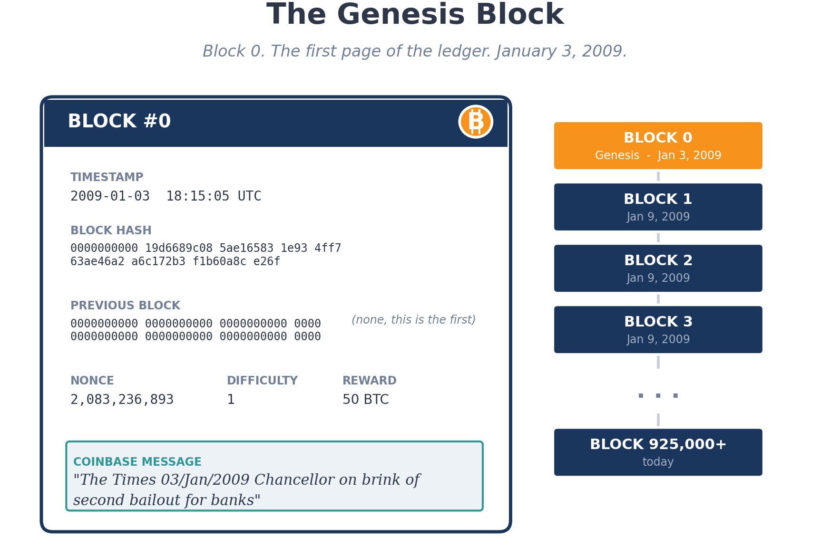
Figure 4. Block 0, the genesis block. The first page of the public ledger.

How a Transaction Actually Flows
When you send bitcoin from your wallet, the transaction does not go straight onto the blockchain. It goes first into a holding area called the mempool, where every pending transaction in the world waits to be picked up by a miner. The mempool is public. Anyone can watch transactions enter it, including bots that look for profitable trading opportunities to front-run.
Miners pick transactions out of the mempool and bundle them into the next block. They tend to pick the ones with the highest fees first, because the fees go to the miner. If the network is busy, fees go up, and your transaction may sit in the mempool for hours waiting to be included. If the network is quiet, your transaction may be included in the next block in minutes.
Once a transaction is in a block and the block is sealed, the transaction has one confirmation. Most exchanges wait for three to six confirmations before crediting your account, because in rare cases blocks can be reversed if a more powerful chain emerges. After six confirmations, a Bitcoin transaction is considered effectively permanent.
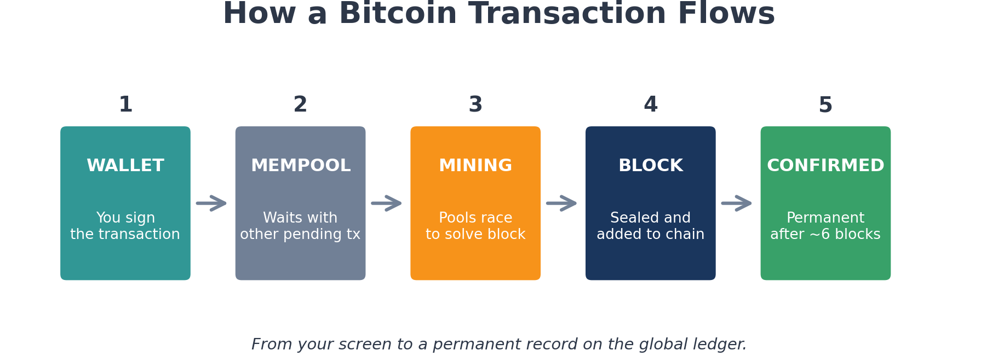
Figure 5. The path of a Bitcoin transaction from your wallet to the permanent ledger.

Tracing Coins
Because every transaction is public, anyone can follow the money. A bitcoin sent from wallet A to wallet B leaves a trail visible to the world. Wallet B sends to wallet C, that is also visible. The chain of transactions can be reconstructed by anyone with a block explorer, which is a website like mempool.space or Blockchain.com that displays the public ledger in a readable format.
Companies like Chainalysis, TRM Labs, and Elliptic have built businesses around analyzing these trails. They cluster wallets that appear to belong to the same owner, identify exchange addresses, label known criminal wallets, and sell their data and tools to banks, exchanges, and law enforcement agencies. When the FBI recovered most of the Colonial Pipeline ransom in 2021, they did it by tracing the bitcoin from the attacker’s wallet through several hops to a wallet they could access. When investigators tied the 2016 Bitfinex hack to a couple in New York in 2022, they did it by tracing the stolen coins through six years of laundering attempts.
Once a transaction hits the chain, it is there forever.

Mixers and Privacy
Some users do not want their transactions traced. Mixers (also called tumblers) blend coins from many users together, then send out coins of the same total value to new addresses, breaking the link between sender and receiver in theory. In practice, advanced tracing techniques can often follow coins through mixers anyway.
Tornado Cash was the largest Ethereum mixer until the US Treasury sanctioned it in 2022 for laundering money for North Korean state hackers. The sanction itself was historic because Tornado Cash is not a company. It is a smart contract, autonomous code that runs on the blockchain with no one in control. Sanctioning code raised legal questions that wound through the courts for years. In November 2024, the Fifth Circuit Court of Appeals ruled that the Treasury’s Office of Foreign Assets Control (OFAC), the agency that administers US sanctions, overstepped its authority because the smart contracts were not "property" under the law that authorized the sanctions. In March 2025, Treasury formally lifted the sanctions. Criminal cases against the developers, however, are a different story (more on that at Layer 5).
Privacy coins like Monero and Zcash take a different approach. They build privacy into the protocol itself, so transactions are encrypted by default. They are popular with people who value financial privacy and people who want to evade tracking, which makes them controversial. Several major exchanges have delisted them under regulatory pressure.

Mining Pools
A single ASIC running alone has almost no chance of winning a block. The math problem is too hard. Pools combine the computing power of thousands of miners, win blocks together, and split the rewards proportionally. Most mining today happens through pools.
The largest pools, like Foundry, Antpool, and ViaBTC, control significant shares of the network’s computing power. This concentration raises concerns about the long-term decentralization of Bitcoin, since a pool could in theory censor transactions or even attack the network if it controlled enough power. So far, no major pool has tried.

LAYER 3

FinTech — Financial Technology
This is the money business built around crypto. Layer 3 includes exchanges, custodians, lenders, stablecoins, the rules that govern all of them, and the lawyers who clean up when they fail.
IN THIS LAYER
This layer covers centralized and decentralized exchanges, institutional custody, spot Bitcoin and Ethereum ETFs, the 2022 lender bankruptcies (Celsius, BlockFi, Voyager, Genesis), stablecoin types and the Terra UST collapse, initial coin offerings and the Howey Test, the GENIUS Act, securities classification fights, anti-money-laundering compliance, and Bitcoin ATMs. If you live in the trading or compliance side of crypto, skip to whatever you do not already know cold.

Exchanges
An exchange is where most people first interact with crypto. You send dollars, you get bitcoin. Send bitcoin, get dollars. The biggest US exchanges are Coinbase, Kraken, and Gemini. Internationally, Binance is by far the largest by trading volume.
Exchanges come in two flavors. Centralized exchanges (CEX) work like a stockbroker. You deposit money with them, they hold it on your behalf, and you trade through their interface. The exchange is a custodian. If they get hacked, go bankrupt, or run off with the money, you have a problem. Mt. Gox famously lost hundreds of thousands of customer bitcoin in 2014. FTX lost about eight billion dollars in customer funds in 2022. Customers in both cases had years of legal proceedings ahead of them, and many never recovered the full value.
Decentralized exchanges (DEX) work differently. They are smart contracts (more on those at Layer 4) that let people trade directly from their own wallets, without a middleman holding the funds. Uniswap is the largest. There is no company to fail, but there is also no customer support, no fraud protection, and no recourse if you send money to the wrong place.

Custodians
A custodian is a company that holds crypto for institutional clients. Hedge funds, pension funds, family offices, and ETF (exchange-traded fund) issuers do not want to manage their own wallet keys. They pay custodians to do it. The biggest crypto custodians are Coinbase Custody, BitGo, Anchorage, and Fidelity Digital Assets.
Custody is harder than it looks. The custodian has to keep keys secure against hackers, insiders, and physical theft. They use cold storage, multi-signature setups, and hardened security infrastructure. The most secure setups involve keys stored in geographically separated vaults, with multiple authorized signers required for any transaction, and ceremonies that look more like nuclear weapons protocols than banking.
When a custodian fails, the legal status of the assets becomes a problem. Are the coins customer property or part of the bankruptcy estate? Recent rulings have gone both ways depending on contract language.

Spot ETFs and Institutional Wrappers
For most of crypto’s history, traditional investors who wanted exposure to bitcoin had three options: buy it directly and figure out custody themselves, buy a futures product that tracked the price imperfectly, or buy stock in a mining or holding company and hope its price moved with bitcoin. None of those were great. The simple thing, an exchange-traded fund that held actual bitcoin and traded on a normal stock exchange, was blocked for a decade by the Securities and Exchange Commission (SEC), the federal agency that regulates US securities markets.
That changed in January 2024 when the SEC approved the first wave of US spot Bitcoin ETFs. BlackRock’s IBIT, Fidelity’s FBTC, Bitwise’s BITB, ARK’s ARKB, and others began trading on the same day. Within their first year, the funds collectively pulled in tens of billions of dollars in inflows. IBIT alone became one of the fastest-growing ETFs in history. Spot Ethereum ETFs followed in July 2024. The funds work by buying actual bitcoin (or ether), parking it with a qualified custodian (mostly Coinbase Custody), and issuing shares that trade on Nasdaq or NYSE Arca. Investors get bitcoin price exposure inside their existing brokerage accounts.
The ETFs are pure Layer 3. They do not change anything on the blockchain. The bitcoin sits in cold storage at a custodian. The shares are a paper claim. But the practical effect on the market is real: pension funds, registered investment advisors, and 401(k) plans that were never going to touch a self-custody wallet can now hold bitcoin exposure through the same plumbing they use for stocks. Combined, the US spot ETFs now hold over a million bitcoin, putting them among the largest concentrations of bitcoin held by any single category of holder, comparable to or exceeding the estimated balance attributed to Satoshi Nakamoto.

Lending and the 2022 Implosions
In the boom years of 2020 and 2021, several companies offered crypto-backed lending. Customers deposited bitcoin or stablecoins, earned interest, and the lender used the deposits to make loans elsewhere. Celsius, BlockFi, Voyager, and Genesis all ran versions of this business.
When the crypto market crashed in 2022, the loans went bad faster than the deposits could be unwound. All four companies filed for bankruptcy. Customers who had treated the platforms like savings accounts discovered, sometimes for the first time, that their deposits were unsecured loans to the company. They became creditors waiting in line behind everyone else. The bankruptcies are still being unwound years later. Some customers recovered partial value. Some recovered almost nothing.
Most of crypto’s recent disasters have lived here.

Stablecoins
Stablecoins are crypto’s response to the fact that bitcoin and most other coins swing wildly in price. A stablecoin is a digital token designed to hold a steady value, almost always pegged to one US dollar. They make trading easier, because you can sell into a stablecoin and stay in crypto without taking on price risk. They also have become the way people in countries with unstable currencies get access to dollars.
There are three main types. Fiat-backed stablecoins are supposed to hold one real dollar in a bank account for every token issued. Tether (USDT) and USDC are the two largest. Tether’s reserves have been the subject of legal action, fines, and ongoing skepticism for years. USDC, issued by Circle, is generally considered cleaner, though it briefly lost its peg in March 2023 when Silicon Valley Bank failed and held some of Circle’s reserves.
Crypto-backed stablecoins use other crypto as collateral. DAI, the largest, is backed by overcollateralized deposits of Ethereum and other coins. If the collateral falls in value too far, the system automatically sells it to keep the peg.
Algorithmic stablecoins try to maintain their peg through code rather than collateral. Most have failed catastrophically. Terra UST was the most spectacular: it lost its peg in May 2022 and wiped out around forty billion dollars in value over a few days, taking the parallel Luna token with it and triggering the broader crypto crash that killed Celsius, Voyager, Three Arrows Capital, and eventually FTX.
In July 2025, Congress passed the GENIUS Act, the first major federal law on stablecoins in the United States. The law requires US stablecoin issuers to back their tokens one-for-one with cash and short-term Treasuries, file regular reserve disclosures, and comply with anti-money-laundering rules. The law was a major shift toward bringing stablecoins into the regulated financial system.

Initial Coin Offerings
In 2017 and 2018, before SAFTs and before any of the regulatory framework around token sales had taken shape, the crypto industry went through a fundraising boom called the ICO era. ICO stands for Initial Coin Offering and it was modeled on the Initial Public Offering (IPO), the way a company sells shares to the public for the first time. The pitch was simple: a project would publish a white paper, set up a website, and sell tokens to anyone willing to send bitcoin or ether to a wallet address. In return, buyers received the project’s new tokens, with the hope that the tokens would gain value if the project succeeded.
More than 2,000 ICOs raised in excess of 15 billion dollars over those two years, with industry trackers reporting figures up to roughly 22 billion dollars depending on what counted. EOS raised about 4.1 billion, the largest token sale in history. Telegram raised 1.7 billion. Tezos raised 230 million. Filecoin raised 257 million. Ethereum itself had earlier raised about 18 million in a 2014 ICO and is widely considered the only one that delivered on its promise. Most of the rest produced lawsuits, regulatory enforcement, or nothing at all. The SEC took the position that most of these tokens were unregistered securities, and starting in 2018 brought enforcement actions against dozens of issuers. Telegram was forced to refund 1.2 billion dollars to investors and pay an 18.5 million penalty. EOS settled for 24 million. The ICO era effectively ended by 2019, replaced by the SAFT structure described next, by IEOs (Initial Exchange Offerings, where exchanges vet the project before offering it), and by various airdrop and yield-distribution models.
The legal framework the SEC used to attack ICOs is called the Howey Test, and it shows up everywhere in crypto law, so it is worth understanding. The test comes from a 1946 Supreme Court case, SEC v. W.J. Howey Co., that involved a Florida orange grove operator selling plots of land along with service contracts to manage the trees. The Court ruled that even though the buyers technically owned land, what they were really buying was an investment contract: they put up money expecting profits from the work of someone else. That makes it a security, regardless of what label the seller puts on it. The Court laid out a four-part test that has been used ever since. There must be (1) an investment of money, (2) in a common enterprise, (3) with a reasonable expectation of profit, (4) derived from the efforts of others. If all four are present, the thing is a security and has to be registered with the SEC or fall within an exemption. The SEC has spent the last decade arguing that most ICO tokens, most SAFT-issued tokens, and many later projects all check all four boxes. Defenders of those projects argue that some tokens are utility tokens (you buy them to use the network, not to profit from it) or that the network became sufficiently decentralized that there is no longer a "common enterprise" or "efforts of others" to point to. Most of the legal fights at Layer 3 and Layer 5 come down to which side wins on those four prongs.

SAFTs and the Securities Question
When a new crypto project wants to raise money, it often does so through a SAFT (Simple Agreement for Future Tokens). Investors give the project money in exchange for the right to receive tokens once the network launches. SAFTs were a direct response to ICO enforcement: by selling agreements rather than tokens, and by selling only to accredited investors under existing securities exemptions, projects hoped to satisfy the Howey Test the first time around and then have the tokens themselves treated as utility commodities once delivered. It was a creative legal structure. The SEC has not entirely accepted it.
The agency has argued for years that many tokens, especially those sold through SAFTs or initial coin offerings, are still securities under Howey because the four prongs do not stop applying just because the wrapper changed. The SEC pursued enforcement actions against Coinbase, Binance, Ripple, and dozens of smaller projects. Ripple’s case in particular produced a split ruling in 2023: the court held that Ripple’s sales to institutional investors were unregistered securities offerings, but its programmatic sales on exchanges to retail buyers were not. That distinction has been argued about ever since. Coinbase and Ripple have largely won their cases. Binance settled with massive fines.
Under the Trump administration that began in January 2025, the SEC under Chair Paul Atkins dropped or paused most of its pending crypto enforcement cases. Congress has been working on a broader market structure bill, the CLARITY Act, which would draw clearer lines between which tokens are securities and which are commodities. The bill is, in effect, an attempt to codify a decision tree that replaces case-by-case Howey analysis for digital assets. The legal landscape is shifting fast.

AML, KYC, and Compliance
Anti-money-laundering (AML) and know-your-customer (KYC) rules require exchanges and other regulated crypto businesses to verify their customers’ identities, report suspicious transactions, and screen against sanctions lists. Compliance is a serious business and a major operational expense.
A failure to comply can be devastating. Binance pleaded guilty in November 2023 to violating AML laws and paid over four billion dollars in fines. Its founder, Changpeng Zhao, served four months in a US federal prison. The case set the tone for the next generation of crypto compliance.

Bitcoin ATMs
Bitcoin ATMs let users buy crypto with cash. They sit in convenience stores, gas stations, and laundromats. The biggest operators are Bitcoin Depot, CoinFlip, and Coinhub. The ATMs charge high fees, often ten to twenty percent above market price, and are heavily used by people without bank accounts and, unfortunately, by scam victims who get tricked into using them to send money to fraudsters posing as law enforcement, IRS agents, or family members in trouble. Several states have passed laws limiting ATM transaction sizes and requiring better consumer disclosures.

LAYER 4

Application
This is where developers build new things on top of the blockchain. Bitcoin was the first crypto, but it was deliberately limited. Ethereum, launched in 2015, opened the door to programmable money, and Layer 4 has been growing ever since.
IN THIS LAYER
This layer covers smart contracts, decentralized finance (DeFi), the Lightning Network, NFTs, cross-chain bridges and the biggest hacks in crypto history (Ronin, Wormhole, Nomad), DAOs, and the terminology overlap with Ethereum "Layer 2" scaling. If you build, audit, or use these protocols, skim and skip.

Smart Contracts
A smart contract is a program that runs on the blockchain and executes automatically when conditions are met. Send a deposit to this address, and the contract releases a digital ticket. Provide proof that an event occurred, and the contract pays out an insurance claim. The idea is to remove the middleman, the lawyer, the escrow agent, and let the code enforce the agreement.
Smart contracts run on Ethereum, Solana, and dozens of other smart contract platforms. They have enabled an explosion of new financial products, but they have also created entirely new categories of failure. A bug in a smart contract can be exploited the same way a bug in any software can. The difference is that on-chain, once you lose the money, you usually cannot get it back.
Once you lose the money, you usually cannot get it back.

DeFi
Decentralized finance, or DeFi, is finance done by smart contracts instead of by banks. The major categories include automated market makers (AMMs) like Uniswap, where users trade tokens against pools of capital instead of through an order book; lending protocols like Aave and Compound, where users deposit crypto and earn interest, or borrow against their crypto as collateral; yield farming, where users move capital between protocols chasing the highest returns; and stablecoin protocols like MakerDAO, which issues DAI.
DeFi grew explosively in 2020 and 2021. At one point, over a hundred and fifty billion dollars in assets sat in DeFi protocols. The numbers have come down since, but the technology has matured. Real users, not just speculators, increasingly use DeFi protocols for international payments, savings, and lending in countries with unstable currencies.
DeFi has also been a constant source of hacks. Smart contract bugs, oracle manipulation, flash loan attacks, and key compromise account for billions in losses every year. The Poly Network hack in 2021 saw an attacker drain over six hundred million dollars from a cross-chain protocol, though most of it was returned voluntarily after the hacker had what he claimed was a change of heart.

Lightning
Lightning is a way to move bitcoin instantly, cheaply, and at huge volume, without writing every transaction to the main blockchain. It does this by opening payment channels between users. The channel is recorded on the main chain, but transactions inside the channel happen privately and instantly. Only the opening and closing of the channel touch the blockchain.
Lightning is used today for tipping, podcast payments, retail purchases in places like El Salvador, and remittances. Companies like Strike, Cash App, and Square’s Bitcoin services route through Lightning. It is one of the few crypto applications that solves a real problem (slow Bitcoin transactions for everyday spending) for a real audience.

NFTs
Non-fungible tokens, or NFTs, are unique digital items recorded on a blockchain. Each NFT has an owner, a history, and (usually) a link to a piece of digital content: an image, a video, a song, a ticket. Bored Ape Yacht Club and CryptoPunks were the most famous early NFT collections, with individual items selling for millions of dollars in 2021.
The NFT market then collapsed. Average prices for most major collections fell by more than ninety percent. The technology, however, is finding real uses beyond speculation. Tickets to concerts and events, in-game items, music ownership, real estate deeds, and identity credentials are all being explored as NFT use cases. Most of these are still experiments.
Fraud has been a constant problem. Wash trading (artificially inflating prices through fake sales between insider wallets), rug pulls (creators abandoning projects after taking the money), and phishing scams that drain wallets remain widespread. Marketplaces like OpenSea and Blur have added fraud protection, but the space is largely unregulated.

Bridges and the Biggest Hacks
Bridges connect different blockchains. A user with bitcoin on the Bitcoin blockchain who wants to use it in a DeFi protocol on Ethereum needs a bridge. The bridge takes the bitcoin, locks it on the original chain, and issues a wrapped version on the destination chain. When the user wants to move back, the wrapped version is burned and the original is unlocked.
Bridges are notoriously fragile. They are complex pieces of code that hold massive amounts of value and are exposed to attacks from all sides. The biggest hacks in crypto history have been bridge hacks. The Ronin Bridge hack in March 2022 lost over six hundred twenty million dollars in a single day, traced back to North Korean state hackers. The Wormhole bridge had been drained of over three hundred million weeks earlier, in February 2022. Nomad lost about a hundred and ninety million in August 2022. Despite the losses, bridges remain heavily used because the alternative, isolated blockchains that cannot talk to each other, is worse.

DAOs
A decentralized autonomous organization, or DAO, is a group governed by smart contracts and token holder votes instead of by executives. A DAO might own a treasury, run a protocol, fund grants, or simply operate as a digital club. The most famous DAOs include MakerDAO (which runs the DAI stablecoin), Uniswap (the DEX), and ConstitutionDAO (which raised forty million dollars in days to bid on a copy of the US Constitution at auction, then narrowly lost the bid and refunded the donors).
DAOs raise unsettled legal questions. Who is liable if a DAO does something illegal? Are token holders members of an unincorporated association? Can a DAO be sued? The Commodity Futures Trading Commission (CFTC), the federal agency that regulates US commodity and derivatives markets, went after one DAO (Ooki DAO) and won a default judgment, treating the token holders as members. The legal framework is still being built.

Confusing Terminology
Inside crypto, the term "Layer 2" is also used to mean Ethereum scaling solutions like Arbitrum, Optimism, Base, and zkSync. These process transactions off the main Ethereum chain and post the results back, making transactions faster and cheaper. They should not be confused with the Layer 2 in this article (the blockchain layer in the broader crypto stack). Crypto has a vocabulary problem, and this is one of its worst examples.

LAYER 5

Regulatory & Enforcement
This is where law meets technology. Governments did not create crypto and did not want it. For more than fifteen years, regulators have been working out how to fit crypto into existing legal frameworks, or whether to create new ones.
IN THIS LAYER
This layer covers the US agency patchwork (SEC, CFTC, FinCEN, OFAC, state money transmitters), the Gensler-to-Atkins enforcement shift, the GENIUS and CLARITY Acts, the Tornado Cash civil and criminal cases, FTX bankruptcy mechanics, and the international landscape (MiCA, UK, Singapore, Japan, Hong Kong, China, El Salvador). If you practice in this space, skim the headers and pick what you need.

The United States
In the US, crypto is regulated by a patchwork of agencies. The SEC thinks many tokens are unregistered securities. The CFTC thinks bitcoin and ether are commodities and oversees crypto derivatives. The Financial Crimes Enforcement Network (FinCEN), a Treasury bureau, handles money laundering rules. The Internal Revenue Service (IRS) handles taxes. OFAC handles sanctions. Each state has its own money transmitter laws. New York has its own crypto licensing regime called the BitLicense, which is famously strict.
Under SEC Chair Gary Gensler from 2021 to 2025, the SEC took an aggressive enforcement stance, suing Coinbase, Binance, and dozens of token issuers. Almost every one of those cases turned on the Howey Test (introduced in the Layer 3 ICO discussion above) and the question of whether the tokens at issue were unregistered investment contracts. Most cases settled. Some, like Ripple, won meaningful court victories. The legal status of many tokens remained unclear because the SEC’s view had not been adopted by Congress and was being challenged in court.
Under the Trump administration that began in January 2025, the SEC under new Chair Paul Atkins dropped or paused most pending crypto cases and signaled a more permissive stance. Congress passed the GENIUS Act in July 2025, creating a federal framework for stablecoins. The CLARITY Act, a broader bill that would draw lines between securities and commodities for digital assets, passed the House the same month and is awaiting Senate action. The regulatory landscape is shifting fast.

The Tornado Cash Case
In August 2022, OFAC sanctioned Tornado Cash, an Ethereum mixer used to launder money for North Korean state hackers. The sanction made it illegal for US persons to interact with Tornado Cash addresses. The case raised an unusual issue: Tornado Cash is not a company. It is a smart contract, autonomous code running on the blockchain. Sanctioning code rather than people had no clear precedent.
In November 2024, the Fifth Circuit Court of Appeals ruled in Van Loon v. Department of the Treasury that OFAC overstepped its authority. The court held that the immutable smart contracts behind Tornado Cash were not "property" under the law that authorized the sanctions, because no one owned or controlled them. In March 2025, Treasury formally lifted the sanctions.
The cofounders of Tornado Cash were also charged criminally, and their cases told a different story. Alexey Pertsev was convicted of money laundering in the Netherlands in 2024 and sentenced to over five years in prison. He is appealing. Roman Storm went to trial in the Southern District of New York in 2025. In August 2025, the jury convicted him of conspiracy to operate an unlicensed money transmitting business but deadlocked on the more serious money laundering and sanctions charges. The case will almost certainly be appealed. The unresolved question of whether software developers are responsible for what users do with their code now has implications far beyond crypto.

Bankruptcy Courts
When crypto companies fail, US bankruptcy courts have to figure out how to handle assets that the law was not written to address. Are customer deposits property of the customer or the estate? What is the fair market value of an illiquid token? Who gets paid first when there is not enough to go around?
The FTX bankruptcy has been the most consequential. Sam Bankman-Fried was convicted of fraud in November 2023 and sentenced in March 2024 to twenty-five years in federal prison. The estate has spent years recovering assets and distributing them to creditors. Customers who held bitcoin at FTX are being paid out at the price bitcoin had when the bankruptcy filed (around sixteen thousand dollars), even though bitcoin’s actual price has been much higher since. Many creditors have argued that this short-changes them. The legal mechanics of these decisions are now case law that future crypto bankruptcies will inherit.

International
Outside the US, the picture is just as fragmented. The European Union passed Markets in Crypto-Assets (MiCA), the first comprehensive crypto regulatory framework, in 2023, with most provisions taking effect across 2024 and 2025. MiCA covers stablecoins, exchanges, custody, and disclosures, and gives crypto businesses clearer rules to operate by than they have in the US.
The United Kingdom has taken a similar approach, creating a regulatory framework adapted from existing financial services rules. Singapore licenses crypto businesses through the Monetary Authority of Singapore. Japan has had crypto rules since 2017 and remains one of the strictest jurisdictions. Hong Kong passed its own stablecoin ordinance in 2025.
China banned crypto mining and trading in 2021 after having been the largest mining hub in the world for years. The ban scattered miners around the globe and benefited the United States, which became the leading mining country. China is now experimenting with its own central bank digital currency, the digital yuan.
El Salvador took the opposite approach. In 2021, it made bitcoin legal tender, the first country to do so. The government also began accumulating a bitcoin treasury that it still holds. In early 2025, under conditions tied to a 1.4 billion dollar IMF loan, El Salvador amended the law to make bitcoin acceptance voluntary rather than mandatory, effectively reversing the legal-tender status while keeping the treasury policy. The Central African Republic briefly followed El Salvador’s original lead, then reversed course. Other countries are watching.

Layer 5 Matters
Layer 5 is not really technology at all. It is law, policy, and enforcement. But it shapes everything in the four layers below it. A crypto exchange’s ability to operate depends on its license. A DeFi protocol’s risk depends on whether its tokens are securities. A miner’s economics depend on the energy regulations of the state it operates in. A wallet developer’s freedom depends on whether the government can prosecute them for what users do with the code.
It shapes everything in the four layers below it.
The next ten years of crypto will be shaped at this layer as much as at any of the others.

Wrapping It Up
Next time you read a crypto headline, ask yourself which layer it is on. A mining site shutting down in a heatwave is Layer 1. Stolen coins being traced across a dozen wallets is Layer 2. An exchange collapsing or a stablecoin losing its peg is Layer 3. A DeFi hack or an NFT rug pull is Layer 4. An SEC lawsuit or a sanctions order is Layer 5.
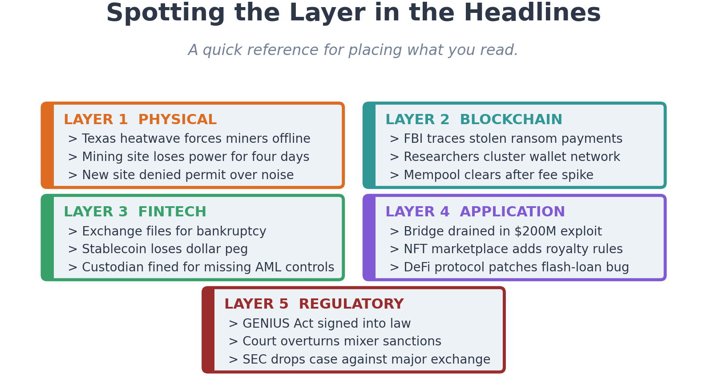
Figure 6. A quick reference card for placing crypto headlines in their layer.
Some headlines hit more than one layer at once. The FTX collapse was Layer 3 (an exchange failed) but the criminal case is Layer 5 (regulatory and enforcement). The Tornado Cash story touched Layer 2 (privacy on the blockchain), Layer 4 (smart contracts), and Layer 5 (sanctions law) at the same time. A miner getting cut off from banking is Layer 1 (operations) crashing into Layer 5 (regulation). The layers are connected, and most real cases involve more than one.
You do not need to be a crypto expert to follow what is happening in the industry. You just need to be able to spot the layer. Once you can do that, the news stops feeling like a wall of jargon and starts feeling like what it actually is: a collection of stories about machines, ledgers, businesses, applications, and laws, none of which are mysterious individually, all of which need to be understood on their own terms.
Crypto is not one thing. It is five layers stacked on each other, each with its own rules and its own kinds of trouble. Once you can see the layers, the whole industry stops looking like a giant mess.

About the Author
Aviran Vargas is the Director of Operations and Infrastructure at EZ Blockchain, a Chicago-based Bitcoin mining and blockchain infrastructure company. He oversees multi-state data center operations, ASIC fleet management, infrastructure compliance, and customer hosting relationships across multi-megawatt facilities, including the SmartBox 3000 modular deployments at the Ranger I and Ranger II sites.
He has more than fifteen years of enterprise data center experience. Before EZ Blockchain, he ran national data center operations for Comcast, including the company’s largest national facility in Northlake, Illinois, and held Tier IV operational roles at the Chicago Mercantile Exchange. He holds BICSI and CI&M Data Center Expert certifications and a Blockchain Fundamentals certification.
Aviran also serves as a crypto expert witness through Aventures Technology LLC. He has been retained on both plaintiff and defense sides in Bitcoin mining and hosting disputes, with engagements covering ASIC valuation, uptime damages, hosting contract analysis, profitability modeling, and operational rebuttals to opposing experts. Notable cases include a defense verdict in Crypto Infiniti v. EZ Blockchain (Cook County, 2025).
For engagements and contact, see BTCExpertWitness.com.

