Millions Spent, Almost Scrapped:
The One-Man Mission That Saved Comcast's National Data Center Intelligence Platform
By Aviran Vargas

An Impossible Number on a Very Real Screen
Twenty-four thousand, two hundred and sixteen. That was the number staring back at me on the screen during a meeting that I will not forget for the rest of my career. Red, a lot of it. Yellow, enough to burden anyone. Green, on a lost room only in single digits. A dashboard that looked less like a data center monitoring portal and more like the inside of a Christmas tree that had shorted out in a thunderstorm. That was my introduction to PowerIQ.
Comcast had spent millions of dollars installing one of the most advanced intelligent monitoring systems available in the industry at the time, a full-stack infrastructure intelligence platform built on technology from Raritan and Legrand. Every cabinet in every one of their national data centers was equipped with sensors, smart power distribution units, and environmental monitoring hardware that could tell you, in real time, whether a server was drawing too much power, whether the air near the top of a rack was creeping into dangerous heat territory, or whether the humidity in a given aisle was trending toward the kind of conditions that make equipment engineers very uncomfortable.
Then somebody opened the software dashboard for the first time in front of a room full of data center supervisors and managers, and everything went sideways.
Nobody wanted anything to do with it.
Nobody, that is, except me.

What Raritan and Legrand Actually Built
Before you can understand the scale of the problem, you have to understand what was actually installed and why it represented a genuinely impressive piece of engineering.
Raritan, a subsidiary of Legrand, produces intelligent Power Distribution Units, commonly called smart PDUs, that are far more than simple power strips. Each cabinet in a properly outfitted data center typically holds two of these units, one for each power feed, to maintain redundancy. Depending on the model and configuration, each PDU carries between 24 and 48 individual receptacles, which means a single cabinet is monitored across 48 to 96 outlet-level data points at minimum.
And that is just the beginning. Each individual receptacle on a Raritan intelligent PDU is capable of measuring:
- Current draw, measured in amps, reported continuously
- Voltage, to detect fluctuations or brown conditions on a circuit
- Active power consumption in watts, the real-time load per device
- Apparent power in volt-amps (VA), which accounts for the phase difference between voltage and current
- Power factor, a critical ratio that tells engineers how efficiently power is being used
- Energy consumption in kilowatt-hours (kWh), tracked cumulatively over time
- Peak current, which flags momentary spikes that might otherwise go unnoticed
- Outlet on/off status, providing remote switching capability for power cycling or emergency shutdown
At the PDU level, separate from the individual outlets, the unit reports total phase-level current, voltage, and power across all three phases of a typical three-phase power feed, along with total energy draw, phase balance percentages, and circuit breaker status. When a PDU is operating well, every circuit is balanced, every breaker is healthy, and the load is distributed evenly across all three phases. When things are off, you know about it.
Then there are the environmental monitoring modules. Raritan's sensor system includes hardware that physically cables to the PDU and extends sensors to the front and rear of each cabinet. These sensors continuously report:
- Ambient temperature at the front of the cabinet, the inlet air temperature before it crosses the servers – 3 sensors at each door.
- Ambient temperature at the rear, the exhaust air temperature after servers have processed it – one sensor at the exhaust.
- Relative humidity at both the front and rear, flagging conditions that are either too dry or too damp
- Air pressure differential across the cabinet face, which can indicate airflow restrictions or containment failures
- Door contact sensors that log every open and close event for security and environmental tracking
- Flood and water detection alerts near cooling equipment and raised floor access points
The PowerIQ software platform, developed by Raritan under the Legrand umbrella, was designed to aggregate all of this sensor data across every cabinet in a facility, and then across every facility in a portfolio, into a unified dashboard. When it was working as designed, a facilities leader could look at a single screen and know the health, power consumption, environmental status, and phase balance of every single cabinet in every data center their organization operated. It was genuinely impressive technology.

The Math That Should Scare You
The Comcast Chicago facility, the one I supervised, was the largest in their national footprint. Here is a simplified picture of what we were dealing with.
Three rooms. Each room held roughly 20 rows of cabinets. Each row held approximately 30 cabinets. That is 1,800 cabinets total. Each cabinet carried 2 PDUs. Each PDU had between 24 and 48 outlets. Each outlet was monitored across at least 6 distinct metrics. On top of that, each cabinet had 4 environmental sensors checking for temperature and humidity conditions.
Run those numbers out and the picture comes into focus fast:
- 1,800 cabinets multiplied by 2 PDUs equals 3,600 PDUs across the facility
- 3,600 PDUs multiplied by a conservative 36 outlets each gives you 129,600 outlet monitoring points
- 129,600 outlet points multiplied by 6 metrics per outlet equals 777,600 individual data measurements
- Add 7,200 environmental sensor readings across 1,800 four-sensor cabinets
- Add phase-level monitoring across 10,800 individual power phases across all PDUs
- The total number of active monitoring points across the Chicago facility alone ran well above 800,000
When you set alarm thresholds across 800,000 monitoring points on a system that has never been tuned, calibrated, or cleared since installation, the resulting alarm count is not a bug. It is a mathematical certainty. And what the national leadership team saw when they opened that dashboard for the first time reflected exactly that.
Chicago: 24,000 plus alarms and warnings. Second highest facility: just over 10,000. Smallest facility: 1,200 plus.
I want you to sit with that Chicago number for a moment. Twenty-four thousand alarms. That was not a system calling for help. That was a system that had been screaming into an empty room for so long it had lost its voice.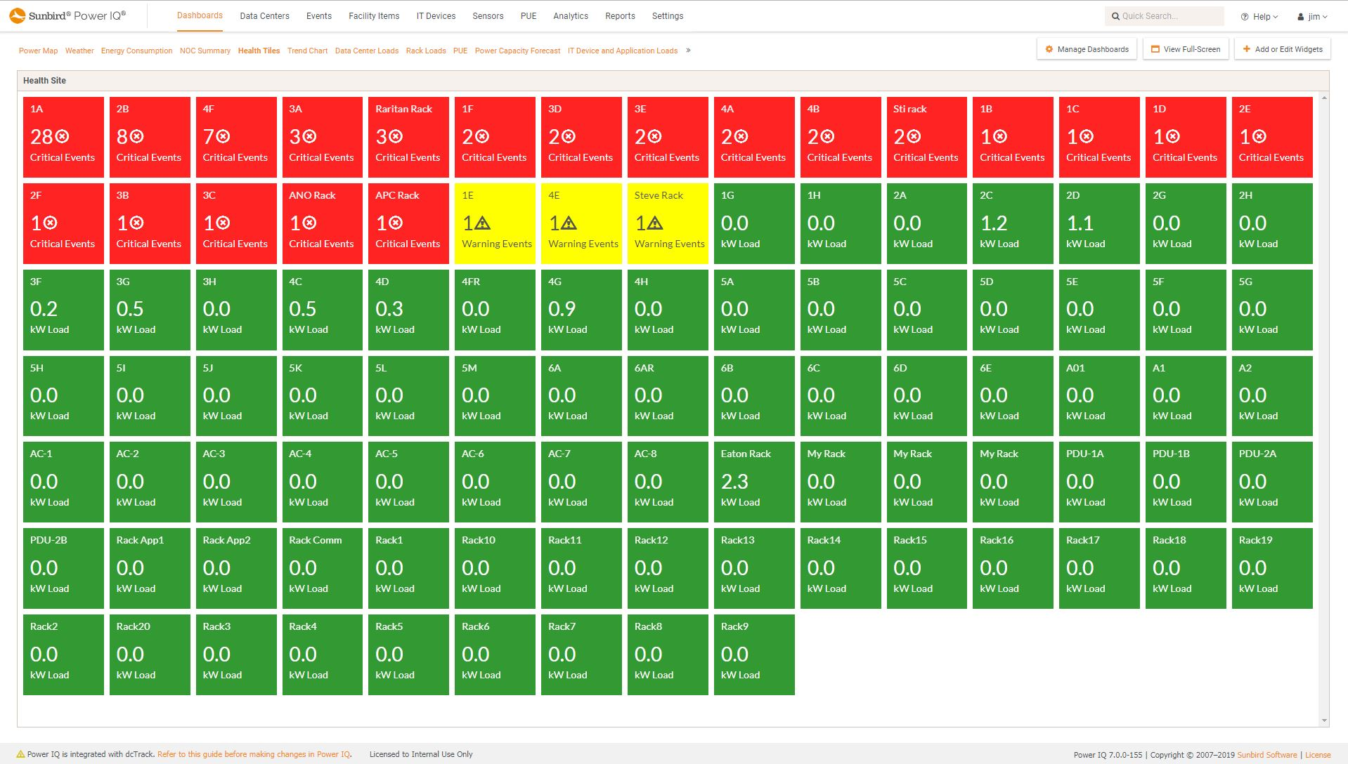
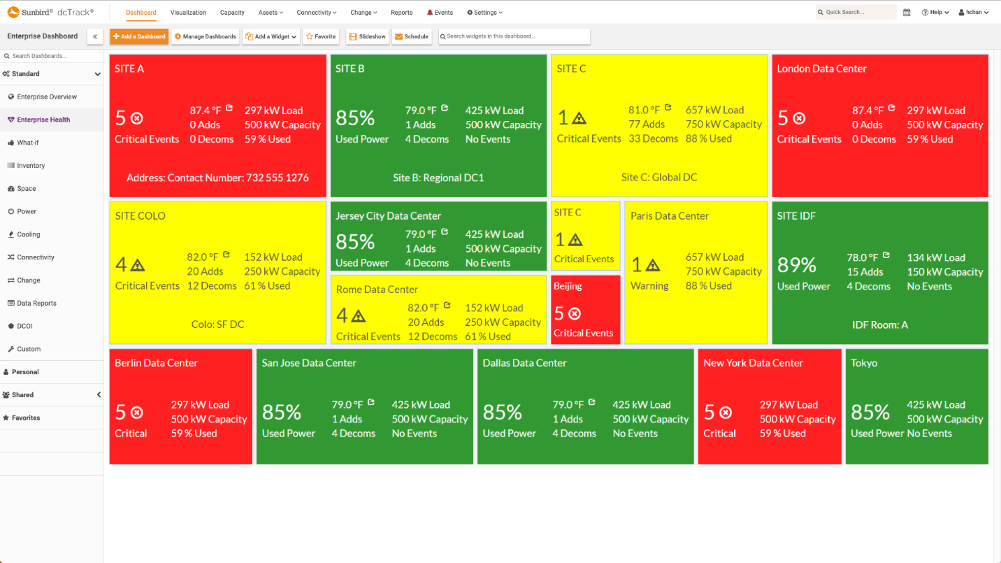

The Meeting Where Everyone Quit Before It Started
The national leadership team gathered the data center supervisors and managers for a presentation on the PowerIQ system. They walked through the capabilities, explained what the technology was designed to do, and then opened the live dashboard on a shared screen.
What the room saw was an ocean of red and yellow. Thousands of alarms. Tens of thousands of warnings. The combined alarm count across the national portfolio was staggering.
The team was walked through the basic mechanics of how to correct the errors and alarms. Then the floor was opened for thoughts. I had questions. Real questions. The kind of questions that get a person excited when a new tool is put in front of them and the possibilities are obvious. But I knew the room. I had worked with these people. I kept my mouth shut and let the senior voices go first.
The first supervisor to speak laid it out clearly. The sentiment was echoed, one by one, by every other manager and supervisor in the room:
- "This is impossible. You can’t expect us to fix all of this."
- "There is no way we’re getting rid of tens of thousands alarms. That isn’t realistic."
- "I’m not spending my time on this. This is not my job."
- "Why can't PowerIQ or Legrand fix their own errors? They installed the system."
- "If they installed it and left it in this condition, that is on them, not us."
- "We didn't break this. We shouldn't have to fix it."
Every complaint was a variation on the same theme. The task was too big. The problem belonged to someone else. The timeline was unrealistic. The expectations were unreasonable.
I sat there, outnumbered and outvoted, with a head full of questions I never got to ask. Speaking up in that moment would have made me exactly the kind of person nobody wants to be labeled as in a room full of peers. The eager one. The brown-noser. The one trying to make everyone else look bad by being enthusiastic about the thing everyone agreed was impossible.
So I said nothing. And I went back to work.

My Team Said the Exact Same Thing
I pulled my engineers together. I pulled up the PowerIQ portal and walked them through what the system was designed to do. I was genuinely excited. The tool, when working correctly, gave us the ability to see every corner of our facility in real time. Temperature issues, power imbalances, sensor anomalies, phase imbalances, all of it on one screen. A green dashboard meant a healthy data center. That was the goal. Green across the board.
Same song, same verse:
- "This is impossible. You can’t expect us to fix all of this."
- "There is no way we’re getting rid of 24,000 alarms. That isn’t realistic."
- "I’m not spending my time on this. This is not my job."
- "Why can't PowerIQ or Legrand fix their own errors? They installed the system."
- "If they installed it and left it in this condition, that is on them, not us."
- "We didn't break this. We shouldn't have to fix it."
Word for word, it was nearly the same speech I had heard in the leadership meeting. My team had not been in that room. They arrived at the same conclusion independently. That told me something. It told me the resistance was not personality-based. It was cultural. The task looked impossible, and when a task looks impossible, most reasonable people choose not to attempt it. It’s a good thing I’m unreasonable.
I was discouraged. I will not pretend I wasn’t. I was alone. I was outnumbered at every level of the organization. My peers did not want to hear about it. My team did not want to touch it. Management had issued the directive and moved on, as management does, leaving the execution to those of us on the floor, as it should be.
But I was not defeated. I have faced longer odds than a few alarms.

Little Village to the Data Center Floor
I grew up in Little Village on the west side of Chicago. It is a neighborhood with character, with culture, with community, and with teachers who would look their students in the eye and tell them, with a straight face, that kids from neighborhoods like ours were not going to end up in high-profile professional roles. That the doors to prestigious careers in technology, finance, and infrastructure leadership were not built for people who looked like us or came from where we came from. That’s why my grade school teacher told me. In other words, she said 24,216 alerts is too much to fix.
I also had people in my life who told me the opposite. That hard work, applied consistently and honestly, could open any door; and if it couldn’t that I’d be strong enough after the effort, to ram it open myself. That the only thing standing between where I was and where I wanted to be was the willingness to put in more effort than the next person. That I could just hit “Clear All” and everything would work out.
I chose to believe the second group. That choice has taken me from a neighborhood where people said I had no future, to the floor of the Chicago Mercantile Exchange's Tier IV data center, to managing the largest national data center facility in the Comcast portfolio, and eventually to directing operations across a 60-megawatt, five-state infrastructure footprint in the Bitcoin mining space for the best company I have ever worked, EZ Blockchain.
So when the room told me that clearing 24,000 alarms was impossible, I heard something different. I heard an opportunity that nobody else was willing to take.
And honestly? The fact that nobody wanted to help me was exactly what I had prepared to contradict. I had gone to work for a billion-dollar international telecommunications conglomerate, climbed into one of the most technically complex roles in their infrastructure organization, and now I had the chance to be the single person willing to pick up a sword and go fight the dragon alone while everyone else debated whether the dragon was real. Just as I planned all along…..
They wanted the app to wither on the vine. They did not want to talk about it. They did not want me to talk about it. If nobody touched it and nobody discussed it, maybe leadership would quietly forget the directive and move on to something else. That was the plan in the room. It was a good plan and perhaps it would succeed.
My plan was different.

Three Dashboards, Three Languages, One Problem, No Problem
Here is something the people who designed this system did not anticipate, or if they did, they did not solve for it: the Raritan and Legrand ecosystem involved three separate software platforms, each of which approached the same physical infrastructure from a different angle, used different naming conventions for the same equipment, reported different subsets of the available data, and generated different alert categories.
PowerIQ handled the power and energy monitoring layer. DC Tracks managed the asset and capacity side of the house, covering floor plans, cabinet layouts, asset placement, and infrastructure capacity planning. A third platform in the same family rounded out the picture with additional infrastructure and environmental management data. Same hardware. Same manufacturer family. Three completely different views of the same cabinets, each with its own taxonomy, its own alarm logic, and its own reporting format.
No AI. No collaborative filtering. No team member sitting next to me willing to cross-reference the reports. Just me, a downloaded stack of raw data exports, three different spreadsheets, and time.
I started mapping how the alarms related to each other across all three systems. A cabinet that appeared in PowerIQ as a power balance alert might show up in DC Tracks as a capacity anomaly or a misidentified asset. Understanding those relationships was the key to finding the fastest paths to the most significant alarm reductions.

The Day I Nearly Got Fired Over a Button
I had already cleared a handful of individual alarms and noticed that many of them did not return. The sensors were fine. The hardware was fine. The alerts were simply stale, artifacts of the initial deployment that had never been acknowledged or resolved. If a fraction of the 24,000 alarms were in that category, clearing them would dramatically reduce the workload.
So I had what I believed, in the moment, was an absolutely brilliant idea.
I selected every alarm in the portal. All of them. And I clicked "Clear All."
If you have ever worked in an organization with 100,000 employees and a mission-critical infrastructure, you already know what happened next.
The system cleared. Then every active alarm, every current condition that was legitimately triggering the monitoring platform, came back at exactly the same time. Hundreds. Then thousands. Then the full alarm cascade hit every stakeholder in the system simultaneously. Supervisors. Managers. Directors. Vice Presidents. Every person in the management chain who had a notification profile connected to that platform received the alert flood at the same instant.
Emails started moving. Instant messages started flying. Phones started ringing. The network engineering team, seeing an alarm volume consistent with a catastrophic failure, opened a Severity One incident call, which, in Comcast's infrastructure world, meant one thing: the Chicago Central Data Center had gone down.
It had not gone down. Everything was running perfectly. But nobody knew that yet.
I started mentally preparing to clean out my desk. I skipped a management level entirely, went directly to the Director, and told him exactly what I had done and exactly why I had done it. No spin. No deflection. I fell on the sword completely.
The Director, to his enormous credit, did something I did not expect. Once the Severity One call was resolved, once communications went out to all stakeholders confirming that the facility was operational and the alarm storm was the result of a manual action taken by someone who was actually trying to fix the problem, he did not terminate me. He did not issue a formal reprimand.
He handed me elevated access to the system and told me to keep going.

Eight Thousand Alarms Is a Great Day
When the smoke cleared, approximately 8,000 alarms had returned after the "Clear All" event. The rest were gone. Just like that, the problem had evaporated to a third. No engineering work. No tickets. No approvals. Just the simple act of clearing the accumulated noise of a never-maintained system.
Some of the people in that initial leadership meeting had looked at 1,200 alarms in the smallest facility and decided the problem was insurmountable. I was looking at 8,000 alarms and felt a surge of motivation. Eight thousand was not the finish line. Eight thousand was proof that the problem was solvable. Eight thousand, now that’s manageable. Let’s go.
I thought of a line I had carried with me for years. "When you pick up one end of the stick, you pick up the other." Fix one alarm, and the fix often cascades. Address one root cause, and three symptoms dissolve on their own. The trick was identifying which stick to pick up first. So, let’s pick up the easiest one to touch.

The Cabinet Was Too Hot. It Wasn't.
I started working through the alarms category by category. Temperature too high was near the top of the list. I pulled the first cabinet flagging an overheat condition and walked out to the floor to check it personally.
The cabinet looked fine. I pulled out my ambient thermometer. The temperature in the aisle was completely normal. The sensor was mounted high in the rack. I grabbed a step ladder, climbed it, and held my hand near the sensor.
Hot air. Immediately. A wall of warm exhaust that should not have existed on the cold aisle side of that cabinet.
The network switch at the top of the rack had been installed facing the wrong direction. The exhaust port was blowing heat directly into the cold aisle instead of out into the hot aisle behind it. The sensor was reading correctly. The problem was a switch installed backward during the original deployment.
I reviewed every temperature alarm in the portal with the same lens. I found 12 cabinets across the facility where network switches had been installed facing the wrong direction. Twelve. All of them generating valid temperature alarms. All of them fixable with a screwdriver and about 6 hours per cabinet on a 50 stakeholder approved maintenance.
When I brought the correction request to management, I heard laughter. Hoots and hollers. The idea that physical equipment had been installed incorrectly was apparently amusing to some of the people in that conversation. I did not tell them at the time how I had discovered the issue. I did not tell them about the first steps on journey of 100 miles. I wanted to eat this elephant, one bite at a time, one issue a day, one problem to correct.
I saved that story for later. When the national comparison data came back, after they all checked for heat alarms, the Chicago facility had the fewest backward-installed switches of any data center in the Comcast national portfolio. Not by a little. By a significant margin.
I did not laugh at anyone when I found out their teams had more issues.

Twelve Columns That Fixed Thousands of Alarms
By working across all three platforms and mapping the relationships between their alarm categories, I built a single master spreadsheet that identified 12 distinct root cause categories. Not 8,000 individual problems. Twelve categories of problems, each of which was responsible for a measurable slice of the total alarm count. Each that had specific, measurable, doable corrections. The problems were no longer insurmountable, they were now categorized, organized and very much solvable.
Some were environmental: sensors placed in incorrect locations, cabinets with improper airflow due to installation errors, or facility cold aisle containment gaps that were allowing hot air recirculation. Broken sensors that needed replacement; sensors installed incorrectly, or lose or installed correctly but not plugged in properly.
Some were power-related: phase imbalances at the PDU level, dual power supply units in servers that were not being properly utilized, and outlet thresholds that had been configured too aggressively for the actual load profiles of the equipment they were monitoring.
Some were data integrity issues: equipment entered in DC Tracks under the wrong cabinet assignment, creating phantom readings that the system could not reconcile with actual sensor data.
Some were broken Raritan computers with a clear resolution. Raritan then produced models with interchangeable modules! So quick and easy to replace!
Once the categories were mapped, I began generating work tickets. Quietly. My team was receiving tickets to fix specific issues, one at a time. They did not know they were working on the PowerIQ project. They thought they were just getting their normal work queue. A sensor relocation here. A switch reinstallation there. A power supply audit on a specific cabinet. Individually, each ticket was routine. Collectively, each resolved ticket was chipping away at the alarm count. Sticks were being picked up, red was turning yellow and yellow started to fade into green.

Power Balancing Without a Three-Level Approval Chain
One of the most significant alarm categories was power phase imbalance at the cabinet level. Cabinets were drawing unevenly across the three power phases and the system was generating alerts. The assumption across the team was that addressing power balance would require an elevated change control ticket, which in Comcast's process meant three separate layers of managerial approval, a formal maintenance window, multiple stakeholder approvals, and a coordination cycle that could take weeks per cabinet.
I looked at the existing pre-approved maintenance ticket framework instead. We already had standing approval to perform dual power supply validation work, which is a routine process of confirming that both PSUs in a server are operational and capable of sustaining the load independently. That process inherently involved temporarily adjusting which power feed was active.
We verified that both power supplies in each flagged server were healthy. The first set of tickets was to verify all power supplies in a particular row were on and working. If a power supply was not working we’d order a replacement and fix the issue.
Now, I was ready to have the team rebalance power at the PDU level. They started moving power cables. They, then, followed a standard 30-second standby interval before moving the secondary power cable. The result was properly balanced phase loads across the cabinets in question, achieved entirely within our existing pre-approved maintenance framework, with no elevated tickets and no multi-week approval cycle. Most importantly, not one server went down, not one service was interrupted, not one owner even knew.
The power balance alarms began clearing in batches. Weeks, not months.

Nine Months Later, One Sensor Left
Nine months after I sat in that meeting and kept my mouth shut while every person in the room announced that the task was impossible, I was looking at a single remaining alert. I waited to get to that one last. It was the only one of it’s kind and I decided not to look at it until the very end. The clear finish line.
One alarm. In the MDF room. A sensor reading "too cold."
I walked to the MDF, found the sensor, and discovered it had been installed directly in front of an air conditioning vent. It was reading the discharge air from the cooling unit, not the ambient room temperature. Of course it was reading cold. It was sitting on a cold air vent.
I assigned the relocation ticket to an engineer. He came back and told me we would need approval to move it, because, in his words, “someone had put it there for a reason”. I asked around. Nobody knew who had put it there or why. I could not find a single person willing to claim ownership of the decision to mount an ambient temperature sensor on an active cooling vent. So, I decided that reason was stupid.
I moved the sensor six inches.
The alarm cleared.
The dashboard was green. All of it. Every cabinet balanced. Every sensor reading within expected parameters. Every temperature alarm resolved. Every power imbalance corrected. Twenty-four thousand alarms, cleared. Not hidden. Not suppressed. Fixed.
I sat there for well over a few minutes. Admiring the work our Engineers had done, but more than that. I reveled in the fact that all of my world said it couldn’t be done. I had gotten it done. Not single handedly, of course not, there’s no way. I had a hidden team behind me. They were not hidden; their goal was hidden. And they did it – after saying they could never do it: they did it.

Who Sends a Meeting Request to a Vice President?
I opened my calendar and created two meeting invitations. One for the Director. One for the VP of our organization.
My colleagues would have thought I had lost my mind. Supervisors do not send unsolicited meeting requests to Vice Presidents. That is not how the hierarchy works. You go up through your manager, who goes up through their director, who eventually filters the message upward through whatever channels exist between the floor and the executive level.
I sent the invitations anyway. I had earned the right. My prize was looking at them in they eye and giving them the good news.
The Director meeting was first. I shared my screen and opened the global PowerIQ dashboard. He looked at it and said, almost apologetically, that leadership had been discussing the system recently and was likely going to decommission it. The technology had not delivered the value they had invested in. The alarm count had not improved meaningfully. The consensus was forming that the system was a failed purchase. We didn’t have the buy-in and the work was far too much and far too complicated.
"You might want to hang tight for a minute, I need to show you something." I said.
I drilled down to Chicago.
The silence on the call outlasted the idea this was impossible.
"Aviran, is there something wrong with your portal?"
"No."
"How did you do that?"
"Rob, how do you eat an elephant?"
"No. Tell me. How did you do that?"
We spent the rest of that meeting going through every step: the three-platform data mapping, the twelve root cause categories, the backward switches, the pre-approved maintenance framework for power rebalancing, the quiet ticket strategy. All of it.
The next day I met with the VP.
"How can I help you, Aviran?"
"I wanted to show you something on PowerIQ."
"Yes, we're looking at that system. Looks like we may have spent millions on a bad product."
I drilled down to Chicago.
"Aviran, is that accurate?"
"Yes."
"How did you get that done?"
"Dan, how do you eat an elephant?"
I loved his response, the response of a great leader:
“Good, good, tell me more.”
Same story. Same questions. Same answers. At the end of that meeting, the VP asked whether the methodology could be replicated in other facilities. He asked me if I could lead the effort.
The rest is history.

Telling the Team the Truth
Once the national rollout of the methodology began and other facilities started working through their alarm counts with structured guidance, I sat my team down and told them what had actually happened over the previous nine months.
Every ticket they had resolved during that period, every sensor relocation, every switch reinstallation, every power supply validation, every cabinet audit, had been part of the PowerIQ remediation project. They had cleared 24,000+ alarms without knowing they were doing it.
They were the ones who had actually done the work. I had identified the problems and opened the tickets. They had gone out to the floor, climbed the ladders, pulled the cables, moved the sensors, and done every physical task required to turn that dashboard green. They did the work that they said could not be done.
Once they understood what they had accomplished, the dynamic in the team shifted in a very drastic manner. They took ownership of the portal. They monitored it. When an alarm appeared, they addressed it. The Chicago facility stayed green for the remainder of my time there.
Those engineers are genuinely the finest I have worked with in my career. They did not need a mission. They just needed a ticket.

What This Story Is Actually About
Comcast spent millions of dollars on the Raritan and Legrand infrastructure intelligence platform. The hardware was state of the art. The software was genuinely capable. The technology worked exactly as designed.
They were within weeks of scrapping the entire investment.
Not because the product was bad. Not because the technology failed. Because nobody was willing to do the work required to make it succeed. The alarm count looked insurmountable. The task looked impossible. The path forward required someone to start walking without knowing exactly where the path ended.
This is the pattern that plays out every day in organizations that invest heavily in infrastructure technology. The hardware gets installed. The software gets deployed. The leadership team sees the dashboard for the first time. The dashboard looks terrible because it was never calibrated. The leadership team concludes that the product is terrible. The product gets decommissioned. The vendor gets blamed. The investment is written off.
And somewhere in that organization, there is a data center engineer or supervisor who looked at the dashboard and saw something different. Who saw a solvable problem, a manageable workload, a clear path from red to yellow to green. Who never got the chance to try because the decision to abandon the investment was made before anyone was willing to start.
If you are a manager facing an impossible task, you have three options. You do it yourself, you find one person willing to believe it can be done, or you fail. You do not need a team. You do not need consensus. You do not need every supervisor in the room to buy in. You need one person willing to never say die, even when that person is you.
The Raritan and Legrand system, the PowerIQ platform, the DCTrack asset management layer, the full suite of intelligent PDUs and environmental sensors, it is genuinely first-class technology. It deserved better than a meeting where everyone in the room decided it was someone else's problem.
As I return to my data center roots after four years running Bitcoin mining infrastructure, I am not looking for easy problems. I have never been particularly good at those; those are boring. I am looking for the next impossible mission. And as a kid in a movie once said, “C.Q. signing off, a little more educated and a little more shocked by his sister.”

About the Author
Aviran Vargas is the Director of Operations and Infrastructure for EZ Blockchain, a Chicago-based Bitcoin mining and blockchain infrastructure company. He currently leads more than 60 megawatts of active operations across a five-state footprint spanning the Midwest and South, overseeing data center facilities, power procurement, and ASIC mining hardware at scale.
His data center career began at the Chicago Mercantile Exchange, where he worked in one of the most operationally demanding Tier IV environments in financial services. He later moved to Comcast, where he managed the company's largest national data center facility in Northlake, Illinois, leading a team of engineers across multi-megawatt infrastructure serving millions of subscribers.
Aviran holds multiple Data Center Expert certifications and earned a Blockchain Fundamentals certification in 2026. He is also a recognized expert witness for Bitcoin hosting and cryptocurrency infrastructure disputes, with notable case experience including a unanimous defense verdict in a significant commercial matter tried in Cook County. He operates his own Crypto Expert Witness practice.
Learn more:
- www.EZBlockchain.net
- www.BTCExpertWitness.com
- www.AviranVargas.com

