Dizzying Consequences: The Hidden Costs of Post-Traumatic Vertigo and Balance Disorders in Motor Vehicle Injury Cases
Why smart litigators should look closer at vestibular dysfunction after head trauma—and how ignoring it can leave money (and justice) on the table.

By Brent R. Driskill, MD
Otolaryngologist and Medical-Legal Consultant

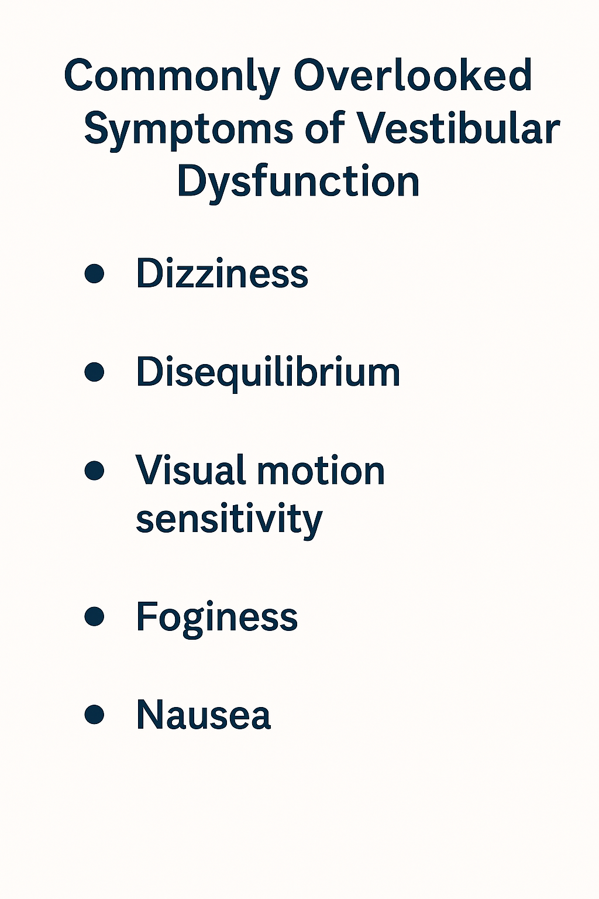
When a client walks into your office after a motor vehicle accident, they might describe the obvious: neck pain, headaches, even a mental fog. But what about the invisible culprit quietly wreaking havoc on their quality of life and earning potential—post-traumatic vertigo and balance disorders?
These symptoms are far more common than most lawyers realize, especially in cases involving even mild traumatic brain injury (mTBI). And yet, they’re underdiagnosed, undercompensated, and often left out of the settlement equation entirely.
It’s time to change that.
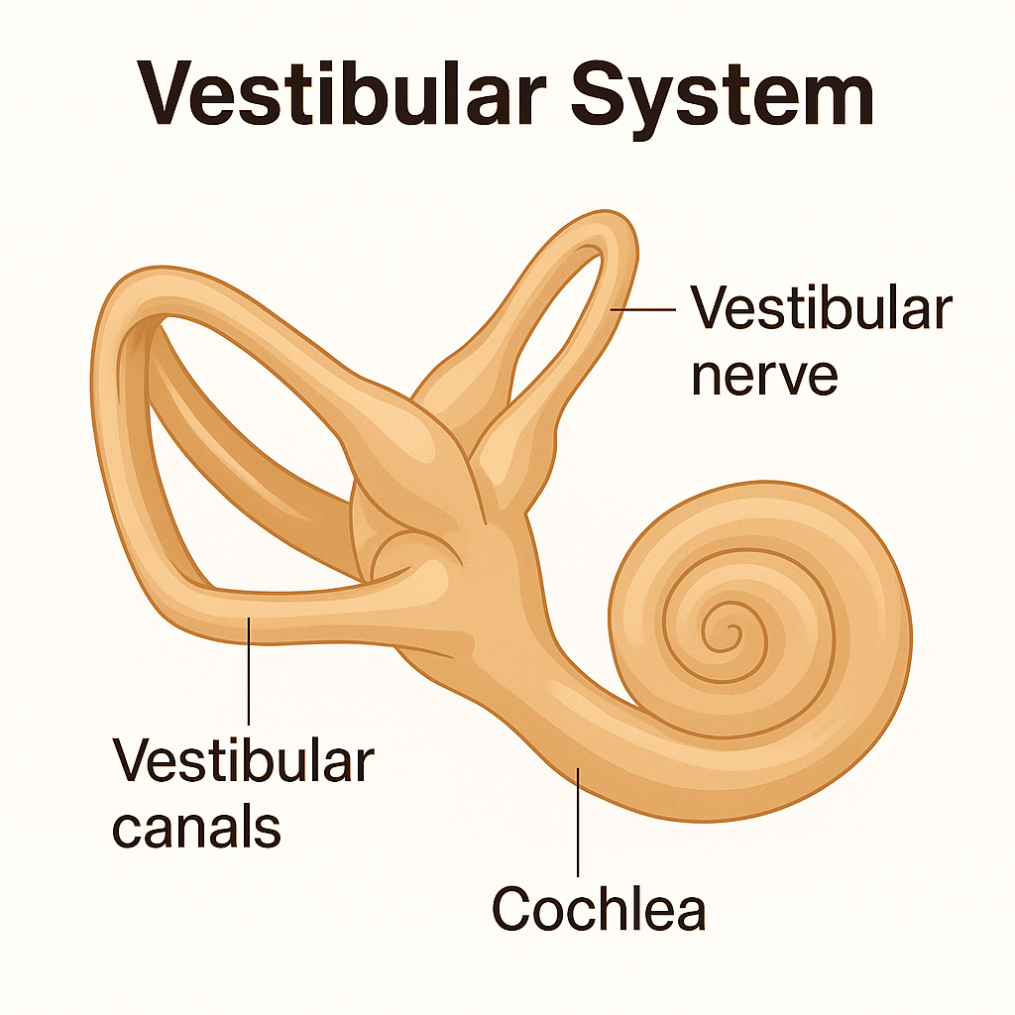
The vestibular system—our internal GPS for balance and spatial orientation—is a delicate network involving the inner ear, brainstem, and cerebellum. Trauma from whiplash, concussive forces, or direct head impact can disrupt this system even when imaging studies like MRI or CT scans appear normal.

Located within the inner ear, the vestibular system functions as the body’s gyroscope. It consists of semicircular canals, otolith organs, and neural connections to the brainstem and cerebellum. This delicate apparatus senses head motion, gravity, and spatial orientation, allowing us to maintain balance, posture, and coordinated movement. When disrupted—even by seemingly minor trauma—individuals may experience vertigo, imbalance, and nausea, sometimes for months or years.
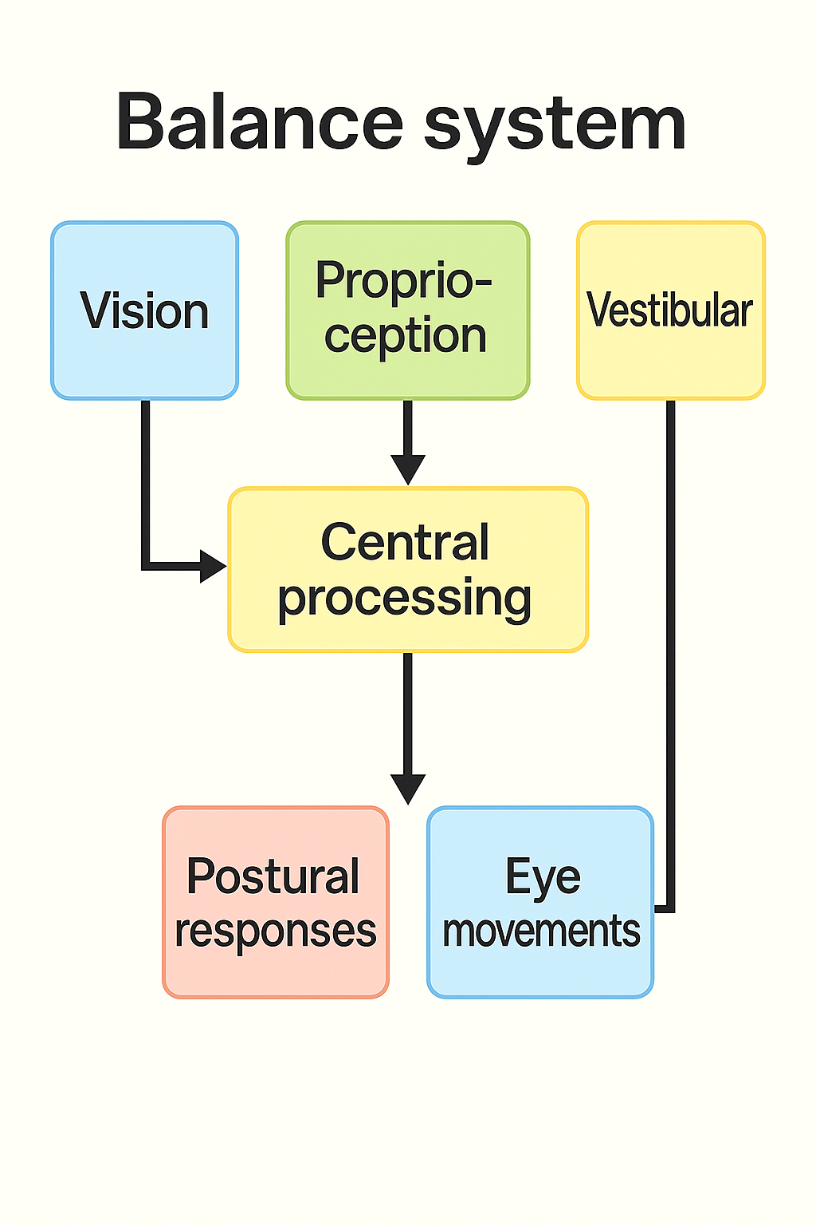

Multiple studies estimate that up to 30–65% of patients with mTBI report vestibular symptoms post-injury. A 2015 study in NeuroRehabilitation found persistent balance issues in 50% of concussion patients three months post-injury, with some deficits lasting over a year.
And here's the kicker: Many of these individuals do not receive targeted vestibular therapy, leading to prolonged symptoms, misdiagnoses (often chalked up to “anxiety”), and—most importantly for your clients—substantial lost income.

The Economic Impact: Vertigo Ain’t Cheap
A 2022 report in The Journal of Head Trauma Rehabilitation estimated the average annual lost income for individuals with persistent post-traumatic vertigo to be $15,000–$25,000, not including healthcare costs. Add in occupational downgrades, missed advancement opportunities, or inability to return to certain professions (think: pilots, mechanics, teachers), and the long-term economic toll can easily reach six figures.
Yet, in most PI cases, this remains an “invisible injury.” Why? Because patients don’t always have the language to describe it—and general practitioners don’t always have the tools to detect it.

Clinical Experience
Throughout my career, I’ve evaluated and treated numerous patients with post-traumatic vestibular dysfunction. I served 24 years in the United States Navy. I had the privilege to take care of Marines returning from war and worked closely with the traumatic brain injury center located next to my hospital. I learned through numerous patients the complexity of these injuries. These patients needed accurate diagnosis and targeted therapy to return to full military duty, which often took more than a year.
I continued after my military retirement to see Worker’s compensation cases in the San Diego area. Numerous patients suffered from complex balance issues after being struck by a forklift at work or falling from a rooftop and striking their head.
One notable case involved a retired firefighter who experienced persistent imbalance and disorientation after a low speed rear-end collision. Despite normal imaging and no visible injury, he was unable to safely return to work on ladders or high platforms. A comprehensive vestibular exam confirmed bilateral vestibular hypofunction. With targeted therapy, his symptoms improved, but not before he lost nearly a year of income.
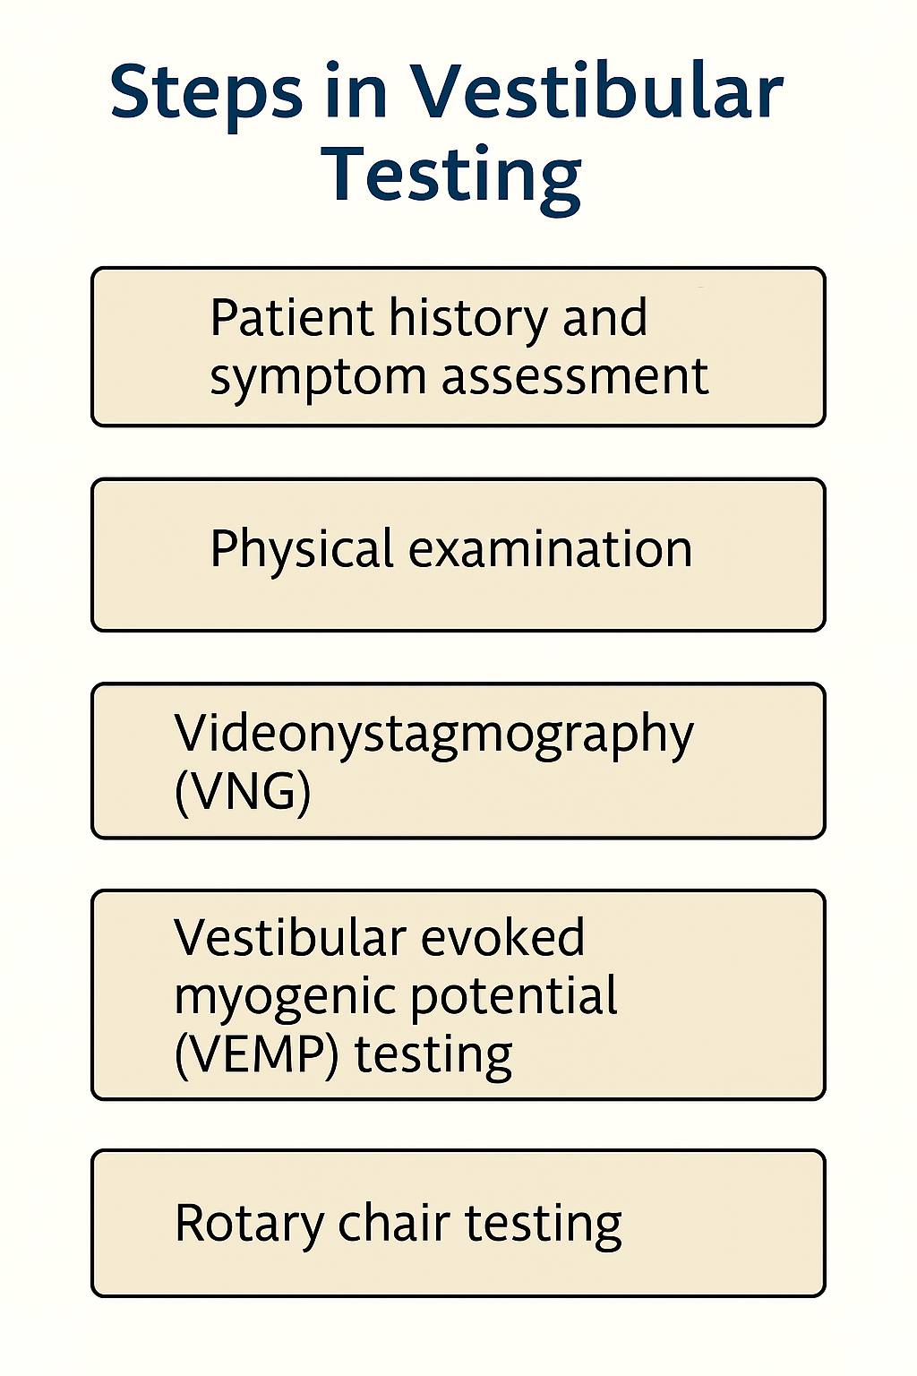
In another case, a 68-year-old woman fell at home two weeks after a minor car accident. Her fall resulted in a hip fracture and hospitalization. It was later determined that undiagnosed post-traumatic vertigo from the accident led to her instability. Older adults are especially vulnerable—age-related sensory decline can mask vestibular symptoms or magnify their impact, increasing the risk for falls, fractures, and functional decline.
These tests help pinpoint whether dysfunction originates in the inner ear, central processing pathways, or a combination of both. Early diagnosis is key to guiding effective therapy. In my legal expert role I aid attorneys and their clients to obtain proper testing and diagnosis of these conditions.
If you're litigating motor vehicle injury claims, especially those involving:
- Concussion or suspected mTBI
- Airbag deployment or whiplash
- Client complaints of fogginess, dizziness, or “just feeling off”
…it’s time to consult an otolaryngologist. Get a vestibular function test. Consider expert testimony. These cases are more common than you think—and more valuable than you realize.

Medical studies support your claim – This is small sample.

Skóra W, Stańczyk R, Pajor A, Jozefowicz-Korczyńska M. Vestibular system dysfunction in patients after mild traumatic brain injury. Ann Agric Environ Med. 2018 Dec 20;25(4):665-668. doi: 10.26444/aaem/81138. Epub 2018 Feb 14. PMID: 30586971.
Conclusions: In patients after mild traumatic brain injury, about one-fourth of them had vestibular system dysfunction with the same frequency of peripheral, central and mixed lesions in videonystagmography. Subjective post-traumatic symptoms and vestibular system dysfunction in patients after MTBI decreases after 6-month follow-up. However, more than half of patients still have abnormal VNG results, which indicate dysfunction of the central vestibular system.

Taylor RL, Wise KJ, Taylor D, Chaudhary S, Thorne PR. Patterns of vestibular dysfunction in chronic traumatic brain injury. Front Neurol. 2022 Dec 1;13:942349. doi: 10.3389/fneur.2022.942349. PMID: 36530624; PMCID: PMC9751886.
Conclusions: This study reviewed vestibular testing on traumatic brain injury patients. The investigators found a 33% prevalence of vestibular dysfunction. Oculomotor dysfunction and postural instability were recorded in 41.1 and 75.5% of patients, respectively. The interesting point is severe traumatic brain injury patients were excluded and the testing wasn’t performed until 12 months after injury.

Feller JJ, Duff MC, Clough S, Jacobson GP, Roberts RA, Romero DJ. Evidence of Peripheral Vestibular Impairment Among Adults With Chronic Moderate-Severe Traumatic Brain Injury. Am J Audiol. 2024 Dec 2;33(4):1118-1134. doi: 10.1044/2024_AJA-24-00058. Epub 2024 Oct 11. PMID: 39392912; PMCID: PMC11622786.
Conclusions: Research assessing vestibular function in adults with chronic moderate-severe TBI found that approximately 63% had abnormal vestibular evoked myogenic potentials (VEMPs), indicating otolith organ dysfunction. Additionally, up to 80% reported vestibular symptoms, with 36% noting a negative impact on quality of life.

Bottom Line
Vertigo is not just a nuisance—it’s a disabling, life-altering, and medically verifiable consequence of head trauma. As more courts recognize vestibular dysfunction’s legitimacy, smart attorneys will leverage this awareness to strengthen their cases and secure rightful compensation.

Your client’s career—and your case value—might depend on it.

About the Author
Dr. Brent R. Driskill is a board-certified otolaryngologist with over 20 years of experience, including military service where he conducted hundreds of vestibular and balance evaluations on service members exposed to blast trauma and other head injuries. His work in the military sharpened his expertise in identifying subtle, yet disabling, post-traumatic balance disorders often overlooked in civilian settings.
As a medical-legal expert, Dr. Driskill provides honest, straightforward evaluations, having served on both plaintiff and defense teams. He specializes in post-traumatic hearing, balance, and cranial nerve injuries and delivers IMEs and expert testimony nationwide through ENTLegalExpert.com.

