Hydrostructural Geology: Examining the Anisotropy Assumption
for Flow and Solute Distribution in Sedimentary Bedrock Aquifers
of the Newark Rift Basin, New Jersey
Thomas D. Gillespie, P.G.
Principal Geologist, Gilmore & Associates, Inc.

Geological Association of New Jersey 2024
Advances in Applied Hydrogeology of the Newark Basin

Abstract

Stratigraphic and structural planar discontinuities which provide for the bulk of groundwater flow through the consolidated rock aquifers of the Newark Rift Basin occur primarily as three-dimensional networks consisting of sets of non-randomly oriented, pervasive, finite, two-dimensional pore spaces. Conceptualizations of groundwater flow through such discontinuity networks range from those in which it is assumed that no planar fabric element exerts a dominating control on flow directions to those in which a single fabric element of several in a network controls flow. The conceptualizations of individual investigators and regulatory agency reviewers are many times applied presumptively, with the investigation being designed and the results interpreted within the constraints of the particular presumptive concept – a practice which has the potential to result in a self-fulfilling prophecy. The position reported herein is that there is no conceptualization of groundwater flow and contaminant transport in bedrock aquifers which can be presumptively applied across all terrains and, more specifically in the case of the structural rift basins inboard of the coastal plain along the length of the Atlantic Continental Margin, no universally applicable conceptualization. That is because both the lithologic and hydraulic properties of the several formations and numerous stratigraphic members within the Basin vary considerably both horizontally and vertically at scales comparable to the study areas of virtually all site investigations, as do the networks of stratigraphic and structural discontinuities through which gravity-driven groundwater flow occurs.

The method described examines flow within individual discontinuities and discontinuity networks at scales of both the Representative Elemental Volume and the hydrogeologic domain and provides for conceptualization of groundwater flow and contaminant transport after site-specific structural and hydrologic data are combined pursuant to the self-evident hydraulic premises that, within the different zones of three-dimensional hydraulic potential fields: all pore spaces are saturated; all particles of groundwater are possessed of a total hydraulic potential; and the local field hydraulic gradient is the controlling factor on groundwater flow direction. The resolution of local field hydraulic gradients into the differently-oriented discontinuity sets of a network determines local groundwater anisotropy characteristics on the scale of the representative elemental volume. The degree to which the anisotropy inherent at the representative elemental volume scale magnifies to the scale of the hydrogeologic domain is a function of: the angular disparity between the field hydraulic gradient and the mean orientation of each discontinuity set considered collectively; the spatial distribution of the discontinuity sets; the connectivity of sets within the network; and the mean surface areas of individual, finite discontinuities in each set. The apparent condition of anisotropy that groundwater is partitioned preferentially into specific stratigraphic zones is herein shown to be a function of lithologic and structural conditions prevalent within those zones; the orientation of the strike of bedding in such zones exerts no more control on flow direction than do the strike directions of other discontinuity sets in the network.
Copyright © Thomas D. Gillespie, P.G.
The material presented herein is copyright protected and is the sole property of Thomas D. Gillespie, P.G. who reserves all rights to the contents. No portion of this work may be copied, reproduced or redistributed for any purpose without written permission of the copyright holder. Violation of this copyright can result in legal penalties, financial damages, injunctions or criminal liability. This presentation contains non-copyrighted materials that have been used under the fair use provisions of U.S. copyright law. Further use, duplication, or distribution is prohibited.

Introduction

Groundwater flow in bedrock aquifers is primarily through three-dimensional discontinuity networks consisting of multiple sets of pervasive, non-randomly oriented structural and/or stratigraphic discontinuities, the strikes of which are typically not co-oriented with the hydraulic gradient. Within each discontinuity set of the sedimentary formations of the Newark Basin, individual discontinuities are finite, two-dimensional pore spaces connected to one or more discontinuities of other sets (Zakharova, et. al., 2016). Formations of the Newark Basin typically contain two types of pervasive discontinuity sets:

- Stratigraphic - consisting of bedding plane partings and member/formation contacts. These tend to be finite, sub-planar partings with generally consistent low dip angles (typically ~10°) toward the northwest, although significant variability is not uncommon;

- Structural – including veins (open and filled; Herman, 2005) and joints, the latter of which are predominantly finite, sub-vertical, planar extensional partings typically consisting of two sets:

- a systematic joint set, which was the first of the two sets to form. Individual joints within this set are sub-vertical and are continuous over surface areas in the range of approximately 200 m² (Twiss & Moores, 2007):

- a non-systematic joint set, also referred to as cross joints. These joints are sub-vertical, are generally sub-orthogonal to the systematic joints and extend only the distance between two successive systematic joint planes.

Accordingly, it is generally the case that sedimentary rocks of the Newark Basin contain at least three mutually orthogonal discontinuity sets (Harms and Stephens, 1979; Herman, 2001, 2005) including joints, veins, faults and stratigraphic fabric (Figure 1). It is commonly observed that within the scale of any site investigation the rock is segmented by two steeply-dipping brittle failure discontinuities and bedding plane partings (Herman, 2001, 2005). Flow within the igneous rocks of the Basin are not considered herein (Figure 1b)

The several major sedimentary formations of the basin display significant differences in the spacing of bedding plan partings, member contacts and structural discontinuity spacing. Accordingly, the research presented herein is applicable to all of the formations, but is specific to none.
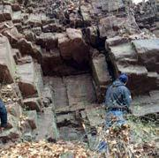
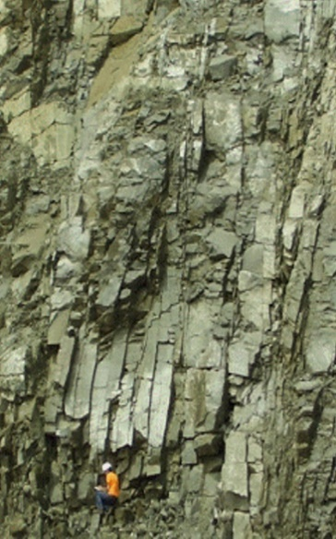

Figure 1b. Photograph of diabase sill, Plainsboro depicting non-randomly oriented extension joints (photo by the author)

Figure 1a. Photograph of the Stockton Formation depicting bedding plane partings and two sub-orthogonal joint sets (photo from NJDEP)

Similar to porous medium aquifers, bulk aquifer flow is down a field hydraulic gradient (Bear, 1983) within the constraints of local/regional three-dimensional hydraulic potential fields and occurs at a velocity consistent with the formation’s bulk hydraulic conductivity (Smith and Schwartz, 1993). Except for hydraulic conditions within zones of influence of permanent water supply wells, the distribution of solutes into a plume (Poehls & Smith, 2009) occurs under the hydraulic influence of the natural prevailing field hydraulic gradient. In a bedrock aquifer consisting of multiple, non-randomly oriented, planar discontinuity sets, distributional anisotropy of solutes with respect to the natural field hydraulic gradient can result from unequal rates of flow into and through the differently-oriented discontinuity sets with respect to the field hydraulic gradient (Figure 2) on the scale of the representative elemental volume (REV, Bear, 1983).
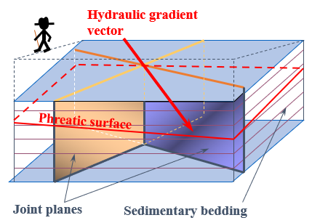

Figure 2b. Strike directions of the three discontinuity sets of Figure 5a, depicting the azimuthal relationships with the field hydraulic gradient vector (red arrow).
Figure2a. Block diagram schematic of a saturated rock mass with three sub-orthogonal discontinuity sets in which the hydraulic gradient vector is not sub-parallel to any of the sets.

The degree to which anisotropy at the scale of the representative elemental volume translates to the domain scale (Surrette and Allen, 2008; Smith and Schwartz, 1993) is a function of: the angular disparity between the field hydraulic gradient and the in-plane gradients of each discontinuity set considered collectively; the spatial distribution of the discontinuity sets; the connectivity of sets within the network; and the mean surface areas of individual, finite discontinuities in each set.

In-Plane Hydraulic Gradients, Flow in Individual Discontinuities and Discontinuity Sets

At the scale of the representative elemental volume, the intersection of the planar phreatic surface and the wall rock of a saturated discontinuity describes an apparent dip (Figure 3). The plunge of the line of intersection (A-B’) is at an angle less than the dip of the phreatic surface (Line A – B) with a trend close, but not equal to, the strike of the more steeply dipping discontinuity plane (Ragan, 2009). Because the along-strike decrease of the phreatic surface elevation within the discontinuity is the measure of decreasing total hydraulic potential (Hubbert, 1940), the plunge of the line of intersection of that phreatic surface resolved within the discontinuity describes an in-plane hydraulic gradient vector between Points A and B’. The result is that flow within individual planar discontinuities is in a direction generally, but not exactly parallel to the strike of that structural plane and at some angle, α, to the horizontal which is less than the dip angle of the field hydraulic gradient (A – B, Figure 3).

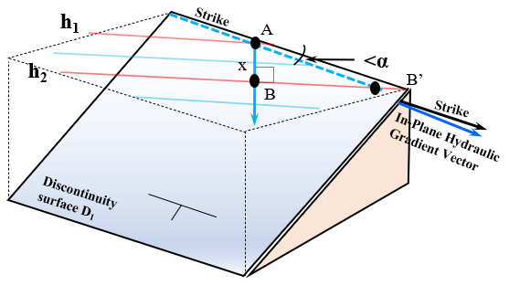
Figure 3. Configuration of the phreatic surface within a planar discontinuity. The line of intersection between the phreatic surface and the discontinuity walls (apparent dip A – B’) is at angle α to the strike of the plane.

All pore spaces below the phreatic surface are saturated so every particle of water in the phreatic zone has a hydraulic potential consisting of an elevation head and pressure head consistent with the total hydraulic potential measured as the phreatic surface at any point. Consequently, every particle of groundwater is both affected by and affects that potential field. Therefore, groundwater in three-dimensional hydraulic potential fields flows simultaneously through all discontinuities within the non-randomly-oriented structural and stratigraphic sets. Instantaneous groundwater flow through any unit volume of aquifer, therefore, occurs in several directions, each sub-parallel to the strikes of the containing planar discontinuities (Figures 2 and 3), typically none of which directions are directly down the field hydraulic gradient on the scale of the representative elemental volume (Figure 4).
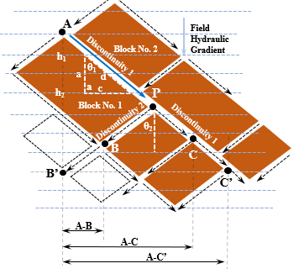
In Figure 4, a particle of groundwater at the upgradient end of discontinuity-bounded blocks of rock (Nos. 1 and 2, Point A) enters Discontinuity 1, a single joint plane in a systematic set, the strike of which is oriented θ₁° from the field hydraulic gradient. Within Discontinuity 1, there is a component of cross gradient flow (c) for every unit distance of downgradient flow (a). The actual distance traveled by the particle of water (d) is longer than the distance directly down the field hydraulic gradient by a factor of: a/cosθ₁ but the difference in elevation (h₁ – h₂) is the same in plane segment, d, as it is in the direction of the field hydraulic gradient, a. The in-plane hydraulic gradient in plane segment d, therefore, (h₁ – h₂)/(a/cosθ₁), is of lesser magnitude than the field hydraulic gradient, (h₁ – h₂/a).

Figure 4. Two-dimensional schematic of flow through multiple, non-randomly-oriented planar discontinuities

The cross gradient component of flow within Discontinuity 1 (leg c of the right triangle), persists until the particle of groundwater reaches Point P where there is a junction with Discontinuity 2. At Point P the particle of groundwater must either continue along the in-plane gradient in Discontinuity 1 ((h₁ – h₂)/(a/cosθ₁)) or enter Discontinuity 2 with an in-plane gradient of (h₁ – h₂)/(a/cos⁻θ₂). It is at the infinitesimal inflection points where a particle of water can move from one discontinuity into another that instantaneous flow can be directly down the field hydraulic gradient (Surrette and Allen, 2008; Smith and Schwartz, 1993). Depending on which discontinuity it enters, the particle’s flow will be in a direction which will, at the end of traversing the distance of one additional representative elemental volume, bring it either nearer to (distance A-B) or farther from (distance A-C) a point directly downgradient of Point A where the local diversion from the field hydraulic gradient began. After having traveled the distance of two representative elemental volumes (particle at either Point B’ or C’), the potential range of resultant cross-gradient deflections would either bring the particle to a point directly down the field hydraulic gradient from Point A (Point B’), or to distance A-C’ in the cross-gradient direction. Continued deflection(s) into the two discontinuity sets depicted in the two-dimensional schematic of Figure 4 can either normalize or amplify the anisotropy of flow with respect to the direction of the field hydraulic gradient. It is also at the intersections where mixing of solutes occurs and which points are, consequently, the loci of anisotropic transport (Smith and Schwartz, 1993).

Because the loss of hydraulic potential within the confines of a discontinuity is continuous along the plunge of the in-plane gradient vector (Toth, 2009; Hubbert, 1940), the orientation of the in-plane gradient can be determined within the discontinuity (Figure 5) using mapped equipotentials of the field hydraulic gradient.

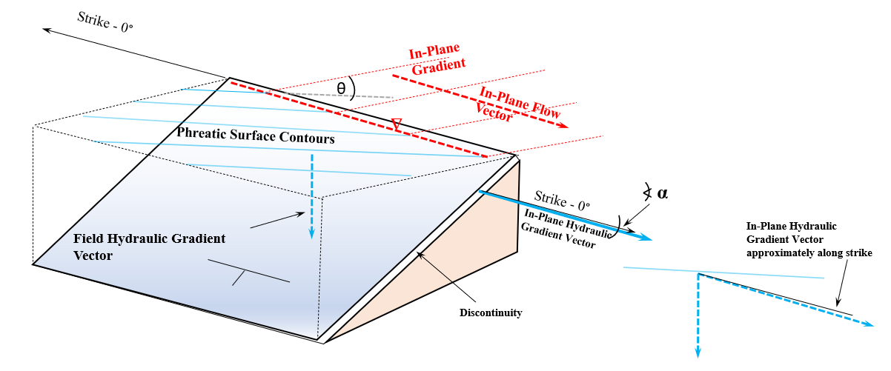
Figure 5. Line of intersection (broken red line) between phreatic surface and planar discontinuity sidewall with a trend direction between the strikes of the two planar surfaces but nearer the strike of the steeper plane and a plunge angle less than the dip angle of the hydraulic gradient (Ragan, 2009).

The degree to which the orientation of the in-plane gradient differs from the field hydraulic gradient can be determined by trigonometrically resolving the field hydraulic gradient contours into the discontinuity. In Figure 6, discontinuity Plane A intersects the field hydraulic gradient at angle Ɵ, forming a right triangle between the field gradient vector (Line A – C) and the plane. The length of the adjacent leg, AC, which is equivalent to the change in distance (ΔX) over which the phreatic surface elevation of the field gradient decreases from h₁ to h₂, is lesser than the length of the hypotenuse, BC, the measured length of the in-plane hydraulic gradient, ΔX₁, which is given by:

Δ X₁ = ΔX/cos Ө eq. 1

The change in elevation, h₁ - h₂, over both distances ΔX and ΔX₁ remains constant (Figure 6), resulting in an In-Plane Gradient, i_{p}, lower than the field hydraulic gradient by an amount given by:

i_{p} = (h₁-h₂)/(ΔX/cos Ө) eq. 2

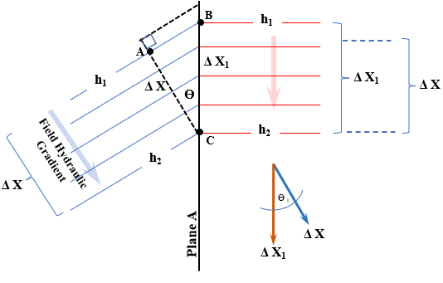

Figure 6. Schematic of groundwater flow within a single discontinuity plane depicting the difference between the FHG and in-plane gradients.

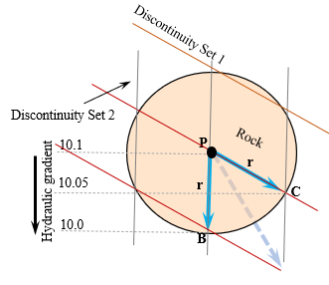
Figure 7 is a schematic of flow within two intersecting discontinuities, the strike of one being parallel to the field hydraulic gradient. The horizontal distances traveled by two particles of groundwater originating simultaneously at the discontinuity intersection, P, and flowing down pathways PB and PC, respectively, are equal (PB = PC = r), but the total hydraulic potential of the particle at Point C is higher than the particle at Point B, having lost only half the energy over the same travel distance. The in-plane hydraulic gradient along pathway PC, therefore, is lower that the gradient along pathway PB. Consequently, the potential velocities of groundwater particles flowing through the two pathways are unequal and can be estimated using the Darcian equation for bulk flow through some domainally-relevant cross sectional area of the formation (Smith and Schwartz, 1993):
Figure 7. Schematic of differential flow potential and anisotropic distribution of solutes in differently-oriented discontinuities under a single field hydraulic gradient on the scale of the representative elemental volume.
V_{PB} = k(⁻0.1/r)/n (eq. 3)

V_{PC} = k(⁻0.05/r)/n (eq. 4)

with the theoretical result that V_{PC} < V_{PB.}

Therefore, two particles of water leaving Point P simultaneously but flowing down the two pathways, would not reach Points B and C at the same time. That is intuitive because if they did, the field hydraulic gradient would be at an azimuth mid-way between the strikes of the two discontinuity planes (grey broken arrow in Figure 7) as described by Smith and Schwartz,(1993).

Because of the lower gradient of path PC, the travel distance for a particle of water to reach the equivalent hydraulic potential of Point B is illustrated in Figure 8 where distance PC’ is given by:

(r/cosΦ) – r (eq. 5)

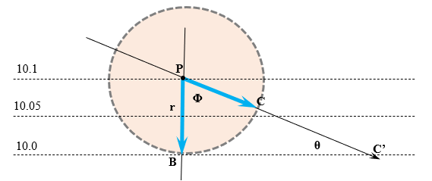
Figure 8. Difference in travel distance for two particles of water beginning at elevation 10.1 at Point P and ending at the same equipotential at elevation 10.0 (Points B and C’).

Relative travel times in the two planes are given by:

Discontinuity PB: t_{PB} = r/(k(⁻0.1/r)/n) (eq. 6)

and

Discontinuity PC’ t_{PC’}= (r/cosΦ)/(k(⁻0.05/r)/n) (eq. 7)

Consequently, on the scale of the representative elemental volume, directional anisotropy in the bulk rate of solute transport down the field hydraulic gradient but partitioned into planar discontinuities at unequal azimuthal angles to the field hydraulic gradient derives from both the difference of in-plane potential velocity (Eqs. 3 and 4) and from extended flow path lengths (eq. 5) with the resulting difference in travel times down the two different pathways (Eqs. 6 and 7). Examining this phenomenon schematically (Figure 9), it is evident that two water particles which begin flowing at time t₀ at Points A and B, but flowing down Planes D₁ and D₂, respectively, will not reach Point C simultaneously. However, because groundwater in the phreatic zone is a continuum, two random particles of water in Discontinuities D₁ and D₂, respectively, have identical total hydraulic potentials at Points D and D’ because they occur within a single flow field and are located on the same equipotential line. But the particles have different potential velocities so the equivalence is instantaneous and transient; i.e., the similar equivalence in hydraulic potential at points E and E’ at some later time would not be between the same two particles of water. Consequently, flow through a discontinuity network is not normal to equipotential lines of the field hydraulic gradient at most locations on the scale of the representative elemental volume with the exception of the infinitesimal points of intersection between the several discontinuity sets of the network.

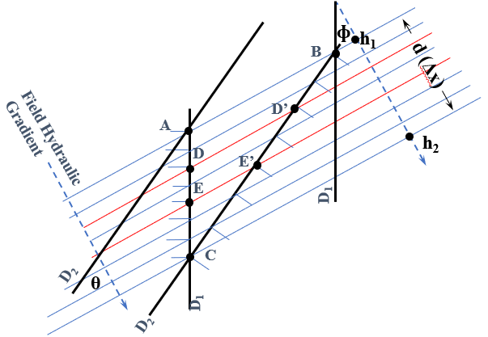
Figure 9. Comparison of in-plane hydraulic gradients in two intersecting discontinuity sets

In Figure 9, the in-plane gradient in Discontinuity Planes D₁ and D₂ are given by:

i_{J1} = (h1-h2)/(d/cosɸ) eq. 8

i_{J2} = (h1-h2)/(d/cosθ) eq. 9

Because bulk formation velocity is v = ki/n, and because k, n are equivalent in both planes but i_{p} in planes D₁ and D₂ are different and unique in that i(D₁) > i(D₂), then the potential velocity v_{p}(D₁) > v_{p}(D₂).

Figure 10 depicts the resolution of a field hydraulic gradient into two discontinuities in the manner examined in Figure 6. Representative discontinuities from two sets are superimposed on contours of the field gradient and the in-plane gradients are calculated using Equation 2, with the result that the in-plane gradient in Discontinuity Set D₂ is not just higher than in Discontinuity Set D₁ but is closer in dip angle to the field gradient as evident by the spacing of the red in-plane gradient contours.

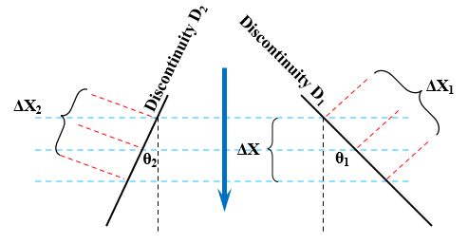
Figure 10. Superposition of two discontinuities onto a field hydraulic gradient, depicting the difference in in-plane gradients

Accordingly, in a condition in which there are no differences between the discontinuities within the two sets other than their orientations, a water particle would have a greater tendency to enter a D₂ plane because it would have a higher gradient than a D₁ plane by a factor of:

((h₁-h₂)/(ΔX₂/cos Ө₂))/((h₁-h₂)/(ΔX₁/cos Ө₁)) eq. 10

and consequently a higher potential velocity. Under such hydraulic conditions, it is many times presumed that the apparent anisotropy of flow would result in a plume deflected from the field hydraulic gradient in the direction of discontinuity D₂. The anisotropy assumption is that the directional anisotropy on the scale of the representative elemental volume translates into directional anisotropy on the domainal scale. That assumption is based on a companion assumption of continuity of the constituent structural or stratigraphic discontinuities across the scale of the domain; i.e., individual discontinuity planes extend over large areas within a hydrogeologic domain.

Individual discontinuities within pervasive sets, whether bedding plane partings or joints, however, are of finite length (Zakharova, et. al., 2016; e.g., Twiss & Moores, 2007; Lacombe and Burton, 2010) and are intersected by other discontinuities (Figure 11). The combination of those two factors necessitates that, with the exception of stranded particles, most groundwater exits each discontinuity by flowing into intersecting ones, or, in the case of discontinuities near a groundwater discharge boundary, to surface water.

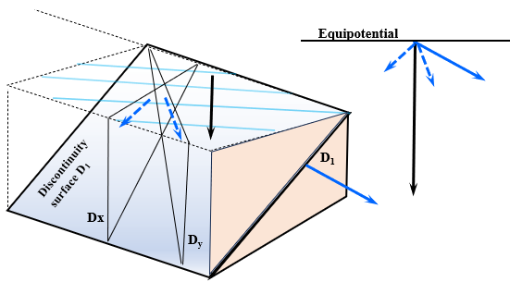
Figure 11 Schematic of available flow path orientations within a discontinuity network

Because all discontinuities below the phreatic surface are members of a connected network and are, by definition saturated with particles of groundwater, each of which possess a total hydraulic potential consistent with the potential of the flow field at that point and measurable as an elevation and pressure head with a total potential manifest as the elevation of the phreatic surface at that location, flow occurs in all available planar pore spaces in a composite direction generally consistent with the potential field. That is especially the case at the intersections between a discontinuity of one set with a discontinuity from another; e.g., a bedding plane parting with a joint. Because the joints are pervasive and connect with bedding plane partings (Lacombe and Burton, 2010), the total hydraulic potential of groundwater particles near the intersections must be identical in both types of planes, so flow in each type is controlled by the orientation of the in-plane gradients as resolved into each discontinuity (Figure 6).

Within any discontinuity (e.g., D₁, Figure 11), the distance a particle of groundwater can travel in a direction other than the field hydraulic gradient (black arrow) is limited by both the finite length of the discontinuity in the direction of the in-plane hydraulic gradient, and by the mean spacing of outlets from that plane in the form of intersecting discontinuities (D_{(x,y)} in Figure 11) which provide flow pathways along other, unique azimuths, each of which serves as a correction factor for flow along a discontinuity strike direction at some azimuthal angle to, and at a lesser gradient than, the field hydraulic gradient (Figure 4). Because there are few situations in nature in which a discontinuity set in a network is oriented directly parallel to the field hydraulic gradient (Figure 4), each particle of water follows an indirect pathway as it moves from discontinuity to discontinuity, always in a direction which takes it from points of higher hydraulic potential to those of lower potential and at each discontinuity point intersection with a theoretical tendency to enter the discontinuity with a strike azimuth closest to the field hydraulic gradient vector and, consequently, the planes with in-plane gradients nearest the field hydraulic gradient. That inter-discontinuity flow occurs sub-parallel to the strikes of the planes (Figure 3) regardless of their respective dip angles.

The orientations of the different discontinuity sets within a network and their angular relationships with the field hydraulic gradient vector result in multiple in-plane gradients on the scale of the representative elemental volume, providing for differing degrees of potential anisotropy. Total anisotropy would occur in two dimensions in an orthogonal discontinuity set pair where the strike of one set is parallel to the field hydraulic gradient vector and the strike of the other set is parallel to groundwater contour lines. Conversely, isotropy would occur in any pair of sub-orthogonal discontinuities where the strikes of each set are equi-angular to the azimuth of the field hydraulic gradient (Smith and Schwartz, 1993), with varying degrees of potential anisotropy resulting from intermediate orientations or from the addition of another discontinuity set. In the former situation, groundwater in the planes oriented normal to the field hydraulic gradient would only flow at times of directional variation of the flow vector, typically after groundwater recharge events or during seasonal fluctuations. For the same reasons of recharge and seasonal variations, some anisotropy would occur in the latter situation. In nature, discontinuities within any set are not precisely parallel but occur in statistically defined sets, the strike of individual planes falling within a range of azimuths. Therefore, there is no condition wherein there is consistently no flow in one set (direction) and all flow is in another.

Although the strike of one set of discontinuities might be oriented closer to the field hydraulic gradient than other sets and therefore possessed of a higher in-plane gradient with a higher potential to convey more flowing water, there are two limiting conditions to the amplification of the inherent anisotropy at the representative elemental volume scale to a pronounced anisotropy on the scale of the hydrogeologic domain:

- discontinuities of all types are of finite length (Zakharova, et. al., 2016). Groundwater is generally not conveyed in directions other than the field hydraulic gradient over distances greater than the mean discontinuity plane length as measured parallel to the in-plane gradient. That metric is a function of the mean surface area of the planes within that discontinuity set;

- virtually all discontinuities are connected within a three-dimensional network of structural and stratigraphic planar discontinuities so discharge from the planes of the discontinuity set with the highest gradient is into planes of the set(s) with lower gradient(s) and, consequently, lower water conveyance potential(s); i.e., no more water can flow through a high-gradient discontinuity than can be received from that discontinuity into intersecting discontinuities of lower gradient and, consequently, lower conveyance capacity.

Figure 12 is a two-dimensional representation similar to Figure 4 with the exception that the assumption of spatial continuity of Discontinuity 1 along a theoretically infinite length along the downgradient scale of the domain has been eliminated with the result that water cannot be conveyed in that specific discontinuity farther than Point C. The result is that the anisotropic distribution of a solute in the direction of the hypotenuse, d, along Discontinuity 1 can not be farther than the cross-gradient distance A – C. Although there is an apparent preference for movement in the set of discontinuities depicted by Discontinuity 1 in Figure 12, water can only flow from points of higher to those of lower potential at a rate and in volumes which can be accommodated by the discontinuities of Set 2.

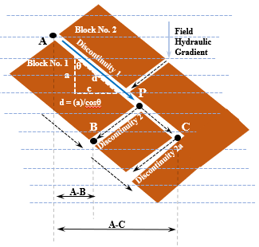
Figure 12. Two dimensional schematic of flow in a network similar to that depicted in Figure 4 but with the truncation of Discontinuity 1, preventing flow along direction d farther than Point C. Continued flow, required by the continuity of the flow field must be into Discontinuity 2a

Figure 12 depicts a condition in which the in-plane gradients of the two discontinuity sets (1 and 2) are essentially equal, resulting in a phenomenon known as the porous medium equivalent because the potential velocity in both sets is essentially the same and there is no limiting condition; i.e., the water conveyed down the planes of either discontinuity set can be accommodated by flow into the other (Smith and Schwartz, 1993). In Figure 13 the orientation of the field hydraulic gradient in relation to the two discontinuity sets results in a potential for anisotropic partitioning into the two in-plane hydraulic gradients.

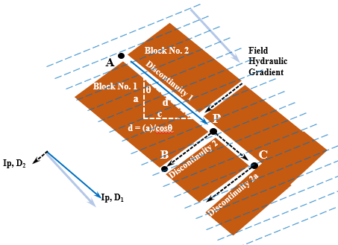
Figure 13. Flow through a discontinuity network in which there is extreme anisotropy between the resolved in-plane gradients and the field hydraulic gradient.

The anisotropy between the two in-plane gradients does not, however, result in an anisotropy in flow velocities between Discontinuities 1 and 2 because the orientation of the in-plane gradient vector of the latter is the limiting condition on flow out of the former; groundwater can only exit Discontinuity 1 at the rate it can be conveyed in the discontinuities of Set 2.

In the configurations depicted in Figures 12 and 13, it is not possible for groundwater to escape from Discontinuity 1 at Point C by moving normal to the plane of the page. Figure 14 is a simplified example of one rock block from Figure 12 arranged so the orientations of planes are in the end-member configuration in which one of the sub-orthogonal plane sets is vertical and parallel to the field hydraulic gradient vector, the second is normal to the field gradient (parallel to the groundwater contours) and a third is horizontal.

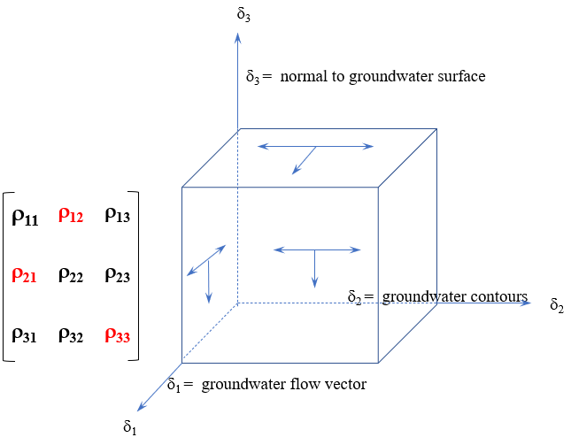
Figure 14. Flow along a rectangular block oriented with the FHG. The second order tensor of three dimensional anisotropic flow on the scale of the REV is defined in the matrix in which the red factors are directions in which flow is not possible.
In Figure 14, it can be seen that flow along any face of the block within a discontinuity of finite thickness consists of two components parallel to two of the directions of the three possible in three-dimensional space but not all are possible hydraulically (red designations in the matrix). Rotating the rock block (Figure 15) so that no bounding discontinuity is parallel to the field hydraulic gradient or groundwater contours and such that the upper bounding discontinuity is no longer horizontal but at some definite angle (Figure 15a) establishes the realistic condition that no discontinuity set is parallel to the field hydraulic gradient. Having established the relationship between the planes and the field hydraulic gradient, the block is rotated back to coincide with a map view (Figure 15b) along with a concomitant rotation of the hydraulic coordinate system. In this configuration, the phreatic surface can once again be depicted similar to the manner shown in Figures 6 and 10 (Figure 15c) and the resolutions into the planes can be calculated.

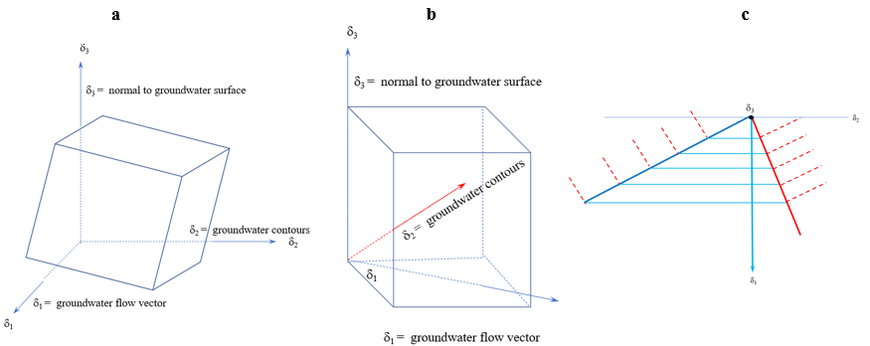
Figure 15. Resolution of flow around a rectangular rock block into two components of flow per face, as described in the text.

Combining the implications of Figures 14 and 15, flow within the confines of a discontinuity of finite thickness consists of a maximum of two components, both parallel to the faces of the bound rock blocks. The relevance to the current matter is that flow at Point C of Figures 12 and 13 can not be in a direction normal to the plane of the page and the rate of flow is limited by the capacity of Discontinuity 2a to convey the water from Discontinuity 1.

Flow in Discontinuity Networks on the Scale of the Hydrogeologic Domain

Despite the conclusion based on the microcosm of an aquifer presented in the foregoing, it is a well-known phenomenon that there are discrete linear or planar zones in bedrock aquifers, often referred to as water-bearing zones but hereinafter referred to as high-conveyance-capacity zones, which appear to convey most of the water through an aquifer. Such zones tend to form along structural and/or stratigraphic trends such as fault zones which tend to convey water preferentially along strike but typically act as barriers to flow in cross-strike directions (Gillespie, 2023). As reported by Parizek (2005), groundwater flow can be highest along lineations formed where a fault plane (zone) intercepts another open planar feature, either, e.g., another fault or an open formation contact. They can also occur within conductive strata, as discussed below.

Figure 16 is an idealized cross-sectional conceptualization of a hypothetical high-conveyance-capacity zone of finite width and thickness (i.e., a linear zone) but of theoretically infinite length along strike (into the plane of the page). Such high-conveyance-capacity zones do not occur in isolation but, rather, intercept innumerable, saturated discontinuities of the pervasive, penetrative, three-dimensional structural-stratigraphic network as described above herein. Similar to a surface water stream, the water which enters and is conveyed through such high-conveyance-capacity zones derives from the integrated inflow from the lower-capacity discontinuities which contact the zone and which are in hydraulic communication with the entirety of the surrounding three-dimensional discontinuity network.

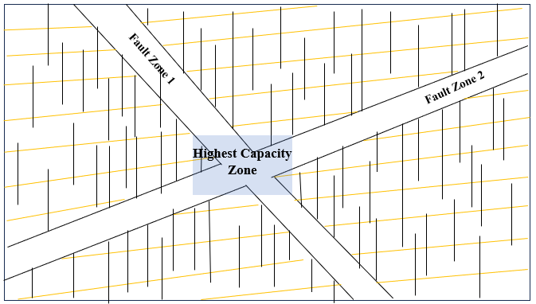
Figure 16. Idealized schematic of high-conveyance-capacity zone formed at the intersection of two fault zones of finite width and thickness but of infinite extent along strike. Groundwater flow is out of the plane of the page.

Such a condition can be modeled on the domainal scale with equipotential lines in the same manner unconfined aquifers can be modeled (Figure 17).

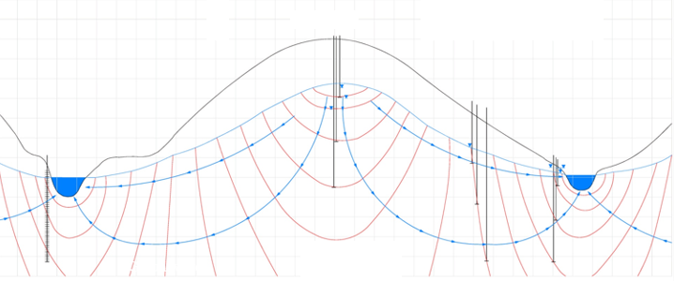

Figure 17. Idealized equipotential field in an unconfined aquifer. Blue lines are groundwater flow lines. Red lines are equipotential lines. Flow within the aquifer has both horizontal and vertical components whether it is an unconsolidated porous medium or bedrock system.

Unlike the situation in the unconfined aquifer of Figure 17 which is bounded at the upper surface and has the lowest hydraulic potential at the surface water discharges, a high-conveyance-capacity zone embedded within the phreatic zone does not have an upper boundary condition (unless it is at a shallow depth), water is conveyed to the zone from all directions (Figure 18) and the lowest hydraulic potential in the local flow field is within the high-conveyance-capacity zone (analogous to the surface stream in Figure 17). It is also possible that there is a lower boundary condition, both of which boundary conditions would limit the vertical development of the equipotential lines depicted in Figure 18.

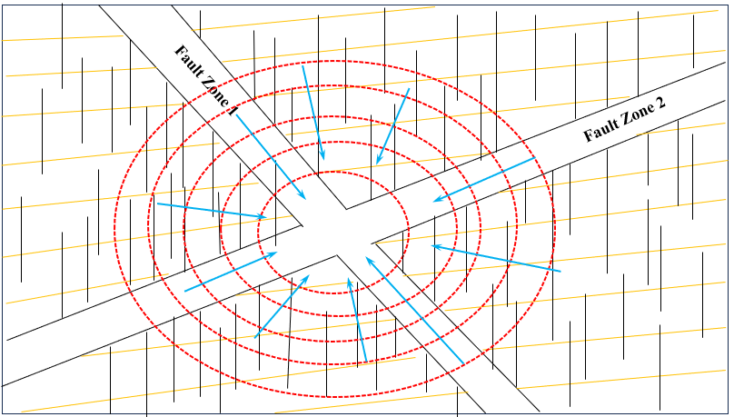
Figure 18. Two-dimensional schematic representation of a three-dimensional equipotential field in an aquifer around a discrete, linear high-conveyance-capacity zone. Blue lines are groundwater flow lines. Red lines are equipotential lines. Flow is toward the viewer.

The hydraulic condition depicted in Figure 18, however, does not exist except in situations in which the high-conveyance-capacity zone is connected to other, downgradient, high-conveyance-capacity zones or extends along-strike far enough that the zone is connected directly to a groundwater discharge. In the absence of an outlet for the water, the volume of water actually conveyed under natural hydrologic conditions through high-conveyance-capacity zones is constrained by the receiving capacity of downgradient zones of the aquifer; i.e., beyond the along-strike extension of the geologic feature(s) which create the high-conveyance-capacity potential. Under conditions where the zone exists but there is no outlet for the water other than the discontinuities of the pervasive, penetrative sets of the three-dimensional networks possessed of a lower bulk hydraulic conductivity, the equipotential field depicted in Figure 18 does not develop and flow is through the discontinuity network as described previously herein.

It is often reported that a monitoring well has encountered discrete high-conveyance-capacity zones and it is assumed that the conveyance of groundwater through the aquifer under natural conditions is predominantly through such zones. It is undeniable that most of the water extracted from such wells during pumping or monitoring derives from those identified zones. However, a well represents a groundwater discharge pathway at those times when observations are being made; i.e., when the well is being purged for sampling or during aquifer testing (Zakharova, et. al., 2016). The presence of the well creates a potential high-conveyance zone or outlet and can create connections between vertically-separated zones which were not otherwise in hydraulic communication naturally (Heisig, 2010). It is not necessarily the case, however, that the high-capacity zones thus identified represent the flow pathways of most groundwater in the absence of the outlet and artificial hydraulic conditions created by the well, although it is possible depending on downgradient conveyance capacities, on the connectivity of such zones with other, downgradient zones either at the same or different elevations within the aquifer and the location of the well within the hydraulic potential field (Figure 17).

Except in a well which is being pumped, the phreatic surface (the physical manifestation of the integrated total hydraulic potential of all particles of water at all points below the phreatic surface) describes a low-angle, planar, dipping surface. In such a situation, there is no hydraulic evidence of the presence of a zone of high conveyance potential. If such a zone is conveying groundwater at a rate higher than the bulk flow rate of the aquifer, it would be measurable as a linear depression parallel to the in-plane gradient of the feature; i.e., along its strike, or, in the case of a planar high-conveyance-capacity zone, a low area on the phreatic surface.

Despite the convergence of flow lines in the profile view of Figure 18, flow along individual discontinuities remains sub-parallel to the strikes of individual planar discontinuities pursuant to the hydraulic requirements as outlined above and in Figures 3 and 5. An analogy to a surface water-groundwater couple is presented in Figure 19 in which the flow lines as depicted in cross section (upper block diagram) are actually sub-horizontal flow lines (map view diagram).

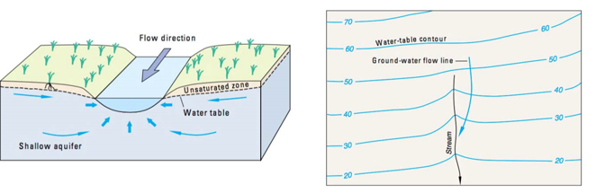
Figure 19. Groundwater flow and discharge to a surface water stream. Flow is dominated by the horizontal component even below the stream with flow lines nearly parallel to the thalweg with an upward component bringing water from lower elevation but higher potential into the stream bed. Original from USGS

Flow into deeper high-conveyance-capacity zones from overlying portions of the aquifer (Figure 18) does not occur via vertical seepage down open discontinuity planes. In the context of this analysis, the term seepage is used in the sense as defined in Poehls and Smith (2009): “The slow movement of water through unsaturated [geologic media] into or out of a body of surface or subsurface water…” A hypothetical particle of groundwater originating at a point below the phreatic surface in the volume of aquifer vertically above a high-conveyance-capacity zone (Figure 18) is possessed of a total hydraulic potential consistent with the elevation of the phreatic surface at that point and occurs on an equipotential line (Figures 17 and 18). The continuum of hydraulic potential between overlying groundwater and groundwater in such underlying high-conveyance-capacity zones is measurable with hydraulic observation points (Figure 17) and is the basis of contours constructed to depict a phreatic surface which is essentially horizontal at any point with gradients similar to aquifers at any location (Figure 19); i.e., typically on the order of 0.01 or less (Gillespie, 2013).

Figure 17 depicts several hydraulic regimes including recharge zones, discharge zones and intervening zones of near-horizontal flow. The zone of near-horizontal flow (between recharge and discharge areas) is the only zone where equipotential lines are essentially vertical and bulk groundwater flow can be sub-parallel to the strikes of discontinuities, whether stratigraphic or structural. If a site is in either a recharge or discharge area, flow has a significant vertical component and can not, in consequence, be sub-parallel to the strike of a conveying discontinuity, including bedding plane partings. The two components of flow (horizontal and vertical - Figures 14 and 15) are accommodated by flow through all discontinuity sets and flow is not controlled solely by the strike of either bedding plane partings, formation/member contacts or joints but is affected significantly by the potential field (gradient) at that point.

Within a zone of near-horizontal flow (i.e., flow along strike), two hypothetical particles of groundwater at the same geographic location but at different elevations (e.g., as measured in nested well sets) are located on the same equipotential and consequently have identical total hydraulic potentials (Figure 20). In that situation, groundwater flow within individual discontinuities is very nearly parallel to the strikes of all discontinuities (Figures 3 and 5) and the hydraulic potential at the top of a saturated discontinuity which connects two vertically-separated high-conveyance-capacity zones is identical to the potential at the bottom of that same discontinuity (Figure 20). In that situation, vertical flow is not possible because there could be no loss of potential (Toth, 2009, Hubbert, 1940). Therefore, at locations in an aquifer where flow is sub-parallel to the strike of the containing discontinuity (where there is no significant vertical flow component), there can be no vertical flow down the dips of steeply-dipping or sub-vertical connecting discontinuities between high-conveyance-capacity-zones.

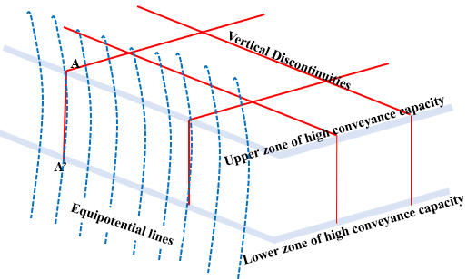
Figure 20. Block diagram depicting two high-conveyance-capacity zones separated by saturated sub-vertical discontinuities in a hydrologic location between recharge and discharge areas characterized by near-horizontal flow (Figure 17). In this situation, the total hydraulic potential at Points A and A’ are identical so there can be no vertical flow.

In recharge and discharge areas (Figure 17), the hydraulic potentials at the tops and bases of discontinuities which connect vertically separated high-conveyance-capacity-zones are higher and lower, respectively (e.g., Heisig, 2010). The corollary is that, in hydrogeologic zones where vertical flow down steeply-dipping to sub-vertical discontinuities is possible (groundwater recharge and discharge areas) flow is not sub-horizontal and not along the strike of any planar discontinuity. That is the hydraulic condition which provides for both aquifer recharge and discharge (Zakharova, et. al., 2016). That recharge and discharge, however, occurs via saturated flow along field hydraulic gradient vectors, modified at the scale of the representative elemental volume by the development of in-plane gradients which have components of both horizontal and vertical flow (Figures 4 and 21) consistent with the conditions depicted in Figures 14 and 15 and with the analogous concept of groundwater discharge to surface water (Figure 19).

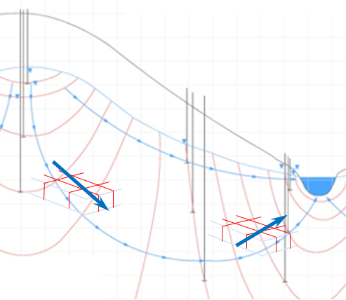

Figure 21. Translation of the block diagram of Figure 20 into recharge and discharge areas from Figure 17. In both end-member situations, there is significant vertical flow which occurs along vertically-oriented discontinuities.

Completely vertical flow through open, connected discontinuities in such a situation could only occur as vadose flow which, if actually measured in the field, would present an irresolvable conundrum because vadose flow occurs at pressures lower than atmospheric and in unsaturated conditions, whereas, at depths below the phreatic surface, all pore spaces are saturated and every particle of water is possessed of a total hydraulic potential at pressures above atmospheric. Because the phreatic surface at a point is the measurable manifestation of the integrated total hydraulic potential of every particle of water in a vertical section of the aquifer at that point, each particle of water is affected by, and exerts a hydraulic effect on, every other particle of water within the field. It is not hydraulically possible in that situation that groundwater in non-vertical two-dimensional pore spaces within the phreatic zone flows under a sub-horizontal hydraulic gradient at an azimuth sub-parallel to the strike of the discontinuities (i.e., ‘flow is along strike’) while flow in the same phreatic zone (same potential field) is down the dip of connected sub-vertical discontinuities. Such a hypothetical situation would necessitate simultaneous flow along two separate hydraulic gradients within the same potential field, or, as above, a vadose zone below the phreatic surface. The hypothetical condition presented here, for illustrative purposes only, differs from that of the refraction of flow lines between aquifers and aquitards (Freeze and Cherry, 1979; Hubbert, 1940) in which the bulk flow is via primary porosity between high-conductivity and low-conductivity strata.

As a result of the configuration of equipotential lines in Figure 21, the water table surface in the area adjacent to the discharge slopes downward toward the stream, but on the scale of the representative elemental volume at the location of the block diagram at depth, a series of infinitesimally spaced observation points intercepting a similar number of equipotential lines would describe decreasing hydraulic potential from depth toward the land surface, so net flow is sub-parallel to the strike of the planes of individual discontinuities with an upward component, (Figure 22), as depicted in Figures 14 and 15 (Heisig, 2010).

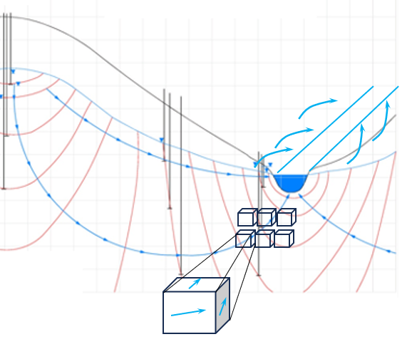
Figure 22. In its flow toward a surface water discharge, groundwater must flow around every matrix block (blue arrows) with an upward flow component in sub-vertical or steeply dipping planes (Figures 14 and 15), but little to no upward flow within sub-horizontal planes because of the constraint of the overlying matrix block unless the surface water discharge is either up-dip or along strike.
Groundwater can flow in any discontinuity only in the direction which results in a loss of hydraulic potential. In a case of jointed sedimentary rock in which there are two predominant, sub-vertical, sub-orthogonal extension joint sets and bedding plane partings/formation contacts are at a low dip angle in a homoclinal configuration (e.g., rocks of the Newark Basin), it is the combination of the field hydraulic gradient and the strike directions of each discontinuity set which exerts the controlling factor on groundwater flow anisotropy on the scale of the representative elemental volume (Surrette and Allen, 2008; Bear, 1993; Smith and Schwartz, 1993; and in Figures 3 through 6 herein). Figure 23 depicts a configuration in which two sub-orthogonal joint sets are mutually orthogonal to bedding and the strikes of all discontinuities do not coincide. This differs somewhat from many locales in the Newark Basin in which the strike of one joint set is very near, or in some cases, coincident with the strike of bedding. The configuration depicted was selected for ease of illustrative purposes, but the concepts discussed below apply equally to configurations in which the resulting rock blocks are more rectangular than the triangular segmentation depicted in Figures 23 through 25 (e.g., Figure 1a).

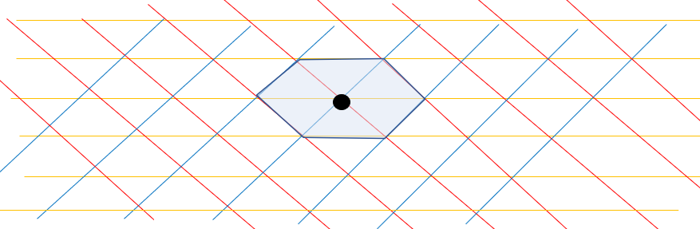
Figure 23. Schematic map view of three idealized sets of planar discontinuities: red and blue are sub-vertical joints and yellow is homoclinally dipping bedding plane partings. The shaded area is a hexagonal region within which all three discontinuity sets intersect. Each hexagonal area overlaps with other adjacent hexagons with each intersection at the locus of the meeting of six triangular prismatic blocks of rock. The diagram has been simplified to eliminate the differences between systematic and non-systematic joints common in the Newark Basin.

In a case below the phreatic surface where all discontinuity planes are saturated and every particle of water is affected by the potential field, the angular relationship between the field hydraulic gradient and the several sets of discontinuities differ, with a resultant difference in flow path lengths and gradients (Figures 24 a, b and c) as depicted in Figures 7 and 8. In the configuration of Figure 23 and 24, each triangular block can be considered a representative elemental volume. However, because it is at the intersections of the six adjacent triangular blocks that groundwater flow anisotropy can initiate (Surrette and Allen, 2008), each hexagonal segment of the aquifer is considered a representative elemental volume.

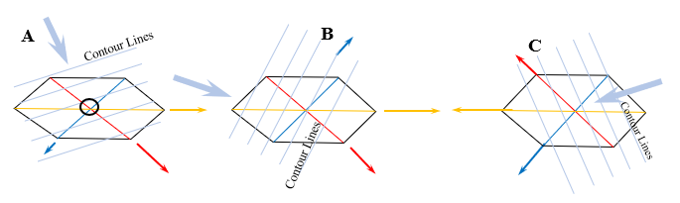
Figure 24. the representative elemental volume of Figure 20 in three configurations of Field Hydraulic Gradients. In each configuration, groundwater is conveyed through all three semi-planes of each discontinuity set, establishing the constraint on solute transport at discontinuity intersections.

Each planar discontinuity set depicted in Figure 23 and 24 is at some angle to the field hydraulic gradient and each set within any hypothetical representative elemental volume is at the same elevation and same depth below the phreatic surface, so flow, constrained by the flow field defined with equipotential nets, occurs in each set. Starting at the intersections of planes, there are two semi-planes for each discontinuity at the center of each hexagonal representative elemental volume. In each set, flow must be along the semi-plane which is at an obtuse angle to the gradient; that is, the pathway along which a loss of potential energy can occur. Using schematic A in Figure 24 as exemplar (Figure 25), the change of total hydraulic potential from the central point intersection of each plane to the respective “downgradient” ends (in-plane gradients) are different, as presented previously herein.

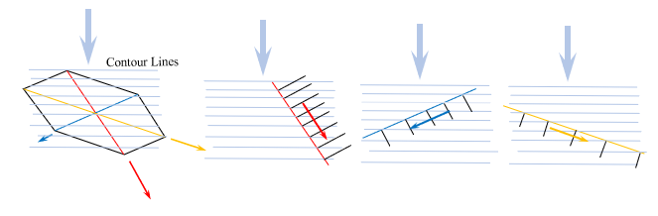
Figure 25. Example of the difference in in-plane gradients resolved from the FHG using the configuration of diagrammatic conditions of Figure 24A.

The significant differences of in-plane gradients results in lateral dispersion but can also magnify anisotropy from the scale of the representative elemental volume to that of the hydrogeologic domain, depending on a number of permutations of the variables, including, but not limited to: discontinuity orientation with respect to the field gradient; mean surface areas of the discontinuity sets; network connectivity; direction and distance to groundwater discharges, including sub-surface high-conveyance-capacity-zones (as described herein); downgradient conveyance capacity as well as factors such as differential discontinuity aperture and/or roughness.

The often cited observation that groundwater flow can be sub-parallel to the strike of bedding plane partings is possibly a result of the predominance and aerial continuity of that set of discontinuities in some members of the Newark Basin formations compared with the frequency and spatial continuity of joint planes. However, as reported by Vecchioli (1969) and Lacombe and Burton (2010), the high-conveyance-capacity zones are possessed of high densities of both stratigraphic and structural discontinuities. In such conditions, flow in all discontinuity planes is sub-parallel to the strikes of the planes and there have been no systematic observations supporting a conclusion that all planes do not convey groundwater to a well or discharge. In fact, such must be the case because a well with a partially penetrating screen extracts groundwater from the full 360° area surrounding the casing, as well as from depths above and below the open interval (Hubbert, 1940; Freeze and Cherry, 1979; Fetter, 2001).

The differential disparities in the spatial distribution of all discontinuities is not uniform across the Basin, however, as depicted in Figure 1a, which is a photograph of the Lockatong Formation. There are members of the Passaic Formation in which the bedding plane partings appear to be more frequent than the sub-vertical joints to the degree that the rock is nearly fissile in directions parallel to bedding. However, the high-conveyance capacity zones even in such members tend to be those in which steeply-dipping to sub-vertical joint planes also occur at high frequency and close spacing (Vecchioli, 1969; Lacombe and Burton, 2010) although they are obscured by the extreme fragmentation of the rock (Gillespie, unpublished data). As observed by Vecchioli (1969), producing zones are lithologically similar to non-producing zones but are distinctly jointed; i.e., the ability of such producing zones to store and convey groundwater (under pumping conditions) is a function of the combined porosity and permeability effects of finely laminated bedding plane partings and closely spaced structural planar discontinuities. That is consistent with the findings of Lacombe and Burton (2010) who report that the degree of fracturing (bedding plane and structural) is directly related to the hydraulic conductivity of strata; i.e., groundwater flow is through both stratigraphic and structural discontinuities.

In such high-conveyance-capacity zones, the limiting condition on flow velocity and anisotropy, reported above to be caused by the inability of low-gradient discontinuities to accept water at the rate of the conveyance capacity of high gradient discontinuities, is eliminated by the high stratigraphic and structural discontinuity densities. In such situations, flow is most similar to that of the porous medium equivalent, as documented by Vecchioli (1960) in which strong responses were recorded both along strike and down dip in contiguous high-conveyance-capacity strata.

Examination of Conceptualizations of Anisotropy

The presence of high-conveyance-capacity zones has been demonstrated by numerous investigators. Such zones in the Newark Basin are finite in both thickness and aerial extent (Zakharova, et. al.,2016), although some lithostratigraphic units can be correlated on the square kilometer scale (e.g., Olsen, et. al., 1996; Kent, et. al., 1995). High-conveyance-capacity zones, however, are possessed of “significant lateral heterogeneity in hydraulic as well as lithologic properties” (Zakharova, et. al. (2016).

Those high-conveyance-capacity zones have been reported variously as independent, leaky aquifers by, e.g., Mikalski and Britton (1997) or as producing zones by, e.g., Vecchioli, et. al. (1969). It is unambiguous that, under the induced stress of pumping, groundwater extracted from the bedrock formations of the Newark Basin derives in large part from specific, finite, structural or stratigraphic zones (Zakharova, et. al., 2016) possessed of high secondary porosity in the form of discontinuities, including both bedding planes and structural planes (Vecchioli, 1969), high storage potential (Heisig, 2010), and, in the case of stratigraphic zones, a strata-parallel permeability higher than surrounding rock of more massive texture (Zakharova, et. al., 2016). What does not follow from that consistent observation is a conclusion that:

“If the water is able to move more freely in the direction of strike than in other directions [during aquifer testing], then the facility for the spread of a contaminant would be greatest along strike.” (Vecchioli, et. al., 1969)

That specific conclusion is not wholly incorrect in that Vecchioli refers to the facility for the spread of contaminants and does not imply that such an outcome is universally the case, although it is the presumption of many investigators and regulators (see below). Unlike the hydraulic behavior within high-conveyance-capacity-zones during aquifer testing, under non-pumping conditions (i.e., the natural prevailing field hydraulic gradient) on the scale of the hydrogeologic domain, groundwater:

- can only flow at the rate of the measured hydraulic characteristics of such high-conveyance-capacity-zones if the zone is connected to an equally transmissive downgradient zone or to a surface water discharge, as described above, herein;

and

- flows in a direction on the hydrogeologic domain scale constrained by the resolution of the field hydraulic gradient into the various planar discontinuities which results in angular disparities between the field hydraulic gradient and the mean orientation of each discontinuity set considered collectively; the spatial distribution of the discontinuity sets; the connectivity of sets within the network; and the mean surface areas of individual, finite discontinuities in each set within the confines of a specific high-conveyance-capacity-zone.

Considering that all discontinuities in three-dimensional networks are saturated and convey groundwater within the hydraulic constraints of the prevailing potential field, a position that groundwater flow is controlled by “the strike” must be evaluated by first asking: “The strike of what?” The hydraulic constraints on flow through discontinuity networks established previously herein require flow through all discontinuities in the network (Lacombe and Burton, 2010) which means that all discontinuities in a three-dimensional network potentially affect flow, whether isotropic or anisotropic. That is especially the case in those Newark Basin formations/members where the disparity in discontinuity spatial distribution between the sets of a network is not high (e.g., Figure 1).

The nomenclature, “producing zone” as described by Vecchioli, et. al. (1969) is perhaps the most accurate representation of the high-conveyance-capacity stratigraphic zones in Newark Basin formations where high conveyance along strike has been measured. Production refers to the rate at which groundwater can be produced via a well and it is the case that under pumping stresses such zones produce more water than other zones. That production, however, does not occur exclusively along the strike of the strata. Vecchioli reported hydraulic responses in down-dip wells which intercepted the high-conveyance-capacity stratum being pumped.

Accordingly, and considering the findings of Lacombe and Burton (2010) and Vecchioli (1969) that the highest producing strata are those which contain a higher proportion of stratigraphic/structural discontinuities than in other strata in a study area, there appears to be no unique relationship between high groundwater production, hydraulic responses to extractive stress, and the strike of a formation’s bedding plane partings or formation/member contacts. That finding calls into question the companion conclusion that contaminant distribution is preferentially along strike (Vecchioli, 1969). The most pronounced and rapid hydraulic responses are measured in directions along the strike of bedding for the same reasons as described in the foregoing sections of this current report: flow within the several member sets of discontinuities in a network, and, indeed, along individual discontinuities, is in directions sub-parallel to the strikes, whether that flow occurs under the influence of a prevailing natural field hydraulic gradient or under the stress of an induced gradient during aquifer testing.

As reported by Vecchioli (1969) the anisotropy observed as preferential flow along bedding plane partings during aquifer testing results from the difference in contribution to well discharge between highly fractured strata, including structural discontinuities (e.g., Lacombe and Burton, 2010) and more massively-bedded strata within the same or adjacent formations. As established by Lacombe and Burton (2010) in finely-bedded members the integrated hydraulic conductivity of the prevalent bedding plane partings as measured in aquifer tests is higher than the collective conductivity of the relatively sparser strata-bound joint planes. The hydraulic response, however, is not restricted to along-strike directions, as reported by Vecchioli (1969) so that which is being recorded is less of a strike-controlled response than it is a general response to a hydraulic stress across a zone of higher bulk hydraulic conductivity than surrounding rock zones, within which hydraulic responses were also recorded, both along strike and down dip, but to a lesser degree (Vecchioli, 1969). Highly conductive zones, such as those described by Vecchioli (1969) and by Lacombe and Burton (2010) are many times composed of thinly bedded rock with closely spaced joints with resultant representative elemental volumes on the scale of a centimeter. In such cases, the aquifer can best be characterized as a porous medium equivalent (Gillespie, 2023) and the effects of the resolution of the field hydraulic gradient into the various planar discontinuities disappear (Figure 7). That condition also contributes to the high production, resulting from high storage, and rapid responses along the strike of bedding, although similar responses have been recorded down dip in the same unit.

That latter condition is consistent with the condition depicted in Figure 18 in which the high potential flows within the linear preferential flow pathway derives its water from the innumerable intersecting, smaller-scale water-conveying discontinuities of the three-dimensional network and from directions constrained by the field potential in and around the preferential conveyance zone. That is also the finding of Lacombe and Burton (2010) who found that, because joints in the Lockatong Formation are strata-bound, the measurement of hydraulic conductivity is predominantly attributable to along-bedding-strike partings and/or formation/member contacts which occur with a higher frequency, are individually more aerially contiguous on the scale of the domain and collectively represent the most prevalent water-bearing discontinuities with the highest collective surface area along which flow can occur compared with the strata-bounded joint planes. The implications for anisotropy are less applicable, or not at all, in members in which the spacing and frequency of all discontinuity sets are equivalent (e.g., Figure 1). The Lacombe and Burton study focused on the Lockatong Formation in which joints, although pervasive, are not penetrative to the same scale of observation as is the case in the other formations of the basin (Gillespie, unpublished data). Accordingly, the representative elemental volume in the Lockatong tends to be statistically larger than is the case in the other formations of the basin and the potential for anisotropy is greater at the scale of the representative elemental volume, as described previously herein.

What has not been addressed within the context of the conceptualizations discussed in the foregoing is the distribution of solutes under the influence of natural field hydraulic gradients through three-dimensional networks of planar discontinuities within and through groundwater drainage areas; i.e., under the prevailing hydraulic conditions within a single area consisting of both recharge and discharge areas with some zone, or at least inflection plane, where near-uniform lateral flow occurs. It is a premise of the conceptualization in which preferential flow is compartmentalized stratigraphically, that flow is along the strike of bedding. In order for the premise to hold, either nearly all sites would have to be located in zones of near-horizontal flow between recharge and discharge areas (demonstrably not the case) or flow in the high-conveyance-capacity zones in recharge or discharge areas is not actually along the strike but consists of significant vertical flow components which must be accommodated by flow through non-bedding discontinuities (Gillespie, 2023). In that latter case, there is no hydraulic rationale which could be applied to conclude that the distribution of flow into all discontinuities of a network does not also occur in the zones of sub-horizontal flow between recharge and discharge areas.

It is not uniformly the case that under non-pumping conditions, discovered solutes became distributed into distinct stratigraphic zones. Many examples can be cited in the Newark Basin in which a plume of contaminants is not distributed coincident with the strike of a stratum but, rather, is distributed in a direction consistent with the field hydraulic gradient with either:

- some degree of anisotropy resulting from preferential flow into one of the discontinuity sets in the network;

or

- isotropy, in which there is no preferential orientational resolution of the field hydraulic gradient into the several discontinuity sets – the condition of the porous medium equivalent.

Figure 26 is a reproduction from a case study in the Newark Basin (Gillespie, 2013) in which the NJDEP concluded, based on groundwater extraction testing conducted by its own contractor, that the direction of flow was along the red arrow (Figure 26a) which is generally parallel to the mean strike of bedding. That conclusion was contrary to the factual evidence that the hydraulic gradient, as mapped quarterly with groundwater elevation contours (equipotential lines in Figure 26b) in approximately 25 monitoring wells over a 30-year period (120 episodes), was consistently oriented with a gradient along the blue arrow (Figure 26a) at an azimuth 40$°$ from the NJDEP-presumed, along-strike flow direction. Flow as conceptualized by NJDEP would require groundwater contours as depicted in Figure 26c, which differs significantly from the contours based on the monitoring data (Figure 26b). Contours consistent with the monitoring data (Figure 26b) are also consistent with the hydrologic function of the perennial stream as a groundwater discharge. Figure 26c depicts a hydrologic condition contrary to the established groundwater-surface water couple in an effluent stream situation. NJDEP defended the conceptualization based on the detection of one compound (of many) in one well in a single monitoring episode at Point A (Figure 26a), the concentration of which was higher than at any monitoring location in any episode near the source (apex of arrows, Figure 26a) and separated from the source by an expanse of uncontaminated groundwater more than a half mile long in which that compound had never been detected.

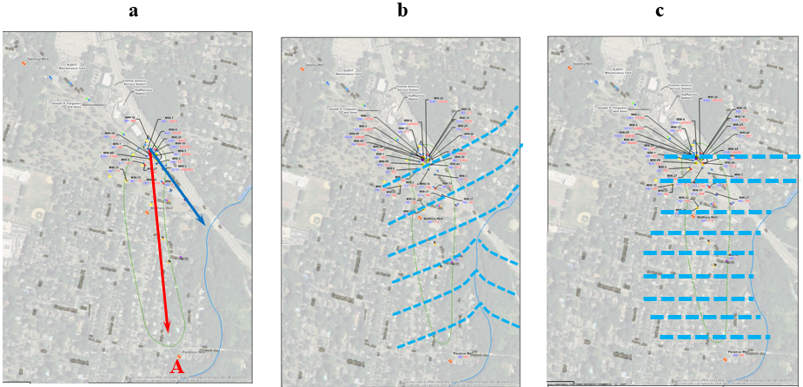
Figure 26. reproduction of results of a field investigation in which the NJDEP, based on a groundwater extraction test, concluded that solute transport and, necessarily groundwater flow, occurred at an angle 41° from the consistently measured hydraulic gradient. From: Gillespie, 2013

Evaluating groundwater flow within the three dominant sets of discontinuities present at the site pursuant to the methods described herein resulted in a predicted plume consistent with the measured field hydraulic gradient and with long term groundwater quality data; i.e., the actual plume was oriented with the gradient depicted in Figure 26b.

The NJDEP, in support of its effort to fit the data to its presumptive conceptualization, presented a distance-drawdown curve based on the aquifer testing which, contrary to its conclusion, was consistent with a single groundwater system, despite the agency’s designation of multiple stacked aquifer units which the presumptive conceptualization treated as separate and hydraulically distinct water-bearing zones (Figure 27). Most significantly, the hydraulic responses to the aquifer test were measured in wells arrayed normal to the strike of the strata, across bedding plane partings and in strata which the Department had designated as different hydrologic units.

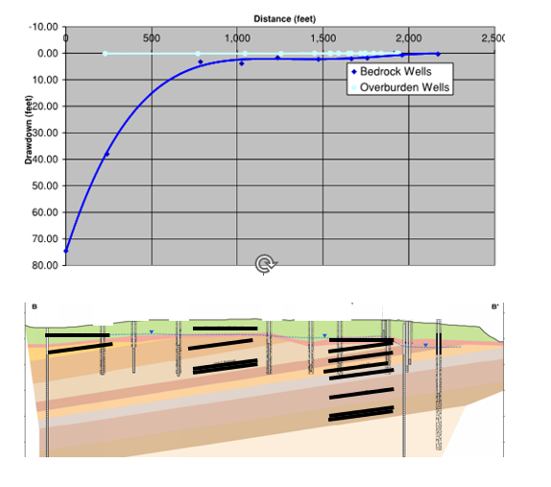
Figure 27. Reproduction distance-drawdown plot and cross section (a non-right-section) in which the wells monitored were completed into rock designated as comprising individual, isolated aquifer units (lower figure), but which were shown by the aquifer test (upper graph) to be part of a single saturated system. From Gillespie, 2013.

In addition to the absence of hydraulic or groundwater quality data to support multiple, distinct aquifer zones (which were, indeed, zones of high production under pumping) the cross section NJDEP presented to support the conceptualization (Figure 27) was not constructed as a right section and the effects of vertical exaggeration between the map and profile scales was not accounted for, both of which errors rendered the geometric basis of establishing contiguous dipping aquifer zones incorrect and, consequently, invalid. Such ostensible hydrologic zones over the scale of the study area (~350 acres) can not be demonstrated to comprise single high-conveyance-capacity zones within the scope of a site investigation (Zakharova, et., al., 2016) – a conclusion supported by the results of the aquifer test (Figure 27).

In the case in the example of Figure 26, NJDEP concluded that flow at an azimuth more than 40° from the field hydraulic gradient was a valid conceptualization because that direction was near (not exactly coincident with) the strike of strata. The effects of planar discontinuities of two pervasive and penetrative joint sets were ignored, despite the fact that one of the joint sets is parallel to the field hydraulic gradient, parallel to the measured plume and coincident with the hydraulic response to the aquifer test (Figure 27).

The presumption that a formation is possessed of, and can be hydraulically characterized by a single strike direction which is presumed to control the hydrology of a study area has become a default conceptualization of investigators and regulators involved in cases with potential contamination of the sedimentary bedrock aquifers in the Newark Basin of New Jersey. That conceptualization is based on a presumption that bedding plane partings and contacts are of significant aerial extent across the scale of the hydrogeologic domain. Although one or both of the presumptions of that conceptualization might be correct, the entire conceptualization ignores that the formations of the Basin are lithologically and hydraulically variable in both vertical and horizontal (down-dip) directions (Zaklharova, et., al., 2016), contain at least three sets of planar discontinuities at any location (Herman, 2001) and that:

- each discontinuity set has a statistically consistent strike direction;

- each discontinuity set is pervasive and penetrative across all hydrogeologically relevant domains of interest in site investigations;

- the geometric and spatial relationship between sets is the basis for the definition of the representative elemental volume;

- all discontinuity planes are saturated;

- every particle of water is possessed of a total hydraulic potential consistent with, and accordingly contributive to, the hydraulic potential field, including the elevation and configuration of the phreatic surface, which, as depicted in Figure 27, incorporates potentials measured across the three-dimensional extent of the study area including along strike and down dip locations.

In terms of the effects of aquifer framework anisotropy on the distribution of solutes which occurs under the hydraulic conditions dominated by natural field hydraulic gradients, the characteristic which must be determined is the anisotropy under non-pumping conditions, if any. It is often times the case that an apparent anisotropy is an artefact of the investigation methods. This is illustrated in Figure 28 which presents a schematic of an analogous situation in a porous medium aquifer. An aquifer test in the sand and gravel aquifer would yield an estimation of the groundwater flow velocity consistent with measured hydraulic conductivity and transmissivity values typical of formations of similar lithology. The rate of groundwater flow into, through and out of the sand and gravel unit, however, is constrained by the conveyance capacity of the surrounding formation with conductivity values orders of magnitude lower. Within the context of the elements depicted, if a more rapid and stronger hydraulic response was measured during an aquifer test in the observation well located within the higher-conductivity paleochannel, as compared with responses in the other observation points, it could not be interpreted that groundwater flow and solute distribution under the influence of the pre-test natural hydraulic gradient had occurred in the direction from the pumped well to that observation point; solutes in groundwater from a source location near the pumping well would have been transported in the downgradient direction despite the presence of a higher-conveyance-capacity zone (the paleochannel) near the source.

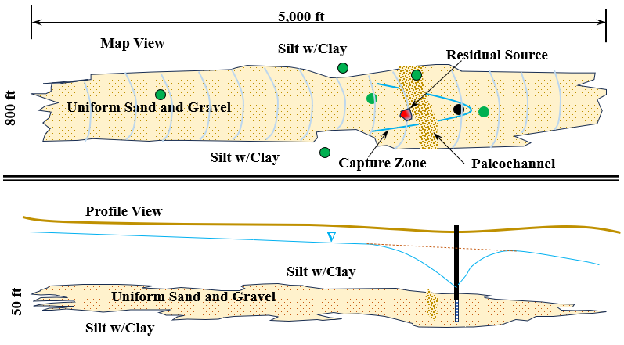

Figure 28. Porous medium analogue of high-conveyance-capacity zones in bedrock aquifers.
As described above herein, a geologic condition which has higher intrinsic conveyance capacity does not cause groundwater to flow in a direction which does not result in a loss of total hydraulic potential. In the case of the example in Figure 28, flow into the paleochannel from the direction of the pumped well under non-pumping conditions would not be possible because there would be no loss of potential; flow in that hypothetical situation would had to have occurred in a direction parallel to the contour lines which is not possible. Analogously, the measurement of a hydraulic response to extraction of groundwater from a high-capacity stratigraphic horizon in a consolidated formation of the Newark Basin reveals nothing about the conditions under which solute distribution occurred under the natural field hydraulic gradient.

There are circumstances in which the distribution of solutes under natural field hydraulic gradients not coincident with the strike of bedding has been along the strike of bedding. In such circumstances, however, the controlling factors must be that:

- there is a degree of coincidence of the field hydraulic gradient and the bedding strike (an exact parallel is not necessary nor is such implied) such that there is continuous loss of hydraulic potential along the flow pathway;

- the aerial extent of the stratum is significant on the scale of the hydrogeologic domain such that the factors of anisotropy enumerated herein result in the observed anisotropic distribution, As demonstrated by Zakharova, et. al., (2016) such aerial continuity of lithology or hydraulic characteristics is not a common condition in the Newark Basin;

- the stratum is connected to either a downgradient conveyance condition (e.g., a fault zone) of similar conveyance capacity or to a surface water discharge, both of which are common and likely the reason that flow generally along the strike of bedding is not uncommon but also not universally the case.

The fundamental role of hydrogeology in groundwater contamination investigations in bedrock aquifers is to determine how solutes became distributed under the field hydraulic gradient. That determination can then be applied to predict if the mechanisms of the extant distribution are still operational and, if so, to what extent:

- further distribution is possible and what specific receptors could be at risk;

- the distribution mechanisms can be reversed and the solutes recovered;

- the distribution mechanisms can be interrupted to reduce further transport;

- a reagent can be distributed uniformly through the same transport pathways under different hydraulic conditions and in a manner which will result in the reagent encountering the entire plume of solutes, rendering it harmless.

The methods described herein can be applied in combination with formation structural data on the scale of both the representative elemental volume and the domain to develop a reasonable estimate of natural anisotropy. In the absence of structural/stratigraphic data and within the scope of an investigation which does not provide for the gathering of such data, the conceptualization presented herein provides the basis to conclude that the measured distribution of solutes in an extant plume is the physical manifestation of the natural anisotropy which should be the guiding data in any remedial decision (e.g., example depicted in Figure 26).

The foregoing conclusion is obvious on face value, but it is commonly the case that a contaminant plume has been delineated pursuant to regulations and consistent with hydrologic theory but NJDEP has required additional wells installed in directions parallel to groundwater contour lines directly cross-gradient of a residual source zone, citing the indefensible and irrational rationale that the direction to those required additional wells coincided with “the strike” of the formation. In such situations (e.g., Gillespie, 2022), flow and transport in a sedimentary formation in the Newark Basin has been demonstrated to be in the down-dip direction, controlled by the natural field hydraulic gradient flowing in three-dimensions through all discontinuity sets.

Such a presumption of directional anisotropy as a default conceptualization despite being hydrologically impossible, necessitating simultaneous operation of multiple gradients within a single potential field, can result in a case of “shoe-horning” investigation designs and results into the conceptual model rather than conceptualizing hydrogeologic conditions based on site-specific geologic data and structural data in particular. The risks associated with interpreting site data in the context of a pre-determined or default conceptualization are that:

- money and time are wasted attempting to prove inapplicable premises;

- delays to project compliance accrue when predicted/expected findings are not realized, resulting in further field efforts;

- remedial actions are either protracted or abandoned in favor of alternatives, but only after additional resources are brought to bear to develop the alternatives.

Summary

Anisotropy in a bedrock aquifer is a direction-dependent characteristic resulting from the preferential directional flow of groundwater within a hydraulic potential field into and through a network of planar discontinuities which occur in non-randomly-oriented sets, typically none of which are orientationally coincident with the local field hydraulic gradient. Anisotropy manifests when flow is not distributed equally into the various sets of pervasive, non-randomly-oriented discontinuity sets. Development of anisotropy is a function of: the angular disparity between the field hydraulic gradient and the in-plane gradients of each discontinuity set considered collectively; the spatial distribution of the discontinuity sets; the connectivity of sets within the network; and the mean surface areas of individual, finite discontinuities in each set.

Natural formation anisotropy can be altered by the installation of long boreholes which connect vertical aquifer zones possessing different hydraulic potentials (i.e., in recharge or discharge areas) or by conducting an aquifer test in which both the direction and magnitude of the hydraulic gradient are altered compared with the field hydraulic gradient. Both are examples of what is referred to in the field of particle physics as the “observer effect” in which, by conducting an experiment (e.g., installing a well) investigators alter the physical conditions being observed. The anisotropic distribution of an established plume, if any, would have resulted from the resolution of the field hydraulic gradient into the several discontinuity sets which comprise the network of hydraulically-connected, two-dimensional flow pathways, as amplified from the scale of the representative elemental volume to that of the hydrogeologic domain; the observation of the hydraulics of the system under altered conditions results in an incomplete and sometimes incorrect characterization of contaminant fate and transport and possibly incorrect remedial decisions.

There is no single or universally applicable conceptualization of groundwater flow in the bedrock aquifers of the rift basins inboard of the Atlantic Coastal Plain. The conceptualization prevalent in New Jersey, although valid in some aspects and site-specific conditions, is not universally applicable. As an example, that specific conceptualization is not recognized in other states in which sibling basins occur, all of which are possessed of similar stratigraphic and structural components as the Newark Basin (including the same basin in Pennsylvania). In those other states investigators and regulators evaluate, delineate, test, monitor, model and remediate contamination successfully using different but equally valid conceptualizations of the hydrogeology of the respective and hydrogeologically identical basins.

Within New Jersey where the conceptualization of bedding strike control of solute distribution is presumptive, data actually support a conclusion that the direction of strike of bedding exerts less control on solute distribution than does the degree of fragmentation of the rock of the high-conveyance-capacity strata by a combination of densely spaced bedding plane partings and joints. In such high storage, conductive strata, hydraulic responses have been recorded both along strike and down dip in those situations where wells intercepted the same high-conveyance-capacity zone; in other cases (e.g., Figures 26 and 27), hydraulic responses have been recorded across strikes, across strata and across zones designated as individual hydrologic units (Gillespie, 2013).

Within the Newark Basin in New Jersey there are members of the formations which are massively bedded and in which the spatial distribution of sub-vertical joints are equivalent to, or even exceed in frequency, that of bedding. In those situations, the hydraulic conditions developed herein and as documented by, e.g., Zakharova, et. al., (2016), Lacombe and Burton (2010), Vecchioli, et. al., (2969) Heisig, (2010) and as modeled by e.g., Surrette and Allen (2008), Bear (1993), Smith and Schwartz (1993), Fogg (1990), Gillespie and McLane (2009) and Gillespie, (2013, 2022, 2023) prevail and the presumption of preferential distribution into densely fragmented strata, as observed in some locations, does not apply. Rather, in those situations, it is flow within three-dimensional flow fields into and through three-dimensional discontinuity networks as described herein that constrains flow, and to a large degree normalizes anisotropic distribution of solutes measurable on the representative elemental volume scale over the scale of the hydrogeologic domain.

In preference to presumptive conceptualizations, it is herein advocated that there should be scope for the initial guiding conceptualizations of aquifer conditions to be refined or modified after hydrostructural data have been gathered and evaluated. That approach provides for the greatest degree of flexibility in reaching remedial decisions by eliminating pre-conceived expectations on the part of agency reviewers from the calculus of the compliance process. In many circumstances, the requisite hydrostructural data are available and can be incorporated into the preliminary stages of site investigation to reduce the collection of data not relevant to the most accurate determination of hydrogeologic conditions.

Acknowledgments:

The author expresses gratitude to Gilmore & Associates for providing the opportunity to pursue the research reported herein. Many thanks are extended to Charles McLane, Ph.D. and Peter Robelin for graciously giving their time to review and critique drafts of this paper. The author also thanks the Pennsylvania Council of Professional Geologists for the many opportunities to vet ongoing research findings to its professional geologist members who have provided invaluable insights to findings presented at PCPG venues throughout the many years over which the research process has been conducted.

References

American Geological Institute, 2005, Glossary of Geology, eds., Neuendorf, K.E., Mehl, J.P., Jackson, J.A.

Bear, J., 1993, Modeling Flow and Contaminant Transport in Fractured Rocks, in Flow and Contaminant Transport in Fractured Rocks, Academic Press

Fogg, G., Architecture and interconnectedness of geologic media: Role of low permeability facies in flow and transport, in Hydrogeology of low permeability environments, Schlomo Neuman and Ivars Neretnieks, eds, International Association of Hydrogeologists V 2

Fetter, C.W., 2001, Applied Hydrogeology, Prentice Hall, Pub.

Freeze, A. and Cherry, J., 1979, Groundwater, Prentice Hall, Pub.

Gillespie, T.D., and McLane, C. F., 2009 Modeling Structural Controls on Groundwater Flow and Solute Transport in Fractured, Consolidated Rock Aquifers, Geological Society of America, Annual Meeting Abstracts with Programs, vol. 41, No. 7, p 465

Gillespie, T.D., 2013, Expert Report of Thomas D. Gillespie, P.G. in the matter of NJDEP v Atlantic Richfield, et. al., prepared on behalf of Shiell Oil Co.

Gillespie, T.D., 2022, From Outcrop to Output, Hydrostructural Geology, Pennsylvania Council of Professional Geologists.

Gillespie, T.G., 2023, Structural Controls on Groundwater Flow in Bedrock Formations, Pennsylvania Council of Professional Geologists.

Harms, T.A., Stephens, G.C., 1979, Jointing in the Newark Basin, Proceedings of the Pennsylvania Academy of Science 53: 198-200

Hermann, G.C., 2001Hydrogeological framework of bedrock aquifers in the Newark Basin, New Jersey, in LaCombe and Herman, eds., 18th Annual Meeting of the Geological Association of New Jersey

Hermann, G.C., 2005, Joints and veins in the Newark Basin, New Jersey in regional tectonic perspective: in Gates, A.E. editor, Newark Basin – View form the 21st Century, 22nd Annual Meeting of the Geological Association of New Jersey

Hubbert, M.K., 1940, The Theory of Groundwater Motion, Journal of Geology, Univ. of Chicago

Kent, D.V., Olsen, P.E., White, W. K., 1995, Late Triassic-earliest Jurassic geomagnetic polarity sequence and paleolatitudes from drill cores in the Newark rift basin, eastern North America, J. Geophysical Res. 100, 14

Lacombe, P.J., and Burton, W.C., 2010, Hydrogeologic Framework of Fractured Sedimentary Rock, Newark Basin, New Jersey, National Groundwater Association, Groundwater Monitoring and Remediation 30, no. 2.

Mikalski, A., and Britton, R., 1997, The role of bedding fractures in the hydrogeology of sedimentary rock – evidence from the Newark Basin, New Jersey, Groundwater, v. 35, no. 2 318-327.

Olsen, P.E., and Kent, D.V., 1996, Milankovitch climate forcing in the tropics of Pangaea during Late Triassic, Palaeogeography, Palaeoclimatology, Palaeoecology, 122(1)

Parizek, R, 2005, Hydrogeologic conceptual model for the Bushkill Creek Watershed, Upper Nazareth/Palmer Townships, Northampton County, PA: Implications to Quarry Expansion, Sink and Shallow Hole [SIC] Development, Stability of Infrastructure and Private Property

Poehls, D.J. and Smith, G.S., 2009, Encyclopedic Dictionary of Hydrogeology, Elesvier Press, Pub.

Ragan, D. 2009 Manual of Field Methods for Structural Geology, Wiley Press

Smith, L. and Schwartz, F. 1993, Solute Transport Through Fracture Networks, in Flow and Contaminant Transport in Fractured Rock, Academic Press,

Surrette, M. and Allen, D. 2008, Quantifying heterogeneity in variably fractured sedimentary rock using a hydrostructural domain; Geological Society of America, Bulletin, v. 120, No. 1/2

Toth, J., 2009, Gravitational Systems of Groundwater Flow, Cambridge Press, Pub.

Twiss, R., Moores, E., 2007, Structural Geology, W.H. Freeman Co., NY. Pub.

Vecchioli, J., Carswell, L.D., Kasabach, H.F., 1969, Occurrence and movement of groundwater int eh Brunswick Shale at a site near Trenton, New Jersey, Unites States Geological Survey Professional Paper 650-B

Zakharova, N.V., Goldberg, D.S., Olsen, P.E., Kent, D.V., Morgan, S., Yang, Q., Stute, M., Matter, J.M., 2016, New insights into the lithology and hydrogeology of the norther Newark Rift Basin, AGU.

