THE NEW CLASS OF HEARING PROTECTION DEVICES FOR WORKERS WITH MODERATE TO SEVERE HEARING LOSS

Robert M. Traynor, Ed.D., MBA, FNAP, Robert Traynor Audiology, LLC, Ft Collins, CO.

Garry G. Gordon, M.S. Audiologist /CEO, E.A.R., Inc., Boulder CO.

INTRODUCTION

In today’s global environment the ramifications of excessive noise exposure could not be more apparent. According to the World Health Organization, unaddressed hearing loss is the third largest health disability. It is more common than diabetes, vision disability, or cancer. The two primary factors causing hearing loss are excessive noise exposure in addition to aging or presbycusis (WHO, 2021),

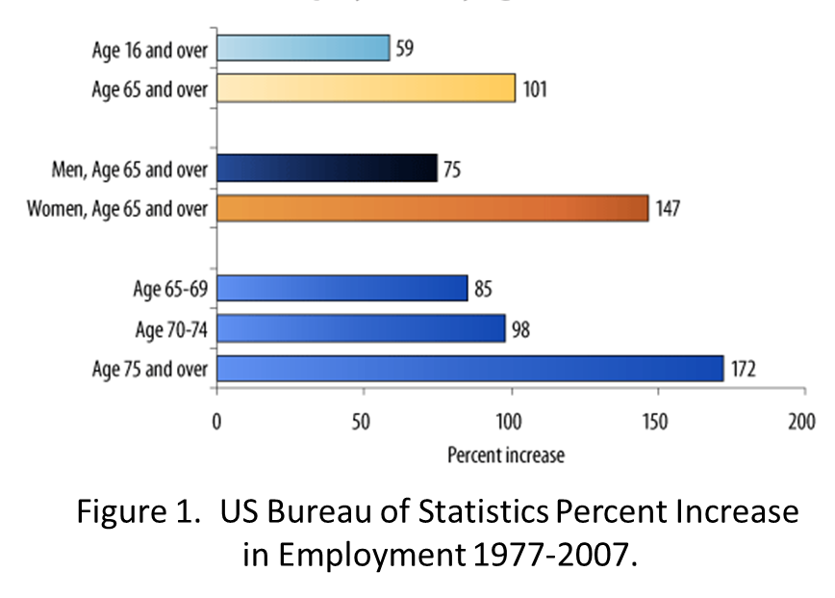
Traditionally, reaching 65 years of age meant a person had become an “old timer” needing to consider retirement. Due to better healthcare and knowledge of successful medical treatments, the 21st century finds that people are working longer and, simultaneously, experiencing hearing loss due to aging in addition to excessive noise exposure. Kachcan et al (2015), in a study of 83,000 subjects compared people who retired to those who worked past age 65. Results discovered that those who worked past age 65 were about three times more likely to report good health and about half as likely to have serious health problems, such as cancer, heart disease, or severe hearing loss. Workers beyond age 65 have been increasing for some time. For example, the data displayed in Figure 1 from the U.S. Bureau of Labor Statistics indicates that from 1977 to 2007 there was a 101% increase in employed workers beyond the age of 65.

According to Loudenback (2019), not all baby boomers are itching to retire. While such studies support the observation that the U.S. work force continues to support an aging population, it is imperative to recognize the possibilities that one of the potential issues in this group of employed workers over age 65 can be a moderate to severe hearing loss.

THE PLIGHT OF MODERATE-SEVERE HEARING-IMPAIRED WORKERS
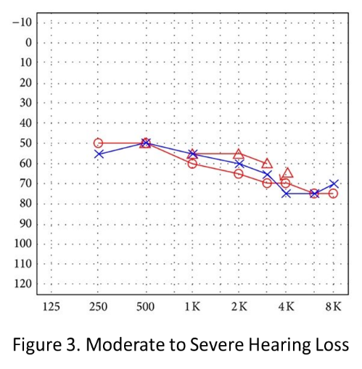
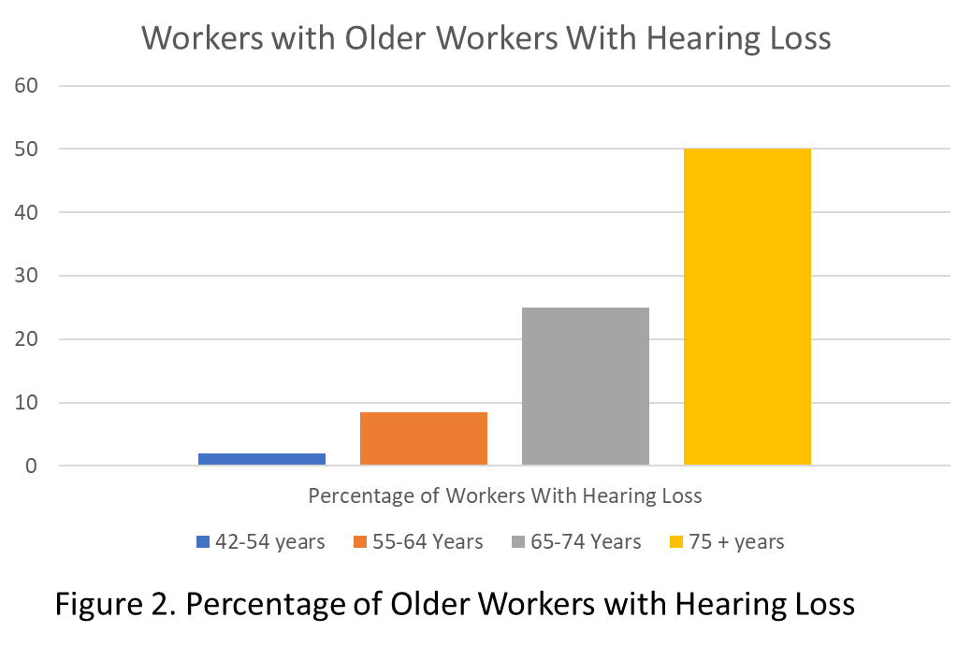
Among all noise-exposed workers, 19% have hearing impairment that impacts day-to-day activities, such as making it difficult to understand speech and enjoy normal routine activities. The incidence of hearing loss in the United States is well known. Figure 2 presents from Hoffman et al (2016) suggesting that due to a combination of possible previous noise exposure complicated by presbycusis (old age hearing loss), the likelihood of older workers with a significant hearing loss is much greater than younger workers, Figure 3. The concern with this issue is that in most cases younger workers can use traditional hearing protection devices (HPDs), while older workers with a hearing loss may require filtered or electronic devices that provide situational awareness.

Situational Awareness & Hearing Protection Devices
Situational awareness is described as an acoustical awareness of environmental surroundings. Berger and Voix (2022) describe this concept as being able to detect, recognize, and identify the source of the

sound. Hearing warning sounds from alarms or machinery in addition to localizing environmental sounds is a critical concern for the safety of the employees in addition to those who work nearby.
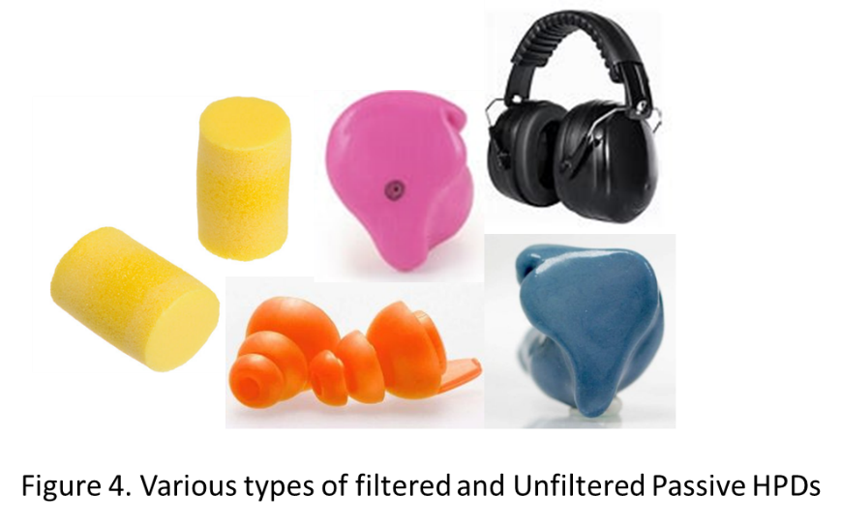
As a means to preserve situational awareness but maintain hearing protection is to attenuate damaging noise, however, too much attenuation has long been recognized as a serious concern in industrial, military, and recreational hearing conservation. Quite some time ago, Nighswonger (2002) recognized major problems with the use of excess attenuation (sound reduction). Over attenuating may contribute to employees being unable to adequately communicante with co-workers or hear critical sounds such as alarms or equipment noise resulting in modifying the fit of the assigned (HPD) device.

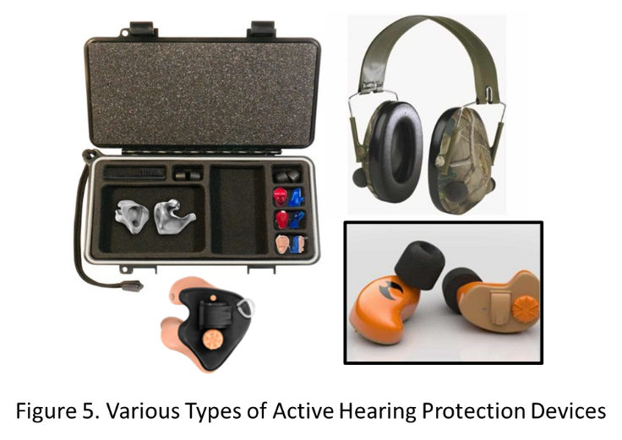
Although passive hearing protection devices (Figure 4) can be frustrating for the hearing-impaired seeking to preserve their hearing, Berger and Voix (2022) indicate that active HPDs (Figure 5) have been proven to offer great benefit to both those with normal hearing and those with a noticeable hearing impairment. Options include filtered ear protection in addition to digital electronic devices that amplify critical sounds while attenuating loud sounds such as wind or impact sounds. For employees with moderate to severe hearing loss, if they are not programmable, they can contribute to poorer hearing.
These researchers state that, when substantial hearing impairment is present, especially in the case of hearing aid users, decisions regarding employment in noisy occupations and/or the use of hearing protection are not clear cut. This has always

been the view of OSHA and industrial audiology consultants as standard hearing aids are not designed to be used as an ear protector.

THE HPD SOLUTION FOR MODERATE TO SEVERE HEARING LOSS
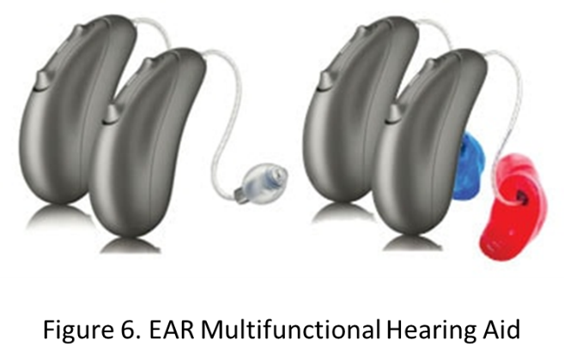
Just in time for the increasing older workers and those that have noisy recreational activities, new technology has become available making special hearing aids multifunctional that can be programmed to an individual’s hearing loss and modified to work very well as an ear protector (Figure 6). Basically, these devices use special ear couplings to the ear to facilitate its use in both modes, hearing aid, and as a hearing protection device. These instruments usually begin as a lower technology device but may be upgraded by audiologists and hearing aid dispensers as necessary to offer premium technology by a simple upgrade. For those experiencing tinnitus (ringing in the ears), 65% of the time when wearing hearing aids, tinnitus is reduced or eliminated (Kochkin & Tyler, 2008).

In summary, there are more individuals working in noisy industrial environments or enjoying recreational activities past the age of 65 and, today, there are multifunctional hearing aids that can be incorporated to continue working or enjoying noisy hobbies. While they are not the over-the-counter type of hearing devices, multifunctional programable instruments are now a reality, enabling better hearing and improved safety for those with moderate to severe hearing loss.

References

Bureau of Labor Statistics (2008). Older workers: Are there more older people in the workplace.
Bureau of Labor Statistics, Washington, DC.

Berger, E., Voix, J. (2022). Chapter 11: Hearing Protection Devices. In The Noise Manual, 6th
Edition, Meinke, D., Berger, E., Driscoll, D., Neitzel, R., Bright, K., Eds., Falls Church, VA:
American Hygiene Association.

Hoffman H., Dobie R., Losonczy K., Themann C., Flamme, G.(2016). Declining Prevalence of hearing loss in US Adults aged 20-69 Yeats. JAMA Otolaryngology – Head & Neck Surgery, Chicago, Il.

Kachan D, Fleming LE, Christ S, Muennig P, Prado G, Tannenbaum SL, et al. (2015). Health Status of
Older US Workers and Nonworkers, National Health Interview Survey, 1997–2011. Prev Chronic
Dis, 12:150040.

Kochkin, S., Tyler, R. (2008). Tinnitus Treatment and the Effectiveness of Hearing Aids: Hearing Care
Professional Perceptions, Hearing Review. 15(13), pp.14-18.

Loudenback, T. (2019). Millions of Americans are working past 65, and it's not because they can't
afford to retire. Insider, Retrieved February 20, 2023.

Maestas, N. (2018). Working later in life can pay off in more than just income.
Staying Healthy. Cambridge, MA: Harvard Health Publishing, Harvard Medical School. Retrieved
February 20, 2023.

Nighswonger, T. (2002). Do Your Workers Wear Too Much Hearing Protection? EHS Today. October.

WHO (2021). World Report on Hearing, World Health Organization, Geneva, Switzerland.

