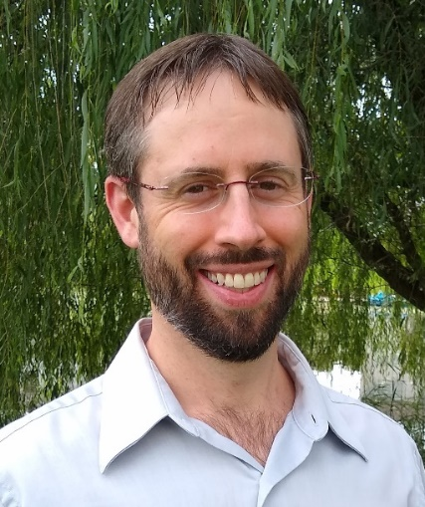
Curriculum Vitae
Eric Thomas Slavin, M.D., FACR
Board Certified, Internal Medicine and Rheumatology
Cell: (989) 798-1057
Email: etslavin@gmail.com

Professional Experience | Multiple award-winning physician  Double board certified  Clinical assistant professor  Active clinical practice  Rheumatologist, West Michigan Rheumatology, PLLC 2015 – Present  1155 East Paris Ave, Ste 100 Grand Rapids, MI  ▪ Providing outpatient continuity care and education  ▪ Providing inpatient consultative care at St. Mary’s Hospital in Grand Rapids  Clinical Assistant Professor, Michigan State University 2017 – Present  1155 East Paris Ave, Ste 100 Grand Rapids, MI  ▪ Providing clinical education to medical students and residents  Hospitalist, St. Vincent Hospital Internal Medicine Department 2012 – 2013  2001 West 86th Street Indianapolis, IN  ▪ Provided inpatient care as a nocturnist with admitting privileges at a tertiary hospital  ▪ Employed as a teaching faculty member, supervising interns and residents  ▪ Triaged and accepted complex patients as transfers from community hospitals throughout the state of Indiana  Fellowship, University of North Carolina 2013 – 2015  3300 Thurston Building Chapel Hill, NC  Residency, St. Vincent Hospital Internal Medicine, Indianapolis 2010 – 2012  2001 West 86th Street Indianapolis, IN  Internship, St. Vincent Hospital Internal Medicine, Indianapolis 2009 – 2010  2001 West 86th Street Indianapolis, IN  The Ohio State University College of Medicine 2005 – 2009  370 West 9th Avenue Columbus, OH  ▪ Doctor of Medicine  ▪ Alspaugh Scholarship - awarded for exemplary altruism, compassion, and integrity  ▪ Roessler Scholarship - awarded for research  University of Michigan 2000 – 2004  500 South State Street Ann Arbor, MI  ▪ Bachelor of Science, Biology  ▪ Graduated magna cum laude  State of Michigan Physician License 2015 – Present  Fellow, American College of Rheumatology 2022 – Present  American Board of Internal Medicine  ▪ Internal Medicine Certification 2013 – Present  ▪ Rheumatology Certification 2015 – Present  St. Vincent Hospital, Indianapolis 2011 – 2012 Indianapolis, IN  ▪ Residency Curriculum Committee: developed wound care curriculum with Laurel Fick  ▪ Residency Clinic Committee  The Ohio State University College of Medicine 2006 – 2007 Columbus, OH  ▪ Landacre Honor Society: inducted for research on Survivin molecule  ▪ History of Medicine Committee  ▪ Wilderness Medicine Interest Group  Grand Rapids Magazine Top Doctors Award 2021, 2022  ▪ A peer-nominated award  Castle Connolly Top Doctor 2019 – Present  West Michigan Rheumatology 2015 – Present Grand Rapids, MI  ▪ Involved in ongoing phase III studies  University of North Carolina 2014 Chapel Hill, NC  ▪ Sjogren’s syndrome update for the American College of Physicians Smart Medicine online module  St. Vincent Hospital, Indianapolis 2010 – 2011 Indianapolis, IN  ▪ Quality Improvement Project: Screening for and treatment of hypertension and hyperlipidemia in the primary care setting  Nationwide Children’s Hospital 2006 – 2007 Columbus, OH  ▪ Slavin E, Kish K, Altura R, Bates C. Expression of Survivin mRNA in Mouse Embryo Kidney. Abstract/poster presented at OSU Medical Center Research Day
Training

Education

Licensure

Committees/
Certifications

Awards

Projects and Research

Presentations | Mercy Health St. Mary’s November 18th, 2022 Grand Rapids, MI  ▪ Internal Medicine residency presentation: “Ordering and Interpreting Rheumatology Labwork”  Mercy Health St. Mary’s 2020 Grand Rapids, MI  ▪ Internal Medicine residency presentation: “Giant Cell Arteritis”  Answer Health 2017 Grand Rapids, MI  ▪ Answer Health Guidelines. Topics included lupus, polymyalgia rheumatica, and gout  Mercy Health St. Mary’s 2017 Grand Rapids, MI  ▪ Family Medicine grand rounds: “Arthritis—Comparing and Contrasting Different Diseases”  North Carolina Rheumatology Association Conference 2015 Charlotte, NC  ▪ Rheumatology case presentation: “Persistent Abdominal Pain in a Patient with SMA Vasculitis”  University of North Carolina 2013 Chapel Hill, NC  ▪ Rheumatology grand rounds: “The Use of Biologics and DMARDs in Infectious Hepatitis”  Medical University of South Carolina 2012 Charleston, SC  ▪ Rheumatology presentation: “Erythromelalgia - A Case of Red Toes”  St. Vincent Hospital, Indianapolis 2011 Indianapolis, IN  ▪ Ambulatory care conference: “Fibromyalgia - A Primer and Management Update”  St. Vincent Hospital, Indianapolis 2010 Indianapolis, IN  ▪ Internal medicine noon conference: “Efficacy of Glucosamine and Chondroitin Sulfate in Osteoarthritis”

