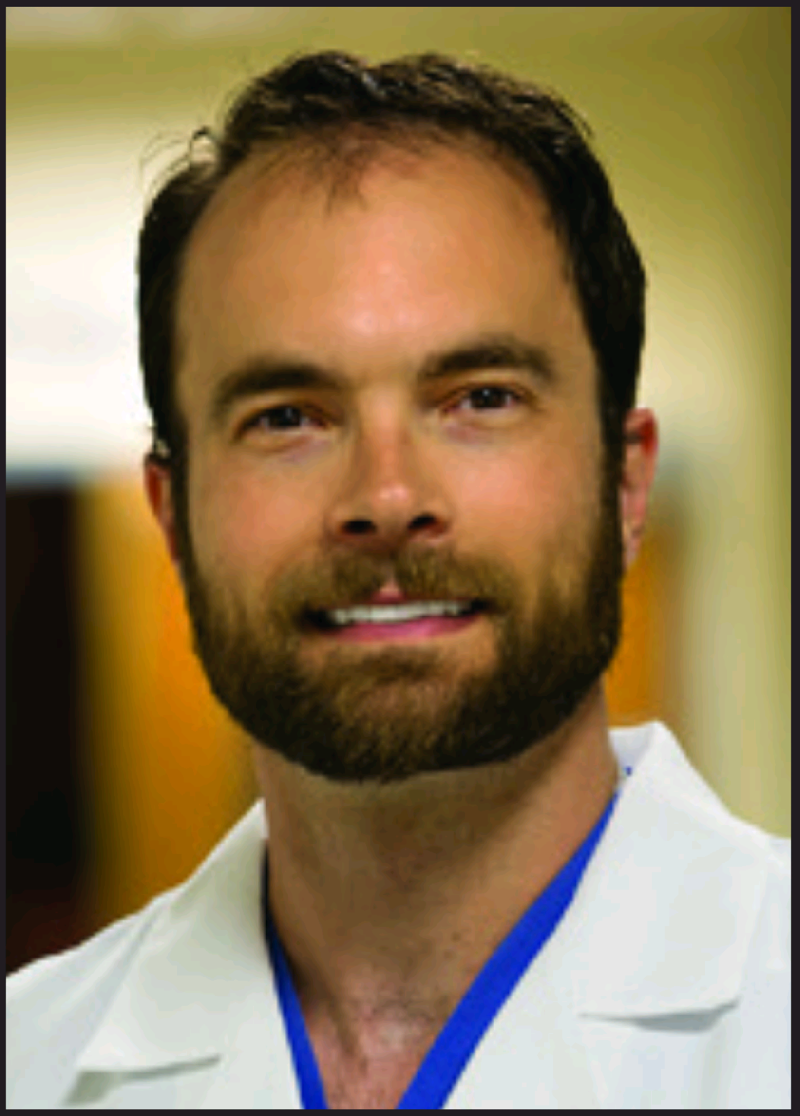
Professional Summary and Qualifications: Board certified anesthesiologist currently working as an Assistant Professor at Saint Louis University Hospital, a level-one trauma center in St Louis, MO. Responsibilities include patient care through medical direction of anesthetists as well as resident physicians in areas including but not limited to: anesthesia for ENT surgery, neurosurgery, cardiac (full TEE competency) and thoracic surgery, endoscopic and vascular surgery, liver and kidney transplant surgery, orthopedic surgery, laparoscopic, outpatient and general surgery, as well as acute pain management with ultrasound guided peripheral nerve blocks and neuraxial anesthesia. Additional duties as floor manager, as well as medical director of the pre-operative anesthesiology clinic, with responsibilities including but not limited to: evaluation, risk stratification, and multi-disciplinary pre-operative optimization of patients scheduled for surgery. Currently also on staff at Mercy Jefferson Hospital and Twin Cities Surgery Center in Festus, MO, where I provide as-needed coverage in a private practice setting. Responsible for supervision of nurse anesthetists, as well as self performing anesthetics for surgeries including but not limited to: obstetrical and gynecological surgery, general surgery, outpatient ENT surgery, orthopedic surgery, outpatient pediatric surgery, and bariatric surgery.

Education
Residency/ 2009-2012
Internship 2008-2009
Barnes-Jewish Hospital at Washington University, Dept of Anesthesiology
660 S. Euclid, Box 8054, St. Louis, MO 63110
Program director: Richard Benzinger, MD PhD
Phone: (314) 362-6978 or (800) 325-5971, Fax (314) 747-4284

MD 2004-2008
Medical College of Georgia (Georgia Health Sciences University), Augusta, GA
1120 15th St, Augusta, GA 30912 , Phone: 706-721-2231

MS 1999-2001
Case Western Reserve University, Cleveland, OH
Master of Science in Anesthesia Program
Lakeside, Room 2533, 11100 Euclid Avenue, Cleveland, Ohio 44106, Phone: 216-844-8077
BA 1995-1999
Bachelor of Arts, Biochemistry
Case Western Reserve University, Cleveland, OH

Experience

- Team Health Anesthesiology 1/10/20 - Present

Christian Hospital Northeast and Alton Memorial Hospital
11133 Dunn Rd 1 Memorial Drive
St. Louis, MO 63136 Alton, IL 62002-6722

Clinical Chief: Hany Tadros MD. Mobile: 314-495-5350

Associate clinical partner in above management company providing clinical care at above locations. Responsibilities include but are not limited to: both medical and non-medical direction of anesthetists, as well as self performing anesthesia. Subspecialty care includes anesthesia for cardiac and thoracic surgery, spine surgery, obstetrical anesthesia, as well as general, orthopedic, GYN, vascular anesthesia, and anesthesia for GI procedures. Further responsibilities include staffing of the pre-anesthesia testing clinic to evaluate and risk stratify patients for upcoming surgeries, providing acute pain management using ultrasound guided peripheral nerve blocks and thoracic epidural placement and pain management.

- Saint Louis University Hospital, Dept of Anesthesiology
3635 Vista Ave, 3rd Floor FDT, Saint Louis, MO 63110
Program Chair: Daniel Roke, MD. Office: (314) 577-8750

Adjunct Asst Professor: 1/09/2020 - Present
Assistant Professor: 10/2016 – 1/09/2020
Adjunct Asst Professor 01/2015 – 10/2016
Assistant Professor: 06/2013 – 01/2015
Clinical Instructor: 07/2012 – 06/2013

Clinical responsibilities: resident training and medical direction of anesthetists for anesthesia including but not limited to: cardiac and thoracic surgery, liver and kidney transplant surgery, acute pain and regional anesthesia, neurosurgery, trauma and orthopedic surgery.
Medical Director of PAT (Pre - Anesthesia Testing) clinic. Former interim director of cardiac anesthesia. Floor manager (board runner).

- Acuity Anesthesiology:
Mercy / Jefferson Regional Medical Center and Twin Cities Surgery Center
1400 Highway 61 South 1101 West Gannon Drive
Festus, MO 63028 Festus, MO 63028

Part time staff: 10/2016 – present
Full time staff: 01/2015 – 10/2016
Part time staff: 10/2012 – 01/2015

Private practice setting involving both medical direction of nurse anesthetists as well as self-performing. Subspecialty areas including: general, orthopedic, cardiac, thoracic, obstetric, and outpatient pediatric specialties.
Reference: George Lappas, MD. Mobile (636) 399-8867

- SSM Cardinal Glennon Children’s Medical Center
1465 S. Grand Boulevard, Saint Louis, MO 63104

Adjunct Assistant Professor: 06/2013 – 12/2014
Adjunct Clinical Instructor: 07/2012 – 06/2013

Clinical responsibilities: medical direction of nurse anesthetists and anesthesiologist assistant anesthetists for pediatric anesthesia including but not limited to general, ENT, ortho, and neuro anesthesia
Program Chair: Daniel Roke, MD. Office (314) 268-2760

- Anesthesiologist Assistant AA-C, 2001-2008
Anesthesiology Associates of Savannah, LLC
6605 Abercorn St Ste 108, Savannah, GA 31405
Reference contact: Frank Busquet MD
Phone: (912) 355-7214

Anesthetist (anesthesiologist assistant) working under medical direction in a multi-specialty practice including cardiac, thoracic, vascular, neuro, and pediatric anesthesia.

Research / Publications
- Research Assistant I
Dept of Cardiology, Medical College of Georgia, Augusta, GA (01/05-01/06)
Principle Investigator: Guy Reed, MD
Project: LV remodeling s/p coronary artery ligation in ANP knockout mice

- Atrial natriuretic peptide increases inflammation, infarct size and mortality after experimental coronary occlusion. Am J Physiol Heart Circ Physiol 296: H655-H661, 2009. Aiilyan K. Houng, Rachel A. McNamee, Attila Kerner, Pallavi Sharma, Almois Mohamad, Jonathan Tronolone, and Guy L. Reed

Awards / Honors
- John F. Schweiss Teaching award (2013-2014). Awarded by Saint Louis University Dept. of Anesthesiology for the most outstanding clinical instructor of the year.

- Midwest Anesthesia Research Conference (Chicago, 2011). 1st place award in area of critical care case presentation at resident conference.: Extracorporeal life support for a patient with VT storm

Presentations
- Midwest Anesthesia Research Conference (Kansas City, 2013). Co-authored: A novel approach regarding placement of popliteal catheters using a posterior in-plane long axis approach to mitigate effect of catheter migration.

- Grand Rounds presentation, SLU Hospital Dept of Anesthesiology. US Guided Regional Anesthesia: Past, Present, and Future. December 2012

- Grand Rounds presentation, SLU Hospital Dept of Anesthesiology. Preoperative anesthesia evaluation for "internists of the operating room." May 2013

- Grand Rounds presentation, SLU Hospital Dept of Anesthesiology. Anesthesia and Hyperthermic Intraperitoneal Chemotherapy. December 2013.

5. Co-authored a poster presentation at national professional society conference (ASA,
New Orleans 2014). Elective Retrograde Intubation for Patient Undergoing Total
Laryngectomy: Combining New and Old Techniques.

6. Co-authored a poster presentation at national professional society conference (ASA,
Boston 2017). Nerve Stimulator Guided Sciatic Block using Phantom Sensation.

7. Midwest Anesthesia Research Conference (Cincinnati 2018) Co-authored: A case of
Delayed Onset Extrapyramidal Symptoms after Propofol Administration

8. Co-authored a poster presentation at national professional society conference (ASA,
San Francisco 2018). Acute Mental Status Changes during Awake Craniotomy for
Skull Based Tumor Resection.

Affiliations/ Active Memberships
1. Diplomat of American Board of Anesthesiologists. License #50254. Expires 12/31/2023
2. American Society of Anesthesiologists. Member # 843800
3. Missouri Society of Anesthesiologists

