HUMAN BEHAVIOR IN ACCIDENT CAUSATION

The direct and sometimes indirect causes of the majority of accidents are at-risk behavior. The reason(s) for the unsafe behavior can be attributed to a number of factors that influenced the errant behavior. Not all at-risk behavior results in an accident that causes injury.

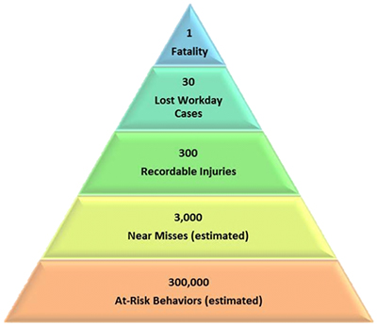

At-risk behavior that results in an accident occurs when the individual:
- is not aware of the hazard
- does not fully understand the potential adverse consequences
- believes the likelihood of the adverse consequences occurring is very low
- is willing to risk the adverse consequences because the perceived benefit is more probable and more immediate (the risk/reward dilemma).



Examples of reasons the above situations occur are:
- insufficient warning or instructions or inadequate training
- inadequate warning sign/label/information and/or inadequate training
- this is especially true if the person exhibited the unsafe behavior before or witnessed others doing it without adverse consequences
- being able to finish a task faster, following unsafe directions or to avoid having to find the correct tool or PPE provides a more immediate and definite perceived benefit than the risk of injury

Extensive training and experience is required to identify the root causes of at-risk behavior. It is essential however if effective action is to be taken to prevent future accidents and identify responsible parties. General Health & Safety Services has over 30 years experience in root cause analysis. Our experts can perform the analysis or train your staff to perform it. We also employ a process that can proactively identify at-risk behavior before an injury occurs, thus making the root cause analysis even more beneficial.

