Marlow Elementary School
Supply List 2022-2023
First Grade

1 Pair of FISKAR Scissors (pointed tip)
4 Boxes of 24 Crayons (basic colors)
1 Plastic School Box
1 Large Box of KLEENEX
4 Large Erasers
1 Plastic Pocket Folder with Brads
2 Large Containers of CLOROX Wipes, or 4 small containers
1 Box of Fabric Band-aids (generic is fine, girls only)
1 Package of Construction Paper (boys only)
6 Package of Glue Sticks (2 count)
1 Large Germ-X Hand Sanitizer (boys only)
2 Quart Sized ZIPLOCK Baggies (girls only)

$5.00 cash only please. This can be given to your child’s teacher on Meet the Teacher Night or the first day of school. This money is for additional supplies that will be bought in bulk for the classroom.
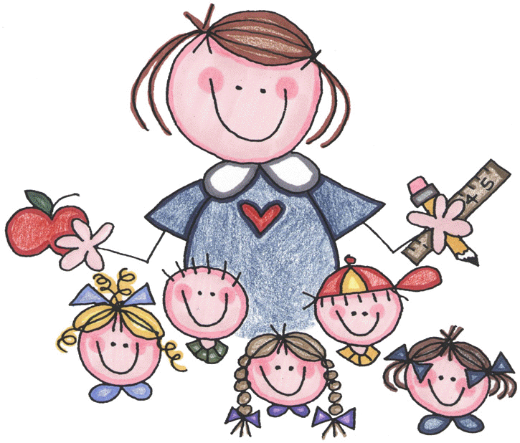
Education is not the filling of a pail, but the lighting of a fire.
William Butler Yeats

Supplies of specific size, color or number are requested because they work better for 1st graders.
Please do not substitute.
Please put your child’s name on all supplies.

