October Newsletter
LEVELLAND HIGH SCHOOL- ACE
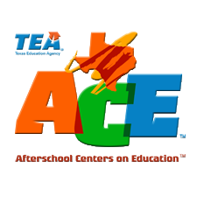

How to Enroll
- Fill out the registration form available in Site Coordinators office or online. Please mark programs interested in
- Send the form back to front office ASAP
- Site coordinator will be in contact with you and your child with confirmation of enrollment

Important Announcement: Family Engagement
THIS MONTH WE WILL HAVE A LIGHTS ON EVENT ON OCTOBER 25TH TO HIGHLIGHT THE IMPORTANCE OF AFTER SCHOOL PROGRAMS. CONTACT THE SITE COORDINATOR FOR MORE INFORMATION AND HOW TO JOIN OUR TEXT REMINDER GROUP!

1400 Hickory St
Levelland, Texas 79336
T: 806.894.8515 ext 4257
Dear Parents and Guardians,
ACE is well underway at Levelland High. We have many great programs for your child including but not limited to credit recovery, driver’s education, and cosmetology. We are also gearing up for a collaboration with the branches of the military to prepare for the ASVAB being offered on November 14th. All of our programs are at NO COST to the families of our participants.
Our programs are Monday thru Friday Mornings: 7-8AM
And
Monday to Thursday Afternoons: 4-6:30PM
All of our programs provided academic assistance, enrichment and prepare your child(ren) for careers and college readiness. Please check the back of this page to see what programming we will have this month and continue checking as we add frequently.

Thank you and please contact me if you have any questions,
Sierra Dubrule
806-894-8515

