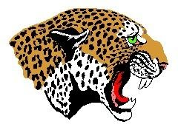 Office of the Athletic Director
De Queen Public Schools
PO Box 950
De Queen, Arkansas 71832

Wednesday, July 29, 2020

Athletic physicals for the 2020 – 2021 school year for De Queen students in grades 7th thru 12th will be conducted during the first week of school, August 24th -28th, at the new Leopard Care Clinic that is located on the De Queen School campus.
If your child has a regular doctor appointment before the week of August 24th, you may have the physical done at that time. Please just make sure that the school receives a copy of that physical so that it can be placed in your child’s file.
All students who plan on participating in sports for the 2020 – 2021 school year must have an up to date physical to be eligible to participate.
If you have any questions, please contact Lance Pinkerton, at the De Queen Administration office at (870)-584-4312.

“It’s a great day to be a Leopard!”

